Paper Title (Times New Roman, 23, Normal, Bold)
Name of Author¹, Name of Author², Name of Author³, Name of Author⁴ (12, Times,Bold)
¹Assistant Professor, Professor (10,Times ,Italic)
Name of the Institute, City, Country, Pin
²Assistant Professor, Professor
Name of the Institute, City, Country, Pin

Abstract – Paper size is A4, Margins 0.7’’ from all four sides .Abstract should be in form of times new roman size 10 italic form. Abstract should be in form of times new roman size 10 italic form. Abstract should be in form of times new roman size 10 italic form. Abstract should be in form of times new roman size 10 italic form. Abstract should be in form of times new roman size 10 italic form. Abstract should be in form of times new roman size 10 italic form. Abstract should be in form of times new roman size 10 italic form. Abstract should be in form of times new roman size 10 italic form. Abstract should be in form of times new roman size 10 italic form. Abstract should be in form of times new roman size 10 italic form. Abstract should be in form of times new roman size 10 italic form. Abstract should be in form of times new roman size 10 italic form.
Keywords- Keyword should be times new roman size 10 italic, bold.
INTRODUCTION
Introduction should be in times new roman size 10 normal, line spacing 1.15 inches, justified. Introduction should be in times new roman size 10 normal, line spacing 1.15 inches justified. Introduction should be in times new roman size 10 normal, justified. Introduction should be in times new roman size 10 normal, line spacing 1.15 inches justified. Introduction should be in times new roman size 10 normal, justified. Introduction should be in times new roman size 10 normal, line spacing 1.15 inches justified. Introduction should be in times new roman size 10 normal, justified. Introduction should be in times new roman size 10 normal, line spacing 1.15 inches justified. Introduction should be in times new roman size 10 normal, justified. Introduction should be in times new roman size 10 normal, line

spacing 1.15 inches justified. Introduction should be in times new roman size 10 normal, line spacing 1.15 inches justified. Introduction should be in times new roman size 10 normal, line spacing 1.15 inches justified. Introduction should be in times new roman size 10 normal, line spacing 1.15 inches justified..
METHOLOGY
All matter of the paper here after should be times new roman size 10 normal size, line spacing 1.15 inches, justified.
Table 1- Title of table (10, Normal)
Sr.No | Item 1 | Item 2 | Item 3 | Item4
1 | Abcd | Abcd | Abcd | abcd
2 | Abcd | Abcd | Abcd | abcd
3 | Abcd | Abcd | Abcd | abcd
4 | Abcd | Abcd | Abcd | abcd

The line spacing for the table content should be single only.
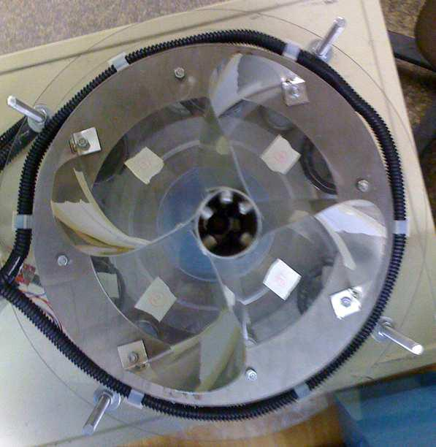

Fig. 1- fig shows the matter (10, Normal)
The contents of the paper should be size 10 normal, line spacing 1.15, justified. The contents of the paper should be size 10 normal, line spacing 1.15, justified.
The contents of the paper should be size 10 normal, line spacing 1.15, justified. The contents of the paper should be size 10 normal, line spacing 1.15, justified. The contents of the paper should be size 10 normal, line spacing 1.15, justified. The contents of the paper should be size 10 normal, line spacing 1.15, justified.
DESIGN
All the equations should be typed using equation editor, equations should not split.
$$\left[\begin{matrix}ω_{1} \\ ω_{2} \\ ω_{3} \\ ω_{4}\end{matrix}\right]=\frac{1}{R} \left[\begin{matrix}1 & 1 & -(l_{1}+l_{2}) \\ 1 & -1 & l_{1}+l_{2} \\ 1 & -1 & -(l_{1}+l_{2}) \\ 1 & 1 & l_{1}+l_{2}\end{matrix}\right]* \left[\begin{matrix}u_{x} \\ v_{y} \\ w_{z}\end{matrix}\right]$$

CONCLUSION
The contents of the paper should be size 10 normal, line spacing 1.15, justified. The contents of the paper should be size 10 normal, line spacing 1.15, justified. The contents of the paper should be size 10 normal, line spacing 1.15, justified. The contents of the paper should be size 10 normal, line spacing 1.15, justified. The contents of the paper should be size 10 normal, line spacing 1.15, justified. The contents of the paper should be size 10 normal, line spacing 1.15, justified. The contents of the paper should be size 10 normal, line spacing 1.15, justified. The contents of the paper should be size 10 normal, line spacing 1.15, justified. The contents of the paper should be size 10 normal, line spacing 1.15, justified. The contents of the paper should be size 10 normal, line spacing 1.15, justified. The contents of the paper should be size 10 normal, line spacing 1.15, justified. The contents of the paper should be size 10 normal, line spacing 1.15, justified. The contents of the paper should be size 10 normal, line spacing 1.15, justified. The contents of the paper should be size 10 normal, line spacing 1.15, justified. The contents of the paper should be size 10 normal, line spacing 1.15, justified. The contents of the paper should be size 10 normal, line spacing 1.15, justified. The contents of the paper should be size 10 normal, line spacing 1.15, justified. The contents of the paper should be size 10 normal, line spacing 1.15, justified. The contents of the paper should be size 10 normal, line spacing 1.15, justified. The contents of the paper should be size 10 normal, line spacing 1.15, justified. The contents of the paper should be size 10 normal, line spacing 1.15, justified. The contents of the paper should be size 10 normal, line spacing 1.15, justified. The contents of the paper should be size 10 normal, line spacing 1.15, justified. The contents of the paper should be size 10 normal, line spacing 1.15, justified. The contents of the paper should be size 10 normal, line spacing 1.15, justified. The contents of the paper should be size 10 normal, line spacing 1.15, justified. The contents of the paper should be size 10 normal, line spacing 1.15, justified. The contents of the paper should be size 10 normal, line spacing 1.15, justified.
ACKNOWLEDGMENT
Acknowledgment to person or the organization supported to the author for the research work. This is not mandatory for all.
REFERENCES
- Ilon, B. E. (1975). Wheels for a Course Stable Selfpropelling Vehicle Movable in any Desired Direction on the Ground or Some Other Base. U.S. Patent. U.S.A.
- Everett, H.R. (1995). Sensors for Mobile Robots: Theory and Application. A K Peters, Ltd, MA, USA.
- Diegel, O.; Badve, A.; Bright, G.; Potgieter, J. & Tlatle, S. (2002). Improved Mecanum Wheel Design for Omni-directional Robots, Proc. 2002 Australian Conference on Robotics and Automation, Auckland, 27-29 Nov. 2002, pp. 117-121.
- Borenstein, J.; Everett, H.R. & Feng, L. (1996). Navigating Mobile Robots: Sensors and Omni directional Mobile Robot – Design and Implementation Ioan Doroftei, Victor Grosu and Veaceslav Spinu “Gh. Asachi” Technical University of Iasi Romania Techniques. A K Peters, Ltd, MA, USA.
- Ioan Doroftei; Victor Grosu and Veaceslav Spinu; “Omnidirectional mobile robot- Design and Implimentation” from “Gh.Asachi” Technical university of lasi, Romania.
- Olaf Diegel, Aparna Badave, Glen Bright, Johan Potgieter, Sylvester Tlale, (2002) “Improved Mecanum Wheel Design for Omni-directional Robot”, Australasian Conference on Robotics And Automation, Auckland.
- Ilon, B. E. (1975). Wheels for a Course Stable Selfpropelling Vehicle Movable in any Desired Direction on the Ground or Some Other Base. U.S. Patent. U.S.A.
- Everett, H.R. (1995). Sensors for Mobile Robots: Theory and Application. A K Peters, Ltd, MA, USA.
- Diegel, O.; Badve, A.; Bright, G.; Potgieter, J. & Tlatle, S. (2002). Improved Mecanum Wheel Design for Omni-directional Robots, Proc. 2002 Australian Conference on Robotics and Automation, Auckland, 27-29 Nov. 2002, pp. 117-121.
- Borenstein, J.; Everett, H.R. & Feng, L. (1996). Navigating Mobile Robots: Sensors and Omni directional Mobile Robot – Design and Implementation Ioan Doroftei, Victor Grosu and Veaceslav Spinu “Gh. Asachi” Technical University of Iasi Romania Techniques. A K Peters, Ltd, MA, USA.
- Ioan Doroftei; Victor Grosu and Veaceslav Spinu; “Omnidirectional mobile robot- Design and Implimentation” from “Gh.Asachi” Technical university of lasi, Romania.

Details of All Authors (Optional)
()
Sr.No | Photo | Details
1
2
3
4

5
6

