**Weight Optimization of Tie Rod Using FEM**

**Satish U. Wayal [1] , Dr. S.S. Deshmukh [2] and Prof. Tushar Katratwar [3]**

*ME Student, Department of Mechanical Engineering, YTIET, Karjat-410201[1]*

*Prof. and Head of Mechanical Engineering, PRMIET,Badnera,Maharashtra[2]*

*Associate Prof. Department of Mechanical Engineering, YTIET, Karjat-410201[3]*

***Abstract*-** *Every organization striving for cost effective product at a lower price and within minimum period of time to market. That keeps pressure on engineers to consistently strive to design the most effective products at, the lower price. The work is focus on functioning of the tie rod, the methods of its performance evaluation its optimization. The tie rod end job is to ensure the wheels are well aligned. It provides the adjustment of wheel alignment that keeps the inner and outer edges of the tires from wearing out. Tie rod having an outer and inner type of ends .the existing tie rod is of solid steel, in this work we make that inner end is hollow with11.0mm ID. After analysis by using FEM method and experimentation. It gives 12.12% less weight than solid tie rod, without failure. Aluminum is suggested as applicable material for future analysis and also we can use the .*

***Index Terms****- Tie Rod, Weight optimization, Transient Dynamic Analysis.*

**I. INTRODUCTION**

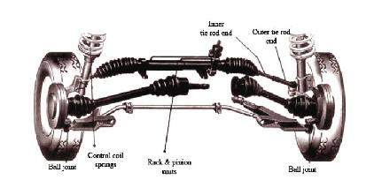 Design of suspensions components in an automotive is very critical as they are constantly under varying loads. While designing the component we must ensure the safety. Apart from design prospective it is important to focus on the weight and cost of an individual component. The tie rod is an important part of suspension system. It connects the steering to the suspension in order to transform the motion. On automobiles with MacPherson strut suspension and rack and pinion steering gears, tie rods connect the end of the rack to the steering knuckle, Fig.1. 1. A tie rod consists of an inner and an outer end as shown in figure. Tie rods transmit force from the steering center link or the rack gear to the steering knuckle, causing the wheels to turn. The outer tie rod end connects with an adjusting sleeve, which allows the length of the tie rod to be adjustable. This adjustment is used to set a vehicle’s toes, a critical alignment angle, sometimes referred to as the caster and camber angles. A vehicle’s steering and suspension systems should be checked regularly, at

least once a year along with a complete wheel alignment.

**Figure1.1:** McPherson suspensions with rack and pinion

Failure of tie rod may occur due to improper material selection, poor design, fatigue load and wear of tie rod. Also the indications given by the tie rod before failure is very less so it can be risky circular rod with threaded part, Outer end and inner end. Tie rod is mostly made up of alloy steel. 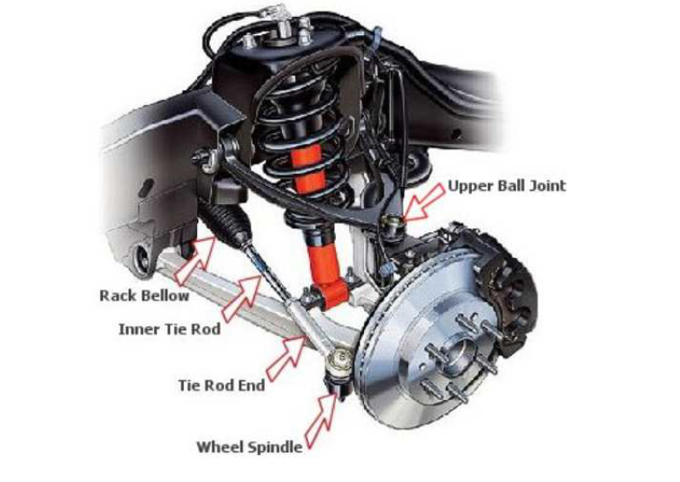 **Figure 1.2:** Location of tie rod in suspension system

**II PROBLEM DEFINITION**

Existing tie rod is assembles using solid, hollow and ball joint. it’s the complex design for manufacturing process. Design becomes bulky due to larger solid part and also becomes less efficient relative to load carrying capacity. The manufacturing process of existing design is critical and time-consuming.so, it is necessary to make the design simple and cost effective such that it gives overall effectiveness in terms of weight, cost, and load carrying capacity and easy in manufacturing process. The main task of this work is to reduce tie rod weight without failure in strength. Set up the benchmark for the proposed design. Try to evaluate the possibility of different material combinations for optimized design. Target is to obtain the design such that critical buckling loads will remain same with a reduced weight of tie rod. The stress targets also need to be achieved. Pre-processing will be carried out using FEM software known as ANSYS. The results will be compared with experimental and theoretical results and optimized design is selected and also evaluation is done.

**2.1 Objectives**  objectives of this work are:

* + An objective of this work is to do the performance evaluation of an existing tie rod. This is done in terms of dynamic analysis.
  + Enlist the parameters affecting the performance of tie rod under different loading condition
  + Decide the optimization scope for weight reduction. Construct the design of new optimized model.
  + Take the necessary physical tests on the tie rod in order to validate it against the actual physical conditions

**2.2 Methodology** In this work, finite element analysis were carried out to determine the factors affecting on the tie rod. All methodology principles and theories discussed were utilized to achieve the objectives. The sequence adopted as follows:

* + - Study of automobile tie rod
    - Modeling of existing tie rod
    - Dynamic Analysis of existing tie rod
    - Optimization based on design parameters
    - Material Selection
    - Optimization based on material
    - Validation of proposed design and conclusion

**III STEERING SYSTEM AND TIE ROD**

Mostly, rack and pinion system is used in passenger car tie rod. The body of a rack-and-pinion steering gear is usually an aluminium casting. The rack is often held to the vehicle body or frame by two U-shaped brackets that are bolted in place. Other units are bolted directly to the vehicle with a series of bolts and nuts that pass through holes in the rack body and the vehicle’s frame. The pinion assembly is a hardened steel gear supported by bearings at the top and bottom. The rack is also made of hardened steel and moves in slide bearings. Seals keep the steering gear lubricant from leaking out of the rack-and-pinion assembly. Figure shows a typical manual rack-and-pinion gear.

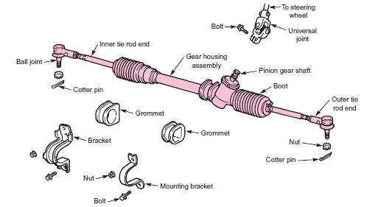

**Figure 3.1:** One type of manual rack-and-pinion steering assembly. Styles will vary.

**3.1 Steering movement ratio and Force calculation on Tie Rod**

The rack and pinion mechanism is designed to transfer the circular input motion of the pinion into linear output movement of the rack.

For a full travel of the rack of 160 mm the pinion has to be rotated 3.25 turns.

Therefore for one turn, the rack travel will be Xo = 160/3.25

= 49.23 mm

Considering the pinion to make one revolution then the input steering movement is:

Xi = 2 π R

= 1099.525

Where, R = 175 mm is the radius of the steering wheel.

And the output rack movement is:

Xo = 2 π r

49.23 = 2 π r

Then, the movement ratio (MR) can be calculated as input movement over output:

MR = Xi/Xo

= 2 π R/2 π r

= 1099.525/49.23

= 23.78

Therefore the movement ratio is 23.78: 1

*(Above data is Given by Company)

We needed to know the movement ratio in order to determine the output load transmitted to the tie rods for a given input load.For an effort of 40 N applied by both hands on the steering wheel and considering no friction, the output load will be:

Fo = Fi * MR

= 40*23.78

**= 951.2 N**

Therefore the load transmitted to the tie rods is 951.2 N.

**IV MODELING AND ANALYSIS OF OPTIMIZED HOLLOW TIE ROD**

from various trials ,we found that the 11.0 mm ID is selected as a optimized condition. following figure shows the deformation, stress in this tie rod

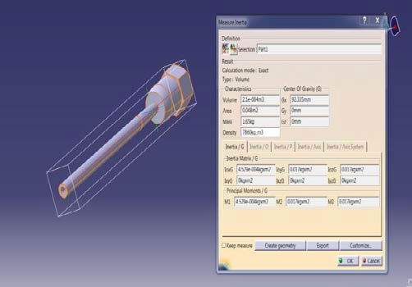

**Fig 4.1:** Cad model and Weight of Tie Rod (ID-11.0 mm)



**Fig 4.2:** Stress in Tie Rod



Fig4.3: deformation in tie rod

**V MATERIAL ANALYSIS RESULT**

**1.Steel- SM45C (Existing)**

The material properties are:

|  |  |
| --- | --- |
| Young's Modulus 'E' | 210 x 103 MPa |
| Poisson's ratio | 0.3 |
| Density | 7860 kg/m3 |
| Tensile strength, yield | 405 MPa |
| Ultimate tensile  strength | 625 MPa |

Allowable Stress = Yield / FOS

= 405/1.8 = 225 MPa

Volume of Tie Rod for 11.0 mm ID = 2.121*10-4 m3

Weight of TieRod is = V x Density = 2.121*10-4 x 7860

= 1.6671 kg

**2.Aluminium Alloy 6082**

The material properties for AL 6082 are:

|  |  |
| --- | --- |
| Young's Modulus 'E' | 72 x 103 MPa |
| Poisson's ratio | 0.33 |
| Density | 2710 kg/m3 |
| Tensile strength, yield | 390 MPa |
| Ultimate tensile  strength | 460 MPa |

Allowable Stress = Yield / FOS

= 390/1.8

= 216.67 MPa

Volume of Tie Rod for 11.0 mm ID = 2.121*10-4 m3

Weight of TieRod is = V x Density = 2.121*10-4 x 2710

= 0.575 kg

**3.Cast Iron – FG 350**

The material properties are:

|  |  |
| --- | --- |
| Young's Modulus 'E' | 110 x 103 MPa |
| Poisson's ratio | 0.29 |
| Density | 7200 kg/m3 |
| Ultimate tensile  Strength | 410 MPa |

Allowable Stress = Ultimate / FOS

= 410/1.8

= 227.78 MPa

Volume of Tie Rod for 11.0 mm ID = 2.121*10-4 m3

Weight of TieRod is = V x Density = 2.121*10-4 x 7200

= 1.527 kg

|  |  |  |  |  |
| --- | --- | --- | --- | --- |
| Material | Stress, MPa | Deflection, mm | Weight, kg | Allowable Stress, MPa |
| **Steel** | **192.58** | **0.13194** | **1.667** | **225.0** |
| Aluminium | 195.75 | 0.37064 | 0.575 | 216.67 |
| Cast Iron | 190.81 | 0.24143 | 1.527 | 227.78 |

**VI CONCLUSION**

Results: (Test results)

|  |  |  |  |
| --- | --- | --- | --- |
| Condition | ID, mm | Material | Deformation, mm |
| New Design | 11.0 | Steel  (Hollow) | 0.37064 |

Hollow tie rod at 11.0 mm ID shows less weight (12.12 %) compare to solid and hence finally suggested for improvement for weight reduction application. Hollow tie rod at 11.0 mm ID shows high Stress (53.77 %) and deflection (29.36 %) values compare to steel but those are within limit while considering weight reduction.

**VI FUTURE SCOPE**

* Composite materials can be tested for less weight applications.
* Effect of Vibrations can be consider
* Dynamic analysis can be carried out for the Impact loading and random changes of the load on Tie Rod due to uneven road.

**ACKNOWLEDGMENT**

I gratefully acknowledge my project guide Prof.Tushar Katratwar sir and HOD of Department Prof.S.R.Wankhede sir I thank him for the encouragement and support he has given me for the project. We thank our Principal Dr. Rajendra Prasad P. and all my professors for imparting their knowledge and their support. Last but not the least we are thankful to all those people who helped in the project activities

**References:**

1] P.A. Simionescu, Ilie Talpasanu, “Synthesis and analysis of the steering system of an adjustable tread-width four-wheel tractor”, The University of Tulsa, Department of

Mechanical Engineering, 17 July 2006.

2] Wei Duan, Suraj Joshi, “Failure analysis of threaded connections in large-scale steel tie rods”, Department of Mechanical Engineering, North China Electric Power

University, Huadian Road, Baoding, China, 17 June 2011.

3] A.H. Falah, M.A. Alfares, A.H. Elkholy, “Failure investigation of a tie rod end of an automobile steering system”, Mech Department, Kuwait University, Jan 2007.

4] A. RahmaniHanzaki ,P.V.M. Rao, S.K. Saha, “Kinematic and sensitivity analysis and optimization of planar rack-and-pinion steering linkages”, Mechanical Engineering Department, Tehran 16788, Iran, 15 August 2008.

5] J. K. Kim, Y. J. Kim W. H. Yang, Y .C. Park, K .H. Lee, “Structural design of an outer tie rod for a passenger car”, International Journal of Automotive Technology, Vol. 12, No. 3, pp. 375−381 (2011).

6] Pradeep Mahadevappa Chavan, M M M Patnaik,” Performance Evaluation Of Passenger Car Tie Rod Using Numerical And Theoretical Approach With Different Materials” Volume:03 Issue:08 /August 2014

7] Jiang Gong Feng, Zhang Yi Liang, “Stability and Failure Analysis of Steering Tie-rod”, International Conference on Experimental Mechanics 2008.