Recent Advancement and Trends in Mechanical Automation, Sensing Devices, and Internet of Things (IoT) in Smart Agriculture

Mamta Tembhare¹, Sunil Kumar²

^{1,2}CSIR-National Environmental Engineering Research Institute (NEERI),
Nehru Marg, Nagpur, 440 020, India

Email Id- mamtatemmbhare@gmail.com, sunil_neeri@yahoo.co.in

Received on: 18 September ,2022 Revised on: 31 December ,2022 Published on: 06 January ,2022

Abstract-India is a developing nation with an annual population growth rate of 1% according to the World Bank Data (2020). Presently, the agricultural sector has successfully managed to meet the population demand and has contributed in annual GDP growth rate of the country. In the coming few decades, the agricultural yield through traditional techniques might fail to meet this growing demand. However, developed countries have managed to upgrade their conventional farm machinery to mechanized devices. The application of sensors and IoT with web-based portals and mobile applications has overcome the environmental challenges of climate change. The innovations in cutting-edge technology have transformed the agriculture sector globally. The application of high-quality sensors in irrigation, fertilizers production, and disease prevention in different crops has increased the overall production efficiency. The application of IoT to acquire information on crops, soil, and the environment has proved to be an efficient tool in rural areas with fewer resources and expertise. It also establishes the intelligent networking systems using GPRS, Zigbee, WIFI, Bluetooth, etc., for easy handling and transportation of agricultural products. The decision support system (DSS) and automatic control system (ACS) reduce time and human interference as well. The present study discusses the potential technology in the field of agriculture to transform rural India. The study emphasizes technology in crucial areas, such as agriculture, renewable energy, information and communication technology (ICT), and sensors for transforming rural India into a developed Nation.
Keywords: Rural Development, Smart Village, Automation, Renewable energy, Sensors

I- INTRODUCTION
Human survival needs agriculture as a source of living. It also imparts livelihood to more than 10% of the global population [1]. In developing countries like India, agriculture is a vital source of livelihood for rural residents with an annual population growth rate of 1% according to the World Bank Data (2020) [2]. As per the study, the global population count is expected to rise more than 31% by 2050, and this will demand an increase in crop production yield [1]. The traditional farming method has failed to meet this growing demand, resulting in the need for advanced technologies and techniques. Researchers across the globe have successfully developed technologies for farming to enhance crop yield [3,4,5]. Advancement in sensors and automation tools in most developed countries have improved farming methods [6]. Agriculture 4.0 is a revolutionary mission led by most developed countries to transform agriculture into a more innovative form [2]. The mission implies the application of machinery with automation, Internet of Things (IoT), Big Data Analysis, Artificial Intelligence (AI), Unmanned Aerial Vehical (UAVs) in monitoring and handling crops. It provides excellent production with minimal cost, labor, and the least environmental pollution [2]. Agriculture 4.0 has also motivated private companies to participate and develop tools for farming and irrigation. Besides this, the application of thermal imaging, remote sensing, machine learning, UAVs, and Wireless Sensors Networks (WSN) has also enhanced crop production and agriculture practices[7]. However, the process has failed to remediate the issues related to management, training, network connectivity, data storage, data sharing lack of essential resources, such as electricity, light, and water.
The recent advancement in agriculture using AI and IoT has caused the following benefits: (a) easy monitoring of crop field, (b) in-house command-driven system to start and haul the process (operating water pump from houses in a radius of 10 km), (c) on-field data collection of soil sample and crops using sensing device, (d) cost-effective and easy understanding, (e) pre-alarming system in case of heavy rain and pump operation, (f) Managing the process of harvesting and crop storage, (g) immediate scientific and technical expertise to farmers, (h) increase in marketing, sales, and production. Apart from the above benefit, the technology has still failed to resolve the operation difficulties to local farmers. Even with rapid advancement in technology, there was a lack in the concept of Smart Sustainable Agriculture (SSA), which can be accomplished by surpassing complex obstacles in controlling and operating AI, data management, collection, and interpolation. The present study explores existing AI/IoT-based technology; its application, benefits, and limitation in SSA, as represented in Fig 1.
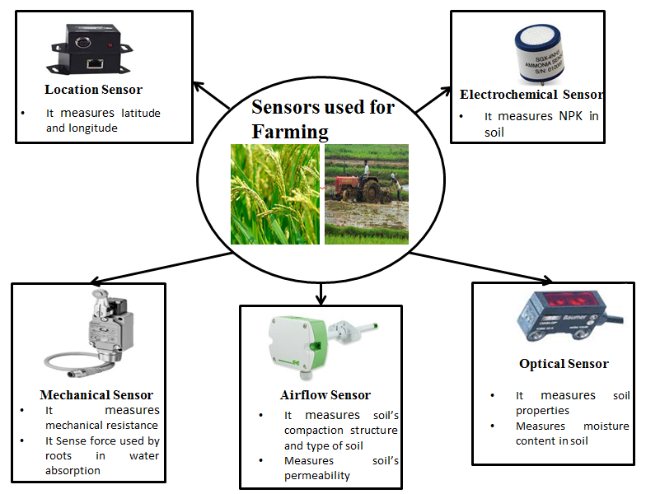
Fig 1-Type of Sensor in Agriculture
II-APPLICATION OF IOT, UAVS AND SENSORS IN SSA
Utilization of IoT, UAVs, Sensors are the recent technologies using in farming, which converts old practices of farming into new agricultural methods. Some of the techiques have been explained in the following sections. Moreover, the Application of smart tools and theologies in agriculture is presented in Table 1.
Table 1. Application of smart tools and theologies in agriculture [8]
Monitoring Parameter | Technology | Objectives
P | RFID | To develop infrastructure for tracking of agriculture supply chain.
PR, SM, W | ZigBee & GPRS | To find out real time calculation of soil moisture
PA | RFID | To improve as well as check a RFID tracking technology with measuring the rhythm of a marine species.
O, CO, N2, Ta | ZigBee | To monitor emission of greenhouse gases.
Ta, Ha, F, FC | WiFi | Identify infections through feed as well as fluid checking, and identify increase in temperature gradient.
T, DO | WiFi | To present actual time monitoring of the water quality.
Ta, Ha | WiFi | To develop system to determine physical chemical property of soil and crops
Ta, Ts, Hs | WiFi & ZigBee | To determine moisture content in agriculture soil.
(Abbreviations: W-water level; P-production information; RH-relative humidity; SM-soil moisture; Ta-air temperature; NT-nitrogen; PS-phosphorous; Hs- soli humidity; Ha- air humidityF-feeding amount; CO-carbon monoxide; O-oxygen sensor; N2-nitrogen dioxide; PR- precipitation; PA-position; FC-field condition; T-temperature;DO-dissolved oxygen; Ts-soil temperature)
2.1 IoT in Smart Energy System
The application of (IoT) in energy management and similar trend has met the demand of the growing population. These new IoT-based devices increase performance efficiency and productivity to resolve issues in agriculture, energy, etc. The IoT was up-graded during the industrial revolution in 21 st century [9]. The IoT application is not limited to energy management only but it exceeds for multiple sectors such as infrastructure, electrical appliances, mechanized machinery [10,11,12]. Observing energy [13], energy harvesting [14], energy use and optimization schedule [15], energy internet [16], efficient data collection [17], energy integration [18], industries and intelligent homes [19,20,21,22], smart grid applications [23,24], energy sustainability [25], auto-energy management [26], and so on. The past studies have claimed potential benefits from IoT-based technology in different domains of research. Technology has vast potential to enhance security and connectivity with real-time problem solutions, which can resolve the real-time problem of monitoring and handling at agricultural farmland.
2.2 UAVs in Farming
Remote sensing includes the application of satellites, aircraft, or small analytical devices to collect, process, and interpret the data from soil and other resources in farming. Sensor nodes intercept the different arena's electromagnetic spectrum and reflect into the atmospheric plane [27]. Generally, optical remote sensing is preferred in agriculture. Initially, it captures energy from an atmosphere of the desired location and creates an image with the help of a visible sensor and near-infrared sensor [28]. Drones are used to collect information from the radiation of the visible spectrum that reflects from the ground. In farming, high-resolution cameras and smart sensors are used as per the requirement of data digging. Moreover, to recognize the amount of water in the plant body thermal sensor is used. It detects because leaves have more water displayed in the blue spectrum in the heat map [29]. In numerous industrialized areas and the agricultural sector, IoT, Cloud computing, Big Data, etc., have made inspiring growth; however, IoT has inadequate network facilities like cellular networks and Wi-Fi routers. Wireless sensors cannot transmit real-time data on the cloud due to the deficiency of a solid communication structure and gathered information. At this stage, UAVs render wireless services by visiting the on-site location to collect appropriate data for further analysis.
UAVs are mainly categorized as multi-rotor and fixed rotor is shown is Fig 2. [30]. Each type has different specifications like payload capacity, hardware parts, size, range, etc. Fixed-wing drones are broadly used to cover a large area because of long-range flying ability like the eBee SQ drone [31]. On the other hand, a multi-rotor drone is preferred for fast configuration and lift off and touch down vertically. It has more advantages than the fixed-wing drone due to its easy control and it flies precisely. Additionally, the multi-rotor can fly at low altitudes to capture high-resolution photographs ex. DJI Matrices 200 and American Robotics [32,33].
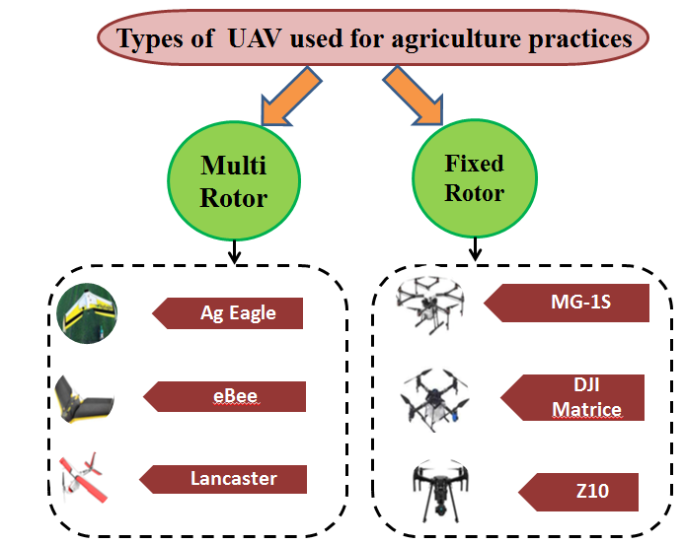
Fig 2-Classification of Drones used for Agricultural Purposes
These UAVs assist in solving many problems, whether it is huge or small. It gives service in the defense sector, agriculture, and many more. Application of advanced tool allows cost reduction and less human resources. UAVs offer soil analysis in the field before plantation, which aids to decide the crop is suitable for this soil condition or not and shows kinds of seeds and procedures of the plantation that should be used [34]. It is used for crop monitoring. This is more convenient for farmers and reliable tracking of isolated farms in real-time [35]. Body sensors and cameras are mounting to detect underwater stress sites and provide appropriate irrigation throughout the land by sprinkling the water on UAVs. This drone technology helps to save water and detects irrigation leaks as well [36]. Moreover, it is also used for spraying pesticides on crops. Spraying the pesticides in fields by labor may lead to suffering from several diseases; for such circumstances, UAV spraying is a valuable method for farming. It is sprayed on affected areas only and helps to minimize overall spraying cost and time, so it is highly economical [37]. Sensors fitted on the drone body, such as visible light and infrared sensors, are used to identify plants' health. Sometimes plants are affected by fungus or bacteria, which deteriorate crops and reduce productivity. But this health valuation plays a vital role in protecting plants from disease [38].
2.3 IoT in Smart Agriculture
IoT has an unique identity to perform applications like monitoring, remote sensing, data storage, etc. IoT devices can exchange real-time data with other hardware modules or applications. The essential components of IoT are input and output coupling for sensors, interface for connection to the internet, memory and storage coupling, Audio/Video interface. This innovation of ICT euipments makes IoT is cost-effective for farming [39,40]. IoT devices are broadly used across the globe with a standard communication protocol. IoT uses multiple technologies to gather information or data by adopting cloud storage software, extensive data analysis, wide sensor networks, communication protocol [41]. IoT aims to connect different devices through a single internet network. It intends to unite all smart tools in the same network topology. In IoT, two kinds of computer technologies are used: i) Hardware (small modules, sensors) ii) Software (advanced algorithms). This technology has been broadly used in several areas like private sectors, bio-medical engineering, agriculture, etc., for data exchange, data transmission [43]. IoT application allows command-driven functions such as water distribution through irrigation networks. Jagey et al., 2019 designed automated irrigation system with a mobile operating mechanism. The smartphone is used to click and process the photographs near the roots of crops and then identify the amount of water [40]. Studies have also suggested that ARM9 processor was found to be appropriate for real-time functioning of drip irrigation systems.
The hierarchy of IoT application in smart agriculture is represented in Fig 3. The application are majorly divided into three parts are preciseness farming, greenhouse and farm animals monitoring. IoT uses various snesors like soil sensor, pH sensor, etc. used for analysis and monitoring purpose. IoT follows communication protocols for data exchange or storage. Few countries such as USA, Russia, etc. adopted smart agricultural methods of farmig. It helps to generate more crop production for the nation.
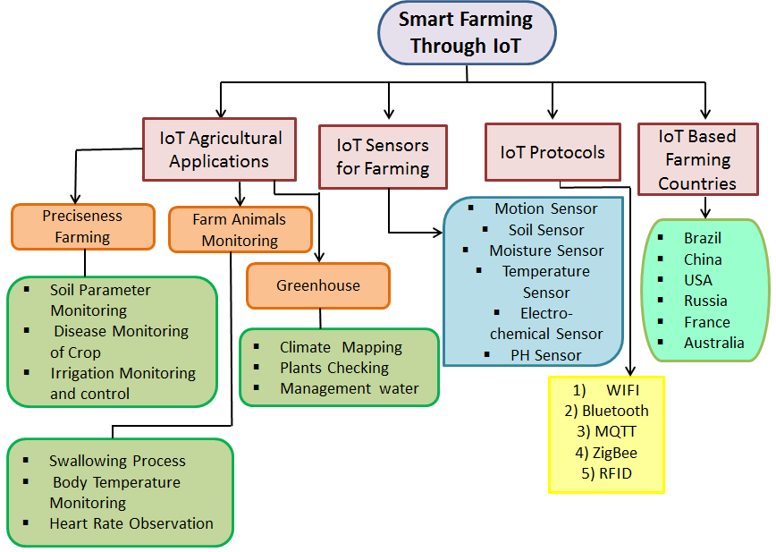
Fig 3.-IoT Based Smart Farming
2.4 Sensors in SSA
Nowadays, the application of sensors in satellite and aerial imagery has transformed the ways of doing agriculture. Smart farming is a combined optimized method in retrieving, analyzing, and storing data [44]. The application of smart sensors implies precise management, followed by productive output in crop yield and process management. The key feature implies easy processing of these methods through mobile phones, tablets, and other electronic appliances. Farmers can use these devices to analyze real-time soil properties such as moisture content, water content, electrical conductivity, pH, temperature, and wind speed [45,46,47,48,49,50]. The detailed description of the above parameters has been represented in Table 2. Various types of sensors have been developed in different aspects of farming. These sensors can be classified as mechanical, electrochemical, and dielectric.
Table 2. Application of Sensors
Parameter | Application of sensor
Water Content (WC) [42] | Determines the ratio of water in soil sample. The sensor interprets the percentage by the change in capacitance value; it ranges from 0 to 100%. The sensor must be calibrated each time before measurement
Moisture Content (MC) [43] | Similar to WC sensor. Estimate soil water tension, which helps in the interpretation of water content present near plant roots. Highly acceptable in irrigation.
Electrical conductivity [44] | Measures salt concentration, based on Faradays principle of conductivity. It prevents salt accumulation into soil and plant roots, which helps in crop yield.
pH [45] | Measures alkalinity and acidity using positive and negative electrodes emerged in solution with highly active ions and cations. This maintains soil fertility, and the range should be 5.5 to 7.5.
Weed seeker [51] | They were designed with optical light coupled with electronic components. The light reflected onto the weed measured the chlorophyll. Spray jets with chemicals are used to destroy the weed.
Temperature [46] | The sensor comprises the p-n junction diode. Measure soil temperature to control absorption, photosynthesis, and transpiration.
Wind speed [47] | Mounted depending upon crop height. The sensor determines the flow of wind depending upon the area and time.

III- CONCLUSION
The elementary requirement of the nation depends on the economic aspect, which is mainly reliable on agriculture. The primary necessity is to utilize the recent technology to mitigate real-time issues in agriculture and irrigation facilities. The present study indicated that the lack of resources and efficacy in most of the developing countries has caused mover usage of agricultural resources, such as water, rain water, and soil, which declined in crop yield. This study recommends the application of recently developed technologies to resolve agricultural problems and make the process more innovative and reliable. At the same time, the article suggested the impacts of modern technology for better economical growth followed by an increase in GDP rate. This will also influence the change in living standards of rural residents.
REFERENCES
- Ayaz, M., Ammad-Uddin, M., Sharif, Z., Mansour, A. and Aggoune, E.H.M., 2019. Internet-of-Things (IoT)-based smart agriculture: Toward making the fields talk. IEEE Access, 7, pp.129551-129583.
- Patil Shirish, S. and Bhalerao, S.A., 2013. Precision farming: The most scientific and modern approach to sustainable agriculture. International Research Journal of Science and Engineering, 1(2). https://www. semanticscholar.org/paper/Precision-farming%3A-The-most-scientific-and-modern-Shirish Bhalerao/7870e54bd38e2f0b76b5b9fe205deacfce68d5a5
- Mandal D. Ghosh SK. Precision farming – The emerging

concept of agriculture for today and tomorrow. Current

Science, 2000; 79 (12): 1644-1647

- Ahmar, S., Gill, R.A., Jung, K.H., Faheem, A., Qasim, M.U., Mubeen, M. and Zhou, W., 2020. Conventional and molecular techniques from simple breeding to speed breeding in crop plants: recent advances and future outlook. International journal of molecular sciences, 21(7), p.2590.

- Zheng, C., Yuan, J., Zhu, L., Zhang, Y. and Shao, Q., 2020. From digital to sustainable: A scientometric review of smart city literature between 1990 and 2019. Journal of Cleaner Production, 258, p.120689.
- Rehman, Z.U., Khan, M.A., Ahmed, F., Damaševičius, R., Naqvi, S.R., Nisar, W. and Javed, K., 2021. Recognizing apple leaf diseases using a novel parallel real‐time processing framework based on MASK RCNN and transfer learning: An application for smart agriculture. IET Image Processing, 15(10), pp.2157-2168.
- Williams, T.O., Mul, M.L., Cofie, O.O., Kinyangi, J., Zougmoré, R.B., Wamukoya, G., Nyasimi, M., Mapfumo, P., Speranza, C.I., Amwata, D. and Frid-Nielsen, S., 2015. Climate smart agriculture in the African context. https://cgspace.cgiar.org/handle/10568/68944 Accessed on 18/11/2021.
- Dassgupta, J. and Pudney, P., Real-time Control of Indoor Lighting to Minimise Energy Use. http://www.iaeng.org/publication/WCE2019/WCE2019_pp181-186.pdf Accessed on 18/11/2021.
- O’Dwyer, E., Pan, I., Charlesworth, R., Butler, S. and Shah, N., 2020. Integration of an energy management tool and digital twin for coordination and control of multi-vector smart energy systems. Sustainable Cities and Society, 62, p.102412.
- Hassan, N., Chou, C.T. and Hassan, M., 2019. eNEUTRAL IoNT: Energy-neutral event monitoring for Internet of nano things. IEEE Internet of Things Journal, 6(2), pp.2379-2389.
- Ko, H. and Pack, S., 2019. Neighbor-aware energy-efficient monitoring system for energy harvesting internet of things. IEEE Internet of Things Journal, 6(3), pp.5745-5752.
- Wu, C., Wang, A.C., Ding, W., Guo, H. and Wang, Z.L., 2019. Triboelectric nanogenerator: a foundation of the energy for the new era. Advanced Energy Materials, 9(1), p.1802906.
- Lin, C.C., Deng, D.J., Liu, W.Y. and Chen, L., 2017. Peak load shifting in the internet of energy with energy trading among end-users. IEEE Access, 5, pp.1967-1976.
- Orsino, A., Araniti, G., Militano, L., Alonso-Zarate, J., Molinaro, A. and Iera, A., 2016. Energy efficient IoT data collection in smart cities exploiting D2D communications. Sensors, 16(6), p.836.
- Zakeri, B., Syri, S. and Rinne, S., 2015. Higher renewable energy integration into the existing energy system of Finland–Is there any maximum limit?. Energy, 92, pp.244-259.
- Gupta, A., Anpalagan, A., Carvalho, G.H., Khwaja, A.S., Guan, L. and Woungang, I., 2019. RETRACTED: Prevailing and emerging cyber threats and security practices in IoT-Enabled smart grids: A survey. https://link.springer.com/chapter/10.1007/978-3-030-49190-1_11 Accessed on 18/11/2021.
- Stojkoska, B.L.R. and Trivodaliev, K.V., 2017. A review of Internet of Things for smart home: Challenges and solutions. Journal of Cleaner Production, 140, pp.1454-1464.
- Lee, Y.T., Hsiao, W.H., Huang, C.M. and Seng-cho, T.C., 2016. An integrated cloud-based smart home management system with community hierarchy. IEEE Transactions on Consumer Electronics, 62(1), pp.1-9.
- Han, D.M. and Lim, J.H., 2010. Smart home energy management system using IEEE 802.15. 4 and zigbee. IEEE Transactions on Consumer Electronics, 56(3), pp.1403-1410.
- Hui, H., Ding, Y., Shi, Q., Li, F., Song, Y. and Yan, J., 2020. 5G network-based Internet of Things for demand response in smart grid: A survey on application potential. Applied Energy, 257, p.113972.
- Batista, N.C., Melício, R., Matias, J.C.O. and Catalão, J.P.S., 2013. Photovoltaic and wind energy systems monitoring and building/home energy management using ZigBee devices within a smart grid. Energy, 49, pp.306-315.
- Khatua, P.K., Ramachandaramurthy, V.K., Kasinathan, P., Yong, J.Y., Pasupuleti, J. and Rajagopalan, A., 2020. Application and assessment of internet of things toward the sustainability of energy systems: Challenges and issues. Sustainable Cities and Society, 53, p.101957.
- Zouinkhi, A., Ayadi, H., Val, T., Boussaid, B. and Abdelkrim, M.N., 2020. Auto‐management of energy in IoT networks. International Journal of Communication Systems, 33(1), p.e4168.
- Kemper, N., 2008. Veterinary antibiotics in the aquatic and terrestrial environment. Ecological indicators, 8(1), pp.1-13.
- Prasad, S., Bruce, L.M. and Chanussot, J., 2011. Optical remote sensing. Advances in Signal Processing and Exploitation Techniques; Springer: Berlin, Germany. https://link.springer.com/book/10.1007%2F978-3-642-14212-3 Accessed on 18/11/2021.
- Cozzolino, D., Porker, K. and Laws, M., 2015. An overview on the use of infrared sensors for in field, proximal and at harvest monitoring of cereal crops. Agriculture, 5(3), pp.713-722.
- Tang, L. and Shao, G., 2015. Drone remote sensing for forestry research and practices. Journal of Forestry Research, 26(4), pp.791-797.
- Mairaj, A., Baba, A.I. and Javaid, A.Y., 2019. Application specific drone simulators: Recent advances and challenges. Simulation Modelling Practice and Theory, 94, pp.100-117.
- Schneider, D., 2017. Air traffic control for delivery drones [Top Tech 2017]. IEEE spectrum, 54(1), pp.32-33.
- Hennage, D.H., Nopola, J.R. and Haugen, B.D., 2019, June. Fully Autonomous Drone for Underground Use. In 53rd US Rock Mechanics/Geomechanics Symposium. OnePetro. https://onepetro.org/ARMAUSRMS/proceedings-abstract/ARMA19/All-ARMA19/ARMA-2019-2028/125084 Accessed on 18/11/202.
- D'Oleire-Oltmanns, S., Marzolff, I., Peter, K.D. and Ries, J.B., 2012. Unmanned aerial vehicle (UAV) for monitoring soil erosion in Morocco. Remote Sensing, 4(11), pp.3390-3416.
- Berbeć, A.K., Feledyn-Szewczyk, B., Thalmann, C., Wyss, R., Grenz, J., Kopiński, J., Stalenga, J. and Radzikowski, P., 2018. Assessing the sustainability performance of organic and low-input conventional farms from eastern Poland with the RISE indicator system. Sustainability, 10(6), p.1792.
- Godovskaya, M.A. and Medynskyi, D.V., 2020. Use of unmanned aerial vehicles in agriculture. https://dspace.nau.edu.ua/bitstream/NAU/47262/1/USE%20OF%20UNMANNED%20AERIAL%20VEHICLES%20IN%20AGRICULTURE.pdf Assessed on 18/11/2021.
- Faiçal, B.S., Freitas, H., Gomes, P.H., Mano, L.Y., Pessin, G., de Carvalho, A.C., Krishnamachari, B. and Ueyama, J., 2017. An adaptive approach for UAV-based pesticide spraying in dynamic environments. Computers and Electronics in Agriculture, 138, pp.210-223.
- Puig, M., Moragrega, C., Ruz, L., Montesinos, E. and Llorente, I., 2015. Controlling brown spot of pear by a synthetic antimicrobial peptide under field conditions. Plant disease, 99(12), pp.1816-1822.
- Liopa-Tsakalidi, A., Tsolis, D., Barouchas, P., Chantzi, A.E., Koulopoulos, A. and Malamos, N., 2013. Application of mobile technologies through an integrated management system for agricultural production. Procedia Technology, 8, pp.165-170.
- Goudos, S.K., Dallas, P.I., Chatziefthymiou, S. and Kyriazakos, S., 2017. A survey of IoT key enabling and future technologies: 5G, mobile IoT, sematic web and applications. Wireless Personal Communications, 97(2), pp.1645-1675.
- Atzori, L., Iera, A. and Morabito, G., 2017. Understanding the Internet of Things: definition, potentials, and societal role of a fast evolving paradigm. Ad Hoc Networks, 56, pp.122-140.
- Bibri, S.E., 2018. The IoT for smart sustainable cities of the future: An analytical framework for sensor-based big data applications for environmental sustainability. Sustainable cities and society, 38, pp.230-253.
- Alreshidi, E., 2019. Smart sustainable agriculture (SSA) solution underpinned by internet of things (IoT) and artificial intelligence (AI). arXiv preprint arXiv:1906.03106.
- Wang, D., Bai, B., Lei, K., Zhao, W., Yang, Y. and Han, Z., 2019. Enhancing information security via physical layer approaches in heterogeneous IoT with multiple access mobile edge computing in smart city. IEEE Access, 7, pp.54508-54521.
- Strobel, D., Oswald, D., Richter, B., Schellenberg, F. and Paar, C., 2014. Microcontrollers as (in) security devices for pervasive computing applications. Proceedings of the IEEE, 102(8), pp.1157-1173.
- [43] Zhu, J., Yu, H., Lin, Z., Liu, N., Sun, H. and Liu, M., 2019. Efficient actuator failure avoidance mobile charging for wireless sensor and actuator networks. IEEE Access, 7, pp.104197-104209.
- Kaewmard, N. and Saiyod, S., 2014, October. Sensor data collection and irrigation control on vegetable crop using smart phone and wireless sensor networks for smart farm. In 2014 IEEE Conference on Wireless Sensors (ICWiSE) (pp. 106-112). IEEE.
- Li, D., Zheng, Y. and Zhao, W., 2019. Fault analysis system for agricultural machinery based on big data. IEEE Access, 7, pp.99136-99151.
- Dachyar, M., Zagloel, T.Y.M. and Saragih, L.R., 2019. Knowledge growth and development: internet of things (IoT) research, 2006–2018. Heliyon, 5(8), p.e02264.
- AshifuddinMondal, M. and Rehena, Z., 2018, January. Iot based intelligent agriculture field monitoring system. In 2018 8th International Conference on Cloud Computing, Data Science & Engineering (Confluence) (pp. 625-629). IEEE.
- Wang, P., Valerdi, R., Zhou, S. and Li, L., 2015. Introduction: Advances in IoT research and applications. Information Systems Frontiers, 17(2), pp.239-241.
- Tao, W., Zhao, L., Wang, G. and Liang, R., 2021. Review of the internet of things communication technologies in smart agriculture and challenges. Computers and Electronics in Agriculture, 189, p.106352.
- Velásquez, D., Sánchez, A., Sarmiento, S., Toro, M., Maiza, M. and Sierra, B., 2020. A method for detecting coffee leaf rust through wireless sensor networks, remote sensing, and deep learning: case study of the caturra variety in Colombia. Applied Sciences, 10(2), p.697.

- Population growth, Availavle on :https://data.worldbank.org/indicator/SP.POP.GROW Accessed on 22 March 2022.

