**Computation of Traffic Shortest Path Using Dijkstra’s Algorithm**

**Diksha Jadhav1,Anjali Ramteke1,PoojaDongre1,Snehal Taraskar1,Antara Bhattacharya2**

*1UG Student,2 Assistant Professor,*

*Department of Computer Science Engineering,*

*G.H.Raisoni Institute of Engineering and Technology,Nagpur, India.*

***Abstract-****The aim of “Computation of Traffic Shortest Path victimization Dijkstra’s rule ”, is to showcase the route that'sabundant easier to travel from initial location to needed destination with none traffic stops additionally it focuses on typical and reliable path to the shopperthat provides the simplest path from variedvariety of routes thatis ready to be economicaland fewertime overwhelming path from the user’s initial location to the last word destination. This package contains a dataset of a townthat have a pair of coordinates(x,y) and varied adjacent or intermediate nodes. this can be imperativein vanguardmotor vehicle route frameworks as a result of it helps drivers to choose wiseselections. To our greatestinfo, there's no effective framework/arrangement which is able tosupplylow cost expenses at eachclient and server sides for manytemporaryapproach calculation. The packagewill set a timeline that shows the objects gift on the trail line. A promising methodology is to let the server gather knowledge and subsequentlyshow shortest pathover remote system on automotive navigation system. this system has ability with the numberof customers. The shortest path not solely provides the approachhowever it in addition provides a wiseapproach through that the user willsimply travel from one location to his/her desired location.*

Keywords: Serivce Provider, Taffic Provider, Dijkstra’s Algorithm, Client-Server Model, Shortest Path, Broadcasting

**INTRODUCTION**

**I**n the proposed work, the designing of shortest path victimization Dijkstra’s algorithmic rule is enforced. In the algorithm, some nodes are enforced to render the traffic circumstances. In this project five modules are designed. In first module, the designing of a Graphical User Interface (GUI) is madethat defines navigation consumer panel. The second module is, informationset uploadingof required data from the bulk of obtainable dataset is allotted. Now, the next module is implementation of traffic feed provider that shows the summary of town map that are obtainable in information set is been provided. The next module is implementation of traffic broadcaster that consists of the traffic, from source to destination in graphical kind to the consumer is given. The last module is finding shortest path in which the shortest path is flaunted to the consumer to achieve their destination. The canvas software is used for the graphical routes to show the shortest path from supply to destination. Canvas is the panel during whichit's black background. The project requires Xampp Server for establishing connections of various modules. The traffic feed collector collects information and timeline then provides it to the Traffic Broadcaster. Consider that, there are 2 routes with completely different distances to the same destination. If one route contains huge traffic although it is shortest, then the user will go for the opposite route that have less traffic as compared to previous one, although it has long distance howeverit'lloffer a traffic-free route to the consumer.A new and promising solution to the shortest path computation is to show on remote system over the wireless network. The main advantages of this model are that the network overhead is freelance of the amount of shoppersand eachconsumerwillreadsome of the complete road map in line with the knowledge.

**2. PROBLEM STATEMENT**

There are many few vendors that provide live traffic based shortest path computation for users in traffic domain. Again the results that are found in existing varies a lot from original traffic conditions.The main purpose of project is to develop a system that can analyze traffic conditions and provide shortest path based on traffic analysis as provided by the timeline.To simulate traffic conditions a road network is developed for generating different traffic conditions.

1. **OBJECTIVE**

The main objectives are as follows:

1. To provide traffic fields to client

2. To provide broadcasting services using traffic broadcast server

3. To provide proper traffic simulation using timeline based dataset.

1. To find shortest path in timeline based trafficanalysis.

**4. LITERATURE REVIEW**

**A. JagadeeshMailu and M. Ganthimathi, ”Enhanced Online Shortest Path Using Traffic Index Approach” [1]:**

The paper highlights an indexing and query processing scheme for the shortest path query answering.The shortest paths are stored in such bags and these local paths together with the tree are the components of the index of the graph.They introduced an indexing and query answering scheme based on the tree decomposition concept for the shortest path query answering.

**B. Leong Hou U, Hong Jun Zhao, Man Lung Yiu, Yuhong Li, and Zhiguo Gong, “*Towards Online Shortest Path Computation*”[2]:**

The paper highlights two new classes of approximate techniques – K-paths and proximity measures to substantially speed up processing.The set of designated routes specified by continuous route planning queries in the face of incoming traffic delay updates.

**C. L. Wu, X. Xiao, D. Deng, G. Cong, A.D. Zhu, and S. Zhou, “*Shortest Path and Distance Queries on Road Networks: An Experimental Evaluation*,”[3]:**

The paper presents a comprehensive comparison of the most advanced spatial-coherence-based and vertex-importance-based approaches .The performance of the state-of-the-art spatial-coherence

based algorithms, SILC and PCPD were tested using only small road networks with up to one hundred thousand vertices.

**5. PROPOSED PLAN OF WORK**

A road network monitoring system generally consists of a service supplier, a large variety of mobile shoppers and a traffic supplier shows an summary of this methodwithin the context of our traffic framework. The traffic provider collects the live traffic circumstances from the traffic monitors via techniques like road sensors and traffic video analysis. The service suppliersporadically receives live traffic updates from the traffic provider and displays the traffic on automotive navigation system or remote system.  
The project is sub-divided in five modules. They are explained thoroughly as follows:  
 **1.GUI Designing:**We style a Graphical User Interface (GUI) within whichwe have a tendency tooutline a navigation consumer panel.

**2. Dataset Uploading:** The information set uploading in which we have a tendency toarea unit uploading needed data from the majority of obtainable dataset.

**3. Implementing Traffic-feed Provider:** In this we offer the overview of town map thatarea unitaccessible in information set.

**4. Implementing Traffic Broadcaster:** In this we show the traffic from supply to destination in graphical type to the consumer.

**5.Finding Shortest Path:**Here we show the shortest path to the consumer to reach their destination. In this module the system will

calculate the shortest distance consistent with the user’swould like from supply to destination.

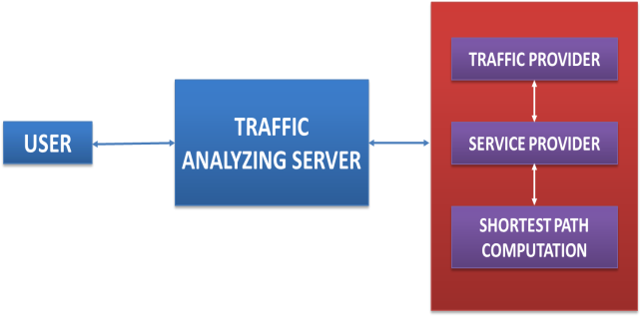

Fig 1: Architectural Block Diagram of Project Flow

**TRAFFIC PROVIDER:**

Realtime traffic feeds are collected from the traffic watching resources planted on the edge and different crowd-sourcing techniques by the supplier. The collected information is shared to completely different service suppliereach as raw and optimized information.They square measure providing the live feed to the service suppliersthat are collected from the advanced time period traffic machine.  
This channel provides a preprocessed traffic data to the Service supplier

**SERVICE PROVIDER:**

The preprocessed raw traffic data collected from the suppliersare being indexed and are orderly broadcasted towards multiple shoppers.   
The traffic datum are organized by compartmentalization the collected info such as to supplytime period feeds to the shoppers, and also in the manner to ease the consumer with their computation value.

**NAVIGATION CLIENT:**

The clients that are in would like of the time period traffic feeds are tuned in a manner to receive the relevant information packets supported the indexed traffic information.The received packets are then used for computing the shortest path question, q(s,d).Generally this computation half is carried over within the server however here they will it in the consumer part to cut back computation overload for the server and to cut backvital computation value

**REAL TIME TRAFFIC SIMULATION:**

The evaluation of spatiotemporal database systems or their components requires the definition of suitable benchmarks simulating the typical behavior of moving objects.Therefore, benchmarks require datasets with such "network-based" moving objects.

**PROPOSED SYSTEM FLOWCHART**



Fig. 2. Flowchart of the system

**6. EXPERIMENTAL RESULTS**

The shortest path result will be computed / updated based on the traffic circumstances. This research is to make highly accurate shortest distance estimation possible for some node on the graph. We solve the scalability and the accuracy problems by optimizing three key factors that affect the performance of distance oracles, namely landmark selection, distributed Breadth First Search and distance estimation.

Analyzing the proposed work and discuss their inapplicability to the problem. We suggest a promising implementation to display shortest path on the car navigation system. We first identify an important feature of the structure which enables us to compute shortest path on a small portion of graph.

**1. NAVIGATION CLIENT:**

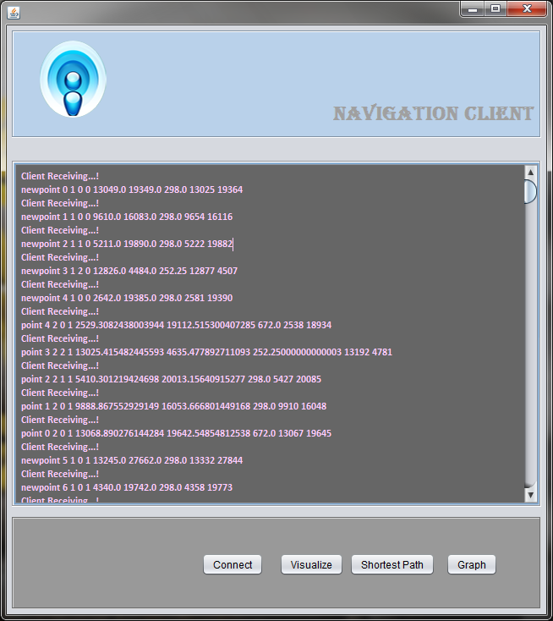

**Fig.6.1 Navigation Client**

**2. TRAFFIC BROADCAST SERVER:**

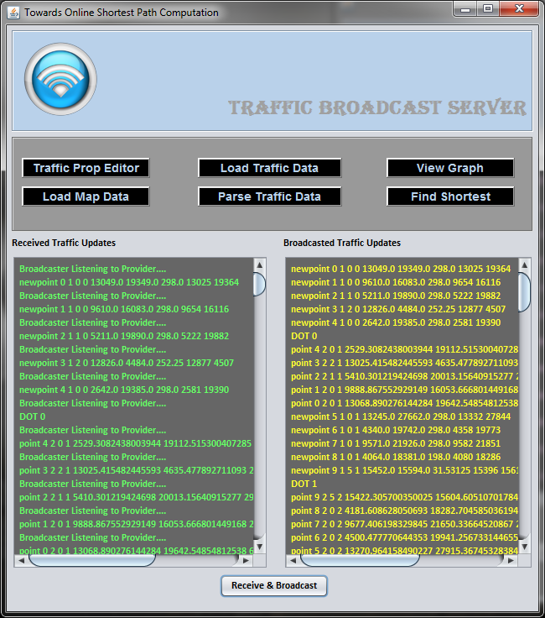

Fig.6.2 Traffic Broadcast Server

**3. MANAGE DATASET SETTING:**

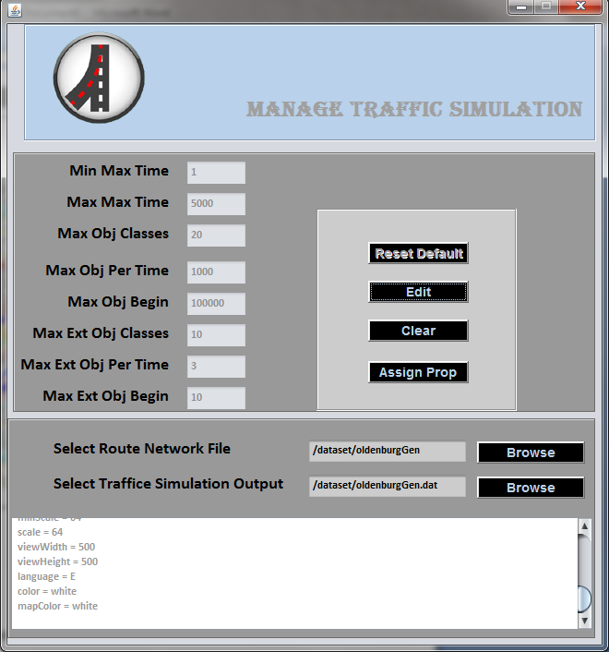

Fig.6.3 Manage Dataset Setting

**4.TRAFFIC FEEDS PROVIDER:**

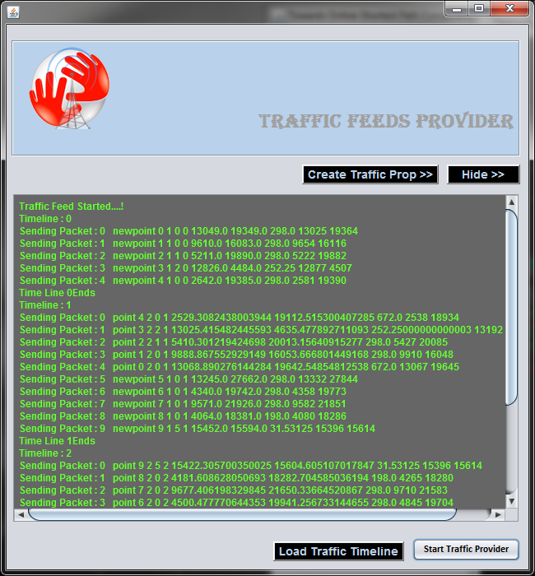

Fig.6.4 Traffic Feeds Provider

**5. GENERATING SIMULATION MAP:**

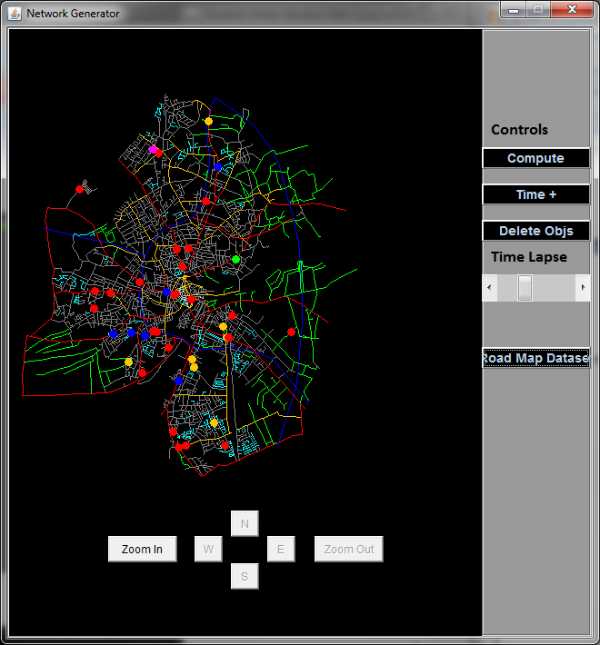

Fig.6.5 Generating Simulation Map

**6. CALCULATING SHORTEST PATH:**

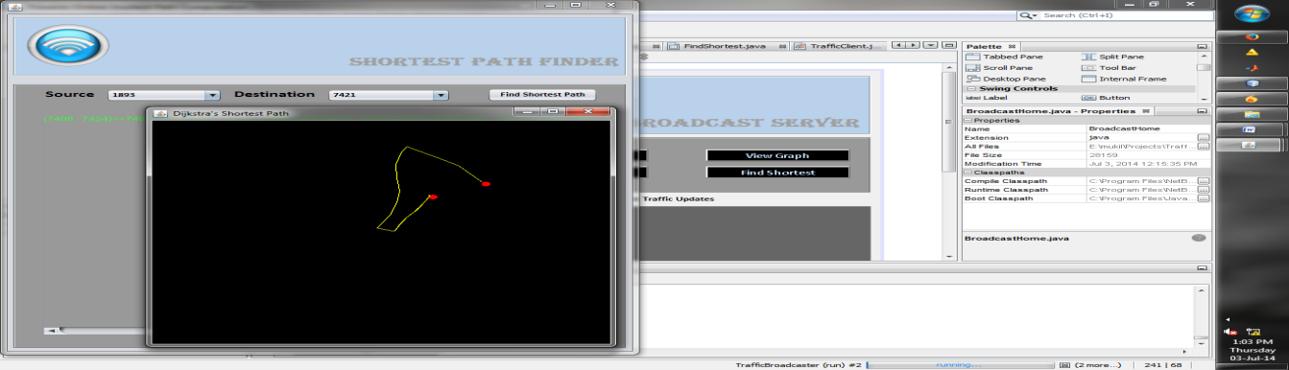

Fig.6.6 Calculating Shortest Path

**FUTURE SCOPE**

In future this algorithm can be implemented for quickly observing data coming from multiple cities. This project can also be implemented using Google API which may provide traffic situations in future for Indian cities.

**CONCLUSION**

The system calculates on-line shortest path computation. The shortest path result's updated supported the live traffic circumstances. It discreetly evaluates the particular work and justify their unconnectedness to the matter. To variety the drawback they advocate a promising springing uptherewith broadcasts the index on the air. 1stAssociate in Nursingalyzeanvitalissue of the hierarchical index format that permits United States to cipher shortest path on atinylowaa part of index.

**REFERENCES**

[1] *JagadeeshMailu and M. Ganthimathi, ”Enhanced Online Shortest Path Using Traffic Index Approach”,International Journal of Computer Application Issue 5, Volume 1 ,Feb. 2015*

*[2]Leong Hou U, Hong Jun Zhao, Man Lung Yiu, Yuhong Li, and Zhiguo Gong, “Towards Online Shortest Path Computation”, IEEE transactions on knowledge and data engineering, vol. 26, no. 4, april 2014.*

*[3] L. Wu, X. Xiao, D. Deng, G. Cong, A.D. Zhu, and S. Zhou, “Shortest Path and Distance Queries on Road Networks: An Experimental Evaluation,” Proc. VLDB Endowment, vol. 5, no. 5, pp. 406-417, 2012.*

*[4] “Google Maps,” http://maps.google.com, 2014.*

*[5] “NAVTEQ Maps and Traffic,” http://www.navteq. com, 2014.*

*[6] “INRIX Inc. Traffic Information Provider,” http:// www.inrix.com, 2014.*

*[7] “TomTom NV,” http://www.tomtom.com, 2014.*