Study of Z-Source Inverter Fed Induction Motor Drive using MATLAB

Rajendra Bhombe1, Vaishnavi Dhole2

1Head Of Deparment , 2Lecturer
Dept. of Electrical Engineering, Gurunanak institute of engg. And tech Nagpur, GWCET polytechnic Nagpur

Abstract : This paper investigates the performance of different control methods of Z-source inverter (ZSI) feeding industrial drives. It compares the all fundamental output parameters of induction motor drive and their THD level of different control methods for ZSI. These results are then compared with conventional SPWM converter. The control methods of ZSI investigated in this work are simple boost control, maximum boost control and constant maximum boost control. The ZSI employs a unique impedance network that couples the converter main circuit to the dc source or load or another converter. The ZSI can produce any desired output ac voltage, even greater than the line voltage,by controlling the shoot-through duty cycle. The Z-source network makes the shoot-through states possible unlike traditional inverters and provides the unique buck-boost feature to the inverter. It overcome all the limitations and conceptual barriers of VSI and CSI and provides a new power conversion concept. Simulations of the circuit configuration and the control methods of the ZSI and conventional SPWM converter have been performed in MATLAB/SIMULINK

Keywords- Z-source inverter, Induction motor, MATLAB, PWM technique, Shoot through state, Simple boost control, Switching states.

I- INTRODUCTION

Inversion is the change of dc power to ac power at a desired output voltage or current and frequency. A static semiconductor inverter circuit does this electrical energy inverting transformation. The terms voltage-fed and current-fed are used in relation with the output from inverter circuits. Conventionally, inverters are classified into two broad categories – voltage source inverter (VSI) and current source inverter (CSI).
A VSI is one in which the dc input voltage would have to keep constant and independent of the load current drawn. The inverter dictates the load voltage while the drawn current shape is specified by the load. These topologies are widely used because they behave as voltage sources naturally as required in many industrial applications, such as adjustable speed drives (ASDs), which are the most famous application of inverters. Similarly, these structures can be used as CSIs, where the independently controlled ac output is a current waveform. These structures are widely used in medium-voltage applications, where good-quality voltage waveforms are required. Static power converters, mainly inverters, are constructed from power switches and the ac output waveforms are therefore constructed of discrete values. This leads to the formation of waveforms that features fast transition rather than smooth ones.

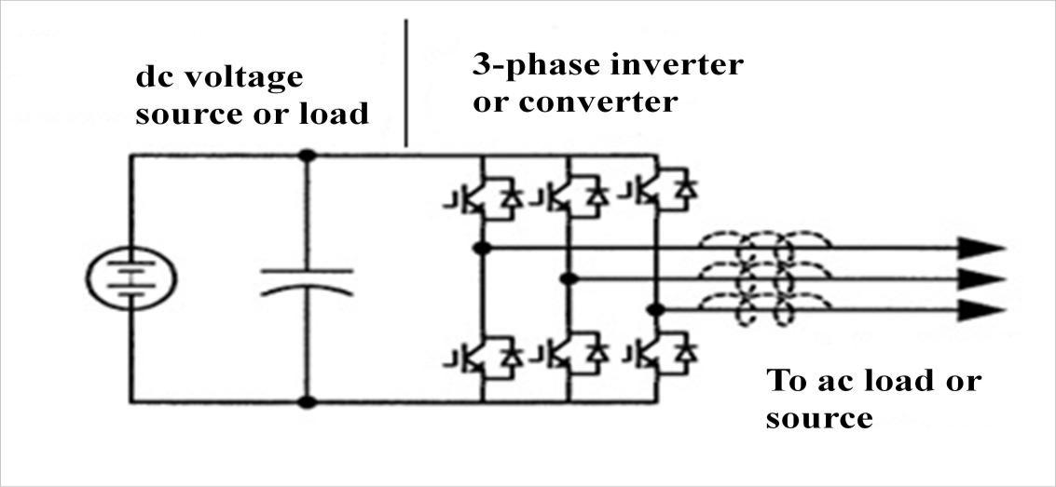

Figure-1.1 depicts the traditional or conventional three-phase voltage-source converter (that can be abbreviated as VSC) structure. A dc voltage source which is supported by a large capacitor feeds the main converter circuit, a three-phase bridge. This dc voltage source can be a battery, fuel-cell stack, diode rectifier, or capacitor. Six switches which are represented by IGBTs with an anti-parallel diode are used in the main circuit; to provide bidirectional current flow and unidirectional voltage blocking capability. The VSC is commonly used. However it has following limitations [10]:

The ac output voltage is limited below and cannot cross the dc-rail voltage. Therefore, the VSC is a buck inverter for dc-to-ac power conversion and the VSC is a boost rectifier for ac-to-dc power conversion
For applications where over drive is required and the available dc voltage is not sufficient then an additional dc-dc boost converter is required to get the desired ac output. These additional converter stages raise the system cost and lower down the efficiency%.
The upper and lower devices of each phase leg cannot be gated on simultaneously otherwise, a shoot-through would occur which would destroy the devices. The shoot-through problem by electromagnetic interference (EMI) noise’s miss-gating-on is one of the main problems in terms of reliability of the converter.
An output LC filter is required to provide a sinusoidal voltage compared with the CSI, which causes additional power loss.

  - Z-SOURCE INVERTER
To overcome the limitations and problems of the traditional or conventional source converters, an impedance-source (or impedance-fed) power converter (that can be abbreviated as ZSC) is introduced. Figure-1.3 depicts the general structure of ZSC.It employs a special impedance network (or circuit) that connect the voltage source converter and current converter main circuit to the power source, load, or another converter, for providing special features that cannot be seen in the conventional voltage source and current source converters where a capacitor and inductor are used, respectively [10]. ZSC structure using the series combination of switching devices like IGBT and diode is depicted in Figure-1.3, The Z-source concept is applicable on all dc-to-ac, ac-to-dc, ac-to-ac, and dc-to-dc power conversion. The configuration of a ZSI consists of the following components:
1. Two Inductors
2. Two Capacitors
3. DC source
4. Inverter or Converter
5. Load or Converter

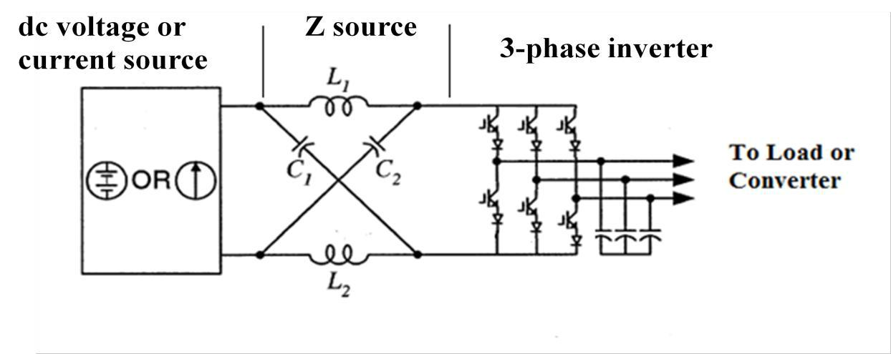
Figure-1.2: Structure of ZSI

Figure-1.2 depicts the general structure of the ZSI. A ZSI structure uses the series combination of IGBT and diode. It overcomes all the theoretical barriers and limitations of the traditional VSI and CSI and gives rise to a new power conversion concept. Figure-1.3 depicts a two-port network that consists of two split-inductors L1, L2 and capacitors C1,C2 connected in X shape to provide an impedance source (Z-source) coupling the converter (or inverter) to the dc source, load, or another converter [10]. The dc source/or load may be either a voltage or a current source/or load. Hence, the dc source can be a battery, diode rectifier, thyristor converter, fuel cell, an inductor, a capacitor, or any combination of these. Series combination of IGBTs and diode are used as switches in the converter circuit. The inductance L1and L2 can be provided by a split inductor or two separate inductors.

II. LITERATURE SURVEY
Power quality [1] is one of the most concerned areas in electric power system. The power quality has serious implication for consumers, utilities and manufacturers. The technological advancement led to complete change in the nature of electric load. The impact of power quality problem is increasingly sensed by industrial, commercial and residential consumers [2]. Some power quality and voltage quality problems such as voltage sag, voltage swell, transients, harmonics [3] etc. have been presented. The solution to the problems can be done either from customer side or from utility side by using custom power devices.
On the other hand, recent developments in power electronics [4-6] and semiconductor technology have led improvements in power electronic systems. Hence, different circuit configurations namely multilevel inverters [7-9] have become popular and considerable interest by researcher are given on them. A static semiconductor inverter circuit performs electrical energy inverting transformation.The terms voltage-fed and current-fed are used in connection with output from inverter circuit. Variable voltage and frequency supply to ac drives is invariably obtained from a three-phase voltage source inverter. A number of Pulse width modulation (PWM) schemes are used to obtain variable voltage and frequency supply. The most widely used PWM schemes for three-phase voltage source inverters are carrier-based sinusoidal PWM (SPWM) and space vector PWM (SVPWM). Inverter output waveforms (either voltage or current) are usually rectilinear in nature and as such contain harmonics which may lead to reduced load efficiency and performance. Load harmonic reduction can be achieved by either filtering, selected harmonic-reduction chopping or pulse-width modulation. Voltage source inverters and current source inverters are used widely but they have certain theoretical and conceptual barriers and limitations like problem of shoot-through, do not have buck-boost feature etc.
An impedance fed power converter i.e. ZSC has been presented [10]. Z-source concept is applicable for all ac to dc, dc to ac, ac to ac, and dc to dc power conversion. Z-source concept is applicable for entire spectrum of power conversion. It has employed a special impedance network coupling the converter main circuit to the dc source or load or another converter. It has overcome the limitations of traditional converters. An example of ZSI for dc to ac power conversion in fuel cell application has been given. By this example operating principle of ZSI has been described.
The three control methods of ZSI namely simple boost control [10], maximum boost control[11] and constant maximum boost control [12] have been discussed. Comparison of voltage gain of control methods for ZSI under a given boost factor has been done. ZSI has utilized shoot through switching states in addition to active states and zero states. It has provided a special feature of buck–boost which was not possible in traditional VSC and CSC.
It has been found that a ZSI at a given boost factor, the maximum boost control method has the greatest modulation index and thus maximum boost control technique has the highest voltage gain [11]. It has been found that there are two maximum constant boost control methods for the ZSI which have achieved maximum voltage gain at any given modulation index without generating any low-frequency ripple that is connected to the output frequency [13]. So, the Z-network requirement would be independent of the output frequency and ascertained only by the switching frequency.
It has been discussed that the analysis of ZSI which was available in literature was based on assumption that inductor current is rather large, continuous and has small ripple. These assumptions have become irrational for low load power factor and for small inductances. A simple method to eliminate the new operating modes by superseding the diodes with a switch has also been proposed. This configuration has also provided bidirectional power flow ability [14].
It has been presented that by using conventional SPWM in case of inductive load the output voltage and current of ZSI suffered from distortion and hence power inverting quality also gets affected. According to the principle of ZSI the control method has been applied to dc-ac by inserting a fixed D into zero state of SPWM. Upgraded SPWM has not only reduced the distortion but also decreases the switch times and quantities in each cycle. Thus Total Harmonic Distortion (THD) has been reduced expertly and hence efficiency has been upgraded [15].
ZSI has been used widely in many applications due to its buck-boost nature and single stage power conversion. For a split-phase grid-connected photo voltaic system, a ZSI system has been nominated. The nominated system has realized the boost and inversion with power tracking in one single power stage thus minimized the number of switching devices. All the merits of ZSI have been combined with six-switch split-phase inverter to develop a reliable PCS system [16].
Another application has been shown by developing a new ASD system based on ZSI [17]. By regulating the open-circuit duty cycle, the ZSI could generate any desired output ac voltage, even less than the line voltage. ZSI has given superior low speed characteristics than conventional CSI fed adjustable speed drives.
Several controllers have been implemented on ZSI to enhance the system performance. A direct peak dc-link boost voltage like-PID fuzzy controller in ZSI has been presented [18]. With the help of this technique a constant peak dc-link voltage could be retrieved with good transient performance which increases the rejection of disturbance, including the input voltage and load current variation, and has also facilitated the design of controller

III. RESEARCH METHODOLOGY
The Z-source inverter is a buck–boost inverter that has a wide range of obtainable voltage. The traditional VSI and CSI cannot provide such obtainable voltage. In the Z-source inverter, the bridge has seven permissible switching states (vectors) unlike the traditional inverter bridge that has six switching states. When the load terminals are shorted through both the upper and lower devices of any one phase leg (i.e., both devices are gated on) or two phase legs shoot through zero state occurs. This shoot-through zero state (or vector) is forbidden in the traditional V-source inverter, because it would cause a shoot-through. The Z-source network makes the shoot-through zero state possible. This shoot-through zero state provides the unique buck-boost feature to the inverter. The inverter bridge is equivalent to a short circuit when the inverter bridge is in the shoot-through zero state, whereas the inverter bridge becomes an equivalent current source, when in one of the four active states. These shoots through states are provided by simple boost controlled PWM technique.
3.1 BLOCK DIAGRAM
The block diagram of single phase Z induction motor is shown in figure inverter, Driver Z-source inverter is utilized to realize inversion and boost function. It contain a unique impedance network of inductors and capacitors, the Z shoot through states by gating on both the upper and lower switches in the same legs, to boost the dc voltage without DC/DC converter fig1:shows that the symmetrical lattice network most commonly used in filter and attenuator circuit. The lattice network contains L1 and L2 which are series arm inductances, C1 and C2 which are diagonal arm capacitances connected between the rectifier legs. Each leg consists of two switches and their anti parallel diodes. The each leg is switched in such a way that when one of them is in off state, the other is in on state. The output current will flow continuously through load and the output voltage is solely dictated by the status of the switches. The Simple boost controllers vary the PWM signal of the control
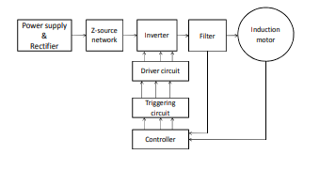

Figure-1.3:Block Diagram of ZSI

IV. CONCLUSION
This paper presents, the theoretical analysis and design of Z-source inverter is studied. The Z-source inverter employs a unique impedance network to couple the inverter main circuit to the power source and thus providing unique feature. The control methods with the insertion of shoot-through states of Z-source inverter have been studied. The proposed scheme under simple boost control is simulated with the help of MATLAB/SIMULINK and the simulation results are obtained for different values of modulation indices. The simulation results shows that both buck and boost operations can be obtained in Z-source inverter by varying Modulation index (M) or Boost factor (B) and hence we can control the speed of the motor

REFERENCES

[1] Sankaran, C., “Power Quality”, CRC Press LLC, 2002.
[2] Dugan, Roger C.; McGranaghan, Mark F.; Santoso, Surya; Beaty, H. Wayne, “Electrical Power System Quality”, The McGraw-Hill, 2007.
[3] Mohammed, Shazly A; Cerrada, Aurelio G; A Abdel-Moamen M; Hasanin B, “Dynamic
Voltage Restorer (DVR) System for Compensation of Voltage Sags, State-of-the-Art Review”, International Journal of Computational Engineering Research, vol. 3, issue:1, pp.177- 183, 2013.
[4] Rashid, M.H., “Power Electronics”, 2nd ed. Englewood Cliffs, NJ, Prentice Hall, 1993.
[5] Mohan, N., Robbin, W.P.; Undeland, T., “Power Electronics: Converters, Applications, and Design”, 2nd ed. New York, Wiley, 1995.
[6] Thorobog, K., “Power Electronics”, Prentice Hall International, 1998.
[7] Krein, P.T., “Elements of Power Electronics”, Oxford University Press, 1998.
[8] Trzynadlowski, A.M., “Introduction to Modern Power Electronics”, New York, Wiley, 1998.
[9] Bose, B.K., “Modern Power Electronics and AC Drives” Upper Saddle River, Prentice Hall, 2002.
[10]Peng, F.Z. “Z-Source Inverter”, IEEE Transactions on Industry Applications, vol. 39, issue: 2, pp.501-510, March/April 2003.
[11]Peng, F.Z.; Shen, Miaosen; Qian, Zhaoming, “Maximum Boost Control of the Z-Source Inverter”, IEEE Transaction on Power Electronics, vol. 20, issue: 4, pp. 833-838, July 2005.
[12] Rostami, H.; Khaburi, D.K., “Voltage Gain Comparison of Different Control Methods of the Z-source inverter”, Iran University of Science and Technology, Tehran, Iran.
[13] Shen, M.; Wang, J.; Joseph, A.; Peng, F.Z.; Tolbert, L.M.; Adams, D.J., “Maximum Constant Boost Control of the Z-Source Inverter”, IEEE/IAS, pp.142-147, Seattle, 2004.
[14] Shen, Miaosen; Peng, F.Z., “Operation Modes and Characteristics of Z- Source Inverter with Small Inductance or Low Power Factor”, IEEE Transaction on Industrial Electronics, vol. 55, issue: 1, pp. 89-96, January 2008.
[15] Gao, Zhiqiang; Wang, Jianze; Chen, Qichao, “An Improved Control Method for Inductive Load of Z- Source Inverter”, School of Electrical Engineering and Automation Harbin Institute of Technology, Harbin, China.
[16]Huang, Yi; Shen, Miaosen; Peng, F.Z., “Z- Source Inverter for Residential Photovoltaic Systems”, IEEE Transactions on Power Electronics, vol. 21, issue: 6, pp. 1776-1782, November 2006.
[17] Fang, Xu-Peng; Qian, Zhao-ming; Qi-Gao, Bin-Gu, Fang-Zheng Peng; Xiao-ming Yuan, “Current Mode Z-Source Inverter-Fed ASD System”, 35th Annual IEEE Power Electronics Specialists Conference, 2007.
[18]Ding, Xinping; Qian, Zhaoming; Yang, Shuitao; Cui, Bin; Peng, F.Z., “A Direct DC-link Boost Voltage PID-like Fuzzy Control Strategy in Z-Source Inverter”, IEEE Power Electronic Specialist Conference, 2008.

