**Review on Energy Generation Using Dynamo**

**Indranil Palit1, Akash Ramdas Salode2, Pallavi Bejgamwar3, Gayatri Hingwe4, Priyanka Devhare5, Pooja kumari6, Prof C.S Kamble7**

*123456Students, Department of Electrical and Power, Priyadarshini College of Engineering, Nagpur, India*

*7Professor, Department of Electrical and Power, Priyadarshini College of Engineering, Nagpur, India*

*Abstract*—*Nikola tesla once said that “all energy sources should be free to fulfill their daily needs”. As we know that Energy cannot be created nor destroyed as it exists throughout space and within matter. “Free Energy” is a term with which the additional energy that can be obtained from a device is adequate with no additional cost which will be charged to run them.*

*This paper deals with the study of “Free Energy Generation” using a dynamo. It converts kinetic energy into electric energy. As the user pedals, the dynamo charges the attached battery. The interesting thing about this system is that a flywheel is used to generate the extra amount of free energy. This extra energy will make the setup more efficient and is used to run various Electrical devices.*

Keywords—Flywheel, Dynamo, Pulley, Inverter, Human Energy, Prototype, Generation, telluric power

# 1. Introduction

**E**nergy is a driving force of the modern societies living on this planet and generation and utilization of this energy is very essential for the socio-economic development. Per capita energy consumption levels are often considered well in the future years which as it will be a measure of economic development. In the recent years scarcity of energy has been a serious problem due to the depletion of Non Renewable energy sources, rapid increase of population, globalization of energy, intensive economic development, Environmental Pollution and global warming.[4]

With the rapid growth of population energy demands keeps on increasing and with the substances namely Coal and Oil keeps on decreasing it will be hard to meet up the demands of people.

Free Energy means “Zero cost Energy”. It is obtained from the blowing force of wind which drives the windmill (Mechanical Energy) or solar energy in solar cell which is converts it into

electrical energy and stored in batteries. Other energies are water power and telluric power. A Dynamo is commonly used to generate these types of energy. This is how we can try to make an energy efficient system to offer benefits and to make the environment comfortable for a common man to breathe. The idea of this project explores the possibility of combining three units i.e. Energy generation; flywheel and Mechanical drive into a single unit, such that the device generates energy.

2. POWER LEVELS

The levels of power that a human can produce through pedalling the bicycle depend on how strong the peddler is and for how much time he/she has to pedal[5]. If a healthy person pedals for some adequate time he/she can generate power which is adequate to fulfil his daily needs which sometimes is doubled considered if the person is an athlete. To be super conservative, let's say we're talking about Lance Armstrong and let's assume he's doping, in that case 500 watts will probably be a rather generous upper bound for sustained energy output:[4]

Human Power Output Pedalling Power levels are also directly related to the environment of the person doing the pedalling from Zero emission of heat to preventing air pollution

# WORKING PRINCIPLE

## The objective of this project is to recover energy of flywheel by using “principle of energy recovery system” and produce sufficient amount of energy to run the external load connected to the system. The project process is inspired by the “Conversion of energy from humans”. The Mechanical Energy drives the Dynamo by using revolution of Flywheel.[3]

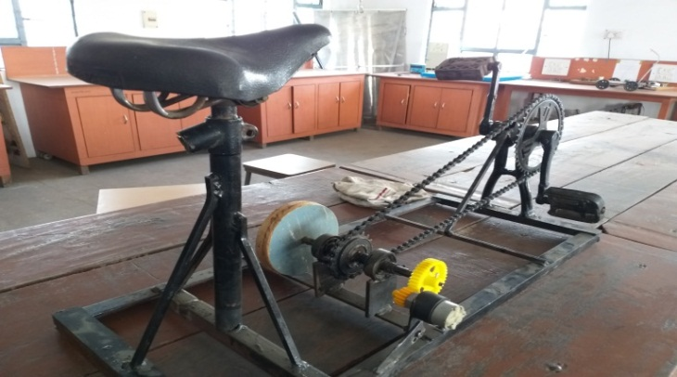

Fig: 2- Bicycle setup

|  |
| --- |
| NOMENCLATURE  V Voltage output of the system (Volts)  I Current of the system (Ampere)  P Total Power output of the system (Watts)  Wh Total Watt hour of the System  RPM Revolutions Per Minute  KHz Kilo-Hertz    FLYWHEEL  Kinetic Energy (Joules)  Momentum (kg. m/s)  Angular Acceleration (rad/s2)  Mass of the Flywheel (kg)  Radius of the Flywheel (m)  Speed of the Flywheel  DYNAMO  Dynamo Torque (N. m)  Force on the Dynamo Shaft (N)  Distance from Pivot (m)  Speed of the Dynamo  MOSFET  PWM Pulse Width Modulation  Duty cycle of the Mosfet’s  Turn On time of the Mosfet  Turn Off time of the Mosfet |

The coil of the Dynamo rotates upon rotating the Flywheel which in turn induces current in the coil of the dynamo as the permanent magnets used conduct electron flow in the circuit.

The battery in the circuit is used to provide adequate power to the circuit which is then stepped up from 12V to 230V, 50 Hz AC to provide adequate supply.

3.1 DYNAMO

## The “Dynamo Principle” of “Werner von Siemens” which exclusively uses self-excitation (self- induction) to generate the DC power. A Dynamo (Generator) uses rotating wire coils and magnetic fields to convert mechanical rotation into direct electric current through Faraday’s law of Induction. The rotation of coil in between the magnetic field which is being produced by the magnet induces a voltage at the coil terminals by pushing the electrons on the coil, which allows powering a load connected to these terminals. We used a 12 volt, 500milliAmpere Dynamo (Generator).

## 

Fig: 3.1 - Dynamo

## 

## 3.2. FLYWHEEL

We have used a Flywheel of Diameter 12.5 cm which is specifically designed to efficiently store Rotational Energy and Delivering energy at rates beyond the ability of an Energy source. The input power may differ from output power in its Design, rotating frequency and other attributes including losses to surroundings.

The stored Energy also known as kinetic energy or more specifically Rotational Energy of the rotor is –



Wherein the Moment of Inertia of the solid Cylinder is





Fig: 3.2- Flywheel System (12.5cm diameter)

3.3. PULLEY

The pulley system which is used in our project is a belt and pulley system wherein we have used a gear system than using a belt instead, where it is characterized by two pulleys attached to a gear and rotating at a constant speed from the rotation of a Flywheel. This allows for torque, mechanical power and speed to be transmitted across the axles and then to the Dynamo where power is being generated. The diameter of the pulley is 2.5 cm

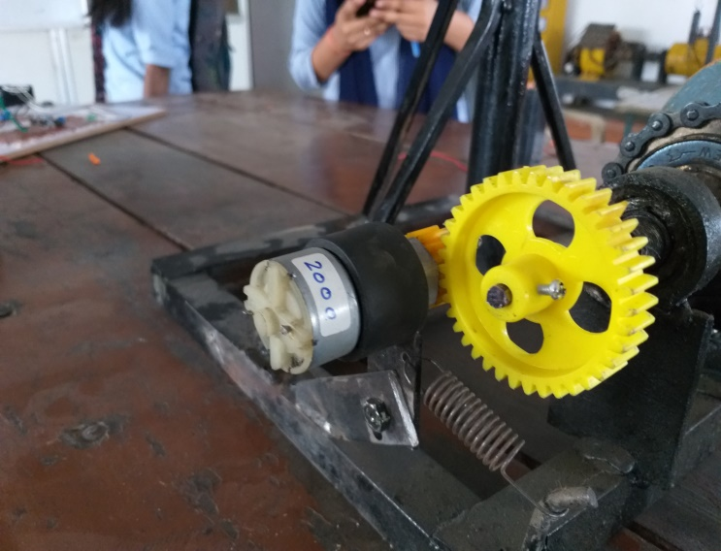

Fig: 3.3- Pulley (Using Gears)

3.4 TRANSFORMER

We have used a Transformer to convert the voltage from DC 12 V to 230V AC; 12-0-12 Trans P31 which is a centre tapped Transformer normally working as a step up transformer (but actually is a step down transformer). A centre-tapped transformer also known as two phase three wire transformers is normally used for rectifier circuits. When a project has to work with AC mains, a Transformer is used to step-down the voltage (in our case, to 24V or 12V) and then converts it to DC by using a rectifier circuit. In a centre-tapped transformer the peak inverse voltage is twice as in bridge rectifier hence this transformer is commonly used in full wave rectifier circuits.

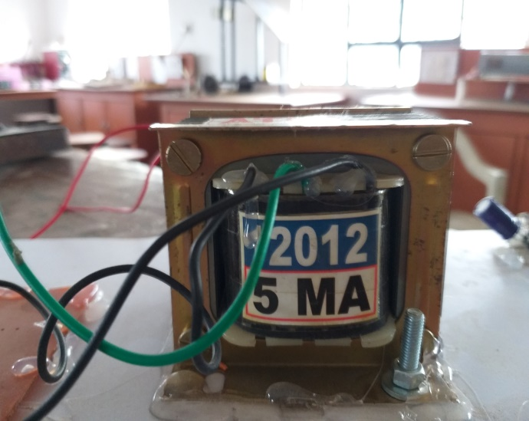

Fig: 3.4- Step Up Transformer

3.5. UC 3843 INTEGRATED CIRCUIT

We have used a UC-3843 which is a Pulse Width modulation controller Integrated circuit that are necessary to implement the DC to DC fixed frequency current mode control schemes. The implemented circuits is used to include an under-voltage

Lockout (UVLO) which features a start-up current less than 1 mA and a precision reference which is trimmed for accuracy at the error amplifier input. The PWM IC is used to switch the Mosfets IRFZ44N present in the circuit which in turn is used to switch a diode also called as the Ultra-Fast Recovery diode which has a switching time in Nanoseconds. The Resistors (combined, 47Ω) are used to carry out the switching’s of the Mosfet’s.

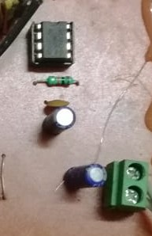

Fig: 3.5- UC 3843 Integrated Circuit

3.6. INDUCTOR

In our project we have used a inductor coil which is working as a Boost convertor and stores the energy in the form of magnetic field and is used to change the rate of current in the circuit. The EMF is induced again if the Magnetic field collapses in the circuit.

A current shunt resistor is used to sense the current passing through the circuit to keep the current in check. The voltage sensing pin is used to sense the voltage and change the current rate according to it. The basic formula used to calculate the changing current is V=IR.

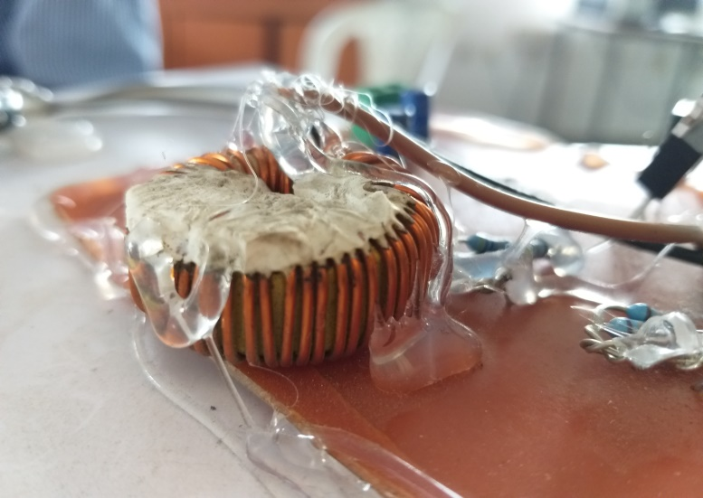

Fig: 3.6- Inductor Coil

3.7. MOSFET

The two Mosfets used here are IRFZ44N Mosfets which is used for switching the diode in Nano-seconds and is used a Buck convertor which has a Duty cycle in Nanoseconds and a and is done to pass a limited output of 12V to the battery

The duty cycle of the Mosfet is-



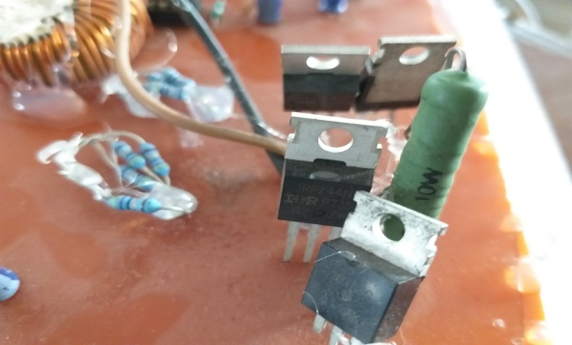

Fig: 3.7- Mosfet IRFZ44N

3.8. BATTERY

In our project we have used a Lead acid battery which is a Dura-cell ultra and stores up to 12V, 4.5 Amp. It is operated from a DPDT (double pole double tap) switch.

The Electrical energy produced during the discharging of the lead acid battery can be attributed to the energy released during the strong chemical bonds of water molecule and are formed from H+ ions of the acid and O2- ions of PbO2. Conversely the battery acts as a splitting device during charging state and the chemical energy of the battery is stored in the acid.

**Negative plate reaction**



The release of two conducting electrons gives the lead electrode a negative charge.

**Positive Plate Reaction**



Taking advantage of the metallic conductivity of PbO2. The total reaction can be written as



The voltage of the cell is 2.05V

There is no need to add electrolyte, as gases generated during charging are recombined in a unique "oxygen cycle”.

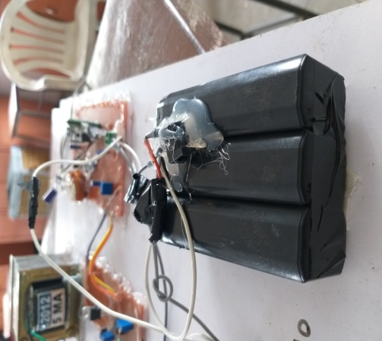

Fig: 3.8- 4V Battery pack

1. OVERCHARGING PROTECTION
   1. OPERATIONAL AMPLIFIER

We have used an OPAMP designated as LM358 which is a low power dual operational amplifier integrated circuit and is used in detector circuits. It indicates an 8-pin comprising a operational amplifiers at low power. The OPAMP is used to compare the voltages which is a fixed voltage and the battery voltage. A transistor will operate as soon as the battery voltage is higher than fixed voltage which will trigger the LM358 OPAMP and will shut down any input to the battery. This circuit is used to ensure battery safety and save it from overcharging. Rated as 3V-32V, 1.5Amps.

* 1. INVERTER CIRCUIT

The SG-3525 which is Pulse Width Modulator integrated circuit and are designed to improve the performance and lowered external parts count when designing all types of switching power supplies. The key features of the SG-3525 are Sink Output Drivers, 8 to 35 V operation, 100 Hz to 500 KHz Oscillator range, Pulse by Pulse Shutdown.

Here we have used a SO16 pin (Narrow) configuration of the circuit and is used to convert Direct Current into alternating current by the two Mosfet’s which are switched alternately by the resistors provided and is called as push-pull arrangement. The Mosfet’s are directly connected to a 12-0-12 Volt Transformer which is a step Up Transformer which then steps up from 12 volt to 230 volt and is supplied to the Load.

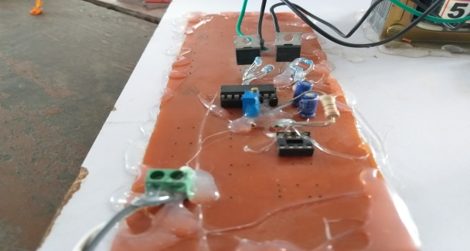

Fig: 4.2- Inverter Switch Circuit

### OBSERVATIONS

1. When a human will pedal the bike, the Flywheel speed, the dynamo speed and voltage will be noted down with the help of a Tachometer and a voltmeter connecting across the Dynamo.
2. The ratio of the Flywheel and the dynamo’s diameter is 5:1, by the formula  where N2 is the Flywheel speed and N1 is Dynamo’s speed the table formed will be -
3. calculation of dynamo and flywheel speed

| **SR NO** | SPEED OF FLYWHEEL (RPM) | SPEED OF DYNAMO (RPM) | DYNAMO POWER (WATTS) | OUTPUT POWER (WATTS) |
| --- | --- | --- | --- | --- |
| 1. | 127 | 635 | 4.39 | 8.35 |
| 2. | 173 | 865 | 5.98 | 10.83 |
| 3. | 259 | 1295 | 8.95 | 14.24 |
| 4. | 317 | 1585 | 10.96 | 18.57 |
| 5. | 370 | 1850 | 12.79 | 21.1 |

DYNAMO CALCULATION

From the observations we found out that our subject (human) is putting a force which is roughly equal to-

*Force on the Dynamo Shaft = 5.2N

*The Dynamo Shaft Diameter is = 0.0254m

Therefore upon finding Torque from the data above, we get

 [2]

=

= 0.06604Nm.

And,

To find Power we need Torque and speed, therefore the formula is –



= 

= 12.79 watt

Therefore the output power of the Dynamo is 12.79 watts.

OUTPUT POWER

At Maximum speed of Pulley which is 1850 RPM

Let, A house of with a normal bulb and a charger, battery (12V) uses standard 15 watt and 6 watt

The pedaling time per person is 20 minutes

Therefore, The average output current = 0.1 Amps

And the output average voltage is 211 Volt

The average output power is



This is–

211*0.1 = 21.1 watt

Therefore the maximum power output of our system if the flywheel rotates at 370 rpm is 21.1 watt.

##### Acknowledgment

We are thankful to our guide Professor C.S kamble who helped us when we were in need and authors are thankful to the staff and colleagues for useful discussion and also for providing library facility.

References

1. *Akhilesh Barwahe, Amrendra Kumar, Ankit Domde, Deepak Dhakad, Manish Kumar Dhadse, Vishal Wankhade, “Electricity Generation Using Flywheel”, International Journal for Reasearch in Applied Science & engineering (IJRASET), e-ISSN 2321-9653, Volume 4 Issue IV, April 2016.*
2. *K.M. Ahsaan-uz-Zaman, Kafi Mohammad Ullah, Md Mishir, Mahafujul Alam, “Generation of Electrical Power Using Gymnasium Bicycle”,2017 IEEE Region 10 Humanitarian Technology Conference (R-10-HTC), 21-23 Dec, 2017, Dhaka, Bangladesh*
3. *Prof Bharat M. Jibhakate, Jayant P. Karemore, Jitendra D. Jaiswal, Kapil V kalambe, Nilesh S. Zade, Siteshkumar K Sonkalihari, “Review of Free Energy Generation using Flywheel”, International Research Journal of Engineering and Technology (IRJET), e-ISSN 2395-0056, Volume 04 Issue 02 / Feb-2017.*
4. *M.P Mohurle, D.S Deshmukh, P.D. Patil, “Human Power Bicycle Mechanism as an alternative Energy Sources: A Critical Review”, International Conference on Global Trends in Engineering, Technology and Management (ICGTETM-2016).*
5. *Rajneesh Suhalka, Mahesh Chand Khandelwal, Krishna Kant Sharma, Abhishek Sanghai, “Generation of Electrical power using Bicycle Pedal”, International Journal of Recent Research and Review, e-ISSN 2277-8322, Vol VII, Issue 2, June 2014*

*[6] Prof Sandeep B Thakre, Mr Swapnil H Zode, Anand S singh,*

*Shubham R Ingole, “Self Generator Free Energy Flywheel”,*

*International Research Journal of Engineering and Technology*

*(IRJET), e-ISSN: 2395-0056, Vol: 05 ISSUE: 01/Jan-2018*