Performance Evaluation of Natural Convection Small Scale Greenhouse Solar Dryer for Drying Grapes

Amol Dhande¹, Ghanshyam Das Agarwal², Madhu Agarwal³

¹ Research Scholar, Department of Mechanical Engineering, Malaviya National Institute of Technology Jaipur, India
² Professor, Department of Mechanical Engineering, Malaviya National Institute of Technology Jaipur, India 302017.
³ Associate Professor, Department of Chemical Engineering, Malaviya National Institute of Technology Jaipur, India
2021rme9081@mnit.ac.in

Received on: 29 March,2023 Revised on: 21,April,2023 Published on:23 April,2023

Abstract – A small-scale greenhouse solar dryer (GHSD) has been used to dry grapes in order to produce cost effective resins. The effectiveness of a small, uneven shaped greenhouse solar drier was studied in this paper. Grapes with an initial moisture content of 85% (w.b.) were dried to a final moisture content of 10.0% to 20% (w.b.) in only 6 days (129.5 hours) utilising an uneven shaped greenhouse solar drier. The GHSD temperature was found in the range 500 C to 700C while relative humidity inside was observed varying 5% to 28% .The weight of 500gm in each tray was found 110gm, 124gm and 121gm. The average weight reduced in all 3 trays was 76%. The grapes took 129.5 hrs to get dried. GHSD helps to dry grapes during adverse weather conditions.
Keywords- greenhouse solar dryer, uneven shape, natural convection, moisture content, drying time.
- INTRODUCTION
In prehistoric times, when there was no electricity, the sun provided all of the necessary heat and light. As the world's population rises, so does the need for fossil fuels, leading to environmental degradation and the possibility of global warming. The use of solar energy technologies in tropical countries have a wide range compared to other countries. In India, the Sun shines over an average of 3600-4000 h/year according to the year 2021. India is located in the northern hemisphere, which receives yearly mean solar irradiation of 6.5 kWh/m² day.

A concern of food, fruits and vegetable became the top priority of all nations ever since because of the fastest growing world population. Fruit crops are one of the significant agricultural products in India [1]. The vitamins, minerals, antioxidants, fibre, and anti-disease elements (such as antioxidants) found in vegetables and vegetable products make them very valuable from a nutritional and health perspective. Unfortunately, fresh fruits and vegetables are not only seasonal but also highly perishable one [2].
Solar food dryers a sustainable technology is a suitable food preservation since drying is one of the finest methods to store fruits and vegetables. Drying products using machinery is far more efficient than drying them in the open air as it requires much less space, and often produces higher-quality dried goods. Yet, the machines are costly and need a lot of fuel or power to run. Therefore, greenhouse solar dryer can be seen as one of the solutions to the world’s food and energy crises. Agricultural goods are protected from harm by insects, vermin, dust, and rain using greenhouse solar dryers (GHSDs), which are specialised machines that regulate the drying process. Greenhouse solar dryers provide greater temperatures, lower relative humidity, lower product moisture content, and less spoiling throughout the drying process as compared to drying in the sun. Most agricultural produce can be preserved and this can be achieved more efficiently through the use of GHSD.
Greenhouse drying is one of the effective methods of drying the fruits with the help of sunlight using the principle of Greenhouse Effect. Passive solar dryers use natural convection phenomena for movement of air inside the greenhouse. The objective of the study is to evaluate performance characteristics of greenhouse solar dryer for drying grapes to produce cost effective resins.

II. LITERATURE REVIEW
Certain research papers on greenhouse solar drying with experimental work were studied. An overview of greenhouse solar dryer (GHSD) is mentioned below:
El-Maghlany, W. M., Teamah, M. A., & Tanaka, H. [3] worked on the calculation of the amount of solar energy absorbed by a greenhouse cover. They used analytical methods with different curved surfaces which are elliptical in nature to find optimum design. The study was done from November to April (2015) i.e., cold weather season for which aspect ratio ranges from 0.25 to 4. According to them solar energy per sq. meter was optimum for aspect ratio 4.
Researchers Gupta V, Gupta K.S., and Khare R. [4] have studied the efficacy of portable greenhouse dryers. The dryer is removable so that it may be moved around quickly and used in different locations. The drying rate has been fairly impressive, and the removable greenhouse drier may end up being a practical option for home usage. The payback period of greenhouse dryer is only 1.5 years.
Azaizia, Z., Kooli, S., Hamdi, I., Elkhal, W., Guizani, A. A [5] have done experimental study on a new mixed mode solar greenhouse drying. They have compared two different solar greenhouses with and without thermal energy storage. Phase change material has been used as thermal energy storage. They aim to investigate the effect of paraffin wax as a phase change material. The experiments were carried out for drying of red pepper. Results showed that inside air temperature of solar greenhouse with paraffin wax as PCM is higher than other by about 7.5°C during night. The relative humidity of solar greenhouse with paraffin wax as PCM is lower by about 18.6% then the ambient during night. Solar greenhouse dryer with PCM takes 30 hours to reduce moisture content by 95% whereas without PCM dryer takes 55 hours and open sun drying takes 75 hours.
Janjai, S. [6] prepared small-sized greenhouse to dry food with parabolic roof structure and polycarbonate sheet at floor having capacity of 1000 kg vegetables with 9 DC fans. The dryer was installed at Thailand for tomato as a product. 3 batches of product were prepared to conduct experiment. The temperature range was found to be 35⁰C to 65⁰C inside the dryer for the drying time of 2-3 days. The investigated payback period was calculated to be 0.65 years. Mishra, S., Verma, S., Chowdhury, S., & Dwivedi, G. [7] reviewed various advancements in the development of greenhouse dryer and their impact on its efficiency. The aim of investigation is intended to be used for observing and addressing research gaps on critical areas of greenhouse dryer. Heat storage units are being one of solution used widely to improve the performance of greenhouse dryers. Integration with solar air heater, results in increment of performance of greenhouse dryer.
Prakash, O., & Kumar, A. [8] conducted experiment under passive mode in no load condition in greenhouse dryer from January to May 2013 at MANIT, Bhopal for 3 days in each month having concept of opaque north wall. With different floor condition (black-painted, barren floor and PVC sheet) the thermal performance of dryer was calculated like coefficient of diffusion Nusselt number, Rayleigh number, Prandtl number. It was determined that 480 kWh of electricity was sufficient for the dryer. Green chilies, green peas, white gramme, Onion, potato, and cauliflower all had their heat transfer coefficients measured while being grown in a ventilated environment by Tiwari G.N. Anwar S.I [9]. Experiments were conducted to find out the data under open and closed simultaneous conditions for determination of coefficients C and n consequently convective heat transfer coefficient. In general, for all crops, the values of convective heat transfer coefficients really from 10.94 W/m² C to 12.8 W/m² C with experimental error ranging from 6 to 7%.
Hamdi, I., Kooli, S., Elkhadraoui, A., Azaizia, Z., Abdelhamid, F., & Guizani, A. [10] presented experimental and numerical analysis on drying of grapes under mixed mode in solar greenhouse dryer. They used chapel-shaped greenhouse with integrated solar air collector. It took the grapes to take 128 hrs to reduce the moisture content from 5.5 (g water/ g dry matter) to 0.22 (g water/ g dry matter). The range of temperature of was found to be 29⁰ C to 56⁰ C inside the greenhouse dryer.

As greenhouse solar drying system has advantages in terms of availability of material and structure of greenhouse which are used in agricultural applications. A number of researchers have reported the performance of the greenhouse solar dryer for drying various products.

III. METHODOLOGY
On a bright, sunny day in the summer, the ground may receive between 800 and 1000 W/m² (global radiation) of solar radiation after it has penetrated through the atmosphere. Fruits and agricultural crops' drying patterns also rely on:
• Type of Product
• Size and shape
• Initial moisture content
• Final moisture content
• Bulk density
• Thickness of the layer
• Temperature of grain
• Temperature, humidity of air in contact with the grain
• Mechanical or chemical pre-treatment
• Velocity of air in contact with the grain

- EXPERIMENTAL SETUP:

An east-west oriented small scale uneven span greenhouse solar dryer (1.5m x 1.0m) as shown in figure 1 was installed MNIT, Jaipur (26.92° N, 75.8° E). A cabinet shaped GHSD has an angle of the slope of the dryer cover is 36° for the latitude of Jaipur. It is provided with two air inlet and one outlet holes along the sides. The capacity of 1.5 kg is accepted for the GHSD. The GHSD consisted of three trays each of dimensions (100 x 45 x 8 cm) placed side by side as shown in figure 2. The following points were considered in the design of the natural convection GHSD system:
1. The quantity of moisture to be extracted from the
grapes.
2. The amount of air required for drying
3. Daily solar radiation to determine energy received by
the dryer per day
4. Air Velocity for Air Vent Dimension Calculation,

Solar radiation, air temperature, relative humidity, and air speed were measured since they have a significant impact on dryer performance. The instruments used in experimentation are mentioned in Table 1.

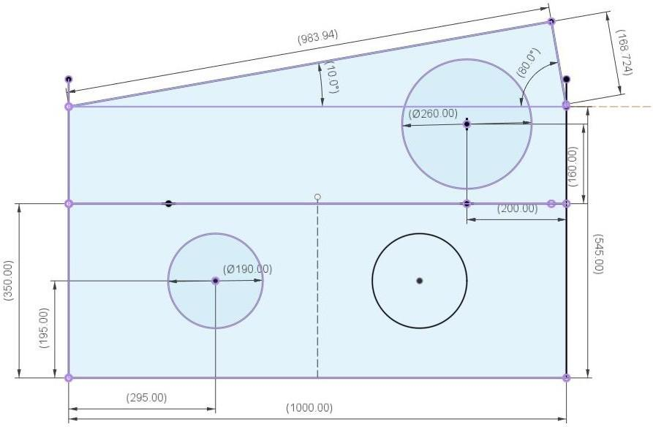
Fig. 1- Schematic view of greenhouse solar dryer

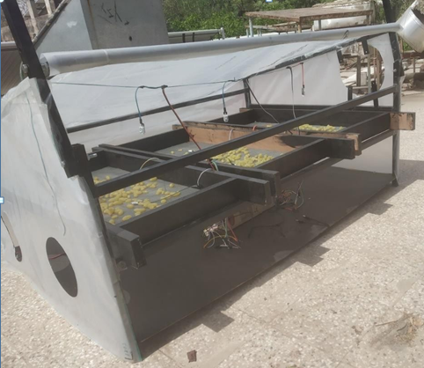
Fig. 2- Photographic view of experimental set up

- EXPERIMENTAL PROCEDURE:
The experiments were conducted from and at 28 April 2022 and 09.00 am and continued till the moisture content was varied 10.0% to 20.0%. Grapes were selected as drying product in order to obtain cost effective resins. These grapes were separated from the bunch, washed and boiled with warm with water till they float on the surface and appear yellowish. The grapes were spread evenly 500gm each over three trays each of dimensions (100 x 45 x 8 cm).
Table 1- List of instruments used in experimentation
S  No. | Parameter | Instrument | Freq. | Location | Accuracy and  Resolution
1 | Temperature | DHT-22  sensor | 30 min | Ambient, inside GHSD  (near tray, upper vent) | ± 1º C,  0.1 ºC
2 | Relative humidity | DHT-22  sensor | 30 min | Ambient, inside GHSD  (near  tray, upper vent) | ± 2.5 %,  0.1 %
3 | Weight | Weighing  scale | 2 hrs | - | ±1gm,  0.1gm
4 | Solar radiation | Solarimeter | 2 hrs | Outside and inside  greenhouse | ±10 W/m²,  1W/m²

There are a total ten DHT-22 sensors mounted on the greenhouse solar dryer with nine inside and one at inlet vent outside to measure ambient properties. Six sensors are placed at tray level which is above 35 cm from the base surface and three sensors are placed at a distance of 41 cm from the base at the exhaust level as shown in figure 3. Three sensors 1,4 and 7 are placed at exhaust level at equal distance of 37.5 cm from inlet in East-West direction. The exhaust level sensors are hung with the use of plastic rope.

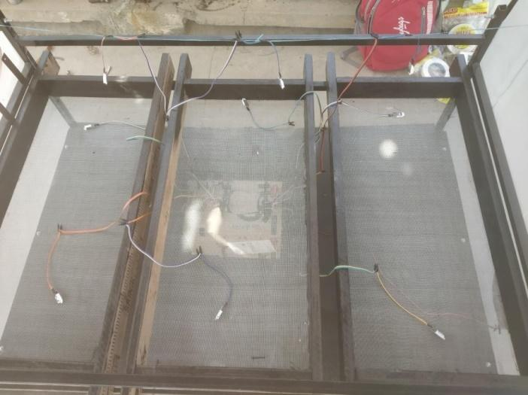
Fig. 3- Location of sensor position

V. RESULT & DISCUSSION
Field scale experimentation was conducted using small scale greenhouse solar dryer to assess the drying performance of GHSD in Jaipur and the results are presented in the following sections:

- Variation in solar intensity:
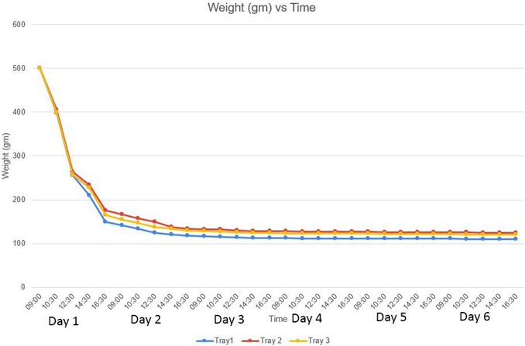
Solar intensity played vital role in the drying process of grapes. It was noted that the sun intensity was low at the morning and maximum at the afternoon while again same was found decreasing in the evening time. The average intensity of 985 W/m² inside GHSD was recorded. Following figure 4 shows variation of solar intensity during experimentation in natural mode. As solar intensity increased, drying time was noticed to decrease sharply.

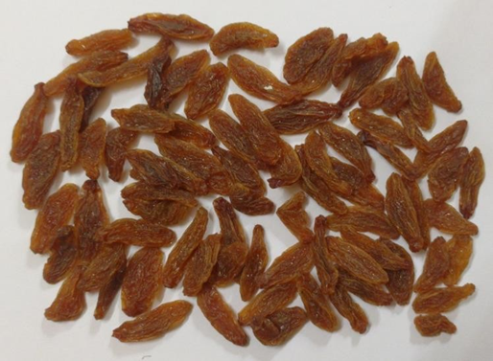
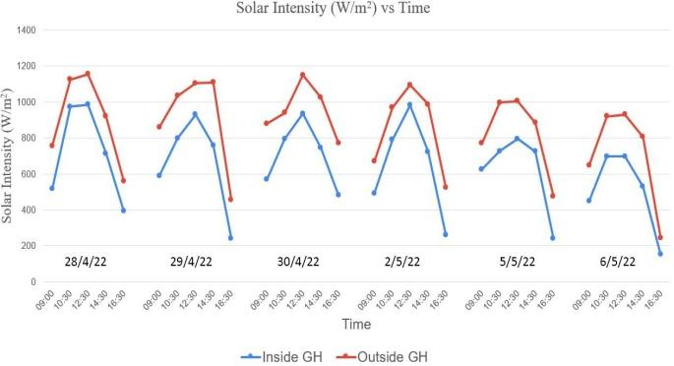
Fig. 4- Variations in solar intensity

- Variation in temperature:
The temperature was observed to be increasing from morning to afternoon. Although the outside temperature rose between 38⁰C to 46⁰C, the inside temperature ranged from 50⁰C to 70⁰C. This shows that the air temperature within the dryers has more potential for the drying process. Figure 5 (a-f) shows variations in temperature inside GHSD for drying grapes during all experimental days and at different locations. The GHSD temperature is significantly higher than the surrounding air temperature.
- Variation in relative humidity:
Relative humidity of air was noticed to reduce progressively from 09.00 am to 04.30 pm during experimental days. The relative humidity was varied from 08% to 29% throughout the experimentation but the relative humidity of ambient air varied in the range of 15.3–30.0%. It was noticed that the relative humidity outside the dryer was always greater than the relative humidity within GHSD.. Figure 6 (a-f) shows variation in relative humidity during experimentation to dry grapes.
- Variation in moisture content:
Figure 7 shows the reduction in weight of grapes during drying. Earlier the weight was 500gm in each tray and as drying in GHSD was progressed, the product started losing moisture. This loss in moisture was depicted in the form of weight reduction of the grapes. The weight of the product was found 110gm, 124gm and 121gm at the end respectively in tray1,2 and 3. The average weight reduced in all 3 trays was 76%.
Fig. 7- Variation of weight under natural ventilation drying of grapes in greenhouse dryer
Following photograph (figure 8) shows grapes dried in GHSD under natural convection and converted in resins with their colour and texture.

VI. CONCLUSION
Field level drying of grapes was carried out to investigate the performance of small-scale greenhouse solar dryer. Grapes were dried to a moisture content of 10 to 20% from
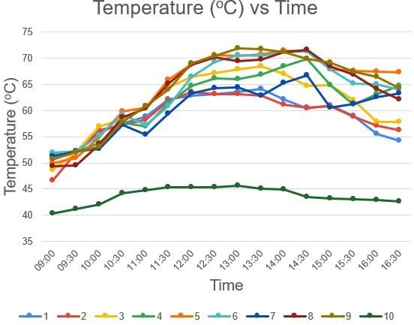  (a) | 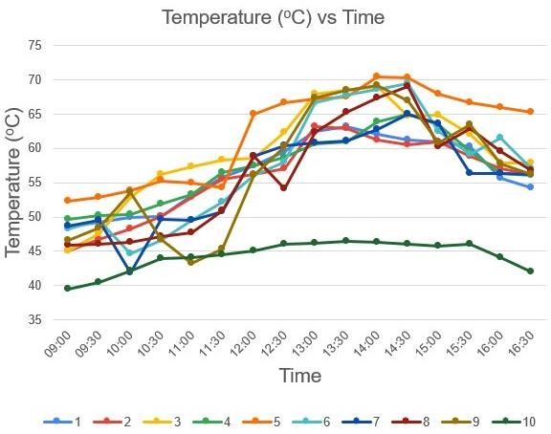  (b)
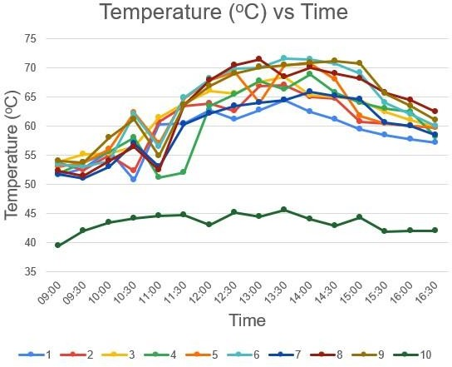  (c) | 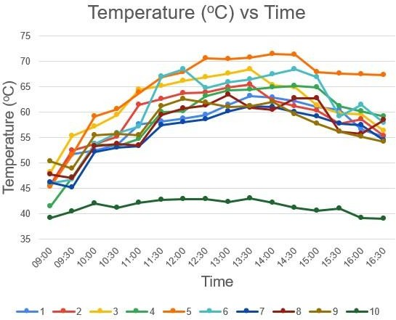  (d)
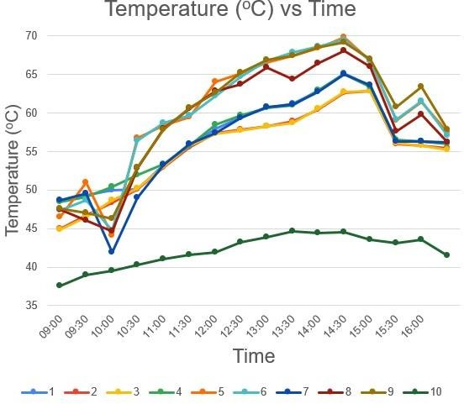  (e) | 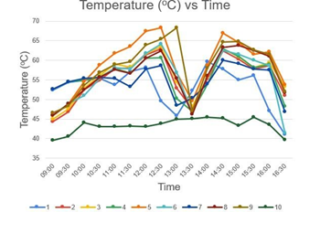  (f)

Fig. 5- Variation in temperature during experimentation

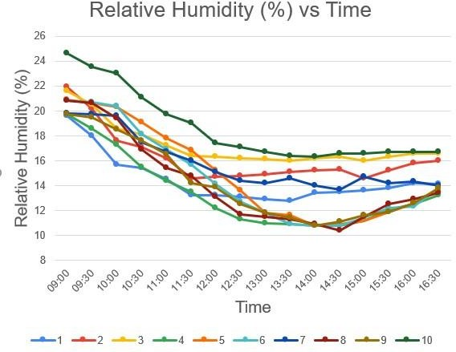  (a) | 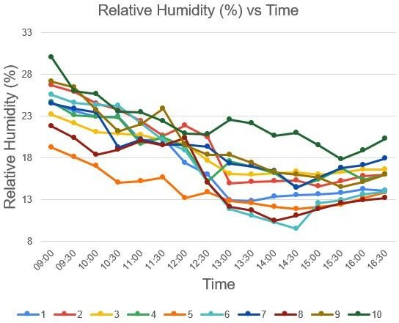  (b)
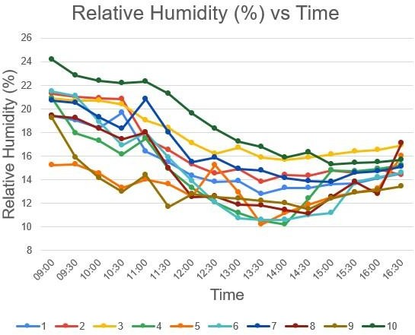  (c) | 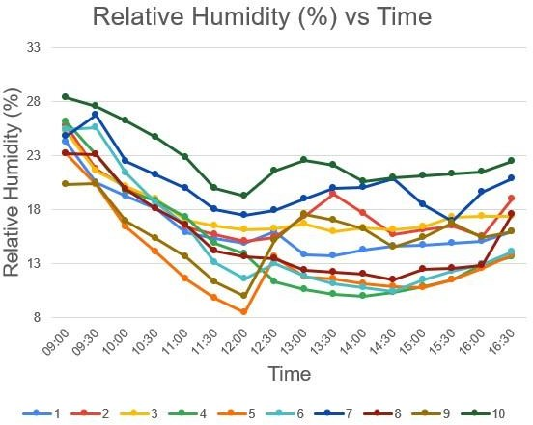  (d)
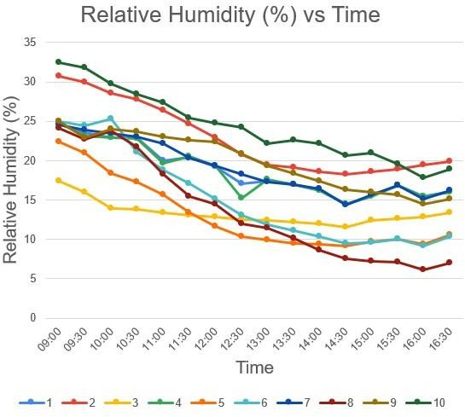  (e) | 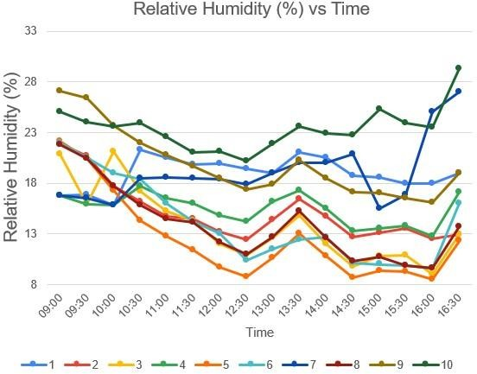  (f)

Fig. 6- Variation in relative humidity during experimentation

initial moisture content of about 80 to 82%. The grapes were dried and formed resins in 129.5 hrs under natural ventilation condition. Greenhouse dryers have considerably higher potential to raise the temperature of inside air by greenhouse effect and to dry grapes placed inside it. It can be comparatively safer and requires a lesser amount of attention if we compare it with open sun drying as open sun drying requires continuous monitoring and has a chance of product losses.
REFERENCES
- A P V Naigam, I M B Ridzuan, A S T Tan, A Abdullah, W A A Z Wan Ismail, and J Janaun (2021). Design, development and performance evaluation of a largescale hybrid solar drye. IOP Conf. Series: Materials Science and Engineering 107, 012016
- Phyu Phyu Thant, Thandar Nwe, Aung Khant Zaw (2019). Design and Experiment of a Natural Greenhouse Dryer. International Journal of Science, Engineering and Technology Research, Volume 8, Issue 7, ISSN: 2278 -7798
- El-Maghlany, W. M., Teamah, M. A., & Tanaka, H. (2015). Optimum design and orientation of the greenhouses for maximum capture of solar energy in North Tropical Region. Energy Conversion and Management, 105, 1096-1104.
- Gupta, V., Gupta, K. S., & Khare, R. (2021). Experimental analysis for drying of potato slices on detachable solar greenhouse dryer. Materials Today: Proceedings.
- Azaizia, Z., Kooli, S., Hamdi, I., Elkhal, W., & Guizani, A. A. (2020) ‘Experimental study of a new mixed mode solar greenhouse drying system with and without thermal energy storage for pepper’ Renewable Energy, 145, 1972-1984.
- Janjai, S. (2012). A greenhouse type solar dryer for small-scale dried food industries: development and dissemination. International journal of energy and environment, 3(3), 383-398.
- Mishra, S., Verma, S., Chowdhury, S., & Dwivedi, G. (2021). Analysis of recent developments in greenhouse dryer on various parameters-a review. Materials Today: Proceedings, 38, 371-377
- Prakash, O., & Kumar, A. (2015). Annual performance of a modified greenhouse dryer under passive mode in no-load conditions. International Journal of Green Energy, 12(11), 1091-1099.
- Anwar, S. I., & Tiwari, G. N. (2001) ‘Convective heat transfer coefficient of crops in forced convection drying–an experimental study’ Energy conversion and management, 42(14), 1687-1698.
- Hamdi, I., Kooli, S., Elkhadraoui, A., Azaizia, Z., Abdelhamid, F., & Guizani, A. (2018). ‘Experimental study and numerical modeling for drying grapes under solar greenhouse’ Renewable Energy, 127, 936-946.

