Synthesis and Characterization of Novel Poly (Amide-Azomethine) S For High Temperature Resistant Requirements

A. S. Patil¹, N. N. Maldar²
¹Department of General Science and Engineering,
Shree Siddheshwar Women’s College of Engineering, Solapur, MS 413 002 India,
²Polymer Research Laboratory, School of Chemical Sciences,
Solapur University, Solapur, MS, 413255, India

:avinashp07@gmail.com

Received on: 29 March,2023 Revised on: 21,April,2023 Published on:23 April,2023

Abstract: A novel aromatic diamine, 2,5-bis-[4”-aminobenzyl)-4’-benzamide]-3,4-diphenyl thiophene (BATP) containing bulky tetraphenyl thiophene group, methylene spacer and preformed amide linkage was synthesized and characterized by FT-IR, NMR (¹H, ¹³C, DEPT ¹³C) and Mass spectrometry. A series of novel aromatic poly(amide-azomethine)s was successfully prepared by solution polycondensation of BATP with aromatic dialdehydes, namely isophthalaldehyde (IPA) and / or terephthaldehyde (TPA) in different mole % proportions. All the poly(amide-azomethine)s were characterized by FT-IR spectroscopy, viscosity measurements, solubility tests, differential scanning calorimetry (DSC), thermogravimetric analysis (TGA) and X-ray diffraction (XRD). The results of characterization shows that these polymers meet high temperature resistant requirements so could find applications as special materials in aerospace, military and microelectronics industries.

Keywords: 2,5-Bis-[4”-aminobenzyl)-4’-benzamide]-3,4-diphenyl thiophene; soluble poly(amide- azomethine)s; thermal stability; thermogravimetric analysis (TGA)
I. INTRODUCTION
Aromatic polyazomethines or Schiff base polymers are a class of particularly attractive conjugated polymers because they show good mechanical strength [1], attractive thermal stability [2], nonlinear optical [3], liquid crystal [4] and fiber-forming properties [5]. They are synthesized by condensation polymerization of dialdehydes (or diketones) with diamines to give Schiff base polymers. However, poor solubility in organic solvents, limited their practical applications in various fields. According to earlier research, adding bulky pendant groups like phenyl, phenoxy, phenylthio, and phenyl carbonyl to the polyazomethines' backbones produces polymers with improved solubility while maintaining excellent thermal stability. Tetraphenyl thiophene-containing aromatic diamine was created by Imai et al. [6] from which soluble and high-temperature resistant polymers were created.
It was believed that adding phenylated moiety, preformed amide, and methylene linkage [7,8] would improve the material's physical characteristics and processability. In order to study the impact of the phenylated moiety [9], methylene, and preformed amide linkage on the resulting high performance materials, it was interesting to synthesise the novel diamine and a number of polyazomethine polymers with improved thermal stability and enhanced solubility in some organic solvents.
A new aromatic diamine, 2, 5-bis-[(4"-aminobenzyl)-4'-benzamide]-3, 4-diphenyl thiophene (BATP), is being studied in the current investigation. Tetraphenylthiophene was used as the starting material to synthesize BATP and it is utilised in the solution poly condensation procedure to synthesize poly(amide-azomethine)s [10]. The inherent viscosity, solubility, IR, XRD, TGA, and DSC characteristics of these polymers were used to highlight the link between structure and property.
II. EXPERIMENTAL
Materials
Sulfur that is readily available in the market was cleaned by dissolving it in water with calcium oxide, and the filtrate was then precipitated with concentrated hydrochloric acid. Fractional distillation of benzoyl chloride was done. N-Methyl-2-Pyrrolidone (NMP) and N, N-Dimethyl Acetamide (DMAc) were refined by distillation under decreased pressure over calcium hydride and stored over 4 Å molecular sieves. The described method was used to produce and purify 4-nitrophenylacetic acid. Palladium on activated carbon (10% Pd/C; Aldrich) and triphenyl phosphite (E. Merck) were utilised exactly as received. Commercially available isophthalaldehyde (IPA) and terephthalaldehyde (TPA) were refined by recrystallization from water. Distillation was used to cleanly separate 2-chloro phenol.
Monomer Synthesis
Compound (I) was used to create the new diamine, 2,5-bis-[(4"-aminobenzyl)-4'-benzamide]-3,4-diphenyl thiophene (BATP). 2,5-bis-(4’-aminophenyl)-3,4-diphenyl thiophene (I) was prepared as in literature [6] starting from benzyl chloride and sulphur in three steps.

Synthesis of 2,5-Bis-[(4”-nitrobenzyl)-4’-benzamide]-3,4-diphenyl thiophene (BNTP) (II)
20.9 g (0.05 mol) 2,5-bis-(4’-aminophenyl)-3,4-diphenyl thiophene (I), 18.1 g (0.1 mol) 4-nitrophenylacetic acid, 64 mL N-Methyl-2-pyrrolidone (NMP) and 16 mL pyridine were added in a 250 mL three necked round bottom flask equipped with a water condenser, a calcium chloride guard tube, a magnetic stirrer, a nitrogen gas inlet and a thermowell. A total of 37.2 mL (0.12 mol) of triphenyl phosphite (TPP) was added, and the reaction mixture was heated to 110 °C while being stirred for 12 hours. After cooling the reaction mixture was poured in to excess water to get precipitate of the dinitro (BNTP) product. It was washed with sodium bicarbonate solution and then with hot water. At 80 °C, the dinitro-diamide molecule (II) was vacuum-filtered and dried. To obtain a pure product, it was recrystallized from an acetone and water combination.
Yield: 32.5 g (87.3 %), M.P.: 270-272 °C.
Synthesis of 2, 5-Bis-[(4”-aminobenzyl)-4’-benzamide]-3, 4-diphenyl thiophene (BATP) (III)
7.44 g (0.01 mol) of BNTP (II), 0.297 g 10% Pd/C, and 110 mL ethanol were taken in a 250 mL three necked round bottom flask fitted with a water condenser and a magnetic stirrer. 15 mL of 99% hydrazine monohydrate was added over the course of an hour after the liquid was heated to reflux. The reaction mixture was refluxed for additional 4 hours. The resulting clear, dark and hot solution was filtered to remove Pd/C and distilled the filtrate to remove some of the solvent. The concentrated solution was added to 200 mL of water while being stirred, producing an off-white product that was then filtered and thoroughly washed with water to remove any remaining hydrazine hydrate. The final product was recrystallized from ethanol and vacuum dried at 80 °C for 6 h.
Yield: 5.10 g (79.1 %), M.P.: 260-262 °C.
Polymer Synthesis:
The new aromatic diamine, 2, 5-Bis-[(4’’-aminobenzyl)-4’-benzamide]-3, 4-diphenyl thiophene BATP (III) was used to synthesize poly(amide-azomethine)s with isomeric aromatic dialdehydes, such as IPA or TPA in 2-chlorophenol. As an example to illustrate the general synthetic route used to produce the poly(amide-azomethine)s, the synthesis of the poly(amide-azomethine), TPM-1 is given below,
2, 5-Bis-[(4''-aminobenzyl)-4'-benzamide]-3, 4-diphenyl thiophene (BATP) (0.684 g, 1 mmol) and dry 2- chloro phenol (5 mL) were placed in a 100 mL three-necked round bottom flask with a magnetic stirrer, a calcium chloride guard tube and a nitrogen gas inlet. Isophthalaldehyde (TPA) (0.134 g, 1 mmol) was added to the mixture after it had been mixed to obtain the clear solution. The mixture was then stirred overnight at 30 °C. By pouring reaction mixture to an excess of quickly agitated methanol, the polymer was precipitated. The precipitated polymer (TPM-1) underwent filtering and a methanol wash. It was dried for six hours at 80 °C. The inherent viscosity of the polymer was 0.26 dL/g, and the yield was 0.712 g (91.1%).
By following a similar process, other poly(amide-azomethine)s, TPM-2 to TPM-5, were created utilising a mixture of IPA and TPA in various mole ratios.
III. RESULT AND DISCUSSION
Aromatic polyazomethines are categorized as conjugated, high-molecular-weight substances with excellent thermal stability. Due to their poor solubility, high melting temperature, and relatively low molecular weight compared to other hetero-atom containing polymers, they pose significant limits for various commercial applications. One of the ways to improve processability of polyazomethines is to introduce bulky pendant groups by using monomer that bears such bulky pendant groups and perform a polycondensation reaction. Thus, a novel diamine BATP (III) containing a tetraphenyl thiophene moiety, a flexible methylene linkage, and preformed amide has been prepared, characterised, and utilised to synthesize poly(amide-azomethine)s in the current work.
Monomer Synthesis:
The novel diamine viz, 2,5-Bis-[(4”-aminobenzyl)-4’-benzamide]-3, 4-diphenyl thiophene (BATP) (III) was synthesized starting from 2, 5-bis-(4’-aminophenyl)-3, 4-diphenyl thiophene (I) (Scheme 1). The structures of BNTP (II) and BATP (III) were confirmed by IR, NMR (¹H and ¹³C), UV-VIS and mass spectrometry.
Scheme 1: Synthesis of 2,5-bis-[4’’-aminobenzyl)-4’-benzamide]-3,4-diphenyl thiophene (BATP)

Polymerization:
Aromatic poly(amide-azomethine)s were synthesized from BATP and isomeric aromatic dialdehydes, namely IPA or TPA by solution polycondensation in 2-chlorophenol. Co-poly(amide-azomethine)s were also synthesized similarly using BATP and a combination of IPA and TPA in various mole ratios (Scheme 2).
Scheme 2: Synthesis of phenylated poly(amide-azomethine)s from BATP and IPA/TPA
Table 1 displays the outcomes of the polyazomethine synthesis. All of the polymers were produced with yields of greater than 91%. These polyazomethines' inherent viscosities, which ranged from 0.20 to 0.35 dL/g, shown that moderate molecular weight polymers were formed.
Table 1: Yield, inherent viscosity of poly(amide-azomethine)s from BATP and IPA/TPA dialdehydes.
Serial No. | Polymer Code | Dialdehyde  (mol %) |  | Yield (%) | Inherent Viscosity η_{inh}, (dL/g)
 |  | TPA | IPA
1. | TPM-1 | 100 | -- | 91.1 | 0.26
2. | TPM-2 | 75 | 25 | 93.3 | 0.22
3. | TPM-3 | 50 | 50 | 91.4 | 0.20
4. | TPM-4 | 25 | 75 | 95.7 | 0.30
5. | TPM-5 | --- | 100 | 94.2 | 0.35

FT-IR spectra provided proof that the poly(amide-azomethine)s had formed. Fig. 1 depicts the characteristic IR spectra of the polyazomethine, TPM-4. At 1625 cm⁻¹, TPM-4 displayed absorption band of the typical azomethine linkage (CH=N). The synthesis of polyazomethine was confirmed by the elimination of the carbonyl band at about 1700 cm⁻¹ due to monomeric dialdehyde and the N-H of the amino group at 3435, 3396 cm⁻¹. Other recognisable absorption bands were also observed at 2924 cm⁻¹ (aliphatic CH) and 3026 cm⁻¹ (aromatic CH).
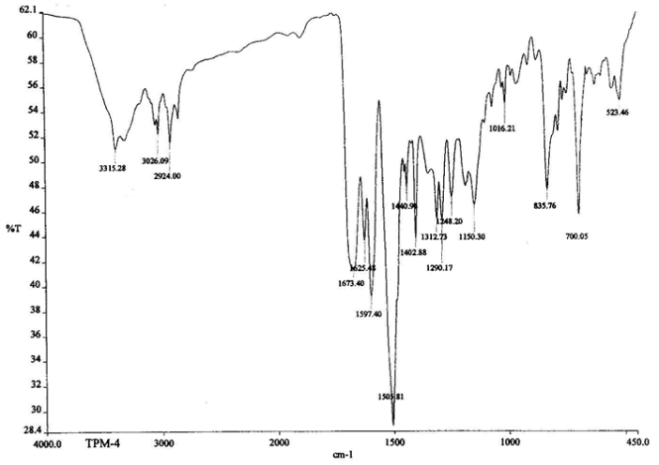
Fig. 1: FT-IR spectrum of TPM-4
Solvent ↓ | TPM-1 | TPM-2 | TPM-3 | TPM-4 | TPM-5
DMAc | ++ | ++ | ++ | ++ | ++
NMP | ++ | ++ | ++ | ++ | ++
DMSO | ++ | ++ | ++ | ++ | ++
DMF | ++ | ++ | ++ | ++ | ++
Pyridine | ++ | ++ | ++ | ++ | ++
m-Cresol | ++ | ++ | ++ | ++ | ++
CHCl₃ | -- | -- | -- | -- | --
DCM | +- | -- | -- | -- | --
THF | S | S | S | S | S
These poly(amide-azomethine)s were quantitatively examined for solubility in a variety of solvents, and the findings are shown in Table 2.
Table 2: Solubility of Poly (amide-azomethine)s

(++): Soluble at room temperature
(+): Soluble on heating (+-): Partially soluble (--): Insoluble (S): Swelling

In aprotic polar solvents such DMAc, NMP, DMSO, DMF, pyridine, and m-Cresol, it was found that the polymers were easily soluble. According to expectations, the careful pairing of an aliphatic methylene group with a tetraphenyl thiophene moiety in the polymer backbone may be the cause of the poly(amide-azomethine)s' improved solubility.
Thermogravimetry (TGA) and differential scanning calorimetry (DSC) were used to assess these polymers' thermal characteristics. Fig. 2 depicts the DSC curves for poly(amide-azomethine)s, while Fig. 3 depicts the TG curves.
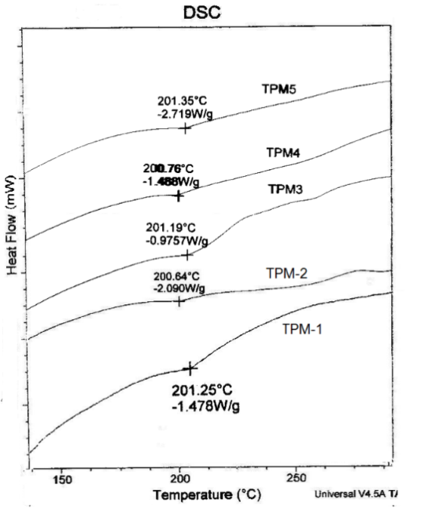. Fig. 2: DSC curves of TPM-1 and TPM-5
Fig. 3: TG curves of TPM-1 and TPM-5

By using DSC, the Tg values for TPM-1 to TPM-5 were found to be around 200 °C. It was discovered that there is a sizable window between the glass transition temperature (Tg) and the temperature of initial decomposition (Ti), which could allow for the melting or compression moulding of these polyazomethines. Table 3 provides a summary of all these thermal characteristics. These polyazomethines' T_{i} and T₁₀ varied between 335 and 370 and 395 and 413 °C, respectively, while their T_{max} values ranged from 442 to 489 °C and their char yields at 900 °C were between 46 and 51%. These variables showed that the polymers had good thermal stability.
Table 3: Thermal properties of Poly (amide-azomethine)s
Polymer code | T_{i} (°C) | T₁₀ (°C) | T_{max} (°C) | Residual wt. (%) at 900 °C | T_{g} (°C)
TPM-1 | 350 | 405 | 485 | 46 | 201
TPM-2 | 370 | 412 | 475 | 48 | 200
TPM-3 | 341 | 413 | 489 | 49 | 201
TPM-4 | 335 | 404 | 457 | 51 | 200
TPM-5 | 349 | 395 | 442 | 46 | 201

In order to study the crystalline or amorphous nature of the polyazomethines, WAXD measurements at room temperature in the region 2θ = 10 to 60° were performed. Fig. 4 depicts typical wide-angle X-ray diffractograms of powder poly(amide-azomethine)s. A very low intensity broad halos in the region 2θ = 20 to 40° during WAXD analysis revealed the amorphous pattern of polyazomethines, which was reflected in solubility of polymers.
Fig. 4: WAXD curves of TPM-1 to TPM-5
IV. SUMMARY AND CONCLUSION
- The novel aromatic diamine monomer containing tetraphenyl thiophene moiety in addition to preformed amide and methylene linkage, 2, 5-bis-[(4’’-aminobenzyl)-4’-benzamide]- 3, 4-diphenyl thiophene (BATP) (III), was synthesized and characterized by FT-IR, ¹H NMR, ¹³C NMR, UV-VIS and mass spectrometry.
- Using the solution polycondensation approach, phenylated poly(amide-azomethine)s were synthesized by reacting stoichiometric amounts of this new diamine with isomeric aromatic dialdehydes.
- By using FT-IR, inherent viscosity (η_{inh}), the solubility test, differential scanning calorimetry (DSC), thermogravimetric analysis (TGA), and X-ray diffraction (XRD), all the polyazomethines were characterized
- Inherent viscosities of the poly(amide-azomethine)s made from BATP ranged from 0.20 to 0.35 dL/g. All polyazomethines have a moderate molecular weight buildup because of their inherent viscosity.
- Different aprotic polar solvents were used to assess the solubility of polyazomethines. The poly(amide-azomethine)s made from BATP showed better solubility in organic solvents. These polymers were soluble in aprotic polar solvents such m-cresol and pyridine as well as DMAc, DMSO, NMP, and DMF. The addition of the bulky pendant group, the tetraphenyl thiophene unit, to the polymer backbone in addition to the methylene spacer and the preformed amide bond, can be blamed for the rise in the solubility of the polyazomethines from BATP. Bulky pendant phenyl groups were added to the polymer, which decreased the effectiveness of chain packing and enhanced solubility.
- The glass transition temperature (T_{g}) of all the polyazomethines prepared from BATP were found to be around 200 °C.
- Because the poly(amide-azomethine)s from BATP had an amorphous X-ray diffraction pattern, it is possible that the inclusion of large pendant phenyls disrupted the chain packing and interchain interaction. The aforementioned findings also lend credence to the polyazomethines' solubility.
- Thermogravimetric analysis carried out under a nitrogen environment was used to assess the thermal stability of polyazomethines. When methylene linkages or bulky pendant phenyl groups are introduced into the polymer backbone, the thermal stability of the polyazomethines made from BATP shows no discernible degradation.

REFERENCES
- Morgan, P. W.; Kowlek, S. L.; Pletcher, T. C.; Aromatic azomethine polymers and fibers, Macomolecules (1987), 20, 4, pp. 729-739..
- Catanescu, O.; Grigoras, M.; Colotin, G.; Dobreanu, A.; Hurduc, N.; Simionescu, C. I.; Synthesis and characterization of some aliphatic–aromatic poly(Schiff base)s, Eur. Polym. J., (2001), 37(11), pp 2213-2216.
- Dutta, P. K.; Jain, P.; Sen, P.; Trivedi, R.; Sen, P. K.; Dutta, J.; Synthesis and characterization of a novel polyazomethine ether for NLO application, Eur. Polym. J. (2003), 39(5), pp 1007-1011.
- Ribera, D.; Manteco´n, A.; Serra, A.; Synthesis and crosslinking of a series of dimeric liquid-crystalline diglycidylester compounds containing imine groups; J. Polym. Sci., part A:Polym. Chem, (2002), 40(23), pp 4344-4356.
- Morgan, P. W.; Pletcher, T. C.; Kwolek, S. L.; Polyazomethine polymers and fibers; Polym. Prepr (1983), 24(2),pp 470-1.
- Imai, Y.; Maldar, N. N.; Kakimoto, M.; J.; Synthesis and characterization of soluble polymides from 2, 5-bis (4-aminophenyl)-3, 4-diphenylthiophene and aromatic tetracarboxylic dianhydrides; Polym. Sci. Polym Chem (1984) 22(9), pp 2189-2196.
- Arati V Diwate, Asiya M Tamboli, Shivaji D Ghodke, Aslam B Tamboli, Mohaseen S Tamboli, Noormahamad N Maldar; New polyamides based on diacid with decanediamide and methylene groups and aromatic diamines; J. Appl Polym Sci (2022), 139(21), pp 52221.
- S Ghodke, A Tamboli, A Diwate, V Ubale, R Bhorkade, N Maldar; Synthesis and characterization of aliphatic aromatic polyamides containing pyridine and methylene spacer group in polymer backbone; Int. J. Polym Anal and Charac(2021), 26 (4), pp 342-353
- Patil, Y. S.; Salunkhe, P. H.; Navale, Y. H.; Patil, V. B.; Ubale, V. P.; Ghanwat A. A.; Tetraphenylthiophene–thiazole-based π-conjugated polyazomethines: synthesis, characterization and gas sensing application ; Polymer Bulletin (2020), 77, pp 2205-2226.
- Mohsen Hajibeygi, Saeid ShafieiNavid, Meisam Shabanian, Henri Vahabi; Novel poly(amide-azomethine) nanocomposites reinforced with polyacrylic acid-co-2-acrylamido-2-methylpropanesulfonic acid modified LDH: Synthesis and properties; Applied Clay Science (2018), 157, pp 165-176.

