**University Student Dashboard System**

**Ganesh Chavan1, Sameer Qureshi2, Komal Ingale3, Lokesh Mali4**, **Keshav Hemnani5**

*Assistant prof-Ganesh chavan1 Stud(BE Comp)-Sameer2 Komal3 Lokesh4 Keshav5*

*Dept of Computer Engg,GF’s Godavari College Of Engineering ,Jalgaon,India,425003*

*2 kureshisame007@gmail.com*

***Abstract****:- In our Project we have make the software that has been help student for the studies. In that students can get solved answer sheet and get much more study material. In this web application we can add audit points for the audit report and also we can print it. it also help the student to and their suggestions about the various question over the software . This software also helps to finds specific of a question with the help of searching algorithm. Student can also get the syllabus of specific semester on this software.[1]*

***Keyword****- Dashboard, PHP, Database.*

**INTRODUCTION**

**T**his software design specification is made with the purpose of outlining the software architecture and design of the Student detail. The document will provide developers an insight in meeting client’s needs efficiently and effectively.

The design and implementation of a comprehensive student information system and user interface is to replace the current paper records. College Staff are able to directly access all aspects of a student’s academic progress through a secure, online interface embedded in the website. Each sub-system has authentication allowing authorized users to create or update information in that subsystem. All data is thoroughly reviewed and validated on the server before actual record alteration occurs. In addition to a staff user interface, the system plans for student user interface, allowing users to access information and submit requests online thus reducing processing time. [1]

**What is general use?**

This system is generally use by students for their studies, this also helps to students to add and read the suggestions about the questions and answers.it also provide facility to search quick answer of any specific question.

**Need of these software?**

This software is much more needed for students for their daily studies with the help of that they can get the content of any subject at the single platform. It reduces the extra time that can be Need to students to search specific answer over various books. [2]

**Problem Statement:-**

Retrieving detail and accurate information is very critical especially for public and People that are involved in any web application. The information reflect on a positive or negative way. The current problems that face by the web application areStudent dashboard needs a proper medium where they can easily manage and display information about questions paper and syllabus info and also Audit Point.The prospective students are also have difficulties to find information about semester information, question paper set, audit point report should provide the right and detail information for them so they are interested to be a part of the web application.[3]

**Prototyping:-**

In designing the Student Help Desk System prototyping will be used to demonstrate underpinning concepts of the designing and for user interfaces. This technique will provide the opportunity for the system users to experiment the software to a certain extent during the development process

**Activity Diagram:-**

Fig. shows the Activity diagram. Based on end user necessities as well as the thorough investigation on current system we have suggested a system that satisfies user requirements. Initially admin will going to login to the system. Once he successfully logged in, he will be able to upload student details and faculty details. Admin may be head of the department.

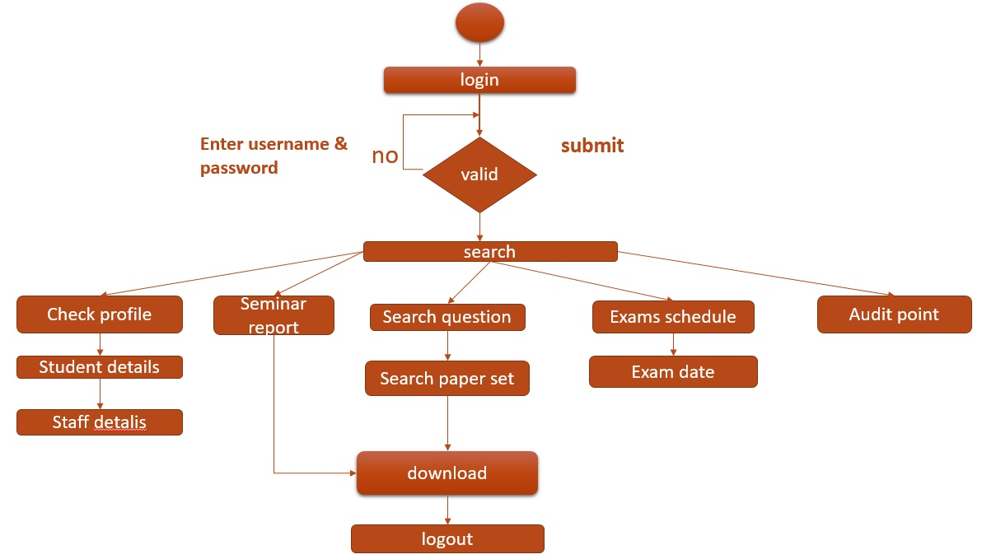

**Fig:-Activity Diagram of Student Help Desk**

**4.3 Detailed Flow Graph:-**

The detailed flow graph is shown in Fig.4.4.The design of the student academic information system includes the design of the home page which provides the way for all the students, staff and other user to access the SHD. Every user of the SHD has a unique username and password provided by the web master of the college. The home page mainly contains a login form through which a new user can register, or an existing user can login to the system by entering the username and password provided by the web master.

**Use Case Diagram:-**

Fig. shows the Use case design of the student Help Desk system. Users will login to the student Help Desk. If the logged in user is an admin user he will be able to register the students and faculties in the system, admin can only have the complete privileges on the system. He will be sending circular to the students as well as faculties regarding the upcoming events that will appear in the college.

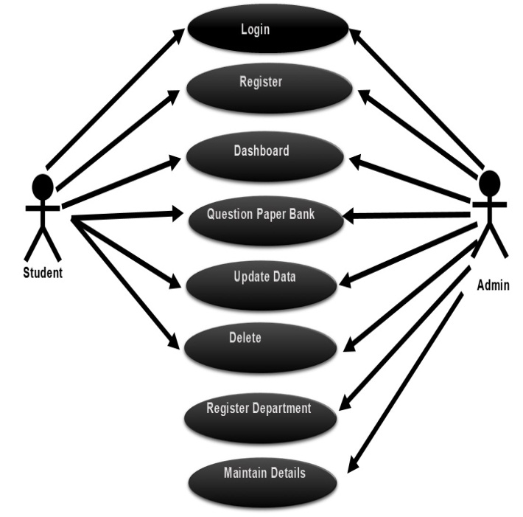

**Fig:-Use case diagram for Student Help Desk**

by entering the username and password provided by the web master. [4]

**Faculty:-**

The staff can update the information regarding the student’s audits, information’s internal marks of the students and any information regarding the subjects they handle. They can also view the student details for better understanding the student performance and improving the efficiency of the student. The staff also gets the updates from the college regarding any events occurring in the college.



**Fig:-faculty**

**Student:-**

The student is of center focus, because in every college student plays the very important role. Student can access the information of the college, course details, subject details, faculty details, training and placement cell information and exam section information. The course details include information regarding branch he is studying, the academic curriculum of the college, year wise subject offered by the branch, the subject details include the syllabus of the subjects, information regarding the staff handling the subjects, the subjects he presently registered for the semester he is presently studying, attendance and internal marks of the subjects, he can also ask any queries to the staff regarding the subjects. company. The exam section details include the internal and external time tables, the room allocation for the exams, it also contains the semester end results

**Administrator:-**

The administrator is responsible for entering the new student, promoting the student from one class to another, from one semester to another and from one year to another. Managing the student accounts like any changes regarding to the name, address etc. The administrator also manages the faulty accounts like entering a new faculty, assigning the faculty to the subjects. [5]

**Functional Requirement:-**

University Student Dashboard System aims to improve the efficiency of college information management, and the main function is managing and maintaining information [3]. The administrator and students are two major functional requirements in the system. The Administrator will be given more powers (enable/disable/ update) than other users. It will be ensured that the information entered is of the correct format. For example name cannot contain numbers. In case if incorrect form of information is added, the user will be asked to fill the information again. Students use the system to query and enter their information only.

**Non-Functional Requirement:-**

**Performance Requirements:-**

The proposed system that we are going to develop will be used as the chief performance system for helping the organization in managing the whole database of the student studying in the organization. Therefore, it is expected that the database would perform functionally all the requirements that are specified.

**Safety Requirements:-**

The database may get crashed at any certain time due to virus or operating system failure. Therefore, it is required to take the database backup

**Security Requirements:-**

We are going to develop a secured database.

There are various categories of people namely Administrator, Student who will be viewing either all or some specific information from the database. Depending upon the category of user the access rights are decided. It means if the user is an administrator then he can be able to modify the data, append etc. All other users only have the rights to retrieve the information about database. [5]

**Database Management System (DBMS):-**

Is a collection of programs that enables users to create and maintain a database. DBMS is a general –purpose software system that facilitates the process of defining, constructing, manipulating, and sharing database among various users and applications. Defining a database involves the specifying the data types, structures, and constraints of the data to be stored in the database. The database definition or descriptive information is also stored in the database in the form of dictionary; it is called Meta data constructing the database is the process of storing the data on the storage medium that is controlled by the DBMS.[6]

**Results:-**

**Login form**:-

The system starts with login page where the registered user can enter user name and password to be able to access the system. Fig. 3 shows login form which includes registration path also.

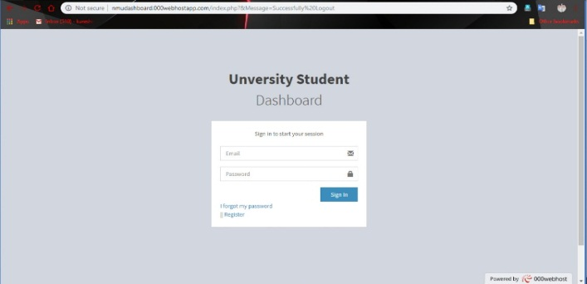

**Fig. 3 Login form**

**Registration form:**

Fig shows registration form which contains details of student information during admission.

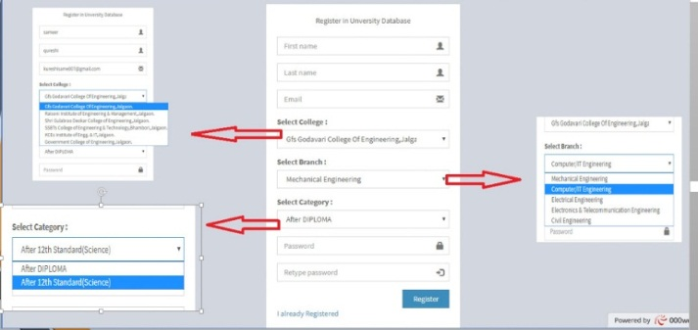

After filling the registration form email will be sent to student to verify the E - mail address and consists of

Student basic information is as shown in which consists of college serial number, university

**Dashboard Section:-**

Dashboard section provides as total information about software like how many material available in the software, how many people registered on software and many branches are available

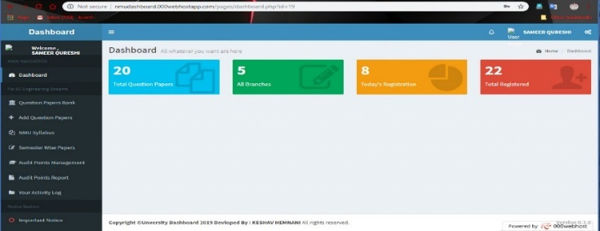

**Add audit point: -**

You can add audit points and create audit report and print it.[6]

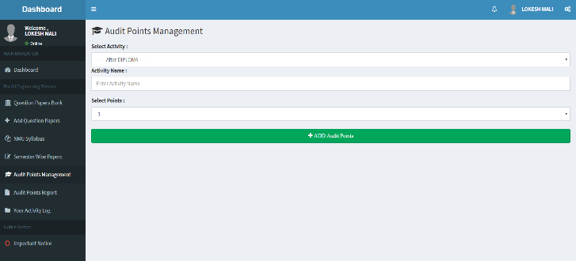

**CONCLUSION**

Student academic System is very useful in an institution or in college or in universities. This project especially minimizes human effort necessary. This application is handled by the college so there is no information leak and data will be secured. Since it is a web based application anyone can use the system anywhere at any time and it is very easy to get the necessary information without the latency. It is very useful to the students to get their report on question paper set and audit information. Parents also get benefited more since college is going to send the notification of the student via the email will be sent to get the recent activities happen in the college.

**REFERENCES**

[1] *Isbudeen Noor Mohamed, Ahmad Tasnim Siddiqui, Syed Ajaz, S. Mohamed Idhris, “Student Information ReportSystem with SMS (SIRS)”, in proc. 2016 International Conference on Computer Communication and Informatics (ICCCI -2016), Jan. 07 – 09, 2016, Coimbatore, INDIA.*

[2] *FU Yue, “A Study of Student Information Management Software”, pp.393-396.*

[3] *Freya. J. Vora, Pooja. L. Yadav, Rhea. P. Rai, Nikita. M. Yadav, “Android Based Mobile Attendance System”, International Journal of Advanced Research in Computer Science and Software Engineering, Volume 6,Issue 2, February 2016, pp.369-371.*

[4] *Liangqiu MENG, “College Student Management System Design Using Computer Aided System” in proc. 2015International Conference on Intelligent Transportation, Big Data & Smart City, pp.212-215.*

[5] *Almahdi Alshareef, 1Ahmed Alkilany “Toward A Student Information System for Sebha University, Libya”, Fifth International conference on Innovative Computing Technology, 2015, pp.34-39.*

[6] *Lalit Mohan Joshi, “A Research Paper on College Management System”, International Journal of Computer Applications (0975-8887) Volume 122 – No.11, July 2015, pp.32-44.*