Optical Shop Management System
Rupal Patil¹, Roshan Patil², Rupali Zunzarrao³, Saima Shaikh⁴ Kanchan Chaudhari⁵
¹ Assistant Professor -1, ² BE Student-2, ³ BE Student -3, ⁴ BE Student -4 , ⁵ BE Student -5
^{1,2,3,4,5} Department of Computer Engineering, GF’s Godavari College of Engineering, Jalgaon, India, 425003
²roshanpatil201818@gmail.com, ³ rupalizunzarrao10@gmail.com ⁵ kanchanchaudhri06091996@gmail.com

Abstract – This report in the title "Optical Shop Manager" which is a shop management system to manage optical shop business and it is implemented with inventory management. There are modules in this system, which are login, master inventory management, transaction management, staff management, and financial management. The problem statement of this thesis are the current management system is filing system to record the sales, customers, staff, stock record and there are no well Transaction management is using and the record of the stock was not complete, only depend on the invoice they received as stock record.

Keywords: Transaction, Dashboard, Dashboard Section
- INTRODUCTION
Business is one of the most important economy generators for each country and since the dawn of the twentieth century, all business companies turned to technology to better improve their business chances and qualities. Thus, such is the reason of the development of this system[1]. This system is developed for the optical business, where it will be implemented in each of the shop outlets of an optical company. The system name is Optical Shop Management (OSM). The system is developed for the purpose of making management much more systematic, secure and efficient. OSM consist of modules which are login, transaction management [2], staff management, and financial management.
Capabilities of modules are described in the Table 1.1.
The system and its functions' will provide the optical shop a computerized method of management which will help increase the efficiency and productivity of the outlet.
Conclusively, once the system is developed and implemented it will increase the productivity of the business.

Table 1.1: Modules and function list
Module | Function
Admin login | - Login to the system
Master | -Use to store record of different things.
Transaction Management | -Select and sell the desired product quickly and precisely  -View transaction receipt, product sales report, and  personal sales report
Staff Management | -Manage the staff attendance and workflow
Financial  Management | -Manage the financial of the company  -Holding every branch financial account to keep record on their earning

2. LITERATURE SURVEY
2.1 Current System
The current system using now in OM OPTICALS is manually system, means that all the process on managing the shop business flow is written in paperwork. During the transaction process, they just only use paper receipt but not printed receipt. Besides, they do not have any record on the customer profile, and staff profile. If they want to refer back their customer eye degree, they only can refer back the receipt that give to the customer before to get their previous record on the eye degree. If need to find out the receipt, they have to check it one by one, so it take quite a long time. Furthermore, the daily sell they record down on a log book and end of the month they have to calculate it manually. Adding for the staff commission, they also need to refer back they receipt one by one to calculate the total sell on the particular staff. These processes are time consuming by do it one by one. The shop does not have any well inventory management at the same time. Overall system flow for OM OPTICALS is using traditional management system.
2.1.1 Apparatus
Tools that are being used in this manual system include log book, receipt and pens. Log book which is use to record daily sell that written by pen. For the receipt, also is manually written by using pen. Appendix A is an outlook of the receipt they using now.
2.1.2 Analysis of Existing System
This chapter is about the existing system that had been analysed which is a optical shop manager.
2.1.3 Optical Shop Manager
Filo to is a software application which created by ACCRA Med Software Inc. This application is developed for optical shop to manage the business flow and consists of four main functions which are point of sale, front office, back office, and office manager.
2.2 Problem Identification
There are two main problem faced by OM OPTICALS.
The two problem statements shown are:
i. The current management system is filing system to record the sales, customers, staffs, stocks record.
ii. There are no well inventory management is using and the record of the stock was not complete, only depend on the invoice they received as stock record.

2.3 Objective
The objectives to create OSM are:-
i. To develop a computerized and systematic optical shop manager.
ii. To implement inventory management into the system to handle the stock management and keep record of the stock information.
2.4 System Scope
This system is design and developed for optical shop. Target users of this system are optical staffs and administrator. This system is a software application. This system contains of modules which are registration and login, inventory management, transaction management, staff management, and financial. The system will develop by using PHP and Microsoft SQL server 2010.
3. METHODOLOGY
3.1 Data Design Terms:
Data objects
A data object is a thing about which you want to store information. It has independent existence and can be uniquely identified.
The following data objects are derived for the system.
- Customer
- Order
- Product
- Invoice
- Category
The following relationships are identified for the system.
For instance let us take the objects CUSTOMER, CATEGORY, PRODUCT, ORDER, BILL the following relationships are identified.
- Customer “places” an Order.
- Order “contains” Product.
- Product “dispatched to” Customer. The relationships between the remaining entities are as follows:
- Customer “receives” Invoice.
- Invoice “has” Product.
3.2 System Software & System Hardware:

System Software: Wamp Server, Dreamweaver
- Operating System: Windows 10
- Programming Languages: PHP, JVP
- Database: MySQL

System Hardware:
  - Processor : core 2 duo
  - Hard Disk : 160 GB
  - RAM : 500MB

3.3 Data Flow Diagrams:
A data flow diagram is a logical model of a system. The model does not depend on hardware, software and data structures of the organization. There is no physical implication in a data flow diagram. Because the diagram is a graphic picture of the logical system, it tends to be easy for every non-technical user to understand and thus serves as an excellent communication tool. Finally a data flow diagram is a good starting point for system design.
3.4 Context Level Data Flow Diagram The first step in drawing the DFD is to draw the context Diagram. This is the top-Level design of the entire system it contains single process it plays a very important role in studying the current system.
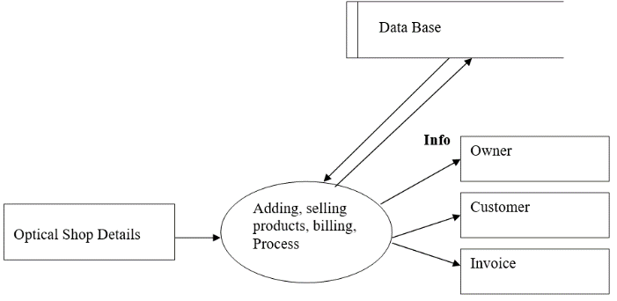
Fig 3.1 Context Level Data Flow Diagram

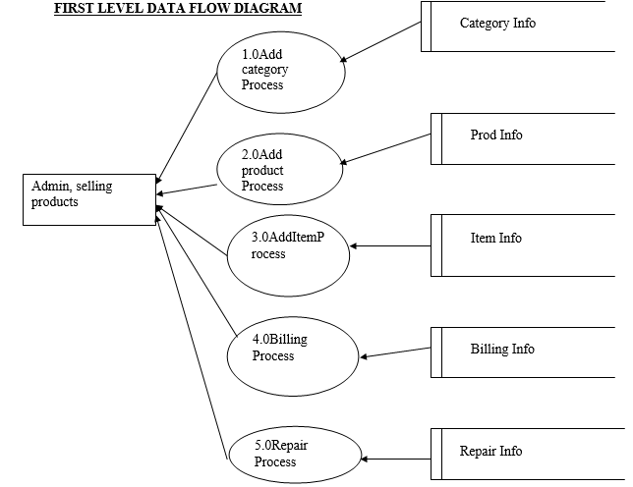
Fig 3.2 1stLevel DFD
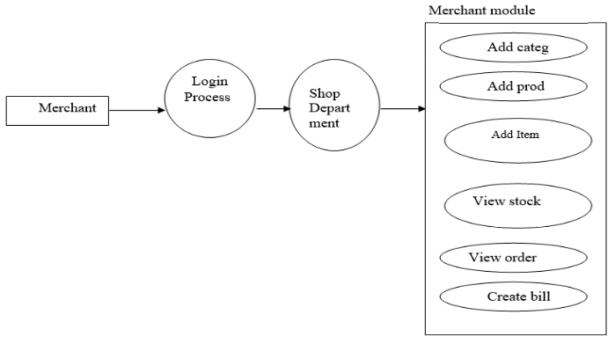
Fig 3.3 2nd Level DFD
4. RESULT AND DISCUSSION
The following outputs are collected for proposed system during the requirements specification from the Shops.

4.1 Invoice
Once an order (either direct customer order or the dealer order) gets serviced partially or fully, an invoice for the same needs to be prepared. Most of the details are picked up from the order itself .An order may have multiple invoices[3]. The discount for special customers is worked out. The rate is got form the product rate file. A copy of the invoice is sent to the direct customer, dealer, in-transit file, invoice file. The invoice details are entered into the issue register. Once supplementary gets service partially or fully nil valued supplementary invoice for the same needs to be prepared. Most of the details are picked up from the supplementary order itself. A copy of the supplementary invoice is sent to the direct customer, dealer, in-tansit file, and supplementary invoice file. The supplementary invoice details are entered into the issue register.

4.2 Dispatch Instructions
The invoice department picks up dispatch instructions for the invoices that are prepared from the order form. This they send to the dispatch department. They prepare a packing slip.
This is a regular report being prepared, consisting of order that are pending as of a particular date. The details for this report are taken from the pending orders[4].
4.3 Weekly Stock Status Report
This is another weekly report prepared giving the details of the stock of each product. The details are obtained from the stock book. Following are the procedure to login the system.

Login: Login to system
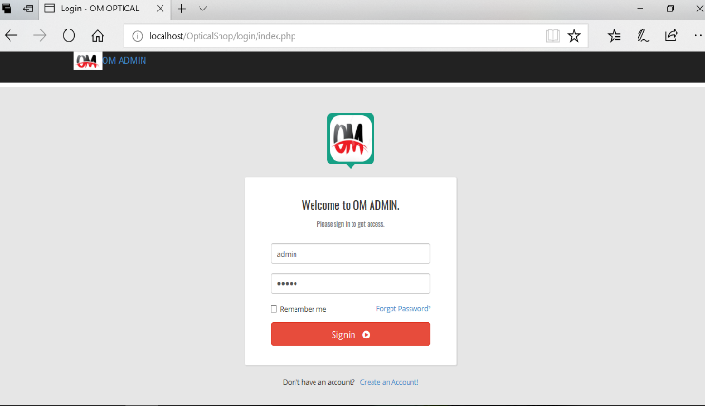
Fig: 4.1 Login to system
Dashboard Section: Dashboard section provides as total data about Om optical like, how many people registered.
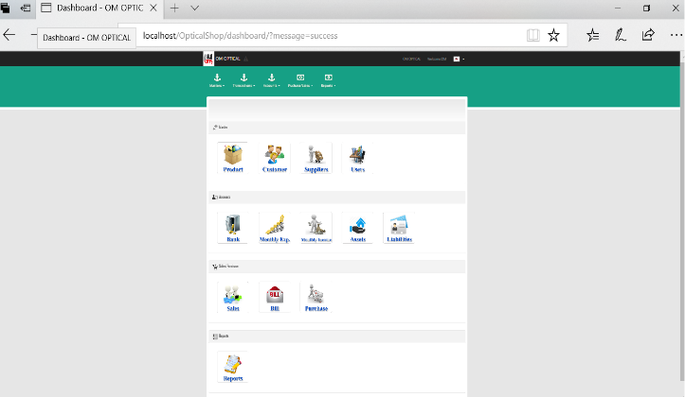
Fig: 4.2 Dashboard Section
Master: Master Menu is used to store record of different things.
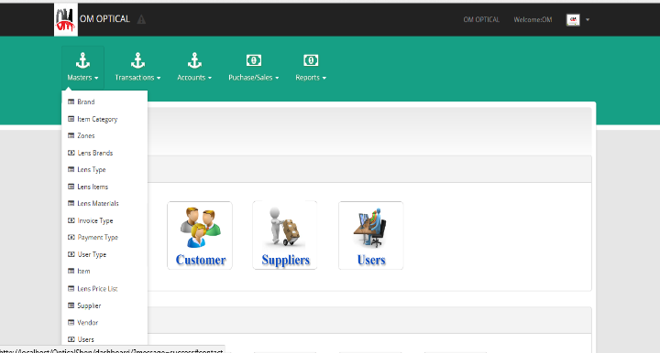
Fig: 4.3 Master Menu
Transaction Management:

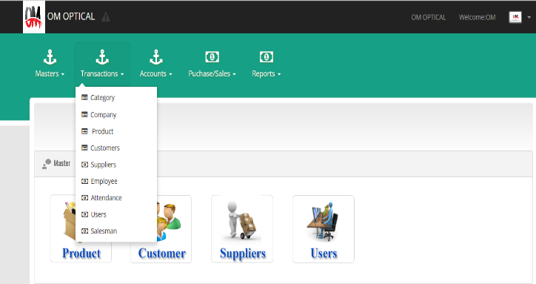
Fig: 4.4 Transaction Management

5. CONCLUSION
This system has been developed for OM OPTICAL SHOP. The current system is a manual system. In order to overcome the drawbacks in the current system a decision to automate some of the departments of the optical shop business. It reduces drawback of manual system.like provide sequrity,less time consuming,do not require any extra storage,easily modify the data,fast and accurate.This system provide better service to the customer.

REFERENCES
- Lesonsky,Riva"Optical Management Software". EGA Future. Retrieved 23 November 2012. International Federation of Automatic Control, Vol.3, No.48, Mar 2015, pp260- 265.
- Dolinsky,Anton"Transaction Management Software". EGA Future. Retrieved 23 November 2012.
- P.G. Matsebatlela and K. Mpofu, “Financial Management Framework to Minimize Supply and Demand Mismatch on a Manufacturing Organization”,
- Lu,Clara"InventoryManagement.SoftwareTradeGecko".

