AI Chatbot Using Dialog Flow

Dr (Mrs). Archana Dehankar¹, Shyamal Kirpan², Abhayraj Jha³,Gitesh Thosare⁴,
Adarsh Bhaisare⁵, Sumit Mankar⁶

Priyadarshini College of Engineering, Nagpur, India, 440019

archana_dehankar@rediffmail.com

Received on: 11 June ,2022 Revised on: 05 August ,2022, Published on: 09 August,2022

Abstract –In this article, conversational AI takes on increasing importance as it enables an easy interaction interface between humans and computers. Thanks to its promising potential and enticing corporate values ​​to serve as virtual and/or social assistants chatbots, major AI, NLP and research & amp; Mining conferences explicitly require conversational studies contributions. The main purpose of the app is to help unassisted customers while minimizing staff distraction. The chatbot responds to the consumer with textual messages. This is accomplished by Natural Language Processing (NLP). Natural language processing (NLP) is a popular method for building Chabot apps, and we're utilizing it to build a versatile customer-specific Chabot. NLP recognizes the purpose of the user entity with a high degree of accuracy by analysing user input against three distinct engines. Customers can get help from this chatbot for their specific requirements. Furthermore, the purpose of this research is to create a knowledge system with a high potential for application specificity.
Keywords- AI chatbot, Natural language processing, Dialog Flow
- INTRODUCTION
NLP is a sort of artificial intelligence that enables intelligent systems to interact with one other. In the field of Artificial Intelligence, there have been several research on chatbots that use Natural Language Processing. AI Chatbots can be used regardless of the domain in which they are utilized, respond to any questions that a user may have. Universities, healthcare, banking and entertainment are just a few of the places where chatbots are used. Some well-known chatbots include Siri, Cortana, Alexa, and others. To reply to consumer queries, several websites use chatbots. A chatbot is a piece of artificial intelligence software that can communicate with humans in real time and react to their questions. A set of principles is applied to AI bots for them to comprehend and respond to human requirements. A user's collection of questions is occasionally matched to relevant replies. They're referred to as "limited" chatbots. Chatbots analyze the user's search and answer in real time. The user's selections and behaviors will determine the replies. They're dubbed "intelligent chatbots."

- LITERATURE REVIEW

Conversational AI refers to the use of artificial intelligence techniques (such as computational linguistics, machine learning, and knowledge graphs) to create intelligent software entities that can converse in natural language with humans or other agents. Smart speakers and chatbots are examples of software in this category[1]. The first era of this technology concentrated on short task-oriented dialogue [2], such as music playback (e.g., "Alexa, play music") or information retrieval. The current challenge in this area is to maintain a continuous, coherent, and attractive dialogue, as current software is still far from being capable of natural everyday conversations with humans [3]. The chat approach is planned in such a manner that human users believe they are naturally conversing with another human. Chatbots can play an essential part in education because, unlike traditional e-learning systems, they are interactive [4]. Chatbots, among other ICTs, are regarded as safe and accessible content and tools that can produce positive learning outcomes. The increased performance of the system is one of the causes that chatbots were indeed popular in a variety of businesses. This argument is often used in education because it improves user–student satisfaction by shortening response times and being available 24 hours a day to answer and clarify any questions [5]. This enables teachers, for illustration, to avoid answering repeated questions that chatbots can easily answer, while also assisting students who have missed yet another or more lessons [6].
A chatbot contributes to addressing the problem of propping up several individual student cases, in addition to simply that provide the question–answer function or communicating knowledge between students and the system. The teacher usually just doesn't have enough time during a lesson to provide formative feedback per each pupil [5]. However, formative feedback during learning processes is one of the most important factors in increasing students' performance and motivation, according to Hattie [7]. An AI chatbot can assist each individual student, having followed different learning paces, and providing knowledge based on their individual mental level[8]. Furthermore, chatbots appear to allow students to access individual support in a bug-free environment, allowing them to apply one‘s cognitive skills at any time and from any location. Furthermore, a tool can be regarded as a good data analysis tool. According to Shawar and Atwell [9], it is critical to remember that the teacher is the backbone of teaching process and that learning technology can serve as an enhancer rather than a substitute. For example, when the robot is used to answer students' research question, the teacher can even use the chat logs and facts and figures reporting to see how far the students having problems as well as what their weaknesses are. As a result, the teacher could use this technology to stare for difficulties, while teenagers use it to solve them[10].
III -METHODOLOGY
A banking chatbot, is included in this system, and it answers all bank-related enquiries. The chatbot's model is made up of three parts: backend, dialog flow, and frontend. The main tasks of the chatbot are handled by dialog flow.
The end user will utilize a web application to access the system. He will put his question into the text area on the front end of the web application. When he presses Enter or submits the doubt, bot controller logic will handle this request. The Flask framework implementation is used to process user requests and then offer replies to those queries as a reply in the bot controller code.
The query will then be sent to the implemented business logic and machine learning logic. The business logic employs Natural Language Processing (NLTK library) and its vectorization approach to execute basic and complex pre-processing techniques on the user input query. Extraneous spaces and stop-words will be deleted from the query, and lemmas will be retrieved for each token. This text format query will then be converted to vectorized format using vectorization. To decide which class this reformed question belongs to, the classification procedure will be applied using Machine Learning reasoning. A classification method will be utilized based on the previously saved model that was ran on train data. The cosine similarity will be applied to all requests from user input data with a class identical to the retrieved class. Based on the respectful similarity values we obtain; the most comparable answer will be sent to the user as a response to the question. We've been gathering our own database of questions and responses that banking clients used to ask bank staff at customer support centers or information desks. We gathered information from a variety of banking websites and FAQs.
Web scraping collects information from websites in an easily digestible manner, allowing you to make rapid judgments. Using the NLTK library, which was built with Natural Language Processing in mind. Because the user input will be in English, we must allow the machine to comprehend the query language we used for Natural Language Processing.

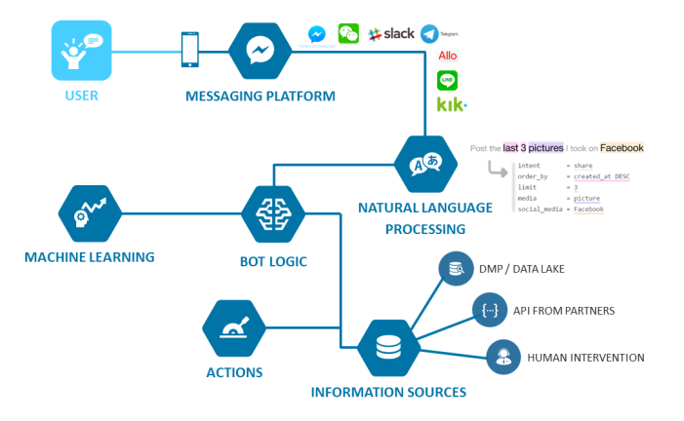
Fig 1- Working of Ai Chatbot

When entities are present within a single entity, Dialog flow recognizes them, and the model understands them better. Generation of Reactions A full explanation of how entities and intents work in Dialog flow is provided, however it is required to illustrate how the platform's present implementation would benefit the suggested method. A purpose is made up of three fundamental components: contexts, training instances, and responses. Contexts overlay the dialogue in such a way that only those intents that are present can be engaged while they are present. Sentences are separated into two categories: templates and examples, and they are utilized as training examples. Each of these statements is labelled with entities or the simple aim in which it is included. Responses are triggered when a user entry matches an intent since they are the outputs of intents. They are available in several forms, with plain text being the most prevalent. Direct connection with apps that fit content into cards, tables, lists, and other content structures is possible with Dialog flow. Entities, as previously stated, are keywords that may be classified in a variety of ways. Creating an intent for each definition is an alternative for educational purposes; this way, data from students' interactions with the bot may be grouped not just using individual queries, but also using these broader structures. Apart from the value of analytics, there is also a benefit for intent detection, because every time an item is discovered, the number of probable intentions that match the query is decreased.

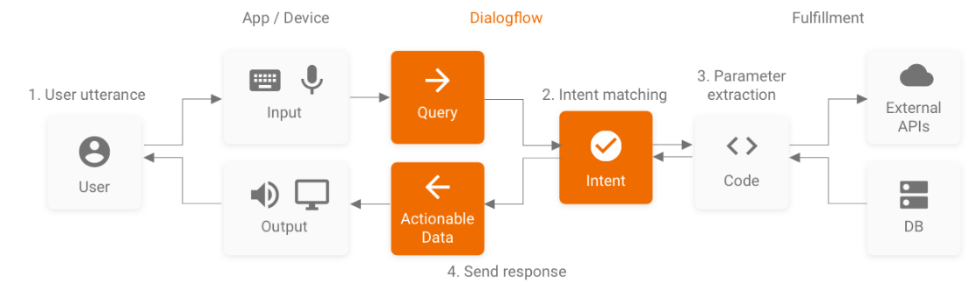
Fig 2.- Flow Chart of The System

Dialog flow: Dialog flow is a natural language understanding platform that makes it simple to develop and integrate a conversational user interface into any mobile app, web app, device, bot, IVR system, and more. You may provide people new and exciting ways to connect with your product by using Dialog flow. Dialog flow is capable of analysing a variety of consumer input, including text and audio. It can also communicate with your consumers in a variety of methods, including text and synthetic speech.
ReactJS : ReactJS is a front-end JavaScript library for creating user interfaces or UI components that is open source. React may be used as a foundation for developing single-page or mobile apps.
NodeJS: Node.js is a backend JavaScript runtime environment that runs JavaScript code outside of a web browser and is free source. Node.js allows developers to utilise JavaScript to create command-line tools and server-side scripting to generate dynamic web page content before sending the page to the user's browser.
Data cleaning: It is a process of removing noise and inconsistent data.
Data integration: In this step data from multiple sources are combined. Data selection: In this step data relevant for mining task is selected.
Data transformation: In this step data will be transformed into form that is appropriate for mining.
Data mining: In this step some intelligent methods are applied for extracting data patterns.
Pattern evaluation: In this step we concentrate upon important patterns representing knowledge based on some measure are identified.
Knowledge presentation: In this step visualization and knowledge representation techniques are used to present the mined knowledge to the user.
Data Mining Techniques Data Mining Algorithms is categorized into different which is given below:
Classification: Classification is the frequently (most commonly) applied data mining mechanism, which explains a set of preclassified examples to develop a (procedure) model that can (identifies or categories) classify the population (Dataset) of records at large.

IV-RESULTS AND DISCUSSION
Dialog flow is an amazing platform because it supports inclusion in the Assistant app as well as inclusion in over 20 social media channels such as Web Demo, Facebook, Slack, Viber, Kik, Twitter, and so on. This Chatbot is integrated into the institute's website by selecting Integrations in the left panel and generating a web demo for the current agent. [11] The following are the steps to creating a chatbot: 1st step: Analyzing the Preset Intentions Dialog flow includes basic presets including a Default Greeting Intent and a Default Fallback Intent. This is simply instructing the bot on what to do when they are greeted or when the bot seems unable to reply their query. From the drop-down menu, choose "Default Welcome Purpose." Step 2: Making a Default You can generate a new response to Welcome Purpose. When an expression is entered in the "Responses" section, the responses for MCA Department Bot are chosen at random. And custom response enables us to create a unique welcoming response for the Department bot. Step 3: Developing New Intentions We're developing an MCA Division Bot to assist users with a few answers: "How long is the MCA course?" "When do colleges begin?" "What are the class times?" We'll create Intents for all of these query forms and then initialise them with the appropriate Expressions and Responses. To create a new Intent, simply click the +' button next to the "Intents" click inside the left menu. When going to name an Intent, keep it simple and easy to remember. Step 4: Including the Response By including responses but rather expressions such as "It is a three-year course with a two-year lateral entry," "we are open Tuesday morning through Sunday from 6 a.m. to 11 p.m.," and "classes begin at 8 a.m. and end at 5 p.m." After that, set the Intent to "end of conversation" at the Training phrases. Integration is the fifth step. The following paper indicates how to incorporate the MCA Department bot: To begin, go to the "Integration" section of the left column and turn "Web Demo" On, then tap it to enter.[12]
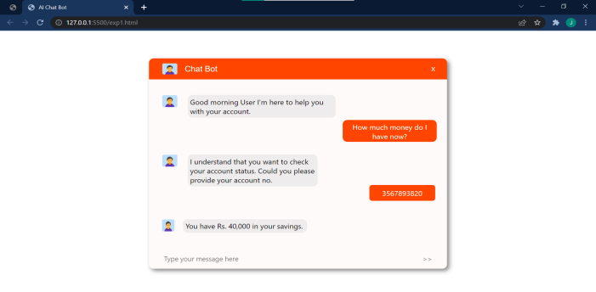
Fig 3- User Interface Ofai Chatbot

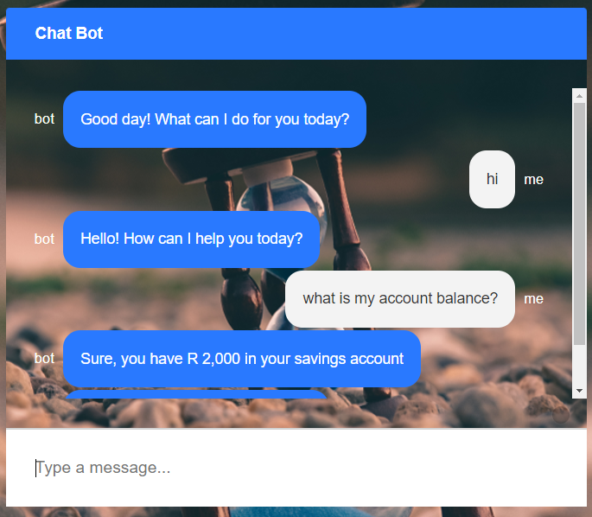
Fig 4-Output of Ai Chat Bot
- CONCLUSION

Artificial intelligence (AI) technology such as chatbots can communicate with humans in a humanlike manner thanks to conversational AI. It enables communication between humans and computers easy and natural by narrowing the gap between human and computer language. It may change a customer's experience into something genuinely transformative by utilizing advanced deep learning & natural language understanding (NLU). Employees no longer must be frustrated by rudimentary chatbot solutions that frequently fall short owing to their limited scope and capabilities. You can do more with conversational AI than merely translate website text into simple chatbot answers. Text and speech, different languages, business layer, single and various intents, and pre-trained and bespoke entities are all supported by the technology. It also connects with current systems & channels while learning from discussions in an interactive manner.

VI -FUTURE SCOPE

Other algorithms can be used instead of AIML-based bots. Voice-based searches are possible. Users will be required to provide voice input, and the system will provide written output. We may also use the chatbot once it has been successfully implemented in the collegiate domain in other domains such as medical, forensic, sports, and so on. It will be advantageous in all disciplines since we will be able to get essential information quickly and without having to sort it.

REFERENCES

- Khan, Aysha, et al. “NEEV : An Education Informational Chatbot.” International Research Journal of Engineering and Technology (IRJET), vol. 6, no. 4, 2019.
- Rahman, A. M., et al. “Programming Challenges of Chatbot: Current and Future Prospective.” 5th IEEE Region 10 Humanitarian Technology Conference 2017, R10-HTC 2017.
- Amey Tiwari, Rahul Talekar, Prof. S. M. Patil, “College Information Chatbot System”, International Journal of Engineering Research and General Science, Volume 2, Issue 2, April 2017.
- Rachit Kulkarni, Ankit Methwani, Nakul Pawar, CharmiValecha, Pooja Shetty, “College Chat-bot”, International Journal of Advanced Research in Computer Engineering & Technology, Volume 6, Issue 4, April 2017.
- Chaitrali S. Kulkarni, Amruta U. Bhavsar, Savita R. Pingale, Prof. Satish S. Kumbhar, “BANK CHATBOT - An Intelligent Assistant System Using NLP and Machine Learning”, International Research Journal of Engineering and Technology, Volume 4, Issue 5, May 2017.
- Yash Mehta, Shreya Sawkar, “The college chatbot”, International Journal of Computer Applications, Volume 173 - No. 7, September 2017.
- Prof. K. Bala, Mukesh Kumar, SayaliHulawale, Sahil Pandita, “Chat-Bot For College Management System Using A.I”, International Research Journal of Engineering and Technology, Volume 4, Issue 11, Nov 2017.
- Salvi, Sanket, V. Geetha, and S. Sowmya Kamath. “Jamura: A Conversational Smart Home Assistant Built on Telegram and Google Dialogflow.” TENCON 2019-2019 IEEE Region 10 Conference (TENCON). IEEE, pp. 1564–1571, 2019.
- S. Raj, Sumit Raj “Building Chatbots with Python Using Natural Language Processing and Machine Learning”Apress. 2018.

- Rohit Tamrakar, Niraj Wani, “Design and Development of CHATBOT: A Review”,April 2021, Conference: INTERNATIONAL CONFERENCE On “Latest Trends in Civil, Mechanical and Electrical Engineering”.
- Mondal, Anupam, et al. “Chatbot: An automated conversation system for the educational domain.” 2018 International Joint Symposium on Artificial Intelligence and Natural Language Processing (iSAI-NLP). IEEE, 2018.
- Ahmad, NahdatulAkma, et al. “Review of chatbots design techniques.” International Journal of Computer Applications, vol. 181, no. 8, 2018.

- Bala, K.; Kumar, M.; Hulawale, S.; Pandita, S. Chat-Bot for College Management System Using A.I. Int. Res. J. Eng. Technol. (IRJET) 2017.

- Ayanouz, S.; Abdelhakim, B.A.; Benhmed, M. A Smart Chatbot Architecture based NLP and Machine Learning for Health Care Assistance. In Proceedings of the 3rd International Conference on Networking, Information Systems & Security, Marrakech, Morocco, 31 March–2 April 2020.

- Kumar, R.; Ali, M.M. A Review on Chatbot Design and Implementation Techniques. Int. J. Eng. Technol. 2020, 7, 11.

- Go, E.; Sundar, S.S. Humanizing chatbots: The effects of visual, identity and conversational cues on humanness perceptions. Comput. Hum. Behav. 2019, 97, 304–316.

- Sheikh, S.; Tiwari, V.; Bansal, S. Generative model chatbot for Human Resource using Deep Learning. In Proceedings of the 2019 International Conference on Data Science and Engineering, Patna, India, 26–28 September 2019.

