IOT ENABLED PESTICIDE SPRAYER ROBOT
Manish Aagase¹ , Nandini Thakrele²
Kiran Suradkar³ , Divya Gadhave⁴
1.(Electrical Engineering ,Government College Of Engineering ,Nagpur
Email- manishagase355@gmail.com)
2(Electrical Engineering ,Government College Of Engineering ,Nagpur
Email- nandinithakarele@gmail.com)
3(Electrical Engineering ,Government College Of Engineering ,Nagpur
Email- suradkarkiran588@gmail.com )
4(Electrical Engineering ,Government College Of Engineering ,Nagpur
Email- divyagadhave3001@gmail.com)
Guide: Prof. Praful Nandankar

ABSTRACT:
aim of this paper is to create an intelligent spraying robot that will decrease pesticide use and human health damage, allowing farmers to be protected and labour intensity can be reduced. The robot will have full route planning and navigation systems, as well as driving control, spraying mechanism and system construction and obstacle avoidance with multi-sensor module integration. The spray robot will be designed, including obstacle avoidance, spraying, and sensor integration simulations and analyses. It is used not only to track motion and monitor orientation, but also to compensate for path errors in order to achieve good stability and reliability. Meanwhile, the spraying system will be improved to eliminate leaks and prevent repeated spraying, with automatic sprays varying according to the target. This project proposes a pesticide spraying system which will help farmers in field of agriculture.

INTRODUCTION

Agriculture is the primary source of revenue for India's population, which accounts for nearly 60% of the country's total. Farmers work in their fields to cultivate various crops based on the environment and resources available. Farmers must use large quantities of pesticides to increase food production in order to meet such high food demand for such a large population. Traditional manual pesticide spraying operations is full of direct exposure to the pesticide liquid work environment, great harm to human body and when this pesticide may come into contact with the farmer during spraying, which may trigger skin cancer and asthma illnesses. Increased pesticide spraying can impact consumer health as it enters the food chain. therefore created an automated robotic system that can spray pesticides in restricted quantities only if pests are discovered to solve the above-mentioned problems. Not only does this save the farmer from life-threatening illnesses and physical issues, but it also saves his cash because of restricted pesticide use. That is why it helps farmers, in turn the nation, to develop economically. The time spent spraying pesticide liquid is reduced when using this type of robot, and it will also help farmers reduce their workload in any season or condition. Surely this idea will speed up their company to achieve new heights and be more lucrative as well. Implementing our project relies mainly on farmers consciousness, which we think will be readily generated owing to its countless benefits . The proposed project's purpose is to increase farmer safety while performing crop activities such as spraying chemicals, fertilizers, and pesticides. The research projects finds its relevance in the field of Agricultural Engineering, Electrical Engineering, Electronics Engineering, Telecommunication Engineering, Mechatronics Engineering, Environmental Engineering, Biomedical Engineering, Mechanical Engineering etc. Detecting and tracking of moving objects are widely used as low-level tasks of computer vision applications, such as video surveillance, robotics, authentication systems, user interfaces by gestures, and a pre-stage of MPEG4 image compression as discussed earlier . The remaining portion of the paper is organized as Section II includes brief picture about Literature Review, Section III includes Proposed System And working of robot, Section IV includes Results about the robot, advantages and its applications in different fields. Finally, Section V and VI includes Conclusion and Future Scope that lay down the outcomes of the proposed system.

LITERATURE SURVEY

In the agricultural field, robotics is steadily increasing its productivity. Some of the major problems in the Indian agricultural are rising of input costs, accessibility of skilled labours, lack of water resources and crop monitoring. In agriculture, automation technologies with robotics were used to solve these problems. Following are some references which highlight the literature review: According to Shubhangi. B. Londhe, K. Sujata [1], robotics model provides a facility to control the movement of agriculture vehicle. Plant diseases may decrease the quality and quantity of agricultural products, resulting in a massive post-effect situation. Plantation crops face a number of challenges, including early pest detection. The first step entails keeping a close eye on plants on a regular basis. The diseased plants will then be categorised, and photographs of the affected parts of the plants will be taken with a camera. Pre-processing, transformation, and clustering are then applied to these images. The images are then presented to the processor as input, and the processor compares them. If the image provided is an affected image, an automatic pesticide sprayer is used to apply the pesticide to a specific area of the leaf. If it isn't, the processors will automatically discard it, and the robot will continue on its way. According to Wasswa Fahad Malende, K. Lokesh Krishna, Omayo Silver, K. Anuradha [2], designed a novel wireless robot is remotely controlled using necessary commands from the PC section in the receiver side. Based on the written program, Independent operations such as making the wireless robot move in the correct path whenever the robot experiences an obstacle, giving some strange sounds whenever wireless robot experiences a unknown movement nearby, spraying of pesticides and switching on the electric motor whenever there is shortage of moisture content in the crop fields. According to Jaggumantry Swapna Kumari, Kazi Khalid Abdul Karim, Mankari Hemant Tanaji, Bodhgire Yogesh Uttamrao, Momin Md. Arbi Md. Husain5 [3], designed an agriculture robot vehicle that navigates between the crops based on the farmer's joystick instructions. The transmitted instructions will be received at the receiver end, and the robot's movement will be determined. This robot will spray pesticides by detection of pests using image processing. According to Aishwarya. B. V, Archana. G, C. Umayal [4] created an agricultural robot car that navigates between the crops using a joystick and motion switches in response to the farmer's instructions. This truck has lower-cost components, making it more cost-effective. The robot navigates between the crops, provides a way to view the crops or path of the robot using wireless camera. The signal is received at the operating end and viewed using television. Thus identification of the pest affected crops is made very much possible and simple. According to Amrita Sneha. A, Abirami. E, Ankita. A, Mrs. R. Praveena, Mrs. R. Srimeena [5], an agricultural robot can be used for ploughing and seeding by classifying into two sections- robotsection and field section. The robotsection includes components for automated ploughing and seed dispensing, while the field section includes humidity measurement and control, pesticide spraying, and other tasks. According to Pvr Chaitanya, Dileep Kotte, A. Srinath, K. B. Kalyan [6], an agricultural robot, reduces farmers' general efforts while also increasing the speed and accuracy of their work. The robot has been created to improve application precision and yield. In this robot, Raspberry Pie is used as a microcontroller which controls the live video motion, spraying impact and robot movement. The robot displays 3 processes, i.e. movement of machine, uploading of video and spraying process for pesticides. For the operation of the robot and the spray unit, the operator uses the Android application. The Raspberry pi is connected to an ordinary USB web cam, which is mounted on the robot to stream live video to the operator-connected PC. Raspberry Pi is programmed with Python's programming code to identify and classify the disease in crops. According to Peng Jian-sheng [7], In this paper, designed an intelligent robot for spraying pesticides by using WiFi module, mobile devices, video capture module, the car module, driver module, spray module and infrared obstacle avoidance module. According to Ege Ozgul, Ugur Celik [8], this study proposes to automate entire process by using robot platform where it allows to avoid exposure of hazardous materials while improving the efficiency. To do so, a semi-autonomous mobile robot will spray plants and repel insects from the field, enhancing sustainable farming conditions by protecting plant and soil health. According to Pranali S. Bhoite, Nisha U. Gurav, Onkar K. Nagarkar, Reshama R. Chaudhari [9], proposed an automated sprinkling bot which serves as a helping hand to the farmers by replacing the manual farming technique with the modern farming technique. It reduces the workload of the farmers by sprinkling pesticides on the crops, scanning and capturing the images of the plants, detecting the infected plants, storing location and sprinkling the pesticides only on the infected plants. Working of this bot would depend upon the mode that farmer would be selecting. According to K Durga Sowjanya, R Sindhu, M Parijatham, K Srikanth, P Bhargav [10], proposed a system which focuses on the design, development and the fabrication of the multipurpose agricultural robot with irrigation system in addition to ploughing and seeding. The three functions of the multipurpose agricultural Robot are soil digging, seed sowing, and levelling the ground to avoid mud and waterspraying

III PRPOSESD MODEL

Pesticide spraying and fertiliser scattering are tedious applications. Despite the fact that pesticide spraying is now required, farmers still find it to be a hazardous process. This project is based on the development of an agricultural robot vehicle that navigates between crops using an Android application based on the farmer's instructions. This truck has lower-cost components, making it more cost-effective. To move the robot in the field, the farmer can use any Android smart phone with this application. Through an IoT application, farmers can control pesticide sprinkling devices. This low-cost robotic vehicle would increase efficiency, safety, and meet labour demand in agricultural appl

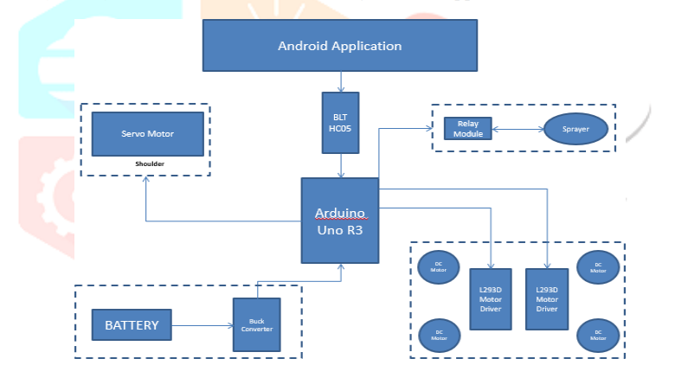
Fig 1: System Architecture

- DESCRIPTION OF PROPOSED SYSTEM COMPONENTS
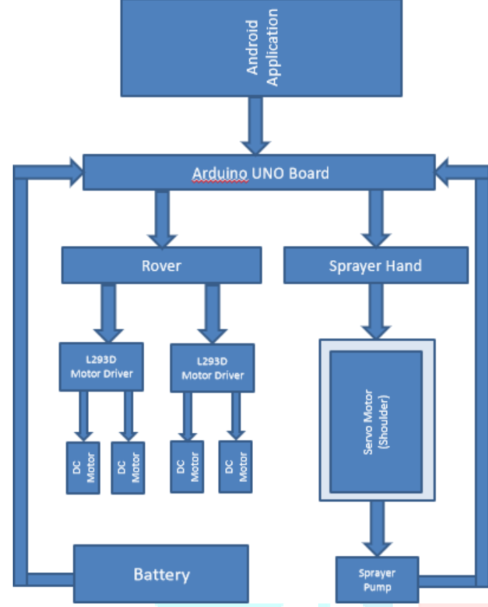
Fig 2: Block Diagram

Firstly, connect the android application with HC05 bluetooth module to control all hardware components of spraying rover. Once connect bluetooth,This can easily control spraying robot. In this robot, attached four brushless DC motors with L293D motor driver. The connection of the microcontroller, Arduino Uno, brushless DC motor through brushless motor driver and received the power supply from 12V battery. The motor drivers are able to manipulate the rotation of the motor using its phase connected to the gate driver MOSFET on its circuit. Another servo motors are also used here to control sprayer part of this rover. A servomotor is a rotary or linear actuator that can control angular or linear position, velocity, and acceleration with precision. The main purpose of this servo motors is to move the sprayer according to the users requirement. used this servo motors as shoulder part to move the sprayer accordingly. Arduino uno board receive commands from android application and works accordingly. In this system used 6V pump, the pump is connected with arduino and passes through buck convertor and relay module which helps to control high voltage pump. A relay is a switch that is regulated electrically by an electromagnet. A low voltage, such as 5 volts from a microcontroller, activates the electromagnet, which pulls a contact to make or break a high voltage circuit. Here, used 12V battery that is actually high, so to convert that high voltage DC current to low voltage DC used buck converter here. From the input to the output, a Buck converter steps down a DC voltage. The operation of the circuit is determined by the MOSFET's conduction state: On-state: The current flowing through the inductor rises, and the diode is turned off. As energy is transferred from the inductor to the capacitor, the inductor current decreases.

- WORKING OF ROBOT

Before spraying the pesticides with this robot, the farmer must follow the steps: 1) Fill the required pesticides into tank 2) Start spraying rover 3) Login with android application 4) Connect app with Bluetooth 5) Send commands using application 6) Move rover on field 7) Change direction of sprayer 8) Switch sprayer/pump on/off 9) Charge the battery The robot is installed in the farm and is operated by an Android application and is powered by IoT. DC motors are used for the robot's motion that are governed electronically by Arduino UNO with the assistance of L293D. The HC-05 Bluetooth module receives signals from the input and sends them to the controller, which in turn spins the engine. By obtaining the signal, DC motors are switched ON and OFF by allowing Arduino to have a specific pin. An adequate velocity is provided by 300rpm DC motors. Bluetooth module connects to the digital key of Arduino UNO, which receives the signal installed on the operator's Smartphone from the Android app. Pesticide spraying, which can be done with the assistance of a pesticide sprinkling pump, can be done on a regular basis if the relay switch is turned on. The agricultural robot is used to control functions such as pesticide spraying, and it is controlled using a Bluetooth module that communicates between an Android application and the robot for a low cost.

IV. RESULTS AND DISCUSSION

This agriculture vehicle proves to be an effective and efficient machine which can be easily navigated and controlled. The robot can traverse a variety of terrains and soils. The android application is used to control the robot's movement as well as spray pesticides. As a result, the robot's control is simple, and farmers can easily operate this intelligent vehicle. The application was build by using MIT app Inventor. This robot focuses on farmers spraying pesticides from a distance without coming into direct contact with them. Because the task's complexity is reduced and the manned task is converted to an unmanned task, this feature would encourage more people to take up agriculture
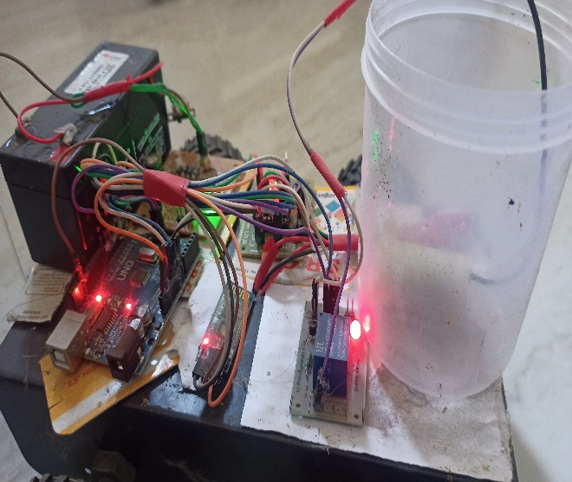
Fig.3: IOT ENABLE PESTICIDE SPRAYER ROBOT

- ADVANTAGES
• Reducing direct exposure to pesticides and the human body and improve production efficiency. • They can operate with closer tolerances
• They produce fewer errors and at higher speeds, and the machines can reliably detect higher-quality goods.
• The robots can reduce up to 30% of farm’s use of pesticide
• Robots have the potential to create jobs for those who must build and repair them.
- APPLICATIONS
• Used in farms and fields
• Hardware industries and business units use it. • Used for gardening.
• Maintain public properties and parks.
• Spray paint can also be used in the automobile industry.
• Provides Agricultural security.

V. CONCLUSION
In this project, A robot for use in agriculture An Agrobot is a concept for improving the product's performance and cost, which, once optimised, would show to be useful in agricultural spraying operations. Farmers' workloads are reduced, as are health issues. Successfully constructed a robot that can travel on rough surfaces as well as carry a sufficient load of compressor and other equipment. Successful in creating a robot with a strong enough structure to resist the field's challenges. Sure, once this idea is presented in a way that is appropriate for the Indian market, it will undoubtedly aid in lowering the 15% molality rate found in Indian formers associated with agriculturalspraying operations. Projects like this inspire people to pursue agriculture as a full-time or part-time occupation. This is critical in developed countries, particularly India, where agriculture is the economic backbone.
VI. FUTURE SCOPE
• This type of robot has a bright future because it is very useful in agriculture and reduces workload.
• It saves time and money by reducing the amount of pesticide liquid that needs to be sprayed.
• It will assist farmers in working in any season and under any conditions.
• It would lessen the risk of various breathing and physical problems for farmers.
• It can be built to grab and analyze data of the farming field and to do pre-defined tasks autonomously.
• Additional use of renewable resources, such as wind energy, will also help reduce the need for more batteries.
• Usage of voice controlled navigation for robotic movements can be used. • Modern technologies such as AI and machine learning can be integrated into IoT-based smart agriculture systems to improve their performance.
• AI-based autonomous robots can be designed specifically for agricultural purposes.
• ML can be used in video analysis to observe the conditions of crops, such as analysing the condition of a leaf to see if it has been attacked by pests and then instructing the system to take the appropriate action.
VII. REFERENCES
[1] Shubhangi B. Londhe, K. Sujata, “Remotely Operated Pesticide Sprayer Robot in Agricultural Field,” International Journal of Computer Applications(0975 – 8887), Vol 167, No. 3,June 2017. [2] K.Lokesh Krishna, K. Anuradha, “Internet of Things Application for Smart Agriculture System Implementation,” I-SMAC (Internet of Things in Social, Mobile, Analytics, and Cloud) International Conference (I-SMAC2017).
[3] Kazi Khalid Abdul Karim, Mankari Hemant Tanaji, Bodhgire Yogesh Uttamrao, Md. Momin, Md. Arbi, Md. Husain, “Agriculture Robotic Vehicles based Pesticide Sprayer,” IJSRD - International Journal for Scientific Research and Development, Vol. 6, Issue 03, 2018.
4] Aishwarya. B. V, Archana G., C. Umayal, 2015 IEEE International Conference on Technological Innovations in ICT for Agriculture and Rural Development, “Agriculture Robotic Vehicle Based Pesticide Sprayer” (TIAR 2015).
[5] Amrita Sneha. A, Abirami. E, Ankita. A, Mrs.R.Praveena, Mrs. R. Srimeena, 2015 IEEE International Conference on Technological Innovations in ICT for Agriculture and Rural Development, “Agricultural Robot for Automatic Ploughing and Seeding” (TIAR 2015).
[6] Pvr Chaitanya, Dileep Kotte, A. Srinath, K. B. Kalyan, “Development of a Smart Pesticide Spraying Robot,” Volume 8, Issue 5, January 2020, ISSN: 2277-3878, InternationalJournal of Recent Technology and Engineering (IJRTE).
[7] Peng Jian-sheng, “Intelligent Robot System for Spraying Pesticides”, The Open Electrical & Electronic Engineering Journal, 2014, 8, 435-444.
[8] Ege Ozgul, Ugur Celik, “Design and implementation of Semi-Automonous Anti-Pesticide Spraying and Insect Repellent Mobile Robot for Agricultural Applications”, 2018 5th International Conference on Electrical and Electronics Engineering. [9] Pranali .S. Bhoite, Nisha .U. Gurav, Onkar .K. Nagarkar, Reshama .R. Chaudhari, “Smart Automated Pesticide Sprinkling Bot”, Proceedings of the Third International Conference on Trends in Electronics and Informatics (ICOEI 2019) IEEE Xplore Part Number: CFP19J32-ART; ISBN: 978-1-5386-9439-8.

