Utility Grid Interfaced Solar Water Pumping System Using PMSM Drive

¹Prof.Umesh G. Bonde, ²Prof.Aishwarya R.Thengre, ³Pallavi P.Nannewar, ¹ HOD ,² Assistant Prof, ³Student Of Department Of Electrical Engineering MTECH (EPS) Shri Sai College Of Engineering &

Technology Bhadrawati-244904

pnannewar04@gmail.com

Abstract— This work presents a solar photovoltaic (PV) array fed grid interfaced, encoder-less, permanent magnet synchronous motor (PMSM) based solar water pumping (SWP) system. This system mitigates the intermittency issues associated with the solar PV energy. In the presence of grid, the SWP system provides an uninterrupted water flow irrespective of available solar insolation. In condition of grid failure, the output water flow is a function of available solar insolation. A boost converter is used on the grid side to facilitate power transfer from the grid and enabling the unity power factor (UPF) operation using unit vector template (UVT) theory. The speed of the PMSM, is regulated using sensor-less vector control. A double second order generalized integrator quadrature signal generator (DSOGI- QSG) is used for extracting the fundamental signal from the distorted grid voltage. Performance of the proposed system is validated using a laboratory developed prototype under varying solar insolation, during grid failure, during voltage sag, voltage swell and distorted grid voltage conditions.
Keywords— SWP; PMSM; Sensor-less vector control; Utility grid; Power quality.

- INTRODUCTION
Rising energy concerns have motivated the researchers to search for alternate energy solutions for reducing the utilization of conventional energy sources. Recently various applications have been identified where renewable energy sources (RES) can replace the use of conventional energy sources. Water pumping is one of the potential areas utilizing large amount of fossil fuels and therefore, the utilization of RES for this application would reduce the emission of greenhouse gases and reduce the carbon foot print [1]. Due to its modular structure, declining installation cost, and zero operating cost, solar photovoltaic (PV) based power generation is gaining wider acceptability [2].
Although solar PV integrated water pumping system (WPS) presents a feasible solution, however, intermittent nature of solar energy limits its use for active hours only i.e. when solar insolation is available. For an effective utilization of WPS, this drawback needs to be resolved. Some of the solutions to this problem, are connecting the battery energy storage at the DC link, use of pump storage and fuel cell as a storage medium. However, these solutions also have their flaws such as increased system complexity, cost and space requirement [3-6]. As the grid is an infinite source of energy, some of the existing
work suggests the integration of utility grid to SWP system [7- 9]. An integration to utility grid enhances the system utilization and improves the system reliability. Although some the existing literature focusses on power factor correction, however, none of the existing work focuses on problems associated with the weak grid. As most of the water pumps are located at the radial end of the utility grid, these systems are exposed to various power quality (PQ) problems such as voltage sag, voltage swell, grid current distortion and grid voltage distortion. For the proper operation of SWP system, these issues need to be resolved. This work aims at mitigation of some of the above mentioned issues for proper operation of WPS.
The salient features of presented work, are highlighted as follows.
- The solar water pumping system is integrated to the single phase utility grid to facilitate an uninterrupted water pumping independent of available solar insolation.
- A double second order generalized integrator quadrature signal generator (DSOGI-QSG) control structure is implemented for filtering the distorted grid voltage and to extract its fundamental component.
- The PQ issues such as voltage sag, voltage swell, grid current distortion and grid voltage distortion, are mitigated so that the presented system follows the IEEE standard for PQ in grid connected system.
- To improve the system reliability and to reduce the system cost, a sensor-less vector control technique is implemented for controlling the speed of the PMSM.
- A UVT technique is implemented for facilitating the power transfer from the grid and maintaining UPF at grid terminals.

- SYSTEM ARCHITECTURE AND CONTROL
The system configuration of grid integrated SWP system using PMSM drive is shown in Fig. 1. This system comprises of a solar PV array, a boost converter for maximum power point tracking (MPPT), a voltage source inverter to drive the motor, another boost converter for power factor correction (PFC) and a PMSM coupled to a pump. The speed of the PMSM is regulated using sensor-less vector control technique.

978-1-5386-9316-2/18/$31.00 ©2018 IEEE

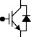
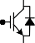
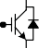
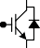
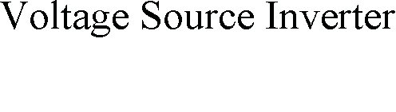
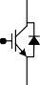
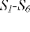
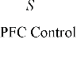
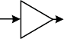
v_{s}
Fig. 1 System Configuration
ω
c₁
c₂

∫
∫
∫
∫

Fig. 3 Structure of DSOGI-QSG
v _{f}

qv_{f}

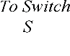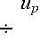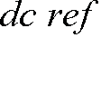

Fig. 4 PFC control for power flow from single phase utility grid

An incremental conductance (INC) algorithm is utilized for MPPT through change in duty ratio of switch S_{b} [10]. The grid is feeding the DC link using PFC converter. The UPF is maintained at AC mains through proper switching of switch S_{pfc}. A RC filter (R_{f}, C_{f}) and an interfacing inductor (L_{f}) are used for removing switching harmonics and current ripples, respectively. The behavior of the WPS is validated under different operating conditions, through experimental investigation on proposed system developed in the laboratory.

- SYSTEM CONTROL
The control of proposed WPS is divided into three parts. First one is MPPT control using INC MPPT algorithm. Second one is speed control of PMSM using sensor-less vector control technique as shown in Fig. 2. A back electromotive force (EMF) based technique is used for speed and position estimation. Third one is power flow control from utility grid. This is achieved using unit vector template (UVT) technique.
For proper operation even during distorted grid voltage conditions, first the grid voltage is filtered using DSOGI-QSG as shown in Fig. 3. The DSOGI-QSG removes the harmonic component and DC offset.
The transfer function for DSOGI-QSG is written as,
current. The sensed and reference currents are compared for generating the gating pulses for S_{pfc}.

- HARDWARE VALIDATION
The presented system is validated using a laboratory prototype and test results are obtained under change in insolation during standalone and grid tied modes. The proposed system is also tested under abnormal grid conditions and test results are discussed here. The solar PV array, PMSM and grid parameters utilized for experimentation, are listed in Appendices.

- Starting and Steady State Performance
Figs. 5 (a-c) and Figs. 6 (a-c) depict the starting and steady state performance of proposed WPS. A smooth starting is observed during starting in both grid tied as well as in standalone mode. A sinusoidal current is drawn by the PMSM steady state operation at rated speed. An excellent MPPT of 99.73% is observed when the PV array is operating at STC (1000W/m2, 250C). The pump draws a sinusoidal current from the grid at UPF, while being fed from the grid which can be visualized from Fig. 6 (d).
- Performance During Insolation Change

DDSOGI
= v _{f} (s) =
v_{s} (s)
c₁c₂ω 2 s²

(s² + c₂ωs + ω 2 )(s² + ω 2 ) + c₁c₂ω 2 s²
(1)
The performance of WPS for insolation change during standalone and grid connected mode are shown in Figs. 7 (a-b) and Figs. 8 (a-d) respectively. Since there is no availability of

QDSOGI
= qv_{f} (s) =
v_{s} (s)
c₁c₂ω3 s
(s² + c₂ωs + ω 2 )(s² + ω 2 ) + c₁c₂ω2 s²
(2)
auxiliary power source during standalone operation, the pump

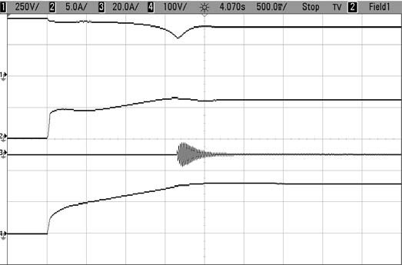
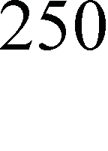
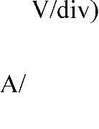
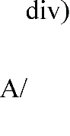
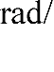
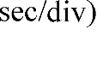
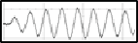
The filtered voltage is divided with the peak voltage for the generation of unit template. The unit template is multiplied with the voltage regulator output for the generation of reference

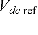
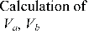
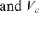
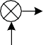
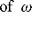
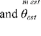
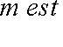
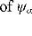
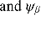
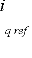
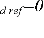
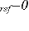
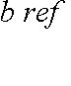
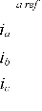
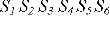
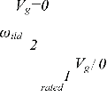
Fig. 2 Sensor-less field oriented control scheme of PMSM
(a)

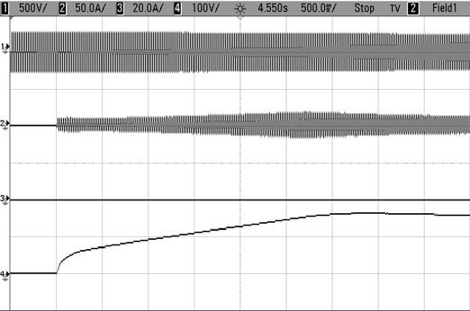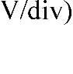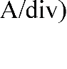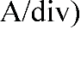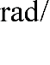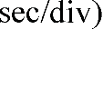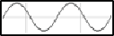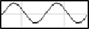
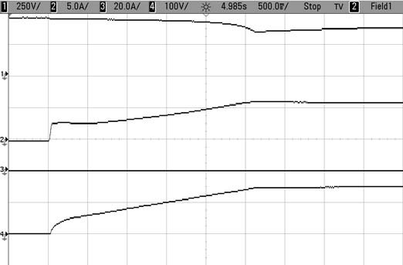
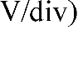
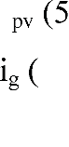
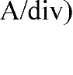
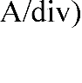
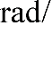
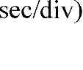
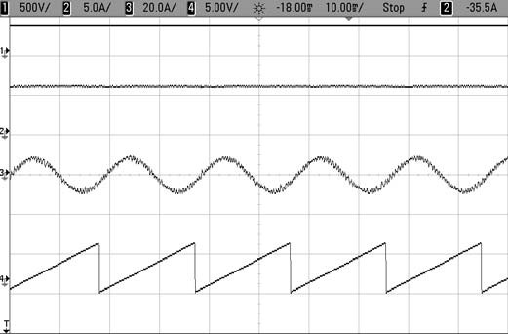
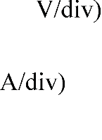
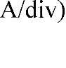
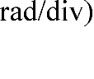
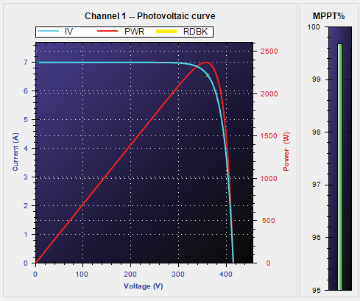
(b)
(b)

(c)
Fig. 5 Starting behavior of SWP system when (a) Solar insolation is 1000W/m2 and grid is available, (b) Solar insolation is 0W/m2 and grid is available and (c) Solar insolation is 1000W/m2 and grid is not available
speed reduces for variation in solar insolation from 1000W/m2 to 500W/m2 and vice versa. During grid tied mode, the speed of pump remains unperturbed with the change in insolation. As the solar insolation reduces from1000W/m2 to 500W/m2, the remaining power necessary to run the PMSM at full speed is provided by the utility grid. During night, when the solar PV energy
(c)

(a)

(d)
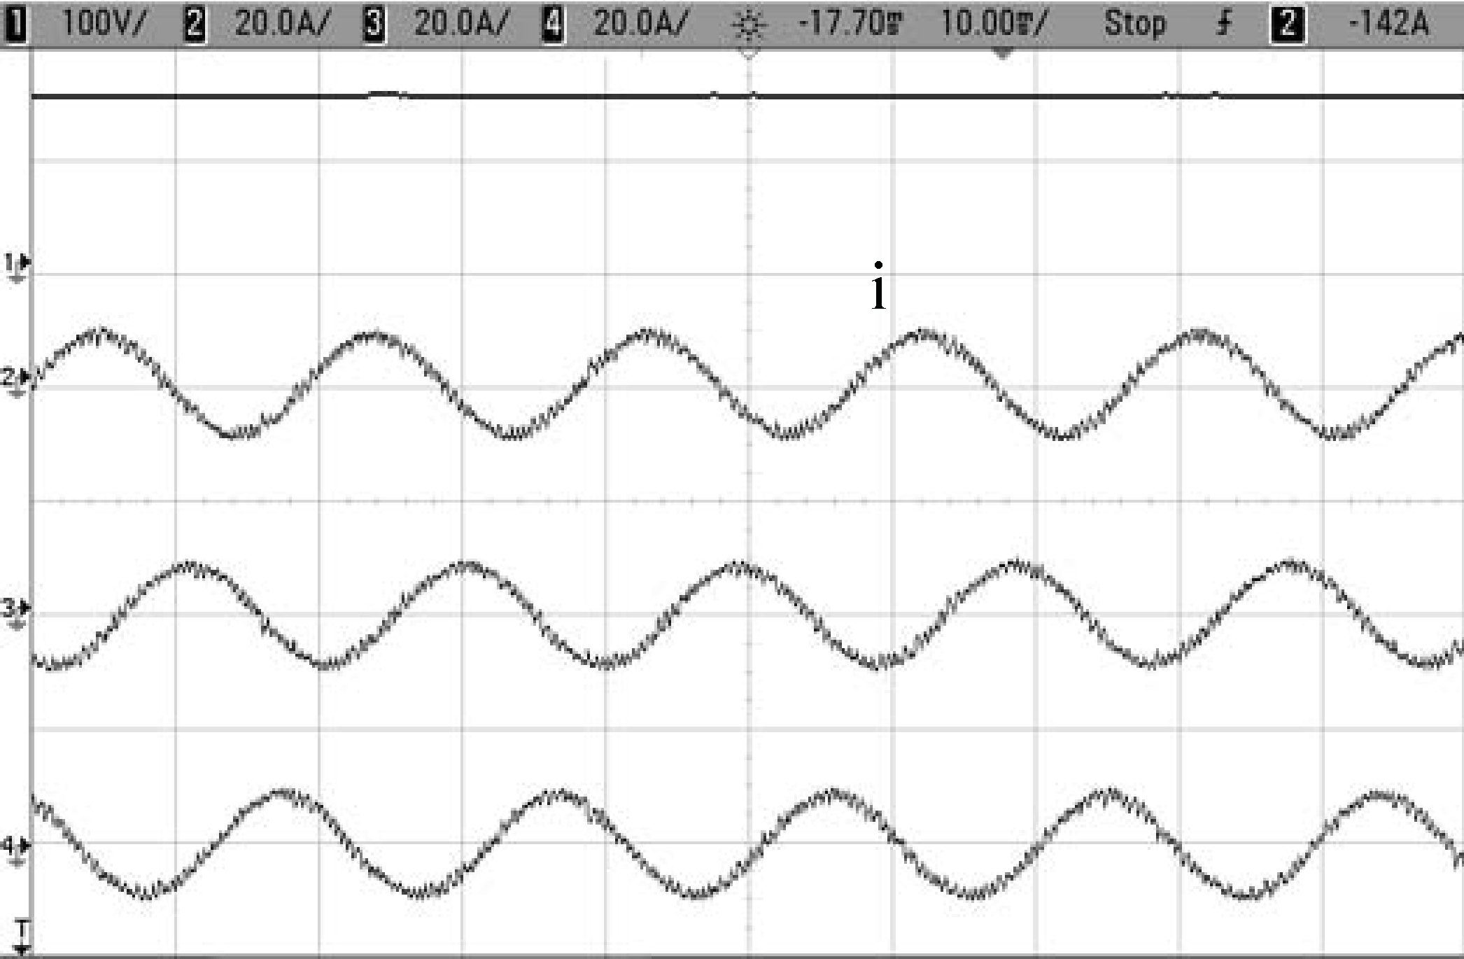
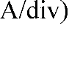
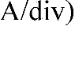
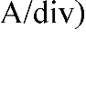
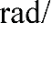
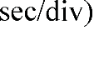
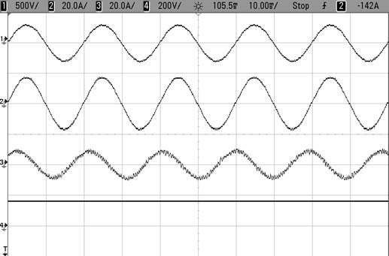
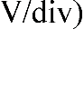
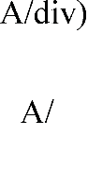
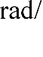
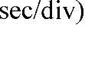
Fig. 6 Steady state performance when (a) Pump is running at rated speed. (b) PV alone is feeding the pump (c) MPPT performance at 1000 W/m2 (d) Grid alone is feeding the pump
is not available, the utility grid drives the pump. This improves the utilization efficiency of the proposed system. Therefore, it can be visualized that the pump speed changes with change in insolation during standalone mode, whereas, it remains constant during the grid connected mode.
- Performance During Abnormal Grid Conditions
In Figs. 9 (a-c), a satisfactory system performance is shown during voltage sag, voltage swell and distorted grid voltage

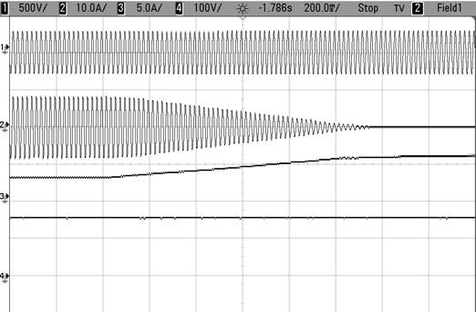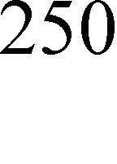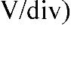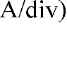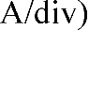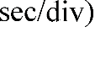
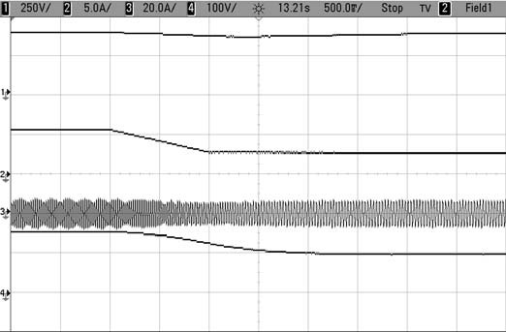
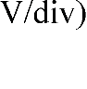
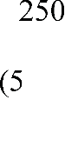
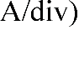
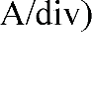
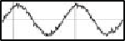
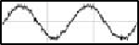
(a) (b)
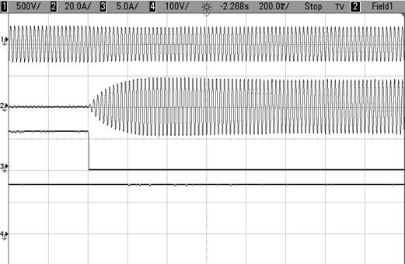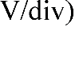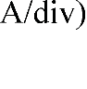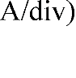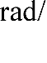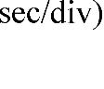

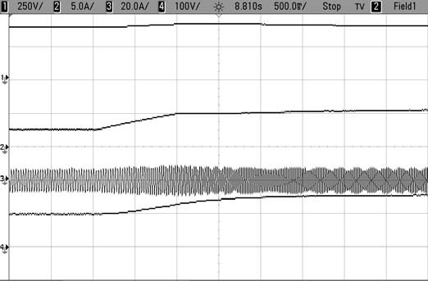
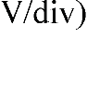
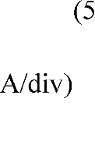
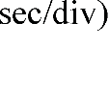
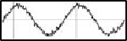
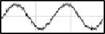
(b)
Fig. 7 Dynamic performance of SWP system during standalone operation when (a) Solar insolation changes from 1000W/m2 to 500W/m2 and (b) Vice- versa
condition. The pump runs at the rated speed even during voltage sag condition. As the voltage reduces, the large current is drawn from the grid to maintain the power required by the pump. The WPS performs vice versa for the grid voltage swell.
The DSOGI-QSG extracts fundamental component from the distorted grid voltage. As the unit template is generated using the filtered voltage template, the reference grid current remains sinusoidal, thereby drawing sinusoidal grid current.
(c)

(a)

(d)
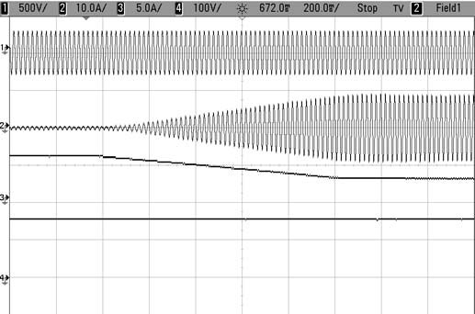
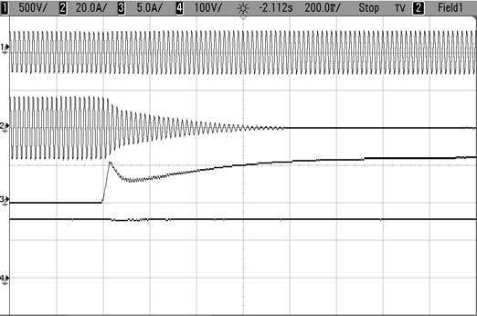
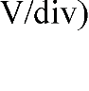
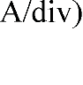
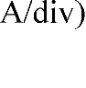
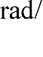
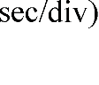
Fig. 8 Dynamic performance of SWP system during grid connected operation when (a) Solar insolation changes from 1000W/m2 to 500W/m2, (b) Solar insolation changes from to 500W/m2 to 1000W/m2, (c) Solar insolation changes from 1000W/m2 to 0W/m2 and (d) Solar insolation changes from 0W/m2 to 1000W/m2
v_{s} (500 V/div)

i_{g} (10 A/div)
I_{pv} (5 A/div)
m_{m} _{est} (100 rad/sec/div)
the grid.
The power quality performance of SWP system, is shown in Figs. 10 (a-d). It can be visualized that the grid current total harmonic distortion (THD) remains below 5% under all conditions. The grid current THD is found to be 2.7 % even when the grid voltage THD is 8.1%.

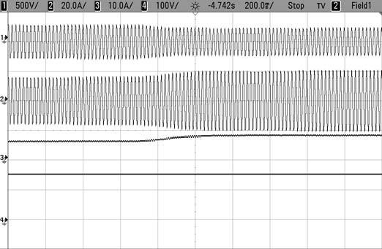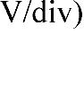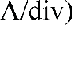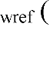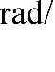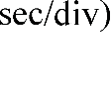
(a)

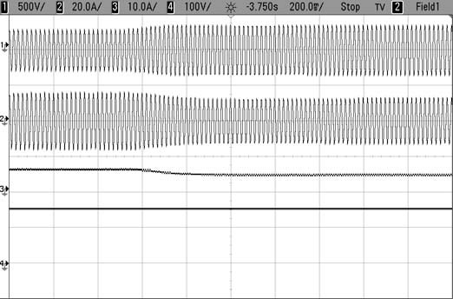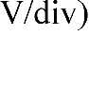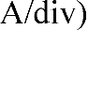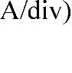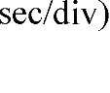
(b)

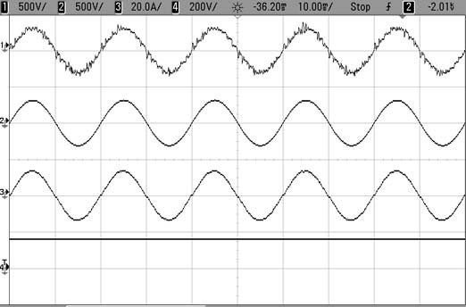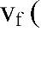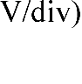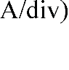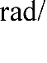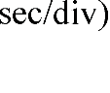
(c)
Fig. 9 Performance of SWP system during (a) Grid voltage sag (b) Grid voltage swell (c) Distorted grid voltage condition

- CONCLUSION
A solar PV array fed grid integrated SWP system has been proposed and its behavior is analyzed under various operating conditions through the developed laboratory prototype. The grid integration has improved the WPS reliability. The pump is fully utilized regardless of varying weather conditions. The INC based MPPT algorithm has effectively extracted the maximum power from the solar PV array. The UVT control
scheme has performed satisfactorily to expedite power flow from the grid. The boost PFC converter maintains UPF at the grid terminals. Moreover, the grid indices obey the criteria imposed for PQ performance as per the IEEE-519 and the IEEE-1564 standards [11]. The use of DSOGI-QSG removes the distortion in grid current and keeps it within the specified limits, even if the grid voltage is distorted. The WPS performs satisfactorily even under grid anomalies such as grid voltage sag, grid voltage swell and grid voltage distortion. The elimination of speed sensor reduces the overall system cost. Therefore, this WPS offers a feasible solution for a reliable solar water pumping.

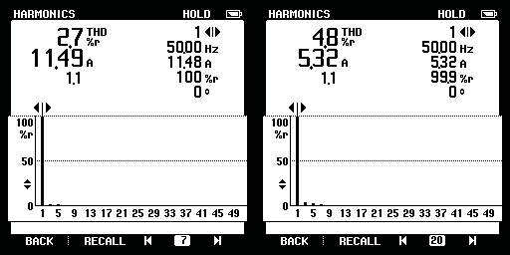
(a) (b)

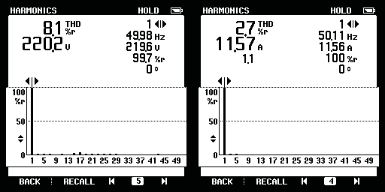
(c) (d)
Fig. 10 Harmonic spectra when (a) Grid alone is feeding the pump (c) Grid and PV at 500 W/m2 feeding the pump and grid feeds the required remaining power (c-d) Grid feeding the pump while grid voltage is distorted
APPENDICES
Solar PV Array: V_{oc}=415V, V_{mp}=357.39V, I_{sc}=7.0A, I_{mp}=6.636A
PMSM Parameters: 2200W, 3-phase, 230V, 4 pole, R_{s}=0.8 fi, L_{s}=4.6 mH, N_{r}=1500 rpm, K_{e}= 216.8 V_{p}/krpm
Grid Parameters: 1-phase, 230V, 50Hz

ACKNOWLEDGMENT
The authors are thankful to Govt. of India, for funding JC Bose project (RP03128) and DST project (RP03222) for financially supporting this work.

REFERENCES
- M. A. Elgendy, B. Zahawi and D. J. Atkinson, “Assessment of Perturb and Observe MPPT Algorithm Implementation Techniques for PV Pumping Applications,” IEEE Trans. Sust. Energy, vol. 3, no. 1, pp. 21- 33, Jan. 2012.

- S. Jain, R. Karampuri and V. T. Somasekhar, “An integrated control algorithm for a single-stage PV pumping system using an open-end winding induction motor,” IEEE Trans. Ind. Elect., vol. 63, no. 2, pp. 956-965, 2016.
- A. Khiareddine, C. Ben Salah and M. F. Mimouni, “Strategy of energy control in PVP/battery water pumping system,” Proc. International Conference on Green Energy, Sfax, 2014, pp. 49-54.
- P. García, C. A. García, L. M. Fernández, F. Llorens and F. Jurado, “ANFIS-based control of a grid-connected hybrid system integrating renewable energies, hydrogen and batteries,” IEEE Trans. Ind. Info., vol. 10, no. 2, pp. 1107-1117, May 2014.
- I. Ducar and C. Marinescu, “Increasing the efficiency of motor-pump systems using a vector controlled drive for PMSM application,” International Symposium on Fundamentals of Electrical Engineering (ISFEE), Bucharest, 2014, pp. 1-5.
- A. B. C. S. B. Slama and A. Chrif, “Efficient design of a hybrid (pv-fc) water pumping system with separate mppt control algorithm,” lJCSNS
International Journal of Computer Science and Network Security, vol.12, pp. 53-60, January 2012.
- R. Kumar and B. Singh, “Grid interfaced solar PV based water pumping using brushless DC motor drive,” IEEE International Conference on Power Electronics, Drives and Energy Systems (PEDES), Trivandrum, 2016, pp. 1-6.
- R. Kumar and B. Singh, “Brushless DC motor-driven grid-interfaced solar water pumping system,” IET Power Electronics, vol. 11, no. 12, pp. 1875-1885, Oct. 2018.
- B. Singh and S. Murshid, “A Grid-Interactive Permanent-Magnet Synchronous Motor-Driven Solar Water-Pumping System,” IEEE Trans. Ind. Appl., vol. 54, no. 5, pp. 5549-5561, Sept.-Oct. 2018.
- T. Esram and P. L. Chapman, “Comparison of Photovoltaic Array Maximum Power Point Tracking Techniques”, IEEE Trans. Energy Conv., vol. 22, no. 2, pp. 439-449, June 2007.
- IEEE Recommended Practices and Requirements for Harmonic Control in Electrical Power Systems, IEEE Standard 519, 1992.

