Non-Newtonian Fluid Speed Breaker

Prof. Pooja J. Chavhan¹ (M-Tech)
Runal Pawar², Shruti Donode³ , Rehan Pathan⁵, Himanshu Damahe⁶ ,
¹Asst. Professors, Dept. of Civil Engineering, M.I.E.T. SHAHAPUR, BHANDARA, INDIA 441906
^{2,3,4,5,6}B.E. Department of Civil Engineering, M.I.E.T. Shahapur, Bhandara, India

Abstract-This technical paper relates to a device that reduces the speed of any over speeding vehicles travelling on a roadway. It is formed by a flexible material which consist of non Newtonian fluid in it i.e. each receptacle is impregnated with a dilatants shear-thickening fluid. The material is placed under compression during impact when the vehicle strikes it and the fluid itself acts as means for controlling the resistance to deformation of the strip. Thus, if the vehicle travels at a low speed the fluid has a low viscosity and the strip is easily deformed, whereas if the speed of the vehicle is high the viscosity of the fluid is high and as a result has great resistance to deformation, thus forming a rigid obstacle to the passage of the vehicle. Drivers must always slow down when driving over the conventional speed breakers to prevent damage to their vehicle. However, the Non Newtonian fluid Speed Breaker is sensitive to the speed of the vehicle. The vehicle needs to slow down only if it is over speeding.

Keywords— Speed Control, Shear Thickening,
Thixotropic Fluid, Liquid Breaker, Speed Breaker.
I. INTRODUCTION
A conventional speed breaker usually consists of a concrete or asphalt breaker formed in the road. They are made to be driven over at a preset comfortable speed, while causing exceeding discomfort at higher speeds. Drivers must slow down when driving over these speed breakers to prevent damage to their vehicle. However, even if travelling at the posted speed limit or below, these conventional speed breakers can take a toll on a vehicle's mechanical components, such as the shock absorbers and steering system. This paper relates to a traffic control device sensitive to the speed of a vehicle. The ideal situation is that if the vehicle travels at a very low speed, the stiffness of the obstacle reduces to facilitate the vehicles passage without any bounce or jump. However if the vehicle exceeds the advisable minimum speed the obstacle stiffness increases and the vehicle encounters a considerable jump. This speed control device will also allow emergency vehicles to traverse speed breakers without having to reduce their speed which in turn will reduce their response time to emergencies.

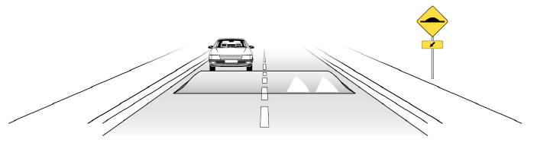
1.1 BASICS OF SPEED BREAKERS
A speed breaker is a hump surface across the pavement having a rounded shape with width greater than the wheel base of most of the vehicles using road. The various types of speed breakers are:
a) Speed bump

Speed bumps are the instruments that use the raised deflection on the road to slow down the moving traffic. They are capable to reduce speeds of the vehicles to around 40 kmph for roads and/or 8 to 16 kmph for car parking. They are normally 1 to 3 feet long and 7 to 15 cm high. The speed bumps reduce speed broadly, avoid accidents and reduce severity of crash. However the provision of bumps may creates significant discomfort to drivers as well as passengers, increased damage to the vehicle, increases response time of emergency services, it requires additional road markings and traffic signs and it increase in traffic noise and pollution.
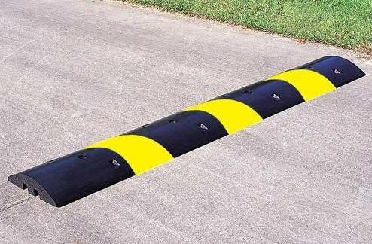
Fig: Speed bump

b) Speed hump
The speed humps are circular, raised areas placed over the roads. They are normally 10 to 14 feet in length in the direction of travel and is 7 to 10 cm high thus making them dissimilar from the speed bumps. The profile of a speed hump can be rounded, parabolic or sinusoidal. They are tapered as they reach the kerb on each end to permit proper drainage. Speed humps are fit where low speeds are desired. Speed humps create a rough ride for drivers as well as passengers and can cause severe pain for people. They enforce large vehicles, such as emergency vehicles and those with rigid suspensions, to travel at slower speeds, they may increase noise and air pollution and have questionable aesthetics.
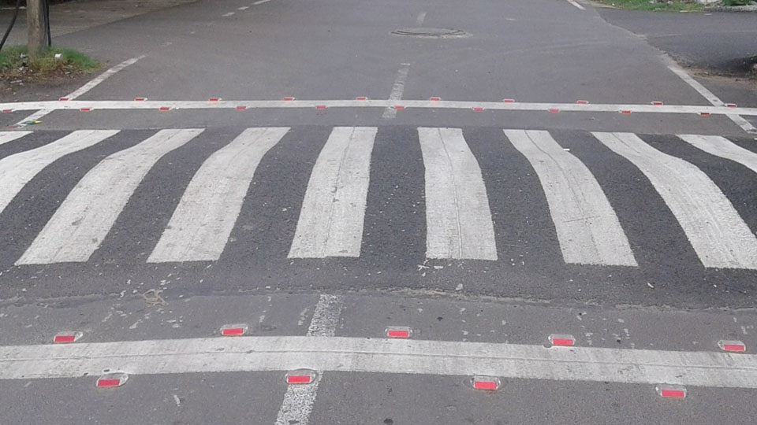Fig: Speed hump
1.2 Speed Breaker Parameters

Speed breakers can be completely described using several geometric and layout design parameters. Length, height, profile and width are the geometric design parameters. The layout design parameters are speed breaker spacing and type of materials, marking and sign location.

Profile
The effects of speed breaker profile, particularly the impacts of varying the slopes of the entry and exit ramps, have not been examined as thoroughly as length or height. Research is ongoing to determine the optimal ramp slopes for various speed bump designs, particularly trapezoidal breakers. Circular breakers as having the best dynamic characteristics at higher speeds.

Length
Length is the most significant speed breaker geometric design parameter. Effective breakers should be as long as an automobile wheelbase to isolate the impacts of entering and exiting the breakers for these vehicles. Longer speed breakers should be used if heavier vehicles are expected. In general, longer breakers exhibit better characteristics for speed reduction. Longer breakers may be even better suited for heavy loaded vehicles, although upper limits have not been dynamically demonstrate.

Width
Speed breakers can either span the entire width of a road or taper short of the curb or road edge. The advantage of the closing approach in an urban setting is that drainage at the curb and gutter is not affected, and installations are therefore less expensive. Drivers can attempt to exploit reduced widths and maneuvers around breakers unless preventative measures are taken.
Height
Speed breaker heights can affect the magnitudes of vertical accelerations and the maximum levels of perceived discomfort. High breakers, may cause damage to vehicle undermanage as they exit the measures. Low breakers can be ineffective. Heights range from 50 to 120 mm, with the most common being 75 or 100 mm.

Spacing
High breaker crossing speeds can lead to high speeds between breakers, as can large distances between them. Since an objective of traffic calming is to reduce vehicle speeds over entire streets, the layout design or spacing of speed breakers is a key factor to be considered. Previous research from several countries suggests that to achieve overall speeds of 25 to 30 km/h, speed breakers should be placed between 40 and 60 meters apart. Maximum spacing, up to 100 meters, can be used for speeds of 50 km/h. Breakers spacing can be increased with the presence of additional traffic calming measures.

Materials, Marking and Sign location
Speed breakers with all speed reducing measures should be highly visible to warn drivers to lower speeds and avoid vehicle damage or loss of control. This critically eliminates the potential for any legal liability on the part of the public road authority. Most countries have developed special signs and markings for their speed breaker installations, and pre-warnings, design speed signs, contrasting materials and protective bollards are usually employed.

II. PROBLEMS WITH CONVENTIONAL SPEED BREAKERS

Conventional devices are known to help slow down the
speed of traffic in selected areas. For example, conventional speed breakers or rumble strips are used in
such places as school zones, parking lots, construction
zones, hospital zones and similar areas where it is desired to control or reduce the speed of vehicles for the safety of pedestrians. A conventional speed breaker usually consists of a concrete or asphalt breaker formed in the road. Drivers must slow down when driving over these speed breakers to prevent damage to their vehicle. However, even if travelling at the posted speed limit or below, these conventional speed breakers can take a toll on a vehicle's mechanical components. The conventional speed breakers are very heavy and, once in place, are typically permanent fixtures on the roadway. In order to remove a conventional speed breaker, the speed breaker must be broken up and the roadway repaired where the speed breaker used to be. Another major problem associated with such speed breakers is that they often cause spinal damage or aggravate chronic backache due to the constant shocks suffered while traversing the speed breakers. Additional criticism of speed breakers includes their effect on emergency vehicles. Response time is slowed by 3–5 seconds per breaker for fire trucks and fire engines and up to 10 seconds for ambulances with patients on board. Also there is an increase in traffic noise from braking and acceleration of vehicles on streets with speed breakers, particularly from buses and trucks. They end up increasing noise levels where they are implemented. Therefore, it would be advantageous to provide a traffic control device that reduces or eliminates at least some of the problems associated with conventional speed breakers. The “Non Newtonian Fluid Speed Breaker” aims to overcome all these short comings of the conventional speed control devices.

III. LITERATURE REVIEW

1) Catherine Berthod, Engineer and Urban Planner Minister Des Transports du Québec Annual Conference of the Transportation Association of Canadian Edmonton, Alberta
To answer to this need, the ministered des Transports du Québec prepare a series of fact sheets on a variety of traffic calming measures including: speed humps and speed cushions, raised crosswalks and intersections, neck downs (curb extensions at intersections),the reduction of the width of streets, centre islands and chicanes. A general fact sheet presents all of the measures and notably outlines the procedure for pre implementation analysis. The presentation will present the first two published fact sheets: the general fact sheet and the fact sheet on speed breakers and speed cushions. Speed control is a important factor in road safety. It is for this reason that the ministered hopes to support municipal initiatives related to the use of traffic calming measures. By issuing these fact sheets, stakeholders will have easy access to pertinent information as well as concrete examples to help them design the solution best suited to every situation.

2) The influence of speed bumps heights to the decrease of the vehicle speed, Belgrade experience Boris Antić, Dalibor Pešić, Milan Vujanić .Krsto Lipovac
In the residential zones where a large number of pedestrians and other vulnerable road users are expected, like school zones, it is necessary to decrease the speed to such a level that the risk of susceptibility is the lowest possible. One of the commonly accepted and often implemented speed decrease measures is vertical rising of the road pavement (speed bumps, speed humps, etc.). This work shows the affects of speed bumps of different heights (3, 5 and 7 cm) to the decrease of vehicle speed. Speed measurements had been done before speed breakers were installed, 1 day and 1 month after the installation. Applying ANOVA analysis and post hoc analysis, using Turkey–Kramer’s multiple comparison test, a comparison was made of mean, 50th percentile and 85th percentile speed, before and after speed bumps setting. It has been shown that there is a eloquent speed decrease on the places where speed bumps were set, compared to the period before setting. Based on the research results, it was suggested that on the locations where susceptible road users are extremely endangered, speed bumps 5 and 7 cm high should be set, whereas at less endangered locations speed breakers 3 cm high could be set. Also, it has been shown that the effects of speed breakers on speed decrease are enduring, because there has not been any significant deviation in vehicle speeds neither 1 day nor 1 month after speed breakers setting.

IV. MATERIALS

A. Polyethylene Glycol
Polyethylene glycol (PEG) is a polymer deduce from ethylene oxide is a beneficial component for acquiring solid dispersions due to their physicochemical properties. They are also responsible for biocompatibility; odorless characteristics; neutrality; nonirritating; and solubility in many organic solvents and in water, providing a quick release of the dispersed drug, and facilitating the process of obtaining by the solvent method PEG has a low melting point, quick solidification rate, capacity to form solid solutions, low cost and low toxicity and is therefore mostly used as vehicle for the anticipation of dispersions.

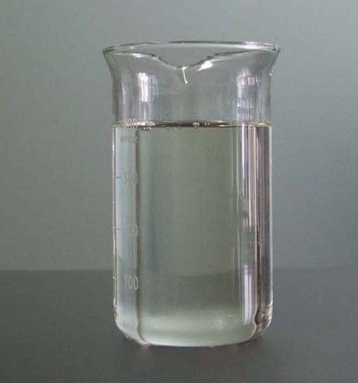
Fig :- Polyethylene Glycol

B. Silica Dioxide
SiO₂ Nano particles, also known as silica Nano particles or Nano silica, are used due to their stability, low toxicity and ability to be functionalized with a range of molecules and polymers. Nano-silica particles are separated into P-type and S-type according to their structure. The P-type particles are characterized by numerous Nano pores having a pore rate of 0.61 ml/g. The S-type particles have a relatively smaller surface area.
Chemical Formula SiO₂
Appearance Amorphous Powder
Molar Mass 60.08 g/mol
Density 2.196 g/cm³

Fig :- Silica Nano Powder

C. Corn Starch

Corn starch or maize starch is the starch deduce from the corn (maize) grain. The starch is derived from the endosperm of the kernel.

Chemical Formula C₂₇H₄₈O₂₀
Appearance Amorphous White Powder
Molecular Weight 692.661g/mol
Density 1.5 g/cm³

Fig :- Corn Starch
D. Reinforced Rubber Layer Pipe

The hose lining is rubber, which is reinforced with multiple layers of spirally applied high tensile steel or fabric reinforcing cords, to provide pressure and external load resistance. At least one helical steel wire is then applied outside of the main reinforcement and this wire is totally embedded within a rubber matrix. The hose carcass is completed with further fabric reinforcement and a rubber cover.

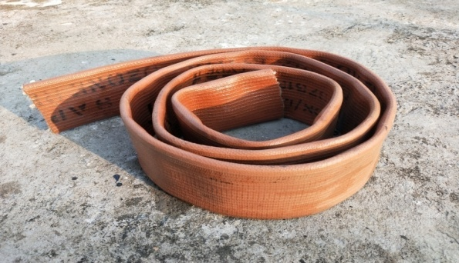
Fig:- RRL Pipe

E. Carbon Rubber Matting

Recycled rubber used in this breaker. The thickness of rubber matting is 3 mm.

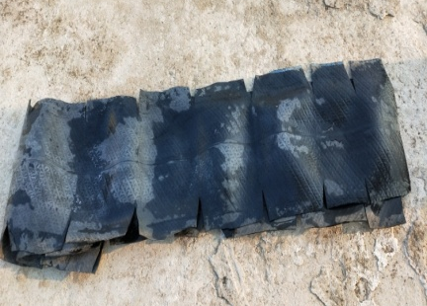
Fig:- Rubber Matting

V. DESIGN AND IMPLEMENTATION

Speed Breaker – Body and Containing Fluid
The speed breaker containing an outer cover and a bottom plate. The bottom plate having more than one fastening holes. The non Newtonian fluid speed breaker can be either permanently or temporarily placed to a roadway with bolts, screws. The cover can be formed of reinforced rubber material and covering material is nylon fabric. The cover encloses with Non Newtonian fluid, which reversibly hardens or stiffens in response to an applied pressure and goes back to its original form when the pressure is relieved. The reinforced rubber layer pipe is in the form of elongated, hollow, flexible tubes having closed ends. The tubes are made up of reinforced rubber layer material. The flexible tubes i.e. reinforced rubber layer pipe are filled with a non- Newtonian fluid .If the vehicle travels at a low speed, fluid is moved and breaker is deformed, depression of the strip occurs in the area in which the wheels pass over, forming a small obstacle to the passage of the vehicle. However, if the vehicle is beyond the speed limit then the fluid has no time to displace and a considerably smaller depression occurs. Hence the non Newtonian fluid include in RRL pipe forms a step with greater height, causing the vehicle to jump, warning the driver about his excess speed. The fluids used to fill the reinforced rubber layer pipe are non-Newtonian fluids. A non-Newtonian fluid is a fluid the viscosity of which varies with the pressure gradient applied. A non Newtonian fluid which does not obey the Newton law of viscosity. As a result, a non- Newtonian fluid does not have a defined and constant viscosity value, like a Newtonian fluid. The Non Newtonian fluid acts like a fluid below a critical shear rate but above the critical shear rate, the material acts like a solid.

Fig: Shear thickening fluid graph

The non-Newtonian fluid acts as controlling the resistance by the strip to its deformation. It depends on the speed of the wheels of the vehicle on it. Thus, if the vehicle travels at a low speed (within speed limit) the fluid has a low viscosity and the strip is easily deformed, whereas if the speed of the vehicle is high (Beyond the speed limit) the viscosity of the fluid is high and as a result has great resistance to deformation, thus forming a rigid obstacle to the passage of the vehicle. Thus the speed of the vehicle is controlled due to the combined effect of non-Newtonian fluids.
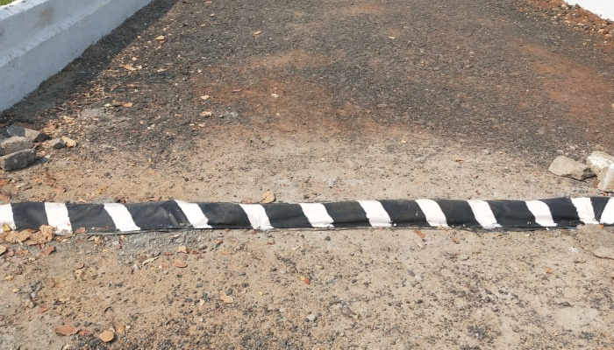Fig: Non – Newtonian fluid speed breaker
Reflector
Reflectors are placed on the road leading to the speed breaker. The safety reflector is meant for pedestrians, motorized and non-motorized vehicles. It aids visibility of a person or vehicle, as it reflects light from headlights of vehicles .The reflector is manufactured in the form of a moulded tile of transparent plastic. The outside surface is plane, allowing light, such as from a car's headlights, to enter. Due to the aspect of the other inside surfaces, any light internally reflecting is directed back out the front of the reflector in the direction it came from. This alerts the person close to the light source, in this case, the driver of the vehicle, to the presence of the speed breaker.

VI. WORKING OF BREAKER

The Non Newtonian fluid speed breaker can be either permanently or temporarily placed at a desired location, such as in street or roadway. The material in the reinforced rubber layer tubes can be selected based on a desired shear rate. The shear rate selected will correspond to predetermined vehicle speed. The non-Newtonian fluid acts as controlling the resistance by the strip to its deformation. It depends on the speed of the wheels of the vehicle on it. Thus, if the vehicle travels at a low speed (within speed limit) the fluid has a low viscosity and the strip is easily deformed, whereas if the speed of the vehicle is high (Beyond the speed limit) the viscosity of the fluid is high and as a result has great resistance to deformation, thus forming a rigid obstacle to the passage of the vehicle.
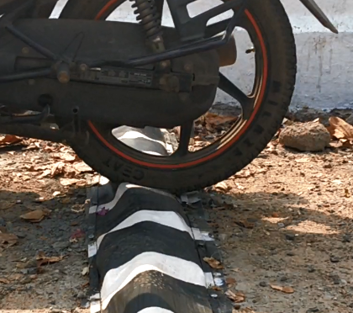
Fig : Deformation of breaker

When the vehicle has passed over the breaker, the breaker returns to its original shape. Thus, below the speed limit, little impact is felt by the driver. Therefore, if the vehicle is traveling under the selected speed limit which will provide a shear rate less than the critical shear rate however, in the event a vehicle impacts the speed breaker at a speed above the predetermined speed that is, providing a shear rate above the critical shear rate, the viscosity of the non Newtonian fluid increases. The fluid material acts as a solid and the speed breaker substantially retains the speed breaker shape. The speed breaker in this scenario acts similarly to a conventional speed breaker and the driver of the vehicle exceeding the selected speed limit will experience a breaker or jerk as would be felt with a conventional speed breaker.

VII. COMPARISION BETWEEN CONVETIONAL SPEED BREAKER AND NON- NEWTONIAN FLUID SPEED BREAKER

Characteristics Of Breaker | Conventional  Speed Breaker | Non-Newtonian Fluid Speed Breaker
Nature | Permanent | Mobile
Sensitivity | Not Sensitive To Speed Of Vehicle | Sensitive
Speed Restriction | Slow- Every Condition | Slow – Only When It Over Speeding
Fuel Efficiency Of Vehicle | Decrease | Not Affected
Toll On Mechanical Components Of Vehicle | Yes | No
Installation Method Requirement | Technical Skilled Labour | No Technical Skilled Labour
Installation Cost | High | Low
Maintenance Cost | High | Low
Medical Problem Arise | Spinal Damage Or Aggravate Chronic Backache | Not Damaged
Traffic Noise Pollution | Increase | Decrease
Response Time Of Emergency Vehicle | Slow Down (3-10sec /Breaker) | Does Not Affect

VIII. RESULT AND CONCLUSION

- The Non -Newtonian fluid speed breaker help in increasing the fuel efficiency of vehicles up to a large extent.
- Vehicles need not come to a complete halt in from of speed breaker, reducing traffic congestion.
- The installation cost and maintenance cost of non Newtonian fluid speed breaker is comparatively low as compare to conventional speed breaker.
- It does not damage on a vehicle's mechanical components, such as the shock absorbers and steering system if the vehicle is following the speed limit.
- The setup is completely mobile and can be installed within an hour. The installation process does not require technically skilled person.
- It helps in reducing traffic noises.

IX. FUTURE SCOPE

- Economical.
- Suitable at parking of malls, toll booths, signals etc.
- Liquid breaker used in France and Germany.
- Reduce air and noise pollution.
- Increase fuel efficiency in some extent.
- Low maintenance cost.
- Response time of emergency vehicle not affected.

REFERENCES

- L. R. Kadiyali, Traffic Engineering and Transport Planning, 2015, pp 456.
- Rahul Bagchi, “Traffic calming measures”, International Journal of Chemical, Environment and Biological Sciences (IJCEBS), Volume 1, 2013.
- IRC: 99 – 1988, “Tentative Guidelines On The Provision Of Speed Breakers For Control Of Vehicular Speeds On Minor Roads”,.
- Roger W. Louson, “The Objections to Speed Humps”, Published by the Bromley Borough Roads Action Group , October 2003.
- K. Subramanya , Tata McGraw-Hill Education ,Hydraulic Machines
- ITE. "Traffic Calming Measures – Speed Hump”. Institute of Transportation Engineers.
- Sahoo P. K., "Geometric Design of Speed Control Breakers," International Journal of Advanced Technology , 2009.
- Ponnaluri Raj V, And Groce Paul W., “Operational Effectiveness of Speed Bumps in Traffic Calming,” It Journal, July 2005.
- Zaidel D., Hakkert A.S., And Pistiner A.H., "The Use Of Road Breakers For Moderating Speeds On Urban Streets.," Accident Analysis And Prevention, Vol. 24
- Ashish Gupta [2014]; Study on Speed Profile across Speed Bumps Department of Civil Engineering; National Institute of Technology Rourkela.
- Himmat S. Chadda, M. ASCE and Seward E. Cross, “Speed (Road) Breakers: Issues”, Journal of Transportation Engineering, July 1985.
- M C Gameiro da Silva, “Measurement of comfort in vehicles”, Article in Measurement Science and Technology, April 2002.
- Philip A. Weber, Towards a Canadian Standard for the Geometric Design of Speed Breakers, Dept. of CivilEngg., Carleton University, Ottawa, , April, 1998

