Design and Optimization Of On-Board

Weighing System
Shubham Krushnaji Zod¹,Nitin Sawarkar², Swapnil Choudhary³, Dr.Bharat Chede⁴

¹M-Tech Student, ²Assistant Professor, Head of Department
Mechanical Engineering, Wainganga college of Engineering and management, Nagpur

Shubhamzod8@gmail.com

Received on: 20 May, 2022 Revised on: 21 May, 2022, Published on: __ May,2022

Abstract – Today we have stepped into the 21st century and our science and technology should be abreast with the fast growing world. New development sin sensing technologies have emerged in response to the ever-increasing demand for solutions of specific Monitoring applications. They have produced fast, more sensitive, and more precise Measuring devices. The advancements in technology have made life simpler and easier. The problems in the conventional designs have led to new and exciting innovations. The onboard weighing systems have revolutionized the method of payload measurement. The equipment is designed to indicate the payload of a truck at any instant of time .Load on the present automobiles on Indian roads is measured in a weigh bridge. When considering which type of weighing machine to use for our own particular operation, it is important to take into account.
On Board Weighing System can weigh loads directly from truck being loaded. The data management unit has built-in software that records each load weight and directly transmits it to your Computer. Even before starting the journey, our On Board Weighing System simply and quickly records the vehicle weight, including trailers or semitrailers, without needing a stationary scale. Other functions mean efficiency can be raised far beyond compliance with legal requirements. We offer the ideal single-source solution for al vehicle and fleet types.
Our On Board Weighing System (OBWS) helps drivers. It demands more frequent weighing of commercial vehicles. It quickly and easily notes the vehicle weight, with trailers or semitrailers, without stationary scales. Fleet operators and drivers will already know that it is safe before the truck starts. Vehicles are loaded more safely, efficiently and economically as the fleet manager sees the data before starting the journey which reduces empty journeys. The data provided also enables anticipatory maintenance and is a basis for new business models, including load-dependent transport tariffs.

- INTRODUCTION

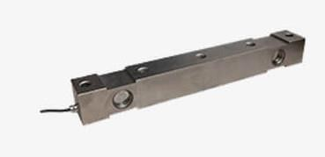
In most of the automobiles at present the dashboard consist of speedometer, odometer, temperature indicator, ammeter, pressure indicator and fuel gages. There isno provision to indicate the load on the vehicle. The load on the vehicle is measured ina weighbridge. The project, Development of Onboard Weighing System Using Sensorin Static Truck found success in solving this problem. In this project the load in the vehicle is sensed and displayed in the LCD. In this project the strain gauge used as sensing element.

Four-strain gauges are bonded on to the chassis at four differentplaces. Two-strain gauges are bonded on to the front side to sense the front-end load.Two-strain gauges are bonded on the rear side to sense the rear-end load. The wheat stonebridge is well suited for the measurement of small changes of a resistance. The straingauge change electrical resistance when it is slightly deformed by deflection of chassis.This deformation produces voltage signal that is proportional to the load. The signal isthen used as a measure of weight.

The output range of strain gauge is in the order ofvery few millivolts. In order to process that succeeding section it should be of voltage range. To make it we need an amplifier section where the input is in the order ofmillivolts and the output is in volts. The amplified analog signal is converted into digital signal wherefore processing transmission and storage purposes it is often convenient to express these variables in digital form. The amplified signal is processedin the microcontroller. By testing and experimental results look up table is formed. Fora particular value of voltage there is a particular value of weight is displayed on the LCD in tonnes.

Double ended shear beam load cells The simple, compact design and rugged hermetically sealed construction of the load cell assures long life. The technologically advanced tension link mounting arrangement ensures high load cell

Accuracy & reliability to weight measurement and smooth performance of the load cell.

Fig 1- Double ended shear beam load cell

- REVIEW OF LITERATURE

Types of onboard Scales - Stress-tek,Inc.is the manufacturer of Vulcan On-Board scales. These scales have been installed on over 20000 vehicles. This design and manufacture solutions for spring, air, and mixed spring/air suspensions. Their sensors provide a broad range of options to fit a wide variety of tractors and trailer configuration across multiple industries.Stress-tex load cells do not have moving parts, and use bonded foil strain gauges as the sensing
element.Typically, four gauges are used in a wheat stone bridge configuration. The strain gauges change electrical resistance when the cell is slightly deformed by load. This deformation produces voltage signal that is proportional to the load. The signal is then used as a measure of weight, force or deflection. This valuable information can then be used to improve the efficiency and safety of operation. PRECISIONLOADSTM kits are simple to install, typically
requiring between 8 and 20 man-hours per truck, including wiring. Several mounting design options are available from Precision Loads, and the system selected will depend on the type of equipment and the intended use of the scale system, i.e. payload maximization or split load/delivery. LoadMan® offers Onboard weighing solutions for both Wheel Loaders and forklifts. For front/bucket loaders, our system consists of a hydraulic pressure sensor, Arm Inclinometer, load-coder converting the analog signal to a pure digital signal, and our extremely functional cab-mounted display meter, allowing you to determine loads dynamically, or on the fly to accuracy over 99%. LoadMan® offers a simple low cost onboard weighing solution for Forklift Trucks. The system consists of a hydraulic pressure sensor, a Load Coder to convert the analog signal to a pure digital signal, and a cab-mounted
display meter. LoadMan measures the high pressure in the hydraulic lines to determine the load on the forks. A 2 wire digital signal is transmitted to the in cab meter makes the pressure measurement immune to moisture.
The LoadMan Meter provides an Accumulate Key to accumulate individual loads to an accumulator that is re settable thru the front panel. An RS232 Printer option is available. Massload.com In a portable system, the computer, and weight sensors are the portable part. A portable system is able to be set up in under 10 minutes, and can be used on any flat, hard, and
level surface. This type of system can be used to weigh vehicles where a pem1anent installation is not feasible, or where the system needs to be moved frequently to different locations. Superior Technologies The Air-Weigh scale system converts air pressure in the tractor and trailer air suspensions into a very accurate, on-the-ground weight. The more weight on the vehicle, the more air pressure required to maintain ride-height. Texmate installed a tiger 320 series Di-50E meter with a permanently cOill1ected serial printer and two remote push button switches. The meter is connected to the weighbridge, calibrated to read in the appropriate engineering units and programmed for the remote tare function with all non application codes blanked out. The output from the weighbridge load cells is fed to the meters input signal conditioner. The meter is programmed to tare the weight of the empty truck on the weighbridge before weighing the truck and its payload. The truck and its payload are then weighed providing a payload weight
only. Salter Brecknell Route mass on board weighing system. The system consist of load cells, bearing plates signal transmitter, and 9100LDmeter.It includes six load cells that are designed to be mounted between a truck body and frame in order to sense payload weight. The load cells are connected to the transmitter, which converts the low level analog signal from the load cells to a more robust digital signal. The transmitter is then connected to the meter with a simple two-wire cable that provides both power and signal. It is clear from above literature that many commercial onboard weighing setupsis incorporated in the trucks. This project aims to develop on board weighing system for Indian trucks where payload indicator is not incorporated in the vehicle.

- EXPERIMENTAL SETUP

The principle of strain gauge helped to develop an idea of bonding the strain gauge in the chassis of the truck to
measure the chassis deflection for the various loads. The strain gauge is bonded on the maximum deflecting point of
the chassis and the output from the strain gauge is measured.

Truck details –
The capacity of the truck is =13500 kgs
The istance between the two wheel is = 4150 mm
The total length of the chasis is =7300mm

The load was considered as a point load because the load of the truck was supported on the 4 points of wooden cross members. By using the Macaulays method the deflection of the beam is calculated for bonding the strain gauge at the maximum deflecting area.

Procedures of General Purpose Tape-Assisted Installation Method

The tape-assisted installation method is the most popular method to install wire type tin gauges. Its procedures can be summarized as follows.

Cleaning surface:

Grease and oil on the specimen surface has to be removed by solvent, e.g, Alcohol ,Acetone, or some other degreasing agent.
Abrading surface: Silicon-carbide paper is used to sand away uneven surface, paint, or rust and smooth the gaging area .Usually 320 grit first, follow by 400 or finer grit. Do not over abrade
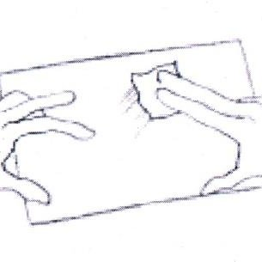
Fig 2 - Surface Abrading

Marking Layout lines: Clean rule and a fine pencil(2H or harder) or ball point pen is used to draw the layout lines, Usually a dash-cross, a cross skip the targeting strain gauge area, for alignment.
Conditioning: Re clean the gauging area.
Neutralizing: This is an optional step. A proper neutralizer will provide the right PH level at the specimen surface for better bonding with adhesive.E.g.Ammonia
Hands were washed with soap and water. Clean the working desk area and all related tools with solvent or degreasing agent.

Preparing gauge:

The folder containing the gauge is carefully opened. Tweezers is used, to grasp the gauge. Avoid touching the grid.

Transferring Gauge:

Proper length(15cm),of cellophane tape is used to pick up the strain gauge and transfer it to the gauging area of the specimen. Align the gauge with the layout lines. Press one end of the tape to the specimen, then smoothly and gently apply the whole tape and gauge into position.

Applying Catalyst:

Lift one end of the tape such that gauge does not contact the gauging area and the bonding site is
exposed. Apply catalyst evenly and gently on the gauge.

Applying Adhesive:

Enough adhesive is applied to provide sufficient coverage under the gauge for proper adhesion. Place the tape and the guage back tospeciman smoothly
“sufficient’ might require some trial and error iterations).Place the tape and the gauge back to the specimen smoothly
and gently. Immediately place thumb over the gauge and apply firm and steady pressure on the gauge for at least one minute.E.g.Anabond

Protective Coatings:

Protective Coatings are mainly used to protect the strain gauge against moisture and other contaminants, which may affect gauge stability. They are recommended for applications in the field and for long term measurements.

Applying Coating:

Apply silicon rubber, polyurethane, or acrylic lacquer to the gaging area. If further protection is needed, PTFE film and neoprene rubber sheets can be used to cover both gauges and nearby lead wires.

CAD MODEL

Wheatstone bridge Circuit:-

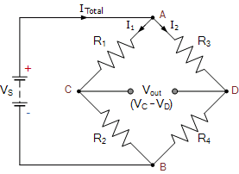
Fig 3 - Wheatstone bridge Circuit

R1=124ohms R2=124ohms R3=124ohms Rg=124ohms
Vin=5 Volts DC Input
Vout=Output
The basic principle of wheat stone bridge is
V1=R1/R2+R2*Vs
V4=R4/R3+R4*Vs
V1=124/124+124*5
V1=2.5v V4=2.5v
Vo=V1-V4=2.5-2.5=0v
V0=0Volts
Hence the bridge is balanced.

Block Diagram

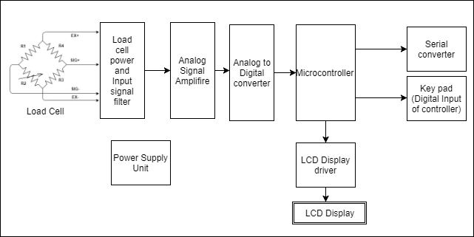

In this Project several mounting options were tried to develop the weighing system in the static truck. The strain gauge method of weighing helped to develop the weighing system. The stain gauge undergoes change in electrical resistance when it is deformed by load. This deformation produces a voltage signal that is proportional to the load. This analog voltage signal is converted into a digital signal for processing in the IT controller and displayed in the LCD

IV. RESULT AND DISCUSSION

Macaulays method

In Macaulays methods a single equation is formed for all loadings on a beam, the equation is constructed in such a way that the constants of integration apply to all portions of the beam. This method is also called method of singularity. This is a convenient method for determining the deflection of a beam subjected to point loads or in general discontinuous loads.

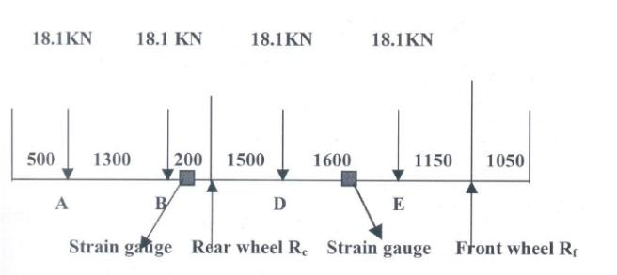
Fig 4- Load Distribution in Truck Chasis

From the above forces the deflection at mid point of A,B,D,E was calculate maximum Deflection in the chassis
Taking moment about Rf
18.1 (5.75) + 18.1 (4.45) + 18.1 (2.75) + 18.1 (1. 15) =Rc *4.25 Rc=60N
Taking moment about Rc
Rf( 4.25)-18.1 (3.1 )-18.1 (1.5)+ 18.1 (.2)+ 18.1 (1.5)=0
Rf =12.35Mx= EId2y/dx2= -18.1 (x-0.5)-18.1 (x-1.8) +59.94(x-2)-18.1 (x-3.5) -18.1 (x-5.1) + 12.35(x- 6.25)
EI(dy/dx) = -9.05(x-0.5)2-9.05(x-l.8)2+29.94(x-2)2-9.05(x-3.5)2 -9.05(x-5.1)2+6.175(x-6.25)2
Ely = -3.02(x-0.5)3+C1x+C2-3.02(x-l.8)3+ 10(x-2)3-3.02(x-3.5)3
-3.02(x-5.1)3+2.06(x-6.25)3
When x=2, y=0
0=-3.375(3.02) +C1 (2)+C2-3.02(8* 10-3)
2C1+C2=10.22 ------- (i)
When x=6.25, y=0
0=-3.02(190.10) +C1 (6.25) +C2-3.02(88.12) + 10(76.76)-3.02(20.8)-3.02(1.52)
0=-146.872-6.25C1+C2
6.25C1 –C2=-146.872 -------- (ii)
Solving both the equation (i) &(ii)
C1=-16.56
C2=43.35
Equation for deflection will now be
EIy = -3.02(x-0.5)3-16.56C1X+43.35-3.02(x-1.8)3+ 10(x-2)3
-3 .02(x-3.5)3-3 .02(x -5.1)3+ 2.06(x -6.25)3
moment of Inertia (I) of the section passing through the neutral axis
I=bh3/12
I=(0.06)(017)3/12
I=2.456/105m4

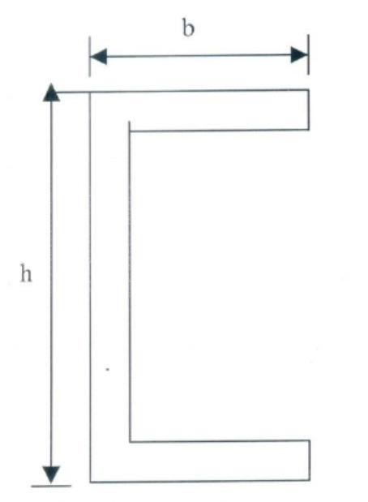
Fig 5 - section of chasis

when x=1150mm
Ely = -.08294-19.044+43.35+.83-6.414+39.19+ 186.12-273.26
Ely = -30.0574
y = -5.828mm (downwards).
when x=1900mm
Ely = -8.287-31.464+43.350-3.02* 1 0-3 -.01 + 12.37+98.96-169.57
Ely = -54.65
y=-10.6mm (downwards)
when x=2750mm
Ely = -118.09mm
y = -22.9mm (downwards).
when x=4300mm
Ely = -134.37mm
y =-26.05mm (downwards).
when x=5700mm
Ely = -181.44mm
y = -35.18mm (downwards)
Hence these strain gauges 1 & 3 were placed in the right side of the frame and at the distance of 1900mm and 4300mm
from the rear side. The strain gauge 2 & 4 were placed in the left side of the frame and at the distance of 1900mm and
4300mm from the rear side.

Cost analysis –
Truck oener per month cost for 6 wheelers for 20 tonne = 100 * 30 = Rs. 3000

Truck owner per year cost for 6 wheelers for 20 tonne= 3000*12 =36000

On an average a truck owner goes to weighbridge at least 100 times in a month. He spends Rs. 30 for weighing once with the load. So for weighing he spends Rs. 36000 per year.

V. CONCLUSION

- The Project "Development of on board weighing system in a static truck" is designed for use in all vehicles.
- The payload indicator is a low cost device suitable for Indian condition. It serves as an easy means of indicating the load on the vehicle.
- It benefits the driver of the vehicle and adjusts himself to various traffic conditions to prevent accidents.
- The resolution of the displayed data can be varied by simple software routine.
- The payload indicator is designed in such a way that facilities available at present can be expanded

VI.SCOPE OF FURTHER WORK

An EPROM may be employed in the circuit to make this project a load indicator as well as recorder. The Wheatstone bridge can be constructed using four strain gages two for sensing the compression and another two for sensing the tension the same point.
Strain gauge has to be bonded in many places for better sensing of load and for accurate measurement.

REFERENCES

[1]Experience with an On-board Weighing System Solution for Heavy Vehicles

[2]Vehicle Weight Limitations—Interstate System, 23 U.S. Code § 127, 2012,obtainedfrom:https://www.gpo.gov/fdsys/pkg/USCODE-2011-title23/html/USCODE-2011-title23-chap1-sec127.htm,lastaccessedDecember29,2015

[3]Lee, C.E. and Garner, J.E. Collection and Analysis of Augmented Weigh-in-Motion (WIM) Data, Research Report Number 987-8, Center for TransportationResearch,The UniversityofTexasatAustin,Austin,TX,1996.

[4]Moses, F. “Weigh-In-Motion System Using Instrumented Bridges,” Journal ofTransportationEngineering,105,233–249,1979.

[5]Francis S. Buckingham and Franklinville N. J.(1955) Weighing apparatus for lifting equipment.USPatent 2-822-095. Available online at http://www.freepatentsonline.com/, Accessed on 3 March 2011.

[6]William M. Wise, Detroit, Mich (1951),Load weighing system for lift trucks and the like. US Patent 2-643-781. Available online at http://www.freepatentsonline.com/, Accessed on 3 March 2011.

[7]Statweigh India Pvt. Ltd. (2004) commercialized on-board Weighing System for wheel Loaders and on-board dumper weighing system (GUARD–53Available online at http://www.freepatentsonline.com/, Accessed on 3 March 2011.
[8]Anonymous (2002), Weighing applications. Omega Engineering.Available online athttp://www.omega.com/literature/transactions/volume3/weigh.htmlAc cessed on 3 March 2011.

[9]GoranRadoičić, MiomirJovanović, MiodragArsić, ETRI JournalVolume 38, Issue 4, First published: 01 August 2016.

[10]R.Thanigaivelan,Muthayammal Engineering College,”Development of on BoardWeighing System Using Sensor in Static Truck”, April 2007 Conference:MULTICON ,At:RASIPURAM.Volume:1\

[11]https://www.essaedig.com/onboard-weighing-system.php

