Comparative Seismic Performance of Post-Tensioned and RCC Flat Slab by using E-TABS
Abhishek Anil Dhawale¹, Dr. D.P.Singh², Prof. S.R.Satone³
¹Student (M.Tech), ²Principal, ³Assistant Professor,
^{1,2,3}Department of Civil Engineering, KDKCE, Nagpur, India-440009

Abstract – The Structural Engineering is the branch of Civil Engineering where the behavior of the structure is to be determined where building is constructed at site location and identify the various forces like shear force and axial forces, bending moments and displacement etc.whose acted on the respective structure. While analysis of such multi-storied and complex designs of structure by means of manual calculation is impossible to perform for an individual, so, hence different types of softwares are used for analysis and design purpose like are STAAD Pro V8i, ANSYS, ETAB, SAP-2000 etc. In the present study the process involves to determine the sizes of components of the structure and to check for stability of the structure for various external forces which we are applying on it. In this study comprises of building having G+11 floors system and in commercial type. One model having RCC Flat Slab and other one having Post-tensioned Flat Slab. A Flat Slab is a two-way Reinforced concrete slab that usually does not have beams and girders and the loads are transferred directly to the supporting columns. In this Study ,Slab will be analyze for Post-Tensioning and comparatively study will be made with conventional RCC Flat slab on various parameters like base shear, storey drift, storey shear, storey stiffness etc. In this study, aim is to compare the behavior of PT flat slab structure and RCC flab slab structure under the same seismic loading. In the present study , an attempt is made to compare the design and cost effectiveness of PT flat slab system with respect to reinforced concrete flat slab system.
Keywords- ETABS-2017, Seismic Analysis, PT Flat Slab

I INTRODUCTION
A Flat Slab is a two-way reinforced concrete slab that it usually does not have any beams and girders , and the loads are transferred directly to the supporting concrete columns. In todays world the exploding population creating the disasters like land scarcity which leads us to the bringing some new construction technology and commercial structures. A normal building structures have number of beams in it. But while taking flat slabs no beams are casted separately. A structure is said to be more stable when it satisfy the stability. Two approximate methods are adopted by the codes for the design and analyze the flat slab or say flat plate. These methods can be used provided the limitations specified therein are satisfied. The two design methods are i) The direct design method, ii) The equivalent frame method. In a developing country like India the benefits of pre-stressing and particularly of post-tensioning are yet to be recognized. The inherent hurdle is undoubtedly the higher initial investment that is required from the clients. This has to be overlooked considering the significant benefits of post-tensioning and the high benefit-aspect ratio that can be advantageously procured. In the present study an attempt is made to be compare the design and cost effectiveness of post-tensioned flat slab with respect to the reinforced concrete flat slab system.
II METHODOLOGY
- Modelling in E-Tabs and Assigning of various properties.
- Analysis and Design of both types of flat slabs under seismic zone III.
- Comparative study of post tensioned and RCC flat slab.
- Comparative study of cost effectiveness of both the slabs.
- Conclusion.
III PLAN VIEW AND 3-D VIEW IN E-TABS SOFTWARE
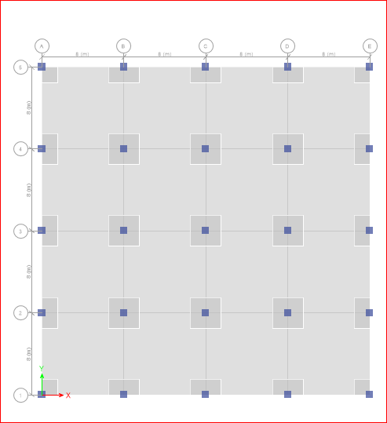
Fig.1 Plan view of RCC FS (G+11) Building in E-TABs 2017 software
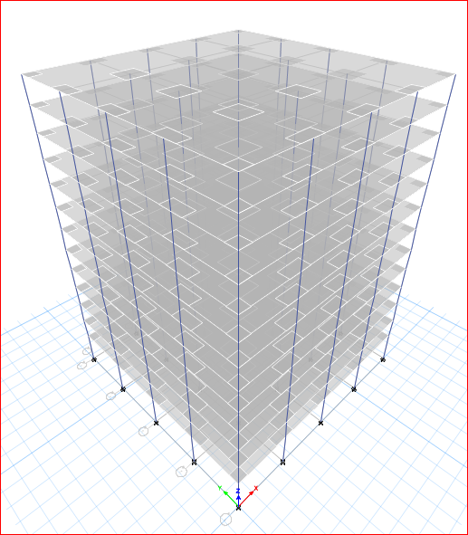
Fig.2 3-D plan view of RCC FS(G+11) Building in E-TABs 2017 software
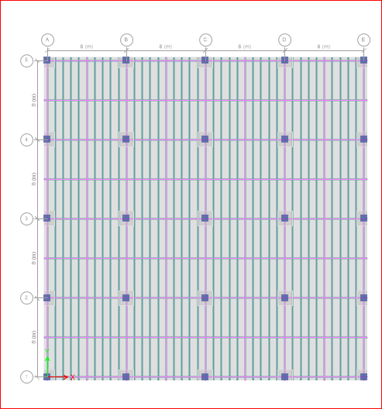
Fig.3 Plan view of PT FS (G+11) Building in E-TABs 2017 software
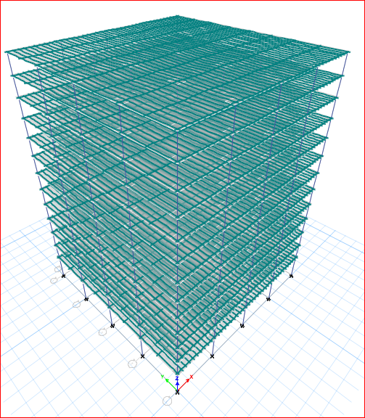
Fig.4 3-D plan view of PT FS (G+11) Building in E-TABs 2017 software

IV PROBLEM DEFINATIONS OF BOTH TYPES OF FLAT SLAB
Basically in this study the performance of the flat slabs on G+11 storey building is studied. For the analysis of both flat slabs using India Standards codes. IS 1893-Part 1( 2002), IS-1893-2016, IS 456 (2000), IS 800:2007. Problem is solved by Response Spectrum analysis method.

Sr. No. | Design Parameters | Values
1 | Area of Plot | 1024 m² (32*32)m
2 | Spacing of column | 8 m
3 | Soil Type | Type II, Medium As Per IS 1893:2002
4 | Seismic zone | III
5 | Number of storey | G+11
6 | Typical storey Height | 3.2 m
7 | Depth of foundation | 5 m
8 | Importance factor | 1
9 | Building Type | Commercial building
10 | Depth of Slab | 250 mm (RCC)
11 | Depth of slab | 150 mm(PT)
12 | Depth of drop panel | 350 mm (RCC)
13 | Depth of drop panel | 150 mm(PT)
14 | Size of column | 700*700 mm
15 | Damping ratio | 5%
16 | Seismic zone factor | 0.16
17 | Response Reduction Factor R | 5
18 | Grade of Concrete | M40
19 | Grade of Steel | Fe 500
20 | Dead Load | (self wt + 1 KN/m² floor finished)
21 | Live Load | 4 KN/m²
22 | Type of frame | Special moment Resisting frame
23 | Type of Foundation | Isolated column footing
24 | Earthquake load | Per IS 1893 (Part 1)-2002

V RESULTS AND DISCUSSION
1. The Shear Forces of PT Flat Slab are comparatively greater than RCC Flat Slab in both the directions X & Y respectively in Fig.5 and Fig. 6, because ,while designing the PT flat slab concrete and tendons are prestressed already hence it can bears high shear forces.

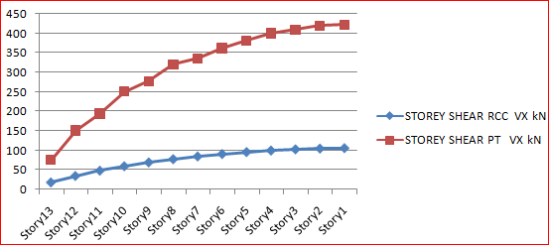
Fig.5 Storey Shear : Max Shear Force in X- Direction
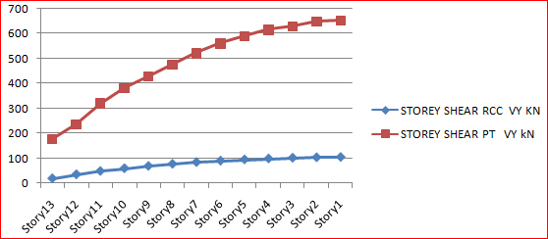
Fig. 6 Storey Shear : Max Shear Force in Y- Direction
2. The values of Moments are Higher in the RCC Flat Slab as compared to Post Tensioned Flat Slab in Fig. 7 & Fig.8 because of high Dead Load of RCC Flat Slab due to large thickness of slab.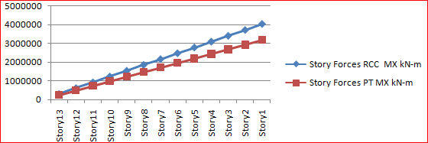
Fig. 7 Storey Forces : Max Moments in X- Direction
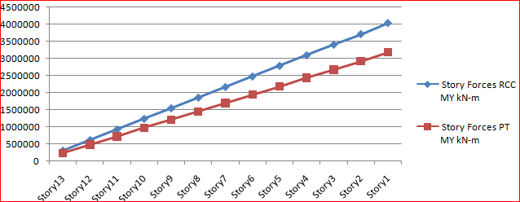
Fig. 8 Storey Forces : Max Moments in Y- Direction

3. The graphical representation of storey stiffness parameter of Post Tensioned Flat Slab is shows in Fig. 9 & Fig.10 the higher values as compared to RCC flat slab due to the post-tensioning effect in PT flat slab.
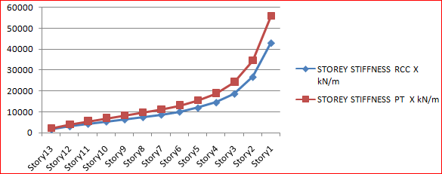
Fig.9 Storey stiffness X-Direction in KN/m
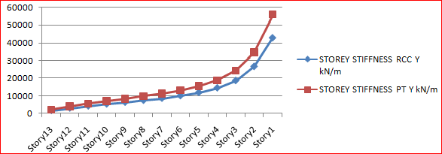
Fig. 10 Storey stiffness Y-Direction in KN/m
4. The nature of graph of a storey drift of RCC Flat Slab is high at the top storey, decreasing gradually according to decreasing in number of storeys, because of the Dead Load is higher in RCC Flat Slab as compared to Post tensioned Flat Slab in both the directions X & Y respectively by Response Spectrum analysis method in Fig.11 ,Fig. 12, Fig.13, & Fig.14 respectively.
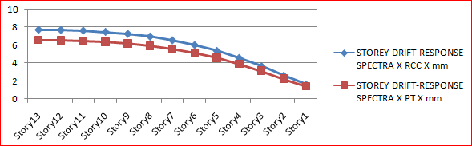
Fig. 11Storey Drift (Response Spectra X) in X-Direction

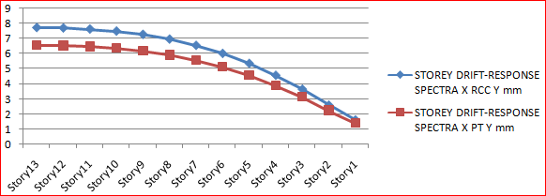
Fig. 12 Storey Drift(Response Spectra X) in Y-Direction
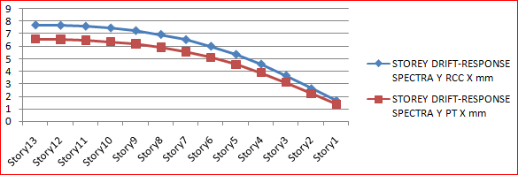
Fig. 13 Storey Drift (Response Spectra Y) in X-Direction
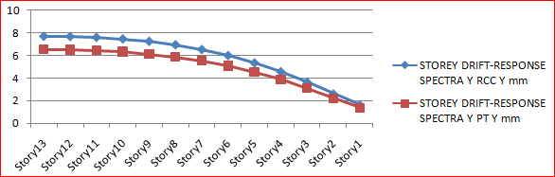
Fig. 14 Storey Drift(Response Spectra Y) in Y-Direction
5. Base shear values are higher in RCC Flat slab than the Post tensioned flat slab, because of Dead load is high in RCC flat slab due to the thickness of RCC flat slab. The base shear values depends upon loading of structure.
- Base Shear (Manual Calculation)
RCC Flat Slab in both directions :- 1521.12 KN Post Tensioned Flat Slab in both directions:- 1311.19 KN
- Base Shear (E-TABS Software):-
RCC Flat Slab in both directions :- 1494.55 KN
Post Tensioned Flat Slab in both directions:- 1289.97 KN

6. The cost is get reduced in Post Tensioned Flat Slab, the reason is that thickness of PT Flat Slab get reduced as compared to RCC Flat Slab, hence the utilisation of concrete get reduced.The Steel Requirement in PT Flat Slab in little bit higher than the RCC Flat Slab,Tendons are introduced in the PT Flat Slab are higher in cost.
RCC Flat Slab :
Total Concrete Quantity:- 4115.59 m³
Total Cost Of Concrete:- Rs.2,61,33,996/-
Post Tensioned Flat Slab:-
Total Concrete Quantity:- 2638.17 m³
Total Cost Of Concrete:- Rs.1,67,52,379/-
RCC Flat Slab :
Total Steel Quantity:- 419.18 Tonne
Total Cost Of Steel:- Rs. 2,09,59,000/-
Post Tensioned Flat Slab:-
Total Steel Quantity:- 338 Tonne
Total Cost Of Steel:- Rs.2,36,60000/-
Total Cost Of RCC Flat Slab:- Rs. 4,70,92,996/-
Total Cost Of Post Tensioned Flat Slab :- Rs. 4,04,12,379 /-
[All the rates are in tentative formats, Rates varies according to the currents markets rates]

VI CONCLUSION
- All the members are passed and safe in analysis and designs in E-TABS software.
- Shear Forces in PT flat slab are 75% greater than RCC flat slab because while designing the PT flat slab, concrete and tendons are prestressed already hence it can bears high shear forces.
- The Moments of RCC flat slab are 21% higher than the PT flat slab because of high Dead Load of RCC Flat Slab due to large thickness of slab.
- The storey stiffness of PT flat slab are 23% higher than the RCC flat slab due to the post-tensioning effect in PT flat slab. Post tensioned flat slab system enhances the stiffeness parameters in high rise structures.
- The storey drifts are 15 % higher in RCC flat slab structure than the PT flat slab, because of the Dead Load is higher in RCC Flat Slab as compared to Post tensioned Flat Slab.
- Base shear values are greater in RCC flat slab structure than the PT flat slab structure, because of Dead load is high in RCC flat slab due to the high thickness of RCC flat slab. The base shear values depends upon loading of structure.
- While estimating the cost of these two structures labour charges are not taken in concern, the labour charges reduced when time period get reduced in case of Post tensioned flat slab.
- The cost is get reduced in Post Tensioned Flat Slab, the reason is thickness of PT Flat Slab get reduced as compared to RCC Flat Slab, hence the utilisation of concrete get reduced, The Steel Requirement in PT Flat Slab in little bit higher than the RCC Flat Slab,Tendons are introduced in the PT Flat Slab are higher in cost. The cost is get reduced 18% less in PT flat slab than the RCC flat slab structure.
- The economy point of view Post-Tensioned Flat Slab is anytime affordable than the RCC flat slab in case of long span structures greater than to 8m span.
- From all of the above points post tensioned flat slab structure is more suitable in case high rise buildings.

REFERENCES
- Comparative Design of RCC & Post-tensioned flat slabs, Boskey Bahoria1, Prof.R. S. Deotale2,Dr D K Parbat3, Institute of Technology, Nirma University,Aahmedabad – 382 481, 09-11 December, 2010
- Seismic performance of post–tensioned interior slab-column connections with and without drop panel, U. Prawatwong1, C.H. Tandian2 and P. Warnitchai3, The 14th World Conference on Earthquake Engineering, Beijing, China October 12-17, 2008.
- Comparative Study of Post Tensioned and RCC Flat Slab in Multi-Storey Commercial Building, Jnanesh Reddy R K1, Pradeep A R2, International Research Journal of Engineering and Technology (IRJET) e-ISSN: 2395 -0056, p-ISSN: 2395-0072,Volume: 04 Issue: 06 | June -2017
- Flat Slab Construction in India, S.S. Patil, Rupali A. Sigi, International Journal of Engineering and Innovative Technology (IJEIT) ISSN: 2277-3754 ISO 9001:2008 Certified Volume 3, Issue 10, April 2014.
- Analysis of Post-Tensioned Flat Slab by using SAFE, Shriraj S. Malvade, P.J. Salunke, International Journal of Scientific Engineering and Applied Science (IJSEAS) – Volume-3, Issue-3, ISSN: 2395-3470,www.ijseas.com, page-92, March 2017.
- IS 1893-1( 2002): Criteria For Earthquake Resistant Design Of Structures, Part 1: General Provisions And Buildings (Ced 39: Earthquake Engineering)
- Criteria For Earthquake Resistant Design Of Structures (General Provisions And Buildings) –IS-1893-2016
- IS 456 (2000) : Plain And Reinforced Concrete –Code Of Practice [Ced 2 : Cement And Concrete]
- IS 800:2007 General Construction In Steel – Code Of Practice (Third Revision)

