Face Sketch Creation and Identification

TejalDilipZope1, HarshalLiladharKoli 2, Devyani Yogesh Gotiwale3, Akshay Rajendra Jagtap⁴, Nilesh Choudhary⁵

^{1,2,3,4} UG Sstudents, ⁵ Assistant Professor
^{1,2,3,4,5}GF’s Godavari College of Engineering, Jalgaon, India 425003

tejalzope14@gmail.com

Received on: 14 April, 2023 Revised on: 15 May,2023 Published on: 17 May,2023

Abstract –Forensic face sketching is a technique used by Investigatory organizations to help identify suspects in criminal investigations. This paper will discuss the process of forensic sketch construction and identification. The paper will begin by providing an over view of the history of forensic sketching and its role in criminal investigations. It will then describe the process of creation of a face sketch, including the initial interview, sketching techniques, and finalizing the sketch. The paper will also discuss the challenges and limitations of forensic sketching and identify potential solutions to these challenges. The paper will conclude by giving a summary of the present status of the research in this field and proposing possible are as for further study.

Keywords: Face Sketch and Construction, Face Recognition, Criminal Identification, Deep Learning, Cloud Computing, AWS.

I -INTRODUCTION
Forensic sketching has been used by Investigatory organizations for decades to help identify suspects in criminal investigations. A forensic sketch is a visual representation of a suspect's facial features and other physical characteristics that can be used to help witnesses or victims identify the perpetrator. The accuracy of a forensic sketch can be crucial in solving a case, and the process of creating a sketch requires skill and expertise.

History of Forensic Face Sketching:-Forensic sketching has its roots in the late 19th century, when law enforcement agencies began using photographs to help identify suspects. However, photographs were often of poor quality, and witnesses or victims may not have been present at the time of the crime. In the 20th century, forensic sketching became more common as artists began using their skills to create sketches of suspects based on witness descriptions.

ProcessofCreatingaForensicFaceSketch:-The process of creating a face sketch begins with aninitial interview of the witness or victim. The artist willask a series of questions about the suspect's physicalappearance, such as the shape of their face, the color oftheir eyes, and any distinguishing features such as scarsortattoos.Theartistmayalsoaskthewitnessto describethe suspect's clothing or other details that could help intheidentificationprocess.

After the interview, the artist will begin sketching thesuspect's facial features using a variety of techniques,including shading and cross-hatching. The artist mayalsousecomputer softwaretocreateadigitalsketch. Theartistwillworkwith thewitnessto refinethesketchuntilitaccurately representsthesuspect'sappearance.

ChallengesandLimitations:-Forensic sketching can be challenging for severalreasons. First, witnesses may have difficulty recallingthe suspect's appearance, particularly if the crimeoccurred under stressful or traumatic circumstances.Second, the artist's interpretation of the witness'sdescription may be subjective and influenced bypersonal biases. Finally, the accuracy of the sketch canbeaffectedbyfactorssuchaslightingandthewitness'sperspective.

To address these challenges, law enforcement agenciesmayusemultiplewitnesses tocreateacompositesketchor may use technology such as 3D facial reconstructionto create a more accurate representation of the suspect's appearance.
CurrentStateofResearch:-The field of forensic sketching is constantly evolving,and researchers are exploring new techniques andtechnologies to improve the accuracy of forensicsketches. Recent research has focused on using facialrecognitionsoftwareto matchsketchestophotographsorvideo footage, as well as developing new techniques forcreating morerealisticand accuratedigitalsketches.

LITERATUREREVIEW

Numerous research studies have looked at differentmethods for creating and identifying face sketches.According to a study by Kemp and others (2016), theaccuracyofforensicsketchesdependsonthequalityanddetail of the witness's description. The study found thatwitnesses who provided more detailed descriptionsproduced more accurate sketches. The study alsosuggested that the use of an interactive sketch systemthat allows witnesses to make changes and adjustmentstothesketch can improvetheaccuracy oftheresult.

In a study by Kovera and others. (2019), the researchers found that forensic sketches were more accurate than composite sketches, which are created using a computer software program. The study also found that the use of a sequential lineup, where witnesses view each suspect one at a time rather than in a group, improved identification accuracy.

Another study by Bruce and others. (2019) examined the impact of race on the accuracy of forensic sketches. The study found that witnesses were more accurate at identifying suspects of their own race, but that this effect was reduced when the sketch artist was of a different race. The study suggests that matching the race of the sketch artist to the race of the witness may improve identification accuracy.

Zhang and others. In 2019, presented an automatic and effective photo to sketch synthesizing method based on Dual transfer, which includes both interdomain and intradomain transfer. This method is extremely difficult to implement and has a high computational cost.

Overall, these studies suggest that forensic sketch construction and identification is an important tool for law enforcement, but that its accuracy depends on a variety of factors including the quality of the witness description, the use of interactive sketch systems, the type of lineup used for identification, and the race of the sketch artist.

Therefore, all above the earlier methods were either inefficient or difficult to implement. This application as mentioned above not only overcomes the limitations of the specified proposed technique, but also own users to upload hand-drawn face sketches, thus linking traditional hand-drawn face sketch techniques with new modernized composite faces.

METHODOLOGY

This application allows you to create an accurate synthetic facial sketch using a predefined set of facial features provided as a tool that can be resized and repositioned as per eyewitness requirements/description. Here, the human face is categorized into different facial features such as head, eyes, eyebrows, lips, nose, ears, etc., and also, we can implement some important wearable components such as hats, eyeglasses in the application.

Security and privacy are the primary concerns of Investigatory organizations before customizing the system. Keeping this in mind, the application is designed to protect their privacy and perform security measures in the following ways:

- Machine Locking: The Machine locking techniquewould ensure that the application once installed on asystem could not be tampered and could not beenoperated on any other system, for which the applicationuses two locking parameters i.e., one software and onehardware locking parameter. HD ID – Volume serial ofhard-drive with OS. NET ID – Hardware ID – MACAddress.

- Two Step Verification: Every law enforcementauthorized user would be given an official E-Mail IDwhich would use to login on to the application, thususingthisstep wouldrequiretheusertoenter arandomcode been shared with them on their mobile/desktop tocompletethe loggingprocess.

- CentralizedUsage:Thesystemwhichhastheapplication been installed would be connected to acentralized server of
the law enforcement department campus containing the database and the other important feature set of the application, thus the application could not be operated once disconnected from the server.

DESIGN

System Flow
The images below show how the system generally works. It starts with a login screen and with a two-step verification confirmation. The program can also be used with hand-drawn sketches or customized face sketches created with the drag-and-drop feature. Each image then undergoes for a feature extraction process that helps the program apply image processing and computer vision algorithms before matching the sketch against a database and displaying the degree of similarity between the sketch and the photo in the database.

Face Sketch Construction:This flowchart shows the user flow the platform followed to create an accurate face sketch based on witnessed description. The dashboard is designed to encourage people not to undergo professional training before using this platform, already saving the timeframe which would have been taken a lot of time and resources of the Department.
Fig.3FlowChartforRecognizingaSketchintheapplication

Fig. 1 Flow Chart for Creating Sketch in
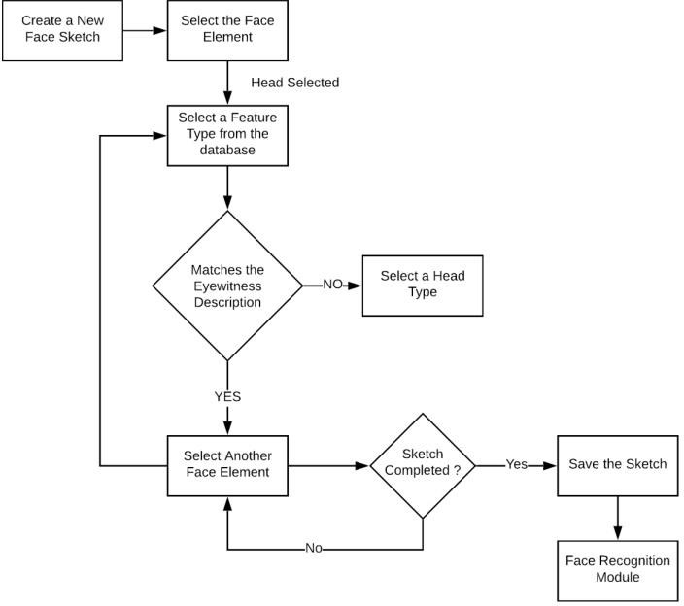

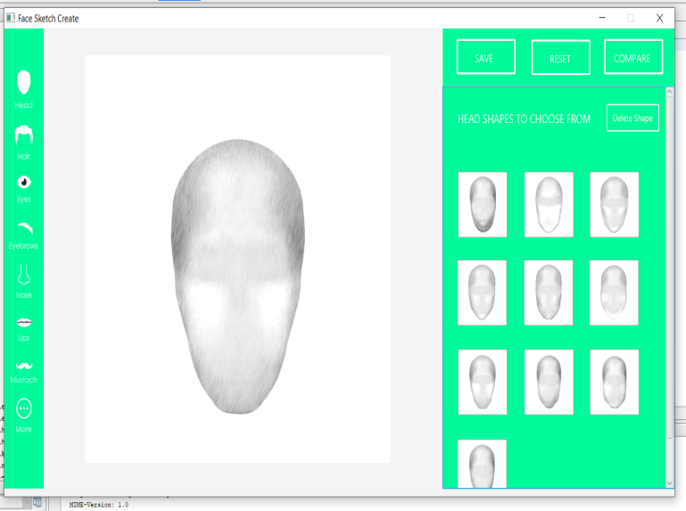
Fig. 2 User Interface of Sketch Creation

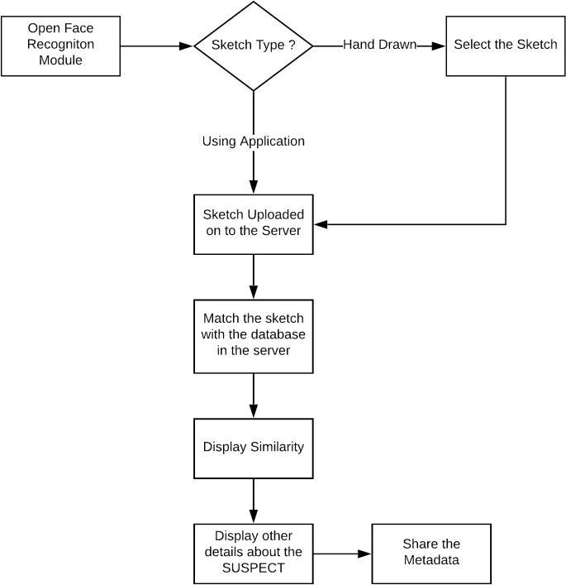
FaceSketchRecognition: This flowchart shows the user flow the platform goes through to recognize an accurate face sketch based on eye witnessed description. The dashboard is simply designed to encourage people not to undergo professional training before already using this platform, saving many departments time and resource-consuming using timeframes.

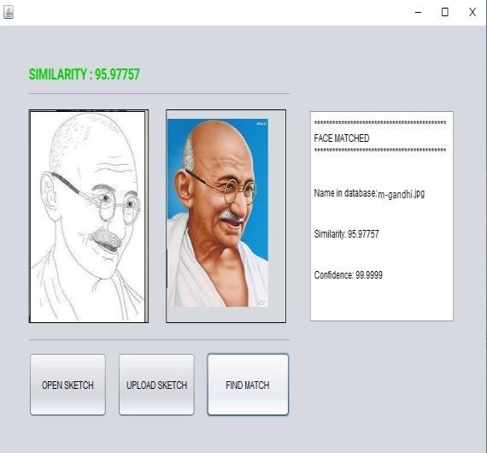
Fig.4 FaceSketchmapped todatabaserecord

RESULT&DISCUSSION

TheProject“Face Sketch Creation andIdentification”hasbeen designed, developed, and finally tested with real-worldscenariosmaintainedfromthefirstsplashscreentothe last screen, capturing data from records with security,privacy, and accuracy as key elements of each scenario.The platform exhibits excellent accuracy and speed, andthe face sketch creation and recognition process achieveanaverageaccuracyofover90%witha100%confidencelevel when tested with different test cases, test scenarios,anddatasets.Thisisaverygoodtoolaccordingtorelevant studies in this field. This platform has uniquefeaturesthatmakeitdifferentcomparedtorelatedstudiesin this area, making it stand out from all related studiesandproposedsystemsinthisarea,thusimprovingoverallsafety andaccuracy.

Method | Accuracy(%)
ProposedMethod | 94.6
HOG+GLCM Descriptor[2] | 94.4
PCA/LDA+GeometricInformation[6] | 94
Generation usingCNN[7] | 93.8
Table 1: Comparison of accuracy with other methods

When tested with various test cases, test scenarios, anddatasets, the platform exhibits excellent accuracy andspeed during the face sketch creation and recognitionprocess, achieving average similarity of over 90%, Thesystem achieved 94.6% accuracy and 100% reliabilitythis is a very good rate according to relevant research inthisarea.

CONCLUSION

In conclusion, forensic sketching is an important tool incriminal investigations that can help identify suspectsbased on eyewitness accounts. The process of creating aforensic sketch involves an initial interview with thewitness or victim, followed by using various techniquestocreateasketchthataccuratelyrepresentsthesuspect'sappearance. However, forensic sketching can also posechallenges, such as difficulties in recalling details of thesuspect's appearance and subjective interpretation of thesketch bythe artist.
Despitethesechallenges,advancementsintechnologyandresearchhaveshownpromiseinimprovingthe accuracyandreliabilityofforensicsketches.Theapplicationdisplayedaepicresultfromasecurityperspective by blocking the use of the platform if theMAC and IP address credentials did not match the user'sassignedcredentialsinthedatabase.Youcanevengenerate a new OTP each time the OTP page is reloaded,ortheusertriestologintotheplatformagain.Theplatform exhibits excellent accuracy and speed, and theface sketch creation and recognition process achieve anaverage accuracy of over 90% with a 100% confidencelevel when tested with different test cases, test scenarios,and datasets.

REFERENCES

- B. Klare and A. Jain, “Sketch to photo matching: afeature-basedapproach”,SPIEConferenceonBiometricTechnology forHumanIdentification,2010.

- KoveraMB,PenrodSD,PappasC,ThillDL(1997)Identiﬁcationofcomputer-generatedfacialcomposites.JournalofAppliedPsychology82(2):235

- ZhangY,McCulloughC, Sullins JR,RossCR(2008)Humanandcomputerevaluationsoffacesketcheswith implications for forensic investigations. In:Biometrics: Theory,Applications and Systems, 2008.BTAS 2008. 2nd IEEE International Conferenceon,IEEE, pp1–7

- BruceV,NessH,HancockPJ,NewmanC,RarityJ(2002) Four heads are better than one:combining facecompositesyieldsimprovementsinfacelikeness.JournalofApplied Psy-chology87(5):894

- HamedKianiGaloogahi and Terence Sim, “FaceSketch Recognition By Local Radon Binary Pattern:LRBP”,19thIEEEInternationalConferenceonImageProcessing,2012.

- N.Wang,X.Gao,and J.Li,“Randomsamplingforfast face sketch synthesis,” Pattern Recognit., vol. 76,pp.215–227,2018.

- Karasolak,Mustafa&Choupani,Roya.(2019).FacePhotograph Recognition via Generation from Sketchesusing Convolutional Neural Networks. InternationalJournal of Multimedia and Image Processing.9459-465.10.20533/ijmip.2042.4647.2019.0057

- D. Liu, C. Peng, N. Wang, J. Li and X. Gao, "Composite face sketch recognition based on components," 2019 8th International Conference on Wireless Communications & Signal Processing (WCSP), 2019, pp. 1-5, doi: 10.1109/WCSP.2016.7752734.

- Bin Sheng, Ping Li, ChenhaoGao, Kwan-Liu Ma,"Deep Neural Representation Guided Face SketchSynthesis",IEEETrans.Vis.Comput.Graph.,vol.25,no.12,pp. 3216-3230,Dec.2019

