Design & Analysis of Industrial Ball valve Using Computational Fluid Dynamics

Mr. Harshal Rajesh Dorsatwar¹, Prof. Prashant Kadu²
¹M.TECH Student
Abha Gaikwad Patil College of Engineering , Nagpur , India , 441108
²Principal
Abha Gaikwad Patil College of Engineering , Nagpur , India, 441108

Abstract – A valve acts as a control device in a larger system; it can be modelled to regulate the flow of material and energy within a process. There are several different kinds of valves (butterfly ball, globe, etc.) selection of which depends on the application and chemical process in consideration. The sizing of valves depends on the fluids processing unit (heat exchanger, pump etc.) which is in series with the valve. Valves need to be modelled to perform effectively with respect to the process requirements. Efficient modelling of the valves can optimize the performance and stability of a process as well as reduce development time and cost for valve manufacturers. Valves are commonly used in industrial applications to control the internal flow of both compressible and incompressible fluids. Pressure loss, flow coefficient, loss coefficient, torque coefficient etc. performance coefficient including in valve. Valve generally use both way in circuit for maintained flow .it give in the form of laminar helps to reduced pressure loss.
Keywords- Ball valve, CFD Analysis , Ball Valve Experimental CFD Analysis

INTRODUCTION
A valve is a fluid control device used in a number of industries where it is installed in a pipeline. Valves are included in pipelines for the purpose of regulating the flow of fluid in the pipeline. When a ball valve is used in a pipeline it is typically used for the purpose of on/off fluid flow control, when in the closed position the ball valve isolates the downstream sections of the pipeline. Valves are broadly split into a number of groups based on their design, these groups are: Ball, Butterfly, Check, Diaphragm, Gate, Globe, Needle, Pinch, Plug and Pressure-Relief Valves. Each of these valve types have inherent advantages and disadvantages because of the features associated with that type of valve. When specifying valves for a pipeline the valve type whose features best suit the application should be chosen. Despite the various types of valves available this thesis is concerned only with ball valves, and more specifically the sub-group of floating ball valves and within that sub-group the soft-seated ball valves constituents. Soft-seated ball valves are a form of ball valve where the seat component is manufactured from a non-metallic material, this material is typically a form of polymer such as PTFE.

METHOLOGY
- Doing the CFD analysis of the ball valve
- Modeling the components using SOLID WORKS2015.
- Meshing the components
- Analyzing each components as follows -(ANSYS14.5)
Mesh independence study is an important process in CFD to determine whether the model result is independent on mesh density. When applying high dense into the model, the result will converge and remain consistent. That way the simulation will not waste any computational time to simulate higher mesh density to obtain the same result.
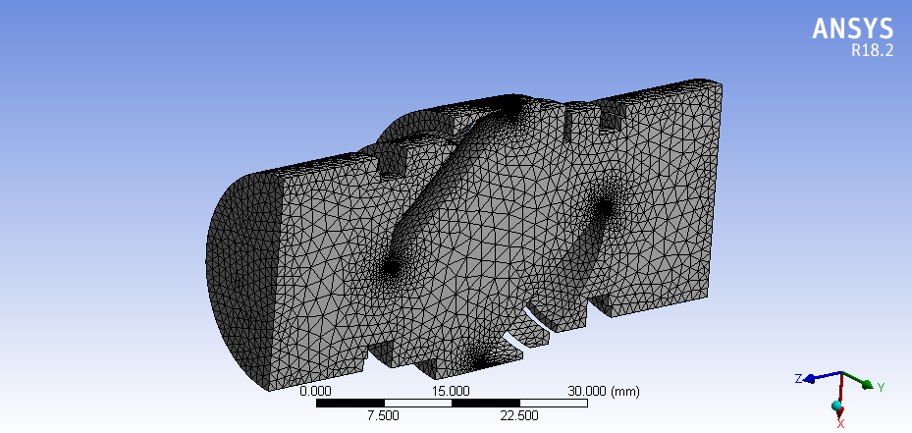
Fig. Meshing of Fluid Domain

No. of node – 69236
No. of element- 353436
Element quality- 0.86161
Orthogonal quality- 0.86223

DESIGN
The present study deals with the design of a One Piece ball valve. The designing of valve depends upon the pressure and temperature ratings and also other factors. The critical components are analyzed using the finite element analysis. Thus obtained engineering analyses are compared with the theoretical calculations. The Fluid (water) acting inside the valve will be calculated and analyzed using the ANSYS software
Detail Ball Valve Description :
1) Material : Brass , Stainless Steel
2) Brand : HPF
3) Exterior Finish : Brass , Steel
4) Inlet Connection Size : 1 Inches
5) Inlet Connection Type : Flange
6) Outlet Connection Type : Flange
7) Model Number : 15 mm

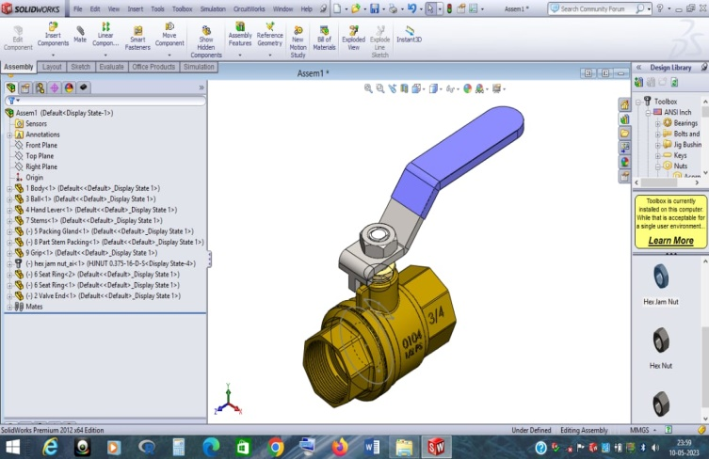
Fig. Designing of Ball Valve in Solid Works
CONCLUSION
Positions | Velocity (m/Sec) | Pressure (kpa)
0° | 0 | 0
45° | 1.478 | 1.86
60° | 4.989 | 3.48
90° | 7.126 | 5.00
As you can see from the above charts and table mentioned that the valve gives best velocity flow at low pressure at 45°.so, by doing an analysis on the standard dimensioned ball valve we conclude that the ball valve gives its best performance at 90°.

As you can see from the table that,

- At 90° the fluid or gas exerts more pressure on the valve and the velocity is High which is effective and causes no harm to the body.
- At 60° the pressure is Medium compared to 90°, which is not good for the performance of the valve, and also velocity obtained is very low.
- At 45° the pressure is Low compared to 90°, which is Rendering to Fail the ball valve and its performance of the valve, and also velocity obtained is very low.
So as per analysis results we conclude that the ball valve performs well at 90° because the pressure acting on the valve is High and the velocity of fluid passing is high compared to other position & Flow rate At 90° of ball Valve is safe for Future Installation

Material | Softness | Corrosion | Pressure Resistance | Temperature Resistance
Stainless Steel | Hard | High | High | High
Brass | Softer | Low | Low | Low

Further We Conclude That the Material which we used for Designing with CFD where Brass & Stainless Steel .We Estimated that Brass material Get’s Failed While Stainless Steel is safe with Its Properties and at Angle of 90° It Gives Requried Flow.

REFERENCES
[1] C. K. Kim, S. M. Lee, and C. M. Jang, 2019 “Performance analysis of a ball valve used for gas pipelines by introducing non dimensional parameters,” Adv. Mech. Eng., vol. 11, no. 1, pp. 1– 10
[2] J. Jablonski and W. Helfer, 2019 “Using ball valves in high-temperature applications,” Hydrocarbon Processing, vol. 2019
[3] Determination of Flow Parameters through CFD Analysis for Agricultural Irrigation Equipment: A Case Study for a Mini Valve" H. Kursat CELIK, Allan E. W. RENNIE, Davut KARAYEL, Ibrahim AKI NCI
[4] C. Srikanth, C.Bhasker, Flow analysis in valve with moving grids through CFD techniques, Advances in Engineering Software, indiameter, 40 (3), 2009, 193-201
[5] R. N. Yerrawar, V. B. Tungikar, S. H. Gawande, Finite Element Analysis of Dynamic Damper for CV Joint, 4(4), 2012, 241-247.
[6] Mahesh Kamkar, S.R.Basavaraddi, “CONCEPTUAL DESIGN AND ANALYSIS OF HIGH PRESSURE BALL VALVE”, International Research Journal of Engineering and Technology (IRJET), Volume 02, Issue 03, pp 1185–1189, (2015)
[7] Dong-Soo KIM, Myoung-Sub KIM, “ANALYSIS AND DESIGN OF CRYOGENIC BALL VALVE”, Proceedings of the 7th JFPS International Symposium on Fluid Power, pp 397–402, (2008 )
[8] Optimization of Industrial Valve Design Considering Flow Parameter using CFD" Shailesh Wamanrao Lokhande, Dr.A.M.Langde
[9] Design and Analysis of Industrial Ball Valve using Computational Fluid Dynamics" P. Ebenezer Sathish Paul, G. Uthaya Kumar, S. Durairaj, D. Sundarrajan

