Review of Designs of Adsorber Bed Heat Exchanger for Adsorption Refrigeration System
Himanshu D. Wagh¹, Vaibhav A. Patankar², Bhushan C. Behede³
¹ Student, M.Tech (HPE), Department of Mechanical Engineering, G. H. Raisoni College of Engineering,
Nagpur, India, 440016
² Student, M.Tech (HPE), Department of Mechanical Engineering, G. H. Raisoni College of Engineering,
Nagpur, India, 440016
³Assistant Professor, Department of Mechanical Engineering, Gurunanak Institute of Technology,
Nagpur, India, 441501

Abstract – Problem of heat loss takes place through various processes in process industries and from combustions in engines and boilers which contribute to increase in temperature of the globe resulting in global warming as the heat lost in such processes contains polluting agents these pollute the environment which is resulting in depletion of ozone layer, on other hand for the comfort conditioning, human needs of cooling are increasing day by day and the large amount of electricity produced is utilised by the cooling system all over the globe in order to overcome the problem of global warming and ozone layer depletion an waste heat powered refrigeration system can be designed abbreviated as adsorption cooling system, which is an eco-friendly system as it does not use of any environmental hazardous refrigerants. This paper extant an overall review of what configuration of adsorber bed heat exchanger are used for the adsorption refrigeration system are discussed in detail with their heat and mass transfer characteristics.
Keywords- Adsorber bed Heat Exchanger, Waste heat, Adsorbent, Adsorbate.

INTRODUCTION
A huge amount of heat is wasted from the exhaust of I.C engine [1,2] and from process industries [3]. Researchers in last decades or so had made a big effort in order to use this waste heat to produce refrigeration; adsorption refrigeration system is the most prominent systems of refrigeration powered by waste heat. Adsorption refrigeration system has some advantages over conventional refrigeration system for example; non-toxic, no rusting problem and simple in operation. Adsorption refrigeration system is green refrigeration system with very fine energy saving the character and due to this the system can be solidly incorporated in places analogous to hospitals and the commercial building where from kitchen waste heat is available [4].
As the awareness for the clean environment and quality ecosystem is increasing quotidian due to global warming[5] and ozone layer depletion[6], adsorption refrigeration is found to be most environment friendly as it do not have any environmental hazardous working substance and it can utilise waste heat undeviating from source for example industrial waste steam, reducing global warming. Commonly water base with zeolite and silica gel system are commercialised in Japan and various other parts of Europe. There is a disadvantage in water based adsorption refrigeration system that advanced technologies are to be used as the system works in a vacuum and is likely to have leakages[7]. The maximum part of the energy produced is now a day consumed by heating, ventilation and air conditioning alone. The HVAC contains CFC’s and HCFC’s which has very high GWP and ODP that therefore it is the demand of world environment to have eco-friendly refrigeration system like adsorption refrigeration for cooling purposes[8].
There are many advantages of adsorption refrigeration system over basic compression cycle such as; energy saving(Powered by waste heat or solar energy), no vibration are present as no moving part is available, the controlling of system is much easier and the operating cost of the system is much less than VCRS[9]. Adsorption refrigeration system can be powered by sources with a wide range of temperature from as low as 50⁰c to 500⁰c and without corrosion effect. This system is most feasible where there is a huge amount of vibration such as fishing boats[10] and locomotives[11].
In this work, various articles are reviewed to give a brief idea of how to select working pair for waste heat compelled adsorption refrigeration system and what are various system development techniques. Physical adsorbents are studied along with their structure and material goods with the detail of the bonding with adsorbate. Various heat exchanger designs such fin tube heat exchanger[12] shell and tube heat exchanger[13], flat plate fin tube heat exchanger[14] are studied and an effective design is suggested agreeing to the application point of the system. Detailed basic working of adsorption refrigeration cycle is discussed along with thermodynamic cycle diagram.
Design of Adsorber Bed Heat Exchanger
Introduction
Adsorber bed heat exchanger is a special type of heat exchanger consisting of packed bed, in which adsorbent is packed in between the fin in packed form. This packed bed to act as a “Thermal Compressor” in adsorption refrigeration system. The main focus while designing the adsorber bed is to increase the heat and mass transfer inside the packed bed as the reduced heat and mass transfer rate result in lowering the COP and SCP of the system[15]. Many designs of adsorber bed can be utilised in adsorption refrigeration system and different types of modification can be made to enhance results[16].
Literature survey on different types of arrangements of packed bed heat exchangers
Mitsuhiro Kubota et all.[17] Developed a heat pump with an adsorber bed heat exchanger having fins and silica gel packed in between the fins with an concept of optimum fin spacing and concluded that module can achieve more than two times higher cooling output per unit adsorber volume than un-optimized module.
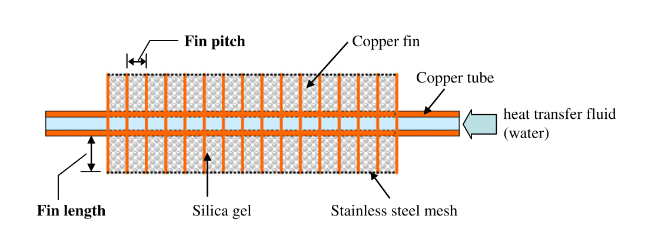
Figure 1: Finned tube with silica gel packed in between the fins[17]

Amir Sharafian et all.[18] In this study author had elaborated different designs for adsorber pack beds that have been used for adsorption refrigeration process which is powered by waste heat. Comparison of nine different type’s adsorber packed bed design is proposed. Fig.4 shows the different types of heat exchanger. Among all designs, finned tube adsorber bed heat exchanger has the highest heat and mass transfer rate. And fin tube heat exchanger is the most commonly used design and more modifications are required in it.

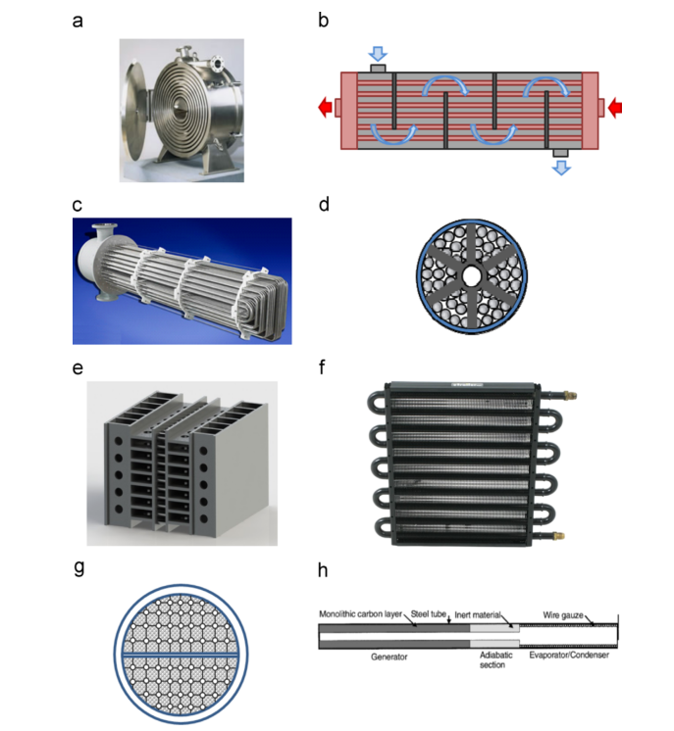

Figure 2: Different types of packed bed used in adsorption refrigeration system[18]

W. S. Chang et all. [19] a two-bed silica gel–water adsorption chiller with plate fin and tube heat exchangers was newly developed. A solar- powered compound system for heating and cooling was designed and constructed in a golf course to conduct the field test. Resulting in increase in Cop of the system by 13%.

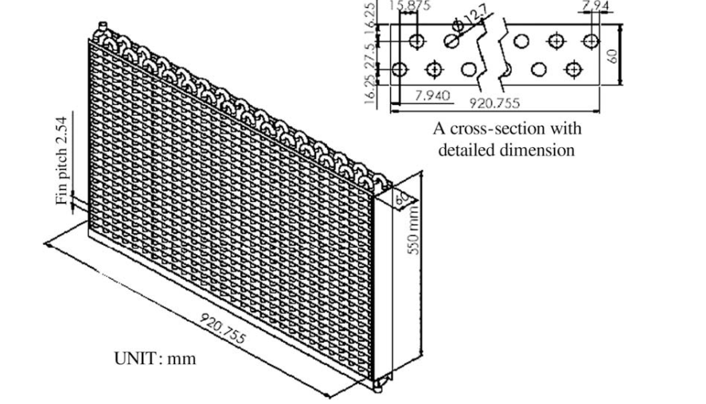
Figure 3: Plate tube heat exchanger[19]

CONCLUSION
The study draws the conclusion that the best configuration used for adsorption refrigeration system of adsorber bed is flat plate finned heat exchanger with a highest heat and mass transfer rate with the largest COP and there is the scope of a lot more research in the area of adsorber bed in order to make the more effective adsorption refrigeration system.

REFERENCES
[1] M. Hamdy, A.A. Askalany, K. Harby, N. Kora, An overview on adsorption cooling systems powered by waste heat from internal combustion engine, Renew. Sustain. Energy Rev. 51 (2015) 1223–1234. doi:10.1016/j.rser.2015.07.056.
[2] C.Y. Tso, K.C. Chan, C.Y.H. Chao, C.L. Wu, Experimental performance analysis on an adsorption cooling system using zeolite 13X/CaCl2 adsorbent with various operation sequences, Int. J. Heat Mass Transf. 85 (2015) 343–355. doi:10.1016/j.ijheatmasstransfer.2015.02.005.
[3] S. Br??ckner, S. Liu, L. Mir??, M. Radspieler, L.F. Cabeza, E. L??vemann, Industrial waste heat recovery technologies: An economic analysis of heat transformation technologies, Appl. Energy. 151 (2015) 157–167. doi:10.1016/j.apenergy.2015.01.147.
[4] C.Y. Tso, C.Y.H. Chao, S.C. Fu, Performance analysis of a waste heat driven activated carbon based composite adsorbent - Water adsorption chiller using simulation model, Int. J. Heat Mass Transf. 55 (2012) 7596–7610. doi:10.1016/j.ijheatmasstransfer.2012.07.064.
[5] J.E. Szulejko, P. Kumar, A. Deep, K.-H. Kim, Global warming projections to 2100 using simple CO2 greenhouse gas modeling and comments on CO2 climate sensitivity factor, Atmos. Pollut. Res. (2016) 1–5. doi:10.1016/j.apr.2016.08.002.
[6] M. Nerentorp Mastromonaco, K. G??rdfeldt, B. Jourdain, K. Abrahamsson, A. Granfors, M. Ahnoff, A. Dommergue, G. M??jean, H.W. Jacobi, Antarctic winter mercury and ozone depletion events over sea ice, Atmos. Environ. 129 (2016) 125–132. doi:10.1016/j.atmosenv.2016.01.023.
[7] A. Bin Ismail, A. Li, K. Thu, K.C. Ng, W. Chun, Pressurized adsorption cooling cycles driven by solar/waste heat, Appl. Therm. Eng. 67 (2014) 106–113. doi:10.1016/j.applthermaleng.2014.02.063.
[8] K.C.A. Alam, A. Akahira, Y. Hamamoto, A. Akisawa, T. Kashiwagi, A four-bed mass recovery adsorption refrigeration cycle driven by low temperature waste/renewable heat source, Renew. Energy. 29 (2004) 1461–1475. doi:10.1016/j.renene.2004.01.011.
[9] R.Z.Ã. Wang, R.G. Oliveira, Adsorption refrigeration — An efficient way to make good use of waste heat and solar energy $, 32 (2006) 424–458. doi:10.1016/j.pecs.2006.01.002.
[10] Z. Lu, R. Wang, Experimental performance study of sorption refrigerators driven by waste gases from fishing vessels diesel engine, Appl. Energy. 174 (2016) 224–231. doi:10.1016/j.apenergy.2016.04.102.
[11] R.Z. Wang, Z.Z. Xia, L.W. Wang, Z.S. Lu, S.L. Li, T.X. Li, J.Y. Wu, S. He, Heat transfer design in adsorption refrigeration systems for ef fi cient use of low-grade thermal energy, 36 (2011) 5425–5439. doi:10.1016/j.energy.2011.07.008.
[12] P. Cheppudira Thimmaiah, A. Sharafian, W. Huttema, C. McCague, M. Bahrami, Effects of capillary-assisted tubes with different fin geometries on the performance of a low-operating pressure evaporator for adsorption cooling system applications, Appl. Energy. 171 (2016) 256–265. doi:10.1016/j.apenergy.2016.03.070.
[13] M. Asadi, Y. Song, B. Sunden, G. Xie, Economic optimization design of shell-and-tube heat exchangers by a cuckoo-search-algorithm, Appl. Therm. Eng. 73 (2014) 1030–1038. doi:10.1016/j.applthermaleng.2014.08.061.
[14] X.H. Li, X.H. Hou, X. Zhang, Z.X. Yuan, A review on development of adsorption cooling - Novel beds and advanced cycles, Energy Convers. Manag. 94 (2015) 221–232. doi:10.1016/j.enconman.2015.01.076.
[15] G.G. Ilis, M. Mobedi, S. Ülkü, A dimensionless analysis of heat and mass transport in an adsorber with thin fins; uniform pressure approach, Int. Commun. Heat Mass Transf. 38 (2011) 790–797. doi:10.1016/j.icheatmasstransfer.2011.03.001.
[16] O. Taylan, D.K. Baker, B. Kaftanoǧlu, COP trends for ideal thermal wave adsorption cooling cycles with enhancements, Int. J. Refrig. 35 (2012) 562–570. doi:10.1016/j.ijrefrig.2010.07.008.
[17] M. Kubota, T. Ueda, R. Fujisawa, J. Kobayashi, F. Watanabe, N. Kobayashi, M. Hasatani, Cooling output performance of a prototype adsorption heat pump with fin-type silica gel tube module, Appl. Therm. Eng. 28 (2008) 87–93. doi:10.1016/j.applthermaleng.2007.04.014.
[18] A. Shara, M. Bahrami, Assessment of adsorber bed designs in waste-heat driven adsorption cooling systems for vehicle air conditioning and refrigeration, 30 (2014) 440–451. doi:10.1016/j.rser.2013.10.031.
[19] W.S. Chang, C.C. Wang, C.C. Shieh, Design and performance of a solar-powered heating and cooling system using silica gel/water adsorption chiller, Appl. Therm. Eng. 29 (2009) 2100–2105. doi:10.1016/j.applthermaleng.2008.10.021.

