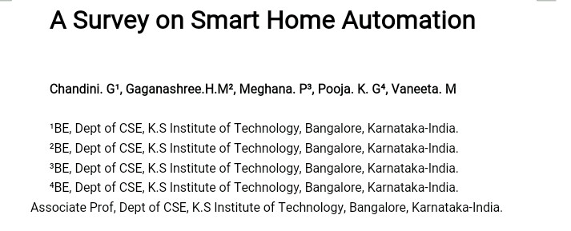

Abstract-Home automation is to control home devices from a central control point.Today we are living in 21st century where automation is playing important role in human life. Home automation allows us to control household appliances like light, door, fan, AC etc. It also provides home security and emergency system to be activated and adopted in many applications beyond just SmartPhones.This design is based on the popular open sourced Arduino prototyping board where the sensors and electrical appliances are connected to the input/output ports of the board.Pattern based password protection is implemented to allow only authorized users to control the appliances. Another implementation is Google’s voice recognition feature that recognizes users’ voice commands to control appliances.The main objective of home automation and security is to help handicapped and old aged people who will enable them to control home appliances and alert them in critical situation. IOT means,the devices communicate themselves to share data..This paper, includes literature study on different ways of implemention IOT for house.
INTRODUCTION
IOT is technology which enable the user to control the devices from anywhere in the world through internet connection. User friendly interface allows a user to easily control these home appliances through the internet.Internet based home automation system is very convenient,easy flexible and cheap.Many devices now have wifi and can connect to smartphones or home computers but these devices cannot communicate with each other or else need additional devices to do so.
These devices can be controlled using one single device ex: controlling lights, fans, air

conditioners, refrigerator, tv etc. By using an application on the smartphone all these devices can be controlled.IOT
devices are predicted to reach 50 billion by 2022
therefore,the IOT device data is too large to be managed efficiently by the existing platforms.Data are extremely concentrated to the platform,and the managing and processing costs are rapidly increased.A new innovative system which uses IOT and Android which automatically initiate some task based on certain role and rule called as Role of things(ROT).
IOT enables devices to sense surrounding situations and to perform certain motion by connecting them through a various internet protocols. The connected devices share information to coordinate decisions and provide services and applications such as healthcare, emergency response, disasters detection and home automation. To provide these IOT applications, many IOT platforms are developed to support connectivity, interoperability and manageability. Another application of smart home is even more sophisticated.
One can provide his or her connected device at home even from anywhere in the world.If one for example leaves the office, it is possible to tell a connected air conditioner device via smart phone to cool down the house to a certain temperature.
LITERATURE SURVEY
Rapid growth in technology and improvement in architecture comes out with many problems of how to manage and control the system. Home automation system has become very popular nowadays. A Smart home is one of the application of IOT. Smart homes are those where home appliances are monitored and controled remotely through Internet using proper network architecture and standard protocols.
In this user study about how to provide fully smart environment condition by using various sensors (temperature, humidity, light and level). Many peoples are not able to move more from one place to another so that systems must be designed with the less human interaction. In this techniques are used that provide notification for the user if any faults are found in the devices, if any problem found it provide a notification for the owner and also to the technician about the problem. The notification is through SMS OR E-MAIL, in future it may be through the VOICE ALERT.It provides detection and resolution of the problem in the devices, for that classification algorithm for data mining is used. Here, user need efficient energy, flexible system to detect the faults in the devices and process to resolve detected problem[2][6].
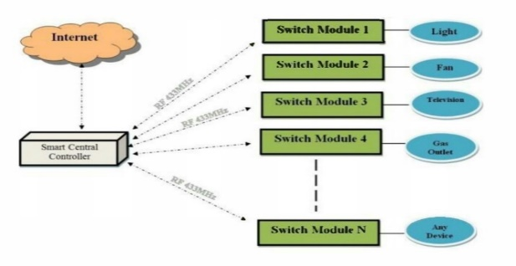
Figure 1: Basic Idea For Smart Home System Using IOT
Figure 1 shows the Basic Idea for Smart Home system using IOT. Due to the advancement of wireless technology, there are several different connections are introduced. Such as Bluetooth, Wi-Fi etc... Each of which has their own unique applications and specifications.
Figure 2 shows ARM 7 LPC2148 kit.Among many popular wireless connections Bluetooth is being chosen because of its suitable capabilities. Bluetooth frequencies 2400HZ is able to provide connectivity up to 100 meters at speed of 3mbps.
This approach is implemented to control various home appliances with ARM9processor.This will also provide safer physical control to the user compare to the conventional high voltage switches. The Bluetooth connection in the system is
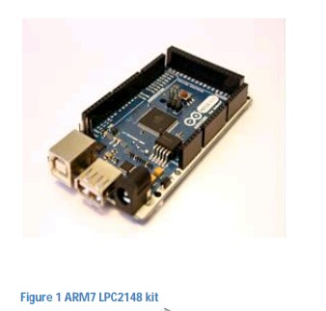
Figure 2:ARM7 LPC2148 KIT
established by Bluetooth module that directly receives /transmits commands from/to ARM9[1].
Mainly, it is used to control home devices from a central control point. The communication between the devices is wireless. The system is secured for access from outside through an SSL algorithm protected server. SSL algorithm to help create a more secure and scalable future.SSL means secure sockets layer it is a computer networking protocol for securing connections between network application such as internet. The users are expected to acquire login and password to access to the site. This adds protection from unauthorized accesses[5].
Figure 3 shows the System Architeture of GSM. Remote home automation improves the value of our lives by automating various electrical appliances. Global System Messaging (GSM) based secured device control system using App Inventor for Android mobile phones. App inventor is a latest programming platform for developing mobile applications for Android-based smart phones. In App Inventor there is no need of writing programming codes to develop apps. Design and implementation of the GSM Home Appliance System (GHAS) using the App Inventor for Android mobile. The purpose of the GHAS is to use mobile phone’s it has a inbuilt SMS facility and modem for automation of home appliances[4].
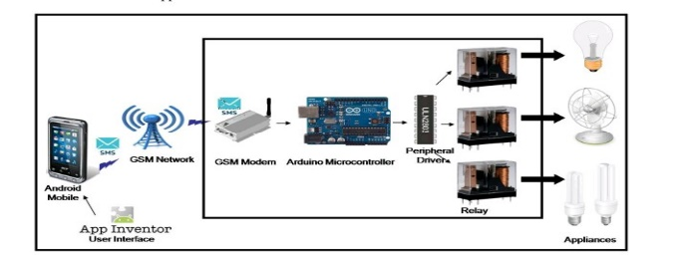
Figure 3: System Architecture
It presents the design and implementation of low cost and secure android smart phone based home automation systems. It is based on open source Arduino prototyping board where the sensors and electrical appliances connected to the input/output port of the board. Smartphone as become more popular around the world and 75% of smart phone are user base. Smartphone has become the human interactive device and so by using this system user can control the task from anywhere in the world. The android is free and open source. This system is used in large scale industry. Google cloud messaging is used to control the home systems from the internet .Thus, it is useful to control some. appliances from anywhere in the world.
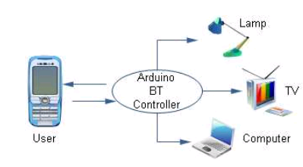
Figure 4 shows the Block diagram of Home Automation system. Wireless technologies are becoming more popular around the world and the consumers appreciate this wireless lifestyle which gives them relive of the well known “cable chaos” that tends to grow under their desk. Now with the embedded Bluetooth technology, digital devices form a network in which the appliances and devices can communicate with each other. Today, home
Figure4:Block diagram of home automation system.
automation is one of the major applications of Bluetooth technology. Operating over unlicensed, globally available frequency of 2.4GHz, it can link digital devices within a range of 10m to 100m at the speed of up to 3Mbps depending on the Bluetooth device class. With this capability of Bluetooth;we propose a home automation system based on Bluetooth technology .
In this paper we have introduced design and implementation of a low cost, flexible and wireless solution to the home automation. The system is secured for access from any user or intruder. The users are acquire pairing password for the Arduino BT and the cell phone to access the home appliances. This adds a protection from unauthorized users. This system can be used as a test bed for any appliances that requires on-off switching applications without any internet connection. The functionality of the home automation system was tested and the Wireless communication between cell phones and Arduino BT has been found to be limited to <50m at a maximum limit of 50 mm and is reported to be applicable in open range. [8]
Iot can be described as connecting everyday objects like Smart phones,internet tvs, sensors and actuators to the internet where the devises are intelligently linked together enabling new forms of communication between things and people, between themselves.
Here this paper present low cost snd flexible home control and Monitoring system using an embedded microweb server. The proposed system doesnt require dedicated server,pc.
The proposed system is RESTful based webservices. The architecture presented in this work can be Customized in different ways in order to accommodate different applications scenarios with minimum recording and design.[7]
A novel architecture for low cost and flexible home control and monitoring system. When wifi Connection is not available mobile cellular network such as 3g or 4g can be used to access the system.
CONCLUSION
This paper has introduced various ways of controlling house.we’ve introduced the design and implementation of a low cost smartphone based home automation system. This system can be easily manufactured on a large scale for mass adoption owing to its simplicity and ease of design. In conclusion, this low cost system is designed to improve the standard living in home. The remote control function by ARM9 provides help and assistance especially to disabled and elderly. In order to provide safety protection to the user, a low voltage activating switches is replaced current electrical switches.
Design and implementation of the GSM Home Appliance System (GHAS) using the App Inventor for Android mobile phone has been discussed. The purpose of the GHAS is to use mobile phone’s which has an inbuilt SMS facility and GSM Modem for automation of Home Appliances.
REFERENCE
[1] D.Naresh, B.Chakradhar and S. Krishnaveni, "Bluetooth Based Home Automation and Security System Using ARM9", vol.2,ISSN 2231-5381, pp.4052-4058,2013.
[2] Vishwajeet H. Bhide, "A Survey On The Smart Homes Using IOT", vol.2,ISSN 2321-7782, pp.243-246,2014.
[3] Syed Anwarullah and S.V.Altaf, "RTOS Based Home Automation Using Android", vol.2,ISSN 2278-3091, pp.480-484,2013.
[4] Mahesh N. Jivani, "GSM Based Home Automation System Using APP-Inventor For Android Mobile Phone",vol.3,ISSN(online) 2278-8875, ISSN(print) 2320-3765, pp.12121-12128,2014.
[5] Ali Ziya Alkar and Umit Buhur, "An Internet Based Wireless Home Automation System for Multifunctional Devices", vol. 2,No.1,page:480-484(2013).
[6] Pranab P. Gaikwad, Jyotsna P.Gabhane, Snehal S. Golait, "A Survey Based on Smart Homes System Using IOT”.978-1-4673-6525-6/15/$31.00 2015IEE.
[7] Rajeev Piyare1 and Seong Ro Lee1 , "Smart home control and monitoring system using smart phone", Vol. 24, pp. 83 - 86, 2013
[8] R.Piyare, M.Tazil, "Bluetooth based home automation system using cellphone", 2011.

