PERFORMANCE OF SOLAR AIR HEATER SYSTEM USING DIFFERENT SHAPES OF TURBULATORS ON THE ABSORBER PLATE
Shashank D. Bhujade¹, R. S. Shelke²
¹ Student of M.Tech
G. H. Raisoni College of Engineering, Nagpur, Maharashtra (India),440016
²Professor
G. H. Raisoni College of Engineering, Nagpur, Maharashtra (India),440016

Abstract – This paper presents a performance analysis of three types of turbulators i.e V-shaped, Square shaped and Transverse wedge shaped turbulator on absorber plate of solar air heater system and are compared with flat plate collector. Effects of different turbulators on absorber plate of solar collector are studied and results are found out. The performance of turbulator used in this experimentation is evaluated in terms of heat transfer, Reynolds number, Nusselt number, Friction factor etc. The results shows that transverse wedge shaped turbulator have remarkable heat transfer enhancement and high Reynolds number as well as Nusselt number. It is also observed that heat transfer from transverse wedge shaped rib is more than that of flat plate collector.
Keywords- Different shapes of turbulator, Absorber plates, Solar Air Heater.
INTRODUCTION
Solar air heater are devices of solar energy system which absorb solar radiation and convert it into thermal energy at absorber surface and finally transformed the energy to the fluid flowing inside the solar collector. A solar collector is basically a flat rectangular box and are composed of three main parts, a transparent cover, black colored absorber plate which carries working fluid and insulation at bottom portion. The solar air collector works on the green house effect principle; solar radiation incident upon the transparent surface of the solar collector is transmitted through though this surface. The inside of the solar collector is usually evacuated, the energy contained within the solar collect is basically trapped inside solar absorber plate converts it into the heat and transforms it to working fluid (air, water, or oil) which is at low temperature into the collector and thus heats the air flowing through the absorber plate. The plates are usually made from copper or aluminum and the absorber plate is painted black in order to absorb maximum solar radiation. The solar collector is usually insulated to avoid heat losses. The solar collector is the major component of the solar system.
Thermal efficiency of simple solar air collector is very poor because of thermos-physical property of air and low convective heat transfer coefficient of air and hence formation of viscous sub-layer appears on absorber which resist to heat transfer rate. Hence, in order to improve efficiency of solar collector, many techniques are available which may be active or passive methods. One may use vortex generator, which consist of turbulators, ribs which acts like disturbance promotor and increases fluid mixing and interrupt development of thermal boundry layer, leads to enhancement of thermal heat transfer.
Many researchers data were used for experimental study. Selection of paper were done on following parameters
Heat transfer and pressure drop: Amin Ebrahimi et.al [2] first time uses pyramidal protrution and analysed it. He studied that protrudes for Reynolds number ranging from 135 to 1430. He studied the effects of protrution on size, shape and arrangement on the hydrothermal performance of a flat channel. He noted that heat transfer boosted upto 277.9% and amplify pressure loss upto 179.4% with respect to plain channel .He also noted that overall efficiency improved upto 12-169.4% .This is due to stronger mixing flow and secondary flow thinner thermal boundary layer and large heat transfer area.
Efficiency: J.C.Han et.al [7] investigates performance of heat transfer ducts with V-shaped broken ribs. Hans turbulator with V-shaped brocken ribs shown in fig.5. He observed that, for the Reynolds number 15000- 90000, relative roughness height 0.0625 and angle of attack 45°, maximum effective efficiency is observed. Heat transfer rate increases by 2.5 – 4 times that of continuous rib or V-shaped continuous rib. For given Reynolds number, the V-shaped rib at 60° is having higher heat transfer as compared to other. For such ribs, he observed that Nusselt number ratio decreases to minimum and increase to maximum value downstream due to favorable secondary flow induced by rib.

Different roughness geometry: Suleyman karsli [11] analyzed the performance of four types of solar air heating system: collector provided with finned shaped turbulator provided at an angle of 75˚, a collector provided with 70˚ finned turbulator, collector with tube and a base collector He found that rise in efficiency mainly depends on incident solar radiation and design of solar collector. He observed that introduction of promotors, turbulators, fins and obstracles in absorber plate increases the heat transfer rate and increases the output temperature of air leaving the collector at outlet. He observed that the maximum efficiency observed in multi V-shaped rib with gap as compared to other geometries. He also observed that absorber temperature remains higher than collector with obstracles, cause thermal heat loss by radiation hence cause reduction in efficiency. He found that creation of turbulence cause higher rate of heat transfer, which lower absorber temperature and reduces thermal heat loss.
From above researches data, by using different parameters like Reynolds number, mass flow rate, Velocity, Heat transfer coefficient, experimentation is done on different shapes of tabulators like V-shaped, Square shaped and Transverse wedge shaped turbulator there effect on various parameters are find out and finally that results were compared with simple flat plate collector.

DETAILS OF EXPERIMENTAL SET-UP
Fig.1 shows the schematic of the experimental setup from front view. The Turbulator with different shapes i.e V-shaped, Square, Transverse wedge shape Turbulator is as shown in fig.2. All the investigation of different turbulator made inside solar collector and absorber plate and turbulators are made of aluminum. The glass cover is used in front of collector in middle portion. A blower is used to draw the air from entrance to solar dryer system. The solar air heater system is mainly made up of aluminum and the solar absorber surface where actually solar radiation is incident is also made up of aluminum. The plate is mounted with turbulators. The upper surface is mounted with glass plate while lower plate is properly insulated. Commercial polyurethane insulation is used on external surface to prevent the heat leakage due to convection and radiation. The inside surface below absorber surface is insulated with cerawool insulation.
In present study, The quantity measured during experiment were inlet and outlet temperature, ambient temperature, air flow rate and solar radiation. Flow rate was easily controlled by dimmer. The Anemometer were used to measure air flow rate, which was placed at outlet of collector. Four set of thermocouple were used for measuring temperature of solar collector. One of the thermocouple placed at inlet and outlet of collector while one near collector surface to measure inlet and outlet temperature, while one was used to measure ambient temperature respectively. This thermocouple used to measure ambient temperature was not in direct contact of sunlight to avoid error.
A solar collector is basically a flat rectangular box and are composed of three main parts, a transparent cover, black coloured absorber plate which carries working fluid and insulation at bottom portion. The solar air collector works on the green house effect principle; solar radiation incident upon the transparent surface of the solar collector is transmitted through though this surface. The inside of the solar collector is usually evacuated, the energy contained within the solar collect is basically trapped inside solar absorber plate converts it into the heat and transforms it to working fluid (air, water, or oil) which is at low temperature into the collector and thus heats the air flowing through the absorber plate and finally hot air gets at dryer outlet were product to be dryed gets dry.

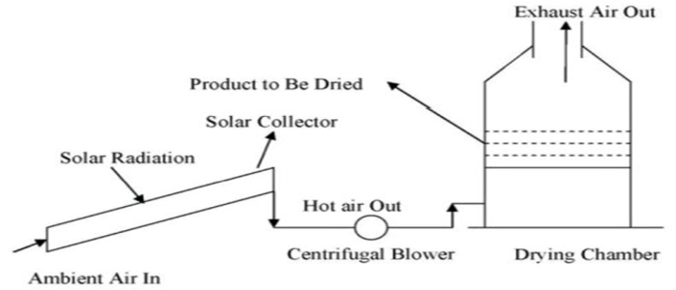
Fig. 1- fig shows schematic diagram of experimental set-up
V-shaped, Square shaped, Transverse wedge shaped turbulator are used. The systematic view of turbulator used in this investigation is given in fig.2. These turbulator are attached in test section by screw arrangement in front portion of the absorber surface. These turbulator are mounted on the heating top surface.

Fig. 2- fig shows different shapes of Turbulators
Four test sections are prepared for experimentation purpose. One test section in experimental procedure validated by running through the solar collector without using any turbulator i.e flat flate collector. In second phase the experimentation is carried out by using various shapes of turbulator inside the solar collector and compared their performance with each other.
RESULTS AND DISCUSSIONS
In this study, three absorber plate with different turbulators and simple flat plate collector were chosen for investigation. The heat carried away by air and collector efficiency were calculated from data obtain from each collector. The experimental results were represented in the form of graphs. In this study, simple method is used for evaluation. In each day, separate collector with turbulator is chosen for experimentation. In one hour, five readings were taken at a interval of 10 minutes at different air flow rate. During experimentation, there is not necessarily clear sky condition.
During experimentation, Heat transfer coefficient, Reynolds number, Nusselt number, mass flow rate and friction factor of each type of turbulator was find out and those results were compared with simple flat plate collector ( without turbulator ) and results were shown in the form of graph are as follows.
Variation of Heat transfer coefficient with respect to Reynolds number is shown in fig 3. It is observed that the heat transfer coefficient increases with increase in Reynolds number. As Reynolds number increases, the air flow will cause more turbulence, so due to which the heat transfer rate will increase. It is also observed that the flat plate collector gives less heat transfer coefficient than with the use of Transverse wedge shaped turbulator. Transverse wedge shaped rib create more turbulence in channel, this is because; due to addition of turbulators on absorber plate results in Swirling effect which enhances the heat transfer rate with increase in Reynolds number. Variation of Nusselt number with and without Turbulator on absorber plate with respect to Reynolds number is shown in fig.4. It is observed that there is increase in Nusselt number with Reynolds number.
.
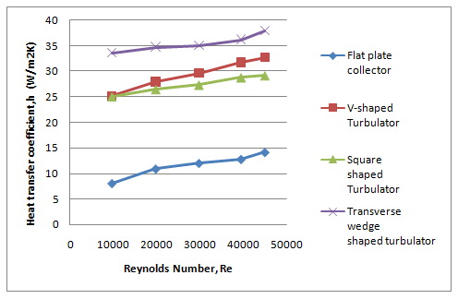
Fig. 3– fig shows variation of Heat transfer coefficient for different test specimens
As Reynolds number increases the air flow will cause more turbulence due to which heat transfer rate will increase. As heat transfer coefficient is directly proportional to Nusselt number, Nu= hD/k i.e increase in heat transfer coefficient increases the Nusselt number. From fig.4, it is observed that maximum Nusselt number is obtained for Transverse wedge shaped rib and least Nusselt number is obtained for Flat plate collector.
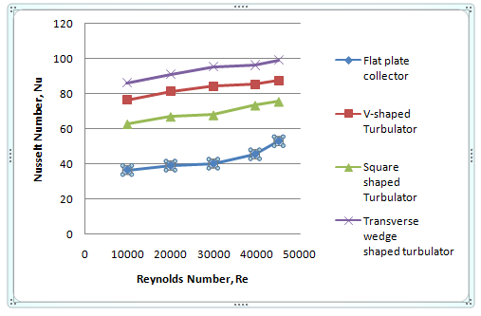
Fig. 4– fig shows variation of Nusselt number for all test specimen for different test specimen
Fig.5 shows variation of mass flow rate with respect to Heat transfer coefficient for different test specimen. From the fig.5, it is observed that the heat transfer coefficient increases with increase in mass flow rate. As mass flow rate are increases, the air flow will cause more turbulence so definitely the heat transfer rate will increase. From the fig.5, it is observed that the rectangular Flat plate collctor without any turbulator gives least heat transfer coefficient. Use various shaped turbulators increases the heat transfer coefficient. Transverse wedge shaped turbulator gives maximum value of heat transfer coefficient as compared with other turbulators. 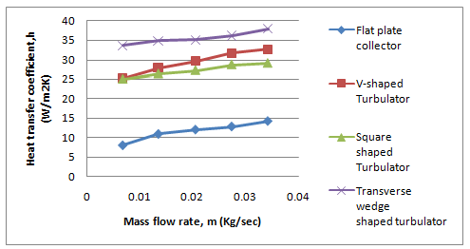
Fig.5– fig shows variation of Mass flow rate with Heat transfer Coefficient for different test specimen
From the fig.6, it is observed that as Reynolds number increases there is increase in friction factor is observed. This is because friction factor is inversely proportional to the velocity, So as velocity increases (i.e. Reynolds number) friction factor will decrease. From fig.6, it is observed that least friction factor is obtained in flat plate collector without turbulator and maximum friction factor is observed in Transverse wedge shaped rib.
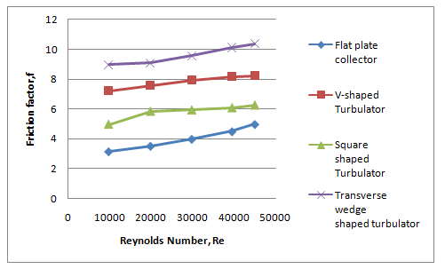
Fig.6– fig shows variation of Friction factor with Reynolds number for different test specimen
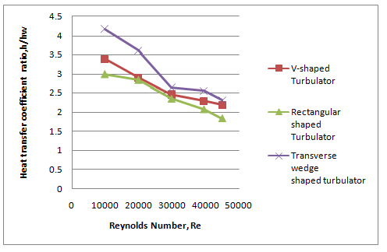
Fig. 7– fig shows variation of Heat transfer coefficient ratio Vs Reynolds number for different test specimen

From the fig.7, it is observed that as the Reynolds number increases there is decrease in the heat transfer coefficient ratio where as for some Reynolds number it is increasing but if we observe the overall heat transfer coefficient ratio it goes on decreasing with increase in Reynolds number.
CONCLUSION
In present work, three type of solar collector with different shaped turbulator were experimented and the comparison is made between all three collector with simple flat plate air collector .From testing on these collector, following conclusions can be derived
- Transverse wedge shaped turbulator have higher heat transfer rate as compare to that of remaining absorber plate with and without turbulator.
- Increase in Nusselt number of air higher for transverse wedge shaped turbulator is higher for V-shaped turbulator and is also higher for Square shaped turbulator as compared to that of flat plate collector (without turbulator).
- Average heat transfer coefficient is higher for transverse wedge shaped turbulator than that of remaining turbulators, due to addition of turbulator air gets maximum time to make more surface contact with absorber plate which cause enhancement in temperature and which indirectly causes enhancement in heat transfer rate .
- Friction factor reduces as the Reynolds number increases. This is because with increase in Reynolds number velocity increases and friction factor is inversely proportional to velocity which as frictional factor increases then velocity will be decrease.
- The friction factor found to be maximum in Transverse wedge shaped turbulator.
REFERENCES
- MominA.M.E ,Saini.J.S , Solanki.S.C, Heat transfer and friction in solar air heater duct with V-shaped rib roughness on absorber plate , International Journal Heat Mass Transfer 45(2002) 3383-96.
- Amin Ebrahimi, Benyamin Naranjanir,An investigation on thermo-hydraulic performance of a flat-plate channel with pyramidal protrusions , Applied Thermal Engineering 186 (2016) 316-324.
- Saini RP, Saini JS. Heat transfer and friction factor correlations for artificially roughened ducts with expanded metal mesh as roughened element. Int J Heat Mass Transfer 1997;40(4):973–86.
- Bhagoria JL, Saini JS, Solanki SC. Heat transfer coefficient and friction factor correlations for rectangular solar air heater duct having transverse wedge shaped rib roughness on the absorber plate.Renewable Energy 25(2002) 341–69.
- Prasad BN, Saini JS. Effect of artificial roughness on heat transfer and friction factor in a solar air heater. Solar Energy 41(1988) 555–60.
- Chii-Dong Ho, Ching-Fang Hsiao ,Hsuan Chang , Yi- En Tien,Investigation of device performance for recycling double-pass V-corrugated solar air collector,Energy Procedia 105 (2017) 28-34.
- Han JC, Zhang YM. High performance heat transfer ducts with parallel, broken and V-shaped broken ribs. Int J Heat Mass Transfer1992;35(2):513–23.
- Chii-Dong Ho,Hsuan Chang , Chun-Sheng Lin , Chun-Chief Chao. Analytical and experimental studies of wire mesh packed double-pass solar air heaters under recycling operation. ,Energy Procedia 75 (2015) 403-409.
- M.K.Mittal ,R.P.Saini , S.K.Singal , Effective efficiency of solar air heater having different types of roughness elements on absorber plate , Energy 32 (5) (2007) 739-745.
- Anil kumar,Analysis of heat transfer and fluid flow in different shaped roughness elements on the absorber plate solar air heater duct, Energy procedia 57 (2014) 2102-2111Suleyman Karsli.,Performance analysis of new-design solar air collectors for drying applications, Ataturk University, Pasinler Meslek YuksekOkulu, Pasinler, Erzurum 25300, Turkey,Renewable Energy 32(2007) 1645-1660.
- Hans.V.S ,Saini.R.P , Saini. J.S , Heat transfer and friction factor correlations for a solar air heater duct roughened artificially with multiple V-ribs , Solar Energy, 84, 2010, pp.898-911.
- Sunil Chamoli , A Taguchi approach for optimization of flow and geometrical parameters in a rectangular channel roughened with V down perforated baffles , Songklanakarian J. Sci.Technol. 36(2) (2014) 201-208.
- Vipin B. Gawande ,A.S.Dhoble , D.B.Zodpe , Sunil Chamoli,Analytical approach for evaluation of thermos hydraulic performance of roughened solar air heater , J.Sci.Technol. 8 (2016) 19-31.
- Varun Naveen Sharma , I.K.Bhat,D.Groover , Optimization of smooth flat plate solar air heater using stochastic iterative perturbation technique , Solar Energy 85 (9) (2011) 2331-2337.

