Contents

1. INTRODUCTION 2

1.1. Brief Introduction 2

1.1.1. Concrete 2

1.1.2. Plastic 2

1.2. Historical Perspective of FRC 6

1.3. Fibre Reinforced Concrete (FRC) and It’s Types 6

1.3.1. Effect of fibers in concrete: 7

1.3.2. Factors Affecting Properties of Fiber Reinforced Concrete: 8

1.3.3. Types of FRC: 10

2. LITERATURE REVIEW 13

3. PROBLEM IDENTIFICATION 19

4. METHODOLOGY 20

4.1. Materials Used and their Properties: 20

4.1.1. Cement 20

4.1.2. Coarse Aggregate 21

4.1.3. Fine Aggregate 22

4.1.4. Water 23

4.1.5. Plastic Fibers 23

# 1. INTRODUCTION

## 1.1. Brief Introduction

1.1.1. Concrete is a multipurpose material for civil engineering construction. It has many beneficial properties such as good compressive strength, durability, specific gravity and fire resistance. Concrete in its simplest form requires three basic components - cement (the binder), aggregates (ranging in size from fine to coarse) and water. Concrete's constituent materials are available naturally in all parts of the world but with the increasing requirement of concrete in various construction industries, these materials are getting scarce day by day.

Some Facts Related to Concrete Consumption:

* Concrete is the 2nd most consumed substance in the world-behind water.
* Statists estimate that in 2020, the total world production of cement will reach 4.4 billion metric tons.
* Concrete can last for thousands of years. The oldest known man-made concrete mix dates back to around 500 BC.
* As of 2006, about 7.5 billion cubic meters of concrete are made each year, more than one cubic meter for every person on Earth.
* The concrete consumption in India by various construction industries is around 370 million m3 per year and it is expected to increase by 30 million m3 every year.

1.1.2. Plastic - The word plastic derives from the Greek πλαστικός (plastikos) meaning "capable of being shaped or moulded" and, in turn, from πλαστός (plastos) meaning "moulded."

Plastics are (mostly) synthetic (human-made) materials, made from polymers, which are long molecules built around chains of carbon atoms, typically with hydrogen, oxygen, sulphur, and nitrogen filling in the spaces. You can think of a polymer as a big molecule made by repeating a small bit called a monomer over and over again; "poly" means many, so "polymer" is simply short for "many monomers." If you think of how a long coal train is made from many trucks coupled together, that's what polymers are like. The trucks are the monomers and the entire train, made from lots of identical trucks, is the polymer. Where a coal train might have a couple of dozen trucks, a polymer could be built from hundreds or even thousands of monomers. Most plastics contain organic polymers. The vast majority of these polymers are formed from chains of carbon atoms, 'pure' or with the addition of: oxygen, nitrogen, or sulphur. The chains comprise many repeat units, formed from monomers. Each polymer chain will have several thousand repeating units. In other words, polymers typically have very large and heavy molecules.

**How Plastics are made: -** We've already seen that plastics are made from polymers, but how are polymers made? They're based on hydrocarbons (molecules built from hydrogen and carbon atoms) that we get mostly from things like petroleum, natural gas, or coal. Crude oil drilled from the land or sea is a thick gloopy mixture that contains thousands of different hydrocarbons, which have to be separated out before we can use them. That happens in an oil refinery, through a process called fractional distillation. It's a more involved version of the distillation you might have used to purify water. If we heat water, it eventually turns into steam, which we can then collect, cool, and condense back to water; that's distillation, and it produces highly purified or "distilled" water. We can heat and distil crude oil the same way, but all those many hydrocarbons it contains have molecules that are different sizes and weights, so they boil off and condense at different temperatures. Collecting and distilling the different parts of crude oil at different temperatures gives us a bunch of simpler mixtures of hydrocarbons, called fractions, which we can then use for making different types of plastics.

Hydrocarbons made in this way are the raw materials for polymerization, the name we give to the chemical reactions that make polymers. Some polymers are made simply by fastening hydrocarbon monomers together, like daisy chains, which is a process called addition polymerization. Others are made by joining together two small hydrocarbon chains and removing a water molecule (two hydrogen atoms and one oxygen), making a bigger hydrocarbon chain in a process known as condensation polymerization. The more often you repeat this, the longer the polymer gets.

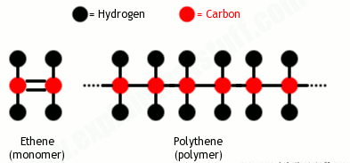

***Fig. 1.1 How Polymers are made from Monomers***

**Properties of Plastic:-**

Physical properties, such as: hardness, density, tensile strength, resistance to heat.

Chemical properties, such as the organic chemistry of the polymer and its resistance and reaction to various chemical products and processes, such as: organic solvents, oxidation, and ionizing radiation. In particular, most plastics will melt upon heating to a few hundred degrees Celsius.

**There are many different types of plastics, and they can be grouped into two main polymer families:**

* Thermoplastics (which soften on heating and then harden again on cooling).
* Thermosets (which never soften once they have been moulded).

**Common Plastics:**

This category includes both commodity plastics, or standard plastics, and engineering plastics.

* Polyamides (PA) or (nylons) – fibers, toothbrush bristles, tubing, fishing line and low-strength machine parts such as engine parts or gun frames
* Polycarbonate (PC) – compact discs, eyeglasses, riot shields, security windows, traffic lights and lenses
* Polyester (PES) – fibers and textiles
* Polyethylene (PE) – a wide range of inexpensive uses including supermarket bags and plastic bottles
* High-density polyethylene (HDPE) – detergent bottles, milk jugs and molded plastic cases
* Low-density polyethylene (LDPE) – outdoor furniture, siding, floor tiles, shower curtains and clamshell packaging
* Polyethylene terephthalate (PET) – carbonated drinks bottles, peanut butter jars, plastic film and microwavable packaging
* Polypropylene (PP) – bottle caps, drinking straws, yogurt containers, appliances, car fenders (bumpers) and plastic pressure pipe systems
* Polystyrene (PS) – foam peanuts, food containers, plastic tableware, disposable cups, plates, cutlery, compact-disc (CD) and cassette boxes
* High impact polystyrene (HIPS) – refrigerator liners, food packaging and vending cups
* Polyurethanes (PU) – cushioning foams, thermal insulation foams, surface coatings and printing rollers: currently the sixth or seventh most commonly-used plastic, for instance the most commonly used plastic in cars
* Polyvinyl chloride (PVC) – plumbing pipes and guttering, electrical wire/cable insulation, shower curtains, window frames and flooring.
* Polyvinylidene chloride (PVDC) – food packaging

**Some Facts Related to Plastic Consumption:-**

* Since the 1950s, around 8.3 billion tons of plastic have been produced worldwide. That’s equivalent to the weight of more than 800,000 Eiffel Towers.
* Only 9% of it has been recycled worldwide.
* A million plastic bottles are bought around the world every minute.
* Plastic is killing more than 1.1 million seabirds and animals every year.
* 90% of the trash floating in our oceans is made of plastic, around 46,000 pieces per square mile.
* A plastic bottle takes between 450-1000 years to decompose.
* A study conducted in 2015 showed that in 2010-12 India generated 25, 940 tonnes of plastic waste daily.
* Annual plastic consumption in India is expected to increase from 12 million tonnes in 2015-16 to 20 million tonnes by 2020

|  |  |  |
| --- | --- | --- |
| **S. No.** | **Year** | **Consumption  (Tonnes)** |
| 1. | 1996 | 61,000 |
| 2. | 2000 | 3,00,000 |
| 3. | 2001 | 4,00,000 |
| 4. | 2007 | 8,500,000 |

***Table 1.1 Plastics Consumption in India***

*(Source: Central Pollution Control Board)*

Thus both the problems- disposal of plastic waste and absence of concrete's constituent materials can be effectively managed by using the plastic waste in concrete. Use of plastic waste materials not only helps in getting them utilized in cement concrete but also helps in reducing the cost of cement and concrete manufacturing. It has also numerous indirect benefits such as decrease in landfill cost, saving in energy, and protecting the environment from possible pollution effects. Various properties of concrete like ductility, durability and tensile strength can be improved by efficiently using plastic waste in concrete. Moreover using plastic waste in concrete decreases its weight also and thus buildings can be made more earthquake resistant by using plastic waste in concrete.

The usage of plastic fibres in the concrete improves the mechanical properties of concrete. Taking into account that concrete will continue to be the main construction material in the future, several research projects have showed that it was possible to use plastic waste in concrete.

## 1.2. Historical Perspective of FRC

The concept of using fibers as reinforcement to construction material dates back to the ancient times. When horse hair, straws were used to strengthen the bricks. In 1911 Porter found that fiber could be used in concrete. Early 1900 saw the use of asbestos fiber. In 1950 fiber reinforced concrete was becoming a field of interest as asbestos being a health risk was discovered. In 1963 Romualdi and Batson published their classic paper on FRC. Since then there was no looking back, glass, steel, polypropylene fiber were used in concrete. Research into new fiber-reinforced concretes continues today.

## 1.3. Fibre Reinforced Concrete (FRC) and It’s Types

Fibre Reinforced Concrete (FRC) - is [concrete](https://en.wikipedia.org/wiki/Concrete) containing fibrous material which increases its structural integrity. It contains short discrete [fibers](https://en.wikipedia.org/wiki/Fiber) that are uniformly distributed and randomly oriented. Fibers include steel fibers, [glass fibers](https://en.wikipedia.org/wiki/Glass_fiber_reinforced_concrete), [synthetic fibers](https://en.wikipedia.org/wiki/Synthetic_fiber) and [natural fibers](https://en.wikipedia.org/wiki/Natural_fiber) – each of which lend varying properties to the concrete. In addition, the character of fiber-reinforced concrete changes with varying concretes, fiber materials, geometries, distribution, orientation, and densities. Fiber is a small piece of reinforcing material possessing certain characteristics properties. They can be circular or flat. The fiber is often described by a convenient parameter called “aspect ratio”. The aspect ratio of the fiber is the ratio of its length to its diameter. Typical aspect ratio ranges from 30 to 150. Fibre-reinforcement is mainly used in shotcrete, but can also be used in normal concrete. Fibre-reinforced normal concrete are mostly used for on-ground floors and pavements, but can be considered for a wide range of construction parts (beams, pliers, foundations etc.) either alone or with hand-tied rebars. Recently, fiber reinforced concrete has already been used for roads, bridges, aircraft runways, pipes, roofs, wall panels, and other elevations.

### 1.3.1. Effect of fibers in concrete:

Fibers are usually used in concrete to control cracking due to plastic shrinkage and to drying shrinkage. They also reduce the permeability of concrete and thus reduce bleeding of water. Some types of fibers produce greater impact–, abrasion–, and shatter–resistance in concrete. Generally fibers do not increase the flexural strength of concrete, and so cannot replace moment–resisting or structural steel reinforcement. Indeed, some fibers actually reduce the strength of concrete.

The amount of fibers added to a concrete mix is expressed as a percentage of the total volume of the composite (concrete and fibers), termed "volume fraction" (Vf). Vf typically ranges from 0.1 to 3%. The aspect ratio (l/d) is calculated by dividing fiber length (l) by its diameter (d). Fibers with a non-circular cross section use an equivalent diameter for the calculation of aspect ratio. If the fibre’s modulus of elasticity is higher than the matrix (concrete or mortar binder), they help to carry the load by increasing the tensile strength of the material. Increasing the aspect ratio of the fiber usually segments the flexural strength and toughness of the matrix. However, fibers that are too long tend to "ball" in the mix and create workability problems.

**How do fibres work?**

The mechanical behaviour of fibre reinforced concrete (FRC) depends largely on the interactions between the fibres and the brittle concrete matrix: physical and chemical adhesion; friction; and mechanical anchorage induced by complex fibre geometry or by deformations or other treatments on the fibre surface. As FRC is stressed (either by external loads or by shrinkage or thermal stresses), there is initially elastic stress transfer between the fibres and the matrix. Because the fibres and the matrix have very different elastic moduli, shear stresses develop at the fibre/matrix interface. When the shear stress at the interface is exceeded, de-bonding gradually begins to occur, and frictional shear stresses become the dominant stress transfer mechanism. At some point during this gradual transition from elastic to frictional stress transfer, some cracking of the matrix occurs, and some frictional slip occurs in the de-bonded areas.

Of course, we are primarily interested in how the fibres in FRC inhibit crack extension once the matrix has cracked, i.e., how they behave in the post-cracking zone. This is governed primarily by the nature of the pull out of the fibres from the matrix. It must be emphasized that failure by fibre pull-out is much the preferred mode of failure of FRC; much more energy is consumed in pulling the fibres out of the matrix than in breaking them. It is possible to define a critical length, lc, at which the fibres break rather than pulling out. This must be taken into account when designing or choosing fibres for a particular application. In a properly designed FRC, following the appearance of the first crack, a process of multiple cracking begins, in which the brittle matrix cracks into successively smaller segments (held together by the fibres bridging these cracks). This leads to toughening of the composite. The crack width and crack spacing during this process can be controlled by proper selection of the fibres and the matrix.

As stated above, straight, smooth fibres cannot develop sufficient adhesional or frictional bond to be efficient; thus, essentially all of the fibres presently used in practice are deformed in some way, or are surface treated, to increase the bonding with the matrix. This turns out to be much more significant than the fibre length in controlling the degree of bonding.

### 1.3.2. Factors Affecting Properties of Fiber Reinforced Concrete:

1. **Relative Fiber Matrix Stiffness -** The modulus of elasticity of matrix must be much lower than that of fiber for efficient stress transfer. Low modulus of fiber such as nylons and polypropylene are, therefore, unlikely to give strength improvement, but the help in the absorption of large energy and therefore, impart greater degree of toughness and resistance to impart. High modulus fibers such as steel, glass and carbon impart strength and stiffness to the composite. Interfacial bond between the matrix and the fiber also determine the effectiveness of stress transfer, from the matrix to the fiber. A good bond is essential for improving tensile strength of the composite.
2. **Volume of Fibres -** The strength of the composite largely depends on the quantity of fibers used in it. It is observed that the increase in the volume of fibers, increase approximately linearly, the tensile strength and toughness of the composite. Use of higher percentage of fiber is likely to cause segregation and harshness of concrete and mortar.
3. **Aspect Ratio of the Fiber -** Another important factor which influences the properties and behaviour of the composite is the aspect ratio of the fiber. It has been reported that up to aspect ratio of 75, increase on the aspect ratio increases the ultimate concrete linearly. Beyond 75, relative strength and toughness is reduced.
4. **Orientation of Fibers -** One of the differences between conventional reinforcement and fiber reinforcement is that in conventional reinforcement, bars are oriented in the direction desired while fibers are randomly oriented. To see the effect of randomness, mortar specimens reinforced with 0.5% volume of fibers were tested. In one set specimens, fibers were aligned in the direction of the load, in another in the direction perpendicular to that of the load, and in the third randomly distributed. It was observed that the fibers aligned parallel to the applied load offered more tensile strength and toughness than randomly distributed or perpendicular fibers.
5. **Workability and Compaction of Concrete -** Incorporation of steel fiber decreases the workability considerably. This situation adversely affects the consolidation of fresh mix. Even prolonged external vibration fails to compact the concrete. The fiber volume at which this situation is reached depends on the length and diameter of the fiber. Another consequence of poor workability is non-uniform distribution of the fibers. Generally, the workability and compaction standard of the mix is improved through increased water/ cement ratio or by the use of some kind of water reducing admixtures.
6. **Mixing -** Mixing of fiber reinforced concrete needs careful conditions to avoid balling of fibers, segregation and in general the difficulty of mixing the materials uniformly. Increase in the aspect ratio, volume percentage and size and quantity of coarse aggregate intensify the difficulties and balling tendency. Steel fiber content in excess of 2% by volume and aspect ratio of more than 100 are difficult to mix. It is important that the fibers are dispersed uniformly throughout the mix; this can be done by the addition of the fibers before the water is added. When mixing in a laboratory mixer, introducing the fibers through a wire mesh basket will help even distribution of fibers. For field use, other suitable methods must be adopted.

**Advantages of Fibre Reinforced Concrete:**

* Improve mix cohesion, improving pumpability over long distances
* Improve freeze-thaw resistance
* Improve resistance to explosive spalling in case of a severe fire
* Improve impact– and abrasion–resistance
* Increase resistance to plastic shrinkage during curing
* Improve structural strength
* Reduce steel reinforcement requirements
* Improve ductility
* Reduce crack widths and control the crack widths tightly, thus improving durability.

### 1.3.3. Types of FRC:

1. Steel Fiber Reinforced Concrete
2. Polypropylene Fiber Reinforced (PFR) cement mortar & concrete
3. GFRC Glass Fiber Reinforced Concrete
4. Asbestos Fibers
5. Carbon Fibers
6. Organic Fibers

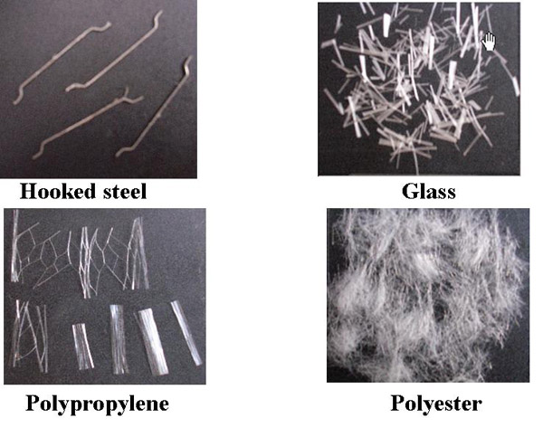

***Fig. 1.2 Different Types of Fibres***

**Polypropylene Fiber Reinforced (PFR) cement mortar and concrete:**

Polypropylene is one of the cheapest & abundantly available polymers polypropylene fibers are resistant to most chemical & it would be cementitious matrix which would deteriorate first under aggressive chemical attack. Its melting point is high (about 165 degrees centigrade). So that a working temp. As (100 degree centigrade) may be sustained for short periods without detriment to fiber properties. Polypropylene fibers being hydrophobic can be easily mixed as they do not need lengthy contact during mixing and only need to be evenly distressed in the mix. Polypropylene short fibers in small volume fractions between 0.5 to 15 commercially used in concrete. Used as secondary reinforcement, polypropylene fibers help reduce shrinkage and control cracking. To use these fibers, concrete mix design does not have to be altered, and no special equipment or slump modifications are required, even for pumping or shotcreting.

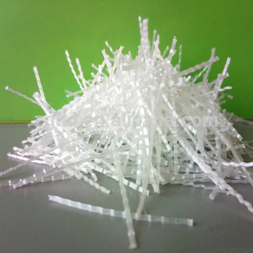  
***Fig. 1.3 Polypropylene Fibres***

**Polyethylene terephthalate (PET)**

It is the most common thermoplastic polymer resin of the polyester family and is used in fibres for clothing, containers for liquids and foods, thermoforming for manufacturing, and in combination with glass fibre for engineering resins. Worldwide, 480 billion plastic drinking bottles were made in 2016 (and less than half were recycled)

The majority of the world's PET production is for synthetic fibres (in excess of 60%), with bottle production accounting for about 30% of global demand. In the context of textile applications, PET is referred to by its common name, polyester, whereas the acronym PET is generally used in relation to packaging. Polyester makes up about 18% of world polymer production and is the fourth-most-produced polymer after polyethylene (PE), polypropylene (PP) and polyvinyl chloride (PVC). PET consists of polymerized units of the monomer ethylene terephthalate, with repeating (C10H8O4) units. Plastic bottles made from PET are widely used for soft drinks.

PET in its natural state is a colourless, semi-crystalline resin. Based on how it is processed, PET can be semi-rigid to rigid, and it is very light-weight. It is strong and impact-resistant.

Polyethylene terephthalate is produced from ethylene glycol and dimethyl terephthalate (DMT) (C6H4(COCH3)2) or terephthalic acid.

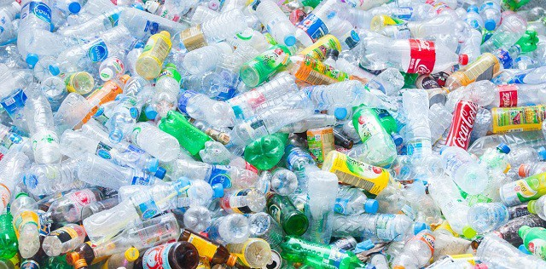

***Fig 1.4 Used PET Bottles***

# 2. LITERATURE REVIEW

Keeping in mind the end goal to contextualize the current work, related works from literature are examined and gives an extensive survey of the work done by different researchers in the field of using used Plastic Fiber as an additive in concrete.

2.1. Venu Malagavell and Neelakanteswara Rao Patura,(2011), “Strength Characteristics of Concrete Using Solid Waste an Experimental Investigation”

They concluded concrete is a mixture of cement, fine aggregate, coarse aggregate and water. Concrete plays a vital role in the development of infrastructure, buildings, industrial structures, bridges and highways etc. leading to utilization of large quantity of concrete. Solid waste disposal i.e. water bottles, polythene bags, disposable glasses, cement bags, cool drink bottles etc. was creating lot of environmental problems. An attempt has been made in this study by using solid waste (non-biodegradable) material in the concrete. Fibre Reinforced Concrete (FRC) is an emerging field in the area of Concrete Technology. This study mainly focused on the use of cement bags waste (High Density Polyethylene (HDPE)) in concrete. Concrete having compressive strength of 30 N/mm2 was used for this study. Cubes, cylinders and beams are casted with 0 to 6% of fibre with 0.5% increment. Samples were tested for the compressive strength, split tensile strength and Flexural strength and comparison analysis was made for the conventional concrete and modified concrete. It has been found that, increase in the compressive strength, split tensile strength and flexural strength of concrete by using the fibres up to some extent.

2.2. R.Kandasamy and R.Murugesan(2011), “Fibre Reinforced Concrete Using Domestic Waste Plastics as Fibres”

Fibre Reinforced Concrete (FRC) is a composite material consisting of cement based matrix with an ordered or chance division of fibre which can be Steel, Nylon, Polythene and etc. The addition of steel fibre increases the properties of concrete, viz., flexural strength, impact strength and shrinkage properties to name a few. A number of papers have previously been published on the use of steel fibres in concrete and a considerable amount of research has been directed towards study the various properties of concrete as well as reinforced concrete due to the addition of steel fibres. Hence, an attempt has been complete in the present investigations to study the influence of addition of polythene fibres (domestic waste plastics) at a dosage of 0.5% by weight of cement. The properties studied include compressive strength and flexural strength. The study were conducted on a M20 mix and tests have been carried out as per recommended procedures of pertinent codes.

2.3. ZainabZ Ismail and EnasaAl-Hashmi (2011), “Validation of Using Mixed Iron and Plastic Wastes in Concrete”

The reason of this paper is to evaluate the possibility of using mixed iron filings and granulated plastic waste materials simultaneously to partially alternative the fine aggregate in concrete composites. Type I Portland cement was mixed with the aggregates to create the concrete composites. Three weight fractions (30, 40, and 50%) of iron filings waste aggregate were used along with 5% of granulated plastic waste. The slump, compressive and flexural strengths as well as the fresh and hard density of the concrete mixture were determined. The results of the mechanical properties were analysed in comparison to the control specimens. The main findings of this investigation revealed that the mixture of iron filings and plastic waste materials could be used successfully as partial

substitutes of sand in concrete composites. Raising the granulated plastic waste in the mixed aggregate waste materials up to 10% did not seriously hinder the strength properties of the waste-concrete specimens.

2.4. Rajat Saxenaa, Abhishek Jaina And Yash Agrawala (2016), “Utilization of Waste Plastic in Concrete Towards Sustainable Development: A Review”

This review paper has presented aspects on plastic waste and its usage in concrete, which could be summarized and concluded as:

* According to prior test studies, it refers that plastic waste can be utilized in concrete up to certain limit without much effecting the properties of concrete.
* Plastic waste has control on the workability property of concrete. Slump value and the compaction factor decreased with the increase in amount of plastic waste in concrete.
* Different studies demonstrates that strength of concrete containing plastic waste were comparable to that of reference concrete up to certain limits.
* Concrete produced by using plastic waste has durability properties comparable to that of reference concrete up to certain limits.
* Use of plastic waste in concrete mix proved exceptionally helpful to produce green sustainable concrete.

2.5. A. Ananthi, A. Jay Tamil Eniyan, S. Venkatesh (2017), “Utilization of Waste Plastics as a Fiber in Concrete”

Based on the test result, the following conclusions are made.

* The compressive strength and split tensile strength increases to maximum when 0.9% of plastic fibres are added to conventional concrete.
* The compressive strength increases to 40.3% than conventional concrete at 7 days.
* The compressive strength increases to 28.5% than conventional concrete at 28 days.
* The split tensile strength increases to 54.8% than conventional concrete at 7 days.
* The split tensile strength increases to 54.4% than conventional concrete at 28 days.

2.6. Sampada Chavan, Pooja Rao (2016), “Utilization of Waste PET Bottle Fibers in Concrete as an Innovation in Building Materials- [A Review Paper]”

PET (polyethylene terephthalate) bottles have increasingly become an indispensable part of a common man’s life. With the phenomenal increase in plastic consumption the problems with plastic waste disposal have also aggravated. Our voracious appetite for PET bottles coupled with the undeniable behavioural propensity of increasingly over consuming, discarding, littering and thereby polluting the natural environment makes it a lethal combination. Hence the need arises to route the waste plastic bottles to their optimum usage. That is why utilization of waste PET bottles has become an attractive alternative for disposal. This review paper reports the properties of concrete when waste PET bottles are used in fiber form as aggregates in reinforced plain concrete. The aim of the paper is to analyse and study the different experiments, case studies based on researches and experimental works and scientific reports to determine the improvement in selected properties of PET fiber reinforced concrete. Also to convey that the use of PET fibers as reinforcement of cement composites is a promising technique for developing sustainable materials to be applied in the civil construction industry. And hence concrete with waste PET bottle fiber can be used not only as an effective plastic waste management practice but also as a strategy to produce more economic and sustainable building materials in the future.

Case studies based on researches and experimental works and scientific reports have proved that waste PET may be applied for the modification of concretes. The incorporation of PET bottle fibers as reinforcement in concrete has shown, on the basis of different tests on its mechanical properties, that there is a significant improvement in the modified concrete. The use of PET fibers as reinforcement of cement composites is a promising technique for developing sustainable materials to be applied in the civil construction industry. And hence concrete with waste PET bottle fiber can be used not only as an effective plastic waste management practice but also as a strategy to produce more economic and sustainable building materials in the future.

2.7. J.M. Irwan1, R.M. Asyraf, N. Othman, H.B. Koh, M.M.K. Annas

and Faisal S.K. “The Mechanical Properties of PET Fiber Reinforced Concrete From

Recycled Bottle Wastes”

This research is carried out to investigate the performance of concrete containing Polyethylene Terephthalate (PET) bottle waste as fiber. PET bottle waste was chosen because it is being thrown after single use and cause environmental problem. One way to recycle wasted PET bottles is grinded into irregular fiber. Then, it was incorporate with the concrete and test the performance of the concrete. The study was conducted using cylindrical mold of concrete to investigate the performance of the concrete in term of mechanical properties. A total of four batches of concrete were produced namely, normal concrete and concrete containing PET fiber of 0.5%, 1.0% and 1.5% fraction volume. In this research, the mechanical properties that were measured are compressive strength, splitting tensile strength and modulus of elasticity (MOE) following British Standard method. The results revealed that the presence of PET fiber in concrete will increase the concrete performance. Nevertheless, the content of PET fiber was specified in a specific limit to avoid effect of concrete strength.

This paper presented the results of mechanical properties of PET FRC which are compressive strength, splitting tensile strength, and modulus of elasticity. Comparison with normal concrete is also presented. The compressive strength, tensile splitting strength and modulus of elasticity value have increase with 0.5% PET fiber content in the concrete mix in compare to normal concrete. Concrete containing 1% and 1.5% PET fiber is lower than the normal concrete in compressive and splitting tensile strength and elastic modulus. Therefore it is concluded that, the fiber content will affect the strength of the concrete. The strong fibers are desired and used to improve concrete strength and ductility, but may lead to loss in segregation, increased porosity, and overall reduction in concrete strength. In addition, high dosages of fiber will cause workability problems because of their relatively surface area. The addition of this essentially PET fiber is an option to construction industry. It is a better means of recycling waste plastic resulted to a sustainable environment.

2.8. Youcef Ghernouti, Bahia Rabehi, Brahim Safi and Rabah Chaid, “Use of Recycled Plastic Bag Waste in the Concrete”

The aim of this study is to explore the possibility of re-cycling a plastic bag waste material (BBW) that is now produced in large quantities in the formulation of concrete as fine aggregate by substitution of a variable percentage of sand (10, 20, 30 and 40 %). The influence of the PBW on the fresh and hardened states properties of the concrete: workability, bulk density, ultrasonic pulse velocity testing, compressive and flexural strength of the different concretes, has been investigated and analysed in comparison to the control concrete. The results showed that the use of PBW improves the workability and the density, reduces the compressive strength of concrete containing 10 and 20 % of waste by 10 to 24 % respectively, which have a mechanical strength acceptable for lightweight materials, remains always close to reference concrete (made without PBW). The results of this investigation consolidate the idea of the use of PBW in the field of construction, especially in the formulation of concrete.

This study investigates the valorisation of plastic bag waste as fine aggregate in field of construction. The effects of an incorporation of this waste on the physic mechanical properties of the concrete have been analysed. The following main conclusions can be drawn:

* The bulk density has decreased considerably for all concrete’s with the content of replacement of sand by plastic waste that also becomes than lighter with 40% of plastic waste. -Being given that the concrete must have good workability, fluidity is significantly improved by the presence of this waste.
* A reduction in the mechanical resistance according to the increase in percentage of plastic bag waste, which remains always close to the reference concrete, when we recorded a fall of compressive strength at 28 days about 10 and 24 % or the concrete’s containing 10 and 20 % of waste respectively.

Finally, PBW aggregates can be used successfully to replace conventional aggregates in concrete without any long term detrimental effects and with acceptable strength development properties.

2.9. Debu Mukherjee, Aritra Mandal1, Parvez Akhtar, Abhishek Basu, “Studies on Mechanical Properties of Plasti-Fibre Reinforced Concrete”

The most commonly used construction material across the world is concrete. The construction industries are looking for making it “greener” by reducing its ecological effects on environment and they are in need of finding cost effective materials for increasing the strength of concrete structures. On the other hand, the non-recyclable pollutants like plastics, rubber, tin, etc. come out from the industries results in an increasing environmental threat. So the use of non-recyclable materials for preparation of concrete can be an encouraging act. Utilization of waste materials and by-products can be a partial solution to environmental and ecological problems. Use of these materials not only helps in getting them utilized in cement concrete and other construction materials, but also helps in reducing the cost of cement and concrete manufacturing. It has also numerous indirect benefits such as reduction in landfill cost, saving in energy, and protecting the environment from possible pollution effects. The use of plasti-fibre in cement concrete has not yet been investigated. This paper covers the mechanical properties of plasti-fibre reinforced concrete (PFRC) prepared from hand shredded plasti-fibres consisting Polyethylene plastic bags of 40 microns and PET bottles. The compressive strength and flexural strength of normal M20 grade PFRC were evaluated after 7days, 14days & 28days and compared with the conventional concrete i.e., normal M20 mix (1:1.5:3) by adding the plasti-fibre by 0.2% & 0.4% of total weight of concrete (30kgs) that has been the aim of this research work. The main findings of this investigation revealed that the plastic waste materials could be used successfully as an addition to concrete composites. Due to exceptionally low density, recycled polymer modified blocks and concrete can be used in non-load bearing structures, floating structures and where lightweight materials recommended.

# 3. PROBLEM IDENTIFICATION

# 4. METHODOLOGY

## 4.1. Materials Used and their Properties:

The composition of the plastic fibre reinforced concrete consists of two components. The concrete matrix component consisting of cements, aggregate, water and fibre constituent consisting of waste plastic fibres added to the concrete mix in different proportion.

### 4.1.1. Cement

Ordinary Portland Cement (OPC) of 53 grade available in local market is used in the investigation. The cement used has been tested for various properties as per IS: 4031-1988 and found to be conforming to various specifications of IS: 12269-1987. The specific gravity was 3.21, normal consistency is 33%, initial setting time is 95 minutes and final setting time is 374 minutes. The fineness of cement is 1%.

|  |  |  |
| --- | --- | --- |
| **Properties** | **Result** | **Permissible Limit as per IS: 12269-1987** |
| Fineness | 1% | Should not be more than 10% |
| Specific gravity | 3.21 | - |
| Normal Consistency | 33% | - |
| Setting Time  a. Initial  b. Final | 95 min  374 min | Should not be less than 30 min  Should not be more than 600 min |
| Compressive strength  of mortar cubes for  a. 3days.  b. 28 days | 34 MPa  53.6 MPa | Should not be less than 27 MPa  Should not be less than 53 MPa |

***Table 4.1 Physical properties Ordinary Portland Cement-53 grade***

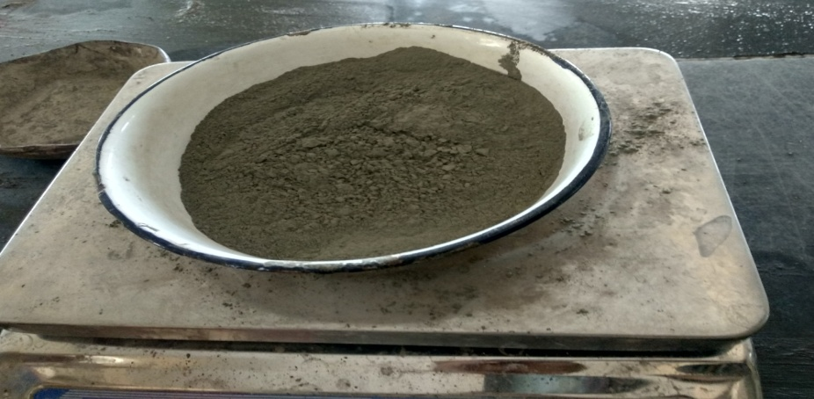

***Fig. 4.1 Ordinary Portland Cement (OPC) of 53 grade***

### 4.1.2. Coarse Aggregate

Locally available coarse aggregate, tested as per IS: 383-1970 and IS: 2386-1963 (I, II and III) specifications, with a maximum size of 20mm and minimum size of 4.75mm are used; specific gravity is 2.84 and water absorption 0.40%. Aggregate impact value is 23.66%

|  |  |  |
| --- | --- | --- |
| **Properties** | **Result** | **Permissible Limit as per IS: 2386-1963** |
| Specific Gravity | 2.83 | 2.6-2.8 |
| Fineness Modulus | 7.29 | 6.5-8 |
| Water Absorption | 0.40% | - |
| Impact Value | 23.66% | Should not be more than 30% |

***Table 4.2 Physical properties of Coarse Aggregate***

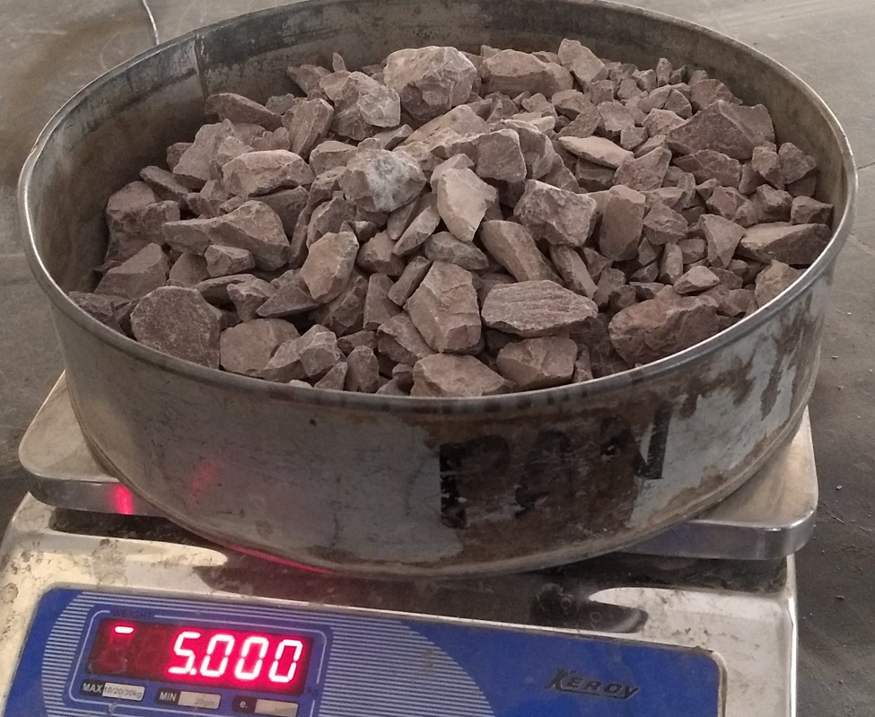

***Fig 4.2 Coarse Aggregate***

### 4.1.3. Fine Aggregate

Locally available sand collected from the bed of river Mahanadi was used as fine aggregate. The sand used was having fineness modulus 2.65 and confirmed to grading zone-III as per IS: 383-1970 specification. Specific gravity and water absorption was found to be 2.59 and 0.401% respectively.

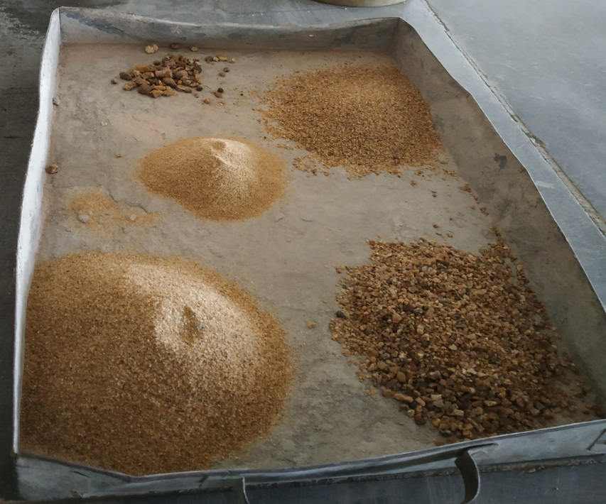

***Fig 4.3 Fine Aggregate (Sand)***

### 4.1.4. Water

Ordinary potable water free from organic content, turbidity and salts as per IS: 456-2000, was used for mixing and for curing throughout the investigation.

### 4.1.5. Plastic Fibers

The waste plastic fibres were obtained by cutting waste plastic bottles (PET), polyethylene, pots, buckets, cans, drums and utensils. These waste plastics were cleaned before cutting to free from any chemicals present. The fibres were cut from steel wire cutter and it is labour oriented. The length of fibres varies between 20mm to 50mm with thickness varying 0.125mm to 0.85mm and width ranging 2mm to 5mm. And these fibres were straight. Four different percentages of fibres 0.5%, 1.0%, 1.5% and 2.0% by weight of cement were used in this investigation. Physical properties of these fibres are given in Table below

|  |  |  |  |  |
| --- | --- | --- | --- | --- |
| Percentage  of  elongation | Tensile  strength  (MPa) | Modulus of  elasticity  (MPa) | Water  absorption | Specific  gravity |
|  |  |  |  |  |

***Table 4.3 Physical Properties of Plastic Fibre***

  
***Fig. 4.5 Plastic Fibres produced from waste plastics***

## 4.2 Mix Design

The process of selecting suitable ingredients of concrete and determining their relative amounts with the objective of producing a concrete of the required, strength, durability, and workability as economically as possible, is termed the concrete mix design. The proportioning of ingredient of concrete is governed by the required performance of concrete in 2 states, namely the plastic and the hardened states. The experimental investigation was carried out to study the properties of M25 grade concrete. The mix was designed as per IS: 10262-2009 and IS: 456-2000. To study the effect of waste plastic fibres on different properties of fresh and hardened concrete different percentages of plastic fibres were added from 0.5% to 2.0% by total weight of cement with 0.50 and 0.55 water-cement ratio. No chemical admixtures were used in this study. 15% wastage is taken into consideration during material’s quantity calculation.

### 4.2.1. Mix Design with w/c 0.50

|  |  |  |
| --- | --- | --- |
|  | **Stipulations for proportioning** |  |
| 1. 1 | Grade designation | M25 |
| 1. 2 | Type of cement | OPC 53 |
| 1. 3 | Max nominal aggregate size | 20mm (Angular) |
| 1. 4 | Minimum cement content | 300 kg/m3 |
| 1. 5 | Max w/c ratio | 0.5 |
| 1. 6 | Workability(slump) | 50-75 mm |
| 1. 7 | Exposure Condition | Moderate |
|  | Max cement (OPC) content | 450 kg/m3 |
|  | Method of Concrete Placing | Pumping |
|  | **Test data for materials** |  |
| 1. 1 | Cement used | OPC 53 |
| 1. 2 | Specific gravity of cement | 3.21 |
| 1. 3 | Specific gravity of water | 1 |
| 1. 4 | Specific gravity of sand | 2.59 |
| 1. 5 | Specific gravity of coarse aggregate | 2.83 |
| 1. 6 | Water absorption of Coarse aggregate | 0.40% |
| 1. 7 | Water absorption of Fine aggregate | 0.401% |
| 1. 8 | Sieve analysis of fine & coarse aggregate | Done |
|  | Fine Aggregate | Confirming to grading Zone III table 4 of IS: 383-1970 |

***Table 4.6 Mix Design Data***

**Step 1.**Target Strength for Mix Proportioning:

f’ck = fck + 1.66*s

Where,

f’ck = Target average compressive strength at 28 days,

fck = Characteristics compressive strength at 28 days, and

s = Standard Deviation.

From Table I of IS 10262:2009, Standard Deviation, s = 4 N/mm2. Therefore, target strength = 25 + 1.65 x 4 = 31.6 N/mm2.

**Step 2.**Selection of Water-Cement Ratio

From the Table 5 of IS 456 for Moderate exposure condition, maximum water-cement Ratio is 0.50  
Adopted maximum water-cement ratio = 0.45

0.45 < 0.50 Hence OK.

**Step 3.**Selection of Water Content

From Table 2 of IS 10262:2009, maximum water content for 20 mm aggregate = 186 litre (for 25 to 50 mm slump range). As per IS: 10262-2009 Clause 4.2 we can increase Water Content 3% for every additional 25mm slump. Estimated water content for 75 mm slump

= 186+ (3*186/100) = 191.58 litre

**Step 4.**Calculation of Cement Content

Adopted w/c Ratio = 0.45

Cement Content = 191.58/0.45 = 425.73 kg/m3

From Table 5 of IS 456, Minimum cement content for ‘Moderate’ exposure conditions 300kg/m3

425.73 kg/m3 > 300 kg/m3 hence OK.

**Step 5.**Proportion of Volume of Coarse Aggregate and Fine Aggregate Content

From Table 3 of (IS 10262:2009) Volume of coarse aggregate corresponding to 20 mm size aggregate and fine aggregate (Zone III) for water-cement ratio of 0.50 =0.64

In the present case water-cement ratio is 0.45. Therefore, volume of coarse aggregate is required to be increased to decrease the fine aggregate content. As the water-cement ratio is lower by 0.05. The proportion of volume of coarse aggregate is increased by 0.01 (at the rate of -/+ 0.01 for every ± 0.05 change in water-cement ratio).

Therefore, corrected proportion of volume of coarse aggregate for the water-cement ratio of 0.45 = 0.64 + 0.01 = 0.65

NOTE – In case the coarse aggregate is not angular one, then also volume of coarse aggregate may be required to be increased suitably based on experience & Site conditions.

For pumpable concrete these values should be reduced up to 10%. Therefore, volume of coarse aggregate =0.65 x 0.9 = 0.585

Volume of fine aggregate content = 1 – 0.585 = 0.415

**Step 6.**Mix Calculations

The mix calculations per unit volume of concrete shall be as follows:

a) Volume of concrete = 1 m3

b) Volume of cement = [Mass of cement] / {[Specific Gravity of Cement] x 1000}

= 425.73/{3.21 x 1000}

= 0.0.1326 m3

c) Volume of water = [Mass of water] / {[Specific Gravity of water] x 1000}

= 191.58/ {1 x 1000}

= 0.191 m3

d) Volume of all in aggregate = [a-(b+c)]

= [1-(0.1326+0.191)]

= 0.6758 m3

e) Mass of coarse aggregate= d x Volume of Coarse Aggregate x Specific Gravity of Coarse Aggregate x 1000

= 0.6785x 0.5585 x 2.83 x 1000

= 1118.8 kg/m3

f) Mass of fine aggregate= d x Volume of Fine Aggregate x Specific Gravity of Fine Aggregate x 1000

= 0.6785 x 0.415 x 2.593 x 1000

= 727.22 kg/m3

**Step 7.**Mix Proportions

|  |  |  |
| --- | --- | --- |
| **Ingredient** | **Quantity**  **Kg/m3** | **Proportion** |
| Cement | 425.7 | 1 |
| Fine Aggregate | 727.2 | 1.708 |
| Coarse Aggregate | 1119 | 2.628 |
| Water | 191.58 | 0.45 |

***Table 4.7 Mix Proportions***

### 4.2.2. Quantities of Various Materials Required for one Cube with 15% wastage:

|  |  |
| --- | --- |
| **Materials** | **Quantity** |
| 1. Cement | 1.65 kg |
| 1. Fine Aggregate | 2.825 kg |
| 1. Coarse Aggregate | 4.34 kg |
| 1. Water | 0.743 kg |
| 1. Plastic Fibre 2. 0.5% 3. 1.0% 4. 1.5% 5. 2.0% | 8.05 gram  16.5 gram  25 gram  33 gram |

***Table 4.7 Quantities for one Cube***