Analysis of Snapdragon 8 Gen 1

Mehar Anjum Khan¹, Prof. Sandhya Dahake²

¹Student, ² Assistant Professor Department of Master of Computer Application,
G.H. Raisoni Institute of Engineering and Technology, Nagpur, India, 440023

monu.zoby@gmail.com

Received on: 11 June ,2022 Revised on: 07 August ,2022, Published on: 09 August ,2022

Abstract – The new phase of computing has emerged in recent years. There is a shift away from desktop computers and toward mobile devices. These gadgets have ushered in a new era of technology, with the intent of giving accessibility and speeds to users, but they also bring with them lots of new study for scientists, engineers, and other interested parties. In this paper, I've tried to focus on Qualcomm's technology, including its features, benefits, applications, and other challenges. The Snapdragon is discussed in the following part with the goal of illustrating why it would be the greatest processor choice for smart phones.

Keywords- Phase of Computing, Ushered, Snapdragon, Predecessor, Latest mobile phone processors, System on a chip, Qualcomm Snapdragon

I - INTRODUCTION

The Microprocessor is main BRAIN of any devices. The processor is always in charge of the software activities' instructions. Every mobile phone has a processor of certain type, which might be built into the core mobile smartphone chip or be a separate PC chip. Applications can run faster with a better Chipset. The speed of an input processor is measured in megahertz (MHz) or gigahertz (GHz). However, some processors are more powerful over others, hence even if two different processors both operate at 1 GHz, if one is more powerful, it might perform software applications much faster. In this paper, I will discuss the Snapdragon Microprocessor. [1] .The Snapdragon 8 Gen 1 Mobile Platform is most advanced 5G technology ever, with the Snapdragon X65 5G Modem-RF System enabling incredible speeds of up to 10 Gbps while giving all-day battery life and more options than ever before. In addition, the Snapdragon 8 Gen 1 has industry-leading Wi-Fi 6 & 6E with multi-gigabit speeds, even when several devices are connected to the same network.

Our 7th Gen Qualcomm AI Engine, which is the most powerful ever, is revolutionizing AI through enablingintelligent use cases in gaming, wellness, photography, and productivity. The Qualcomm Sensing Hub third Generation is the world's first generally on ISP and has a progressive Low Power AISystem In addition, the Snapdragon Sight 18-bit ISP captures 8K HDR films.

Gaming, music, and other multimedia experiences that are leagues ahead of the predecessor round out this premium platform. Snapdragon Elite Gaming Features provide desktop-quality realism and response times, while Bluetooth audio and Snapdragon Sound Technology provide premium and immersive wireless audio.

- ALL ABOUT SNAPDRAGON 8 GEN 1

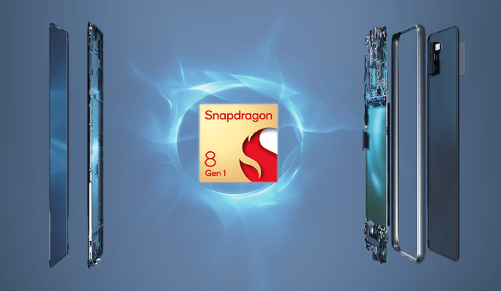
Fig.1 Snapdragon Processor

Qualcomm's latest flagship smartphone chipset is the Qualcomm Snapdragon 8 Gen 1. Most high-end Android smartphones set to appear; it will include the Snapdragon 8 Gen 1 processor. For higher speed and increased efficiency, the new CPU is created utilizing a more power efficient technology and a completely new architecture. Compared to its predecessor, the chip offers a number of enhancements. The Snapdragon 8 Gen 1 is developed using Samsung Foundry's 4nm technology, which allows for greater power efficiency.
In comparison to the Snapdragon 888+, the new processor delivers a 20% increase in CPU processing speed and a 30% increase in graphics capability. The Snapdragon 8 Gen 1 comes with the X65 5G modem for download rates of up to 10Gbps, an 18-bit Triple-ISP, 8K HDR video recording, and Wi-Fi 6E. The Qualcomm Snapdragon 8 Gen 1 includes a three-cluster CPU design, with all cores based on the ARMv9 architecture. There is one ARM Cortex-X2 CPU core running at 3GHz, three ARM Cortex-A710 CPU cores working at 2.5GHz, and four ARM Cortex-A510 CPU cores performing at1.8GHz in this system. In comparison to the Snapdragon 888+, Qualcomm says that the processor provides a 20% performance boost and a 30% power savings.

The graphics processor unit, which is the heart of the smartphone display. Mobile computing needs to support visualization. Otherwise, the user who gives birth will not be able to understand these systems. Therefore, you need to build a user-friendly interface. That's why smartphones need to support a great gaming experience and rich video displays that encourage users to use them. Mobile devices of great interest. To perform this task, the Snapdragon 820 comes with an Adreno GPU that improves by about 40%. Improvements to its predecessor. This will improve your computing power. [2]

The Snapdragon 8 Gen 1 has an X65 5G modem that enables sub-6GHz and mmWave 5G networks. Thanks to CA, it can achieve peak download rates of 10Gbps (Carrier Aggregation).
Because consumers nowadays take a lot of photos and videos, the Snapdragon 8 Gen 1 processor puts a lot of emphasis on image and video processing. Its 18-bit Spectra Triple-ISP collects 4000x more camera data than the Snapdragon 888's 14-bit ISP. It contains three separate ISP cores, allowing it to run three 36MP cameras at 30fps or up to 200MP sensors at the same time. [1]
The ISP also allows recording videos in several video formats such as Dolby Vision, HDR10, HDR10+, and HLG at 4K 120fps or 8K HDR 30fps. MFNR (Multi-frame Noise Reduction), Locally Motion Compensated Temporal Filtering, and enhanced low-light photography are all supported by the processor. Face identification, focusing, and auto-exposure are all powered by AI.The Snapdragon 8 Gen 1 processor supports up to a 4K 60Hz external display with 10-bit color depth and HDR10+, in addition to 4K 60Hz or QHD+ 144Hz displays. Dolby Vision, HDR10+, HDR10, HLG, H.264 (AVC), H.265 (HEVC), VP8, and VP9 video decoding and encoding are all supported by the chipset. For improved sound quality, the new CPU now supports Qualcomm's aptX Lossless wireless audio codec and Snapdragon Sound Technology.

Moving on to the Snapdragon 8 Gen 1's AI capabilities, Qualcomm has included a 7th Gen Qualcomm AI Engine with 27 TOPS of performance. The chipset supports SA (Standalone) and NSA (Non-Standalone) 5G networks, as well as FDD, TDD, Dynamic Spectrum Sharing, 444 MIMO, Qualcomm AI-Enhanced Signal Boost, Wi-Fi 6E, Bluetooth 5.2, Beidou, Galileo, GLONASS, NavIC, GPS, QZSS, NFC, USB 3.1, and USB-C.

II -WHY 8 GEN 1? REASONS AND FEATURES

The Snapdragon 8 Gen 1 Chipset, that powered the new Samsung Galaxy S22 series, is one of the quickest and most energy-efficient processors available. Qualcomm is known for making some of the greatest chipsets for Android devices, and their current flagship SoC is the Snapdragon 8 Gen 1. Despite the fact that the chip was unveiled in November 2021, few devices have taken advantage of its capabilities. The Motorola Edge X30, which was released in December 2021, was the first smartphone to include a Snapdragon 8 Gen 1 processor.

The OnePlus 10 Pro, which is available, is another smartphone that uses the Snapdragon 8 Gen 1 chipset. However, due to Samsung, Qualcomm's next flagship processor is going to become much more widely available. The Snapdragon 8 Gen 1 processor is found in the Galaxy S22, Galaxy S22+, and Galaxy S22 Ultra.

New Features

The Snapdragon 8 Gen 1 is an octa-core processor with one high-performance core working at 3000 MHz, three balanced cores running at 2500 MHz, and four efficient cores running at 1800 MHz With LPDDR5 RAM and an Adreno 730 GPU, the Snapdragon 8 Gen 1 provides great multitasking and gaming performance. The Snapdragon X65 modem also enables 5G connection, and the chipset can capture 8K footage at 30 frames per second. The CPU, which is based on 4nm technology, is one of the most powerful and energy-efficient mobile chipsets for Android devices. It is the successor of the Snapdragon 888+, which was present in most of the flagship Android phones released in 2021.

III- LITERATURE SURVEY

Qualcomm announced the latest 5G-powered flagship smartphone processor, the Snapdragon 888, on the first day of the Snapdragon Tech Summit. However, in the second day's keynote, the company provided all the details about the new chipset that will be the brain of almost every major Android flagship in 2021.All Snapdragon predecessors have a Krait CPU, but in the Snapdragon 820 series, the Kryo CPU is a very powerful processor. Performance is about twice that of the previous series. This optimizes the selection of 820 snapdragons Mobile phone selection. This will improve the efficiency of your mobile phone. [8]Kryo-CPU has sophisticated energy managementtechniques, hyper-threading, automatic cache shutdown, voltage scaling, frequency scaling, and other software layers. A management technique for optimizing and improving processor performance. Equipped with a working 64-bit dual-core CPU 2.2 GHZ itself performs very well compared to other mobile processors. [3]
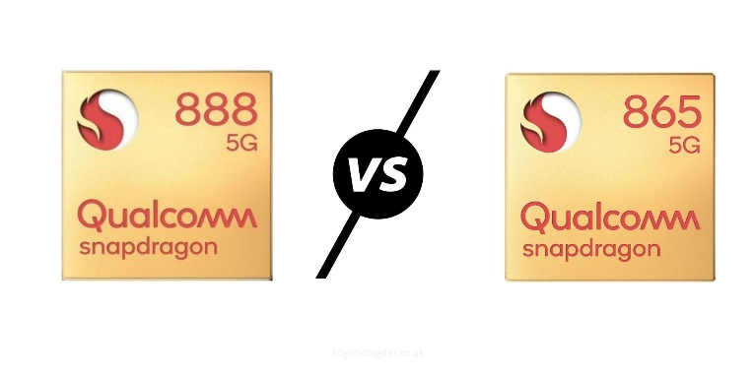

Compared to the Snapdragon 865's 15TOPS, the Snapdragon 888 can perform 26 trillion operations (TOPS) per second and is three times more power efficient. In addition, Qualcomm promises significant improvements in both scalar and tensor AI tasks as part of these upgrades.The Snapdragon 888 also features a second-generation Qualcomm Sensing Hub. This is a low power AI processor dedicated to small hardware-based tasks such as reads. B. Detects when to lift the phone to illuminate the display. The new 2nd generation sensing hub has been significantly improved. This means that the phone is less likely to rely on the Hexagon main processor for these tasks.

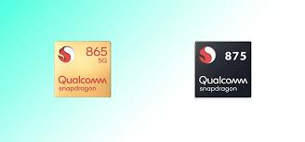

The Qualcomm Snapdragon eight Gen 1 Mobile Platform is a high-cease SoC for smartphones that became delivered in past due 2021 and synthetic in four nm at Samsung. Integrates one “Prime Core” primarily based totally on a ARM Cortex-X2 structure clocked at up to a few GHz. Three greater overall performance cores are primarily based totally at the Cortex-A710 however clocked as much as 2.five GHz.

Furthermore, 4 power saving cores are incorporated which might be primarily based totally at the ARM Cortex-A510 structure and clocked at as much as 1.eight GHz. All cores can use the shared 6 MB stage three cache.According to Qualcomm, the performance of the CPU part is improved by 20% and the energy saving is improved by 30% compared to Snapdragon 888 (Plus). This makes the Snapdragon 8 Gen 1 the fastest CPU on Android-based smartphones and needs to be placed between the CPUs of the Apple A13 and A14.

It is also said to be based on the ARM Cortex A510 architecture and has four energy-saving cores that are clocked up to 1.8GHz. All cores have access to a 6MB level 3 shared cache. According to Qualcomm,CPU parts have 20% better performance and 30% less energy than the Snapdragon 888 (Plus). Theprocessor integrates the Adreno 730, which provides 30% better graphics than the previous Adreno 660.

IV- COMPARISON BETWEEN SNAPDRAGON 888, 888+, 8 gen 1

Parameters | Snapdragon 888 | Snapdragon 888+ | Snapdragon 8 gen 1
CPU performance | 86 | 86 | 91
Gaming Performance | 92 | 93 | 98
Efficiency of Battery | 94 | 94 | 89
Stability | 92% | 99% | 55%
Graphic test | 31 FPS | 33 FPS | 48 FPS
Connectivity Modem | X60 | X60 | X65
Announced Date | December 2020 | June 2021 | December 2021

Table 1. Comparison of 888, 888+, 8 gen 1.

GPU:

The Snapdragon 8 Gen 1 GPU, according to Qualcomm, is 30% quicker in terms of performance while using 25% less power than its predecessor, the Adreno 660. Frame Motion Engine, Volumetric Lighting, and Variable Rate Shading Pro are just a few of the new Adreno GPU's intriguing gaming capabilities.

ISP:
The image signal processor (ISP) of the Snapdragon 888 was good, but the Snapdragon 8 Gen 1 is so much better. The Snapdragon 8 Gen 1's 18-bit HDR ISP can shoot 8k HDR films with electronic picture stabilization.It also has a specialized engine for 4k Bokeh video recording and can snap 240 photographs of 12MP resolution in one second. You may shoot in 18-bit RAW for expert video editors.

Connectivity:

New is sometimes preferable to old. The Snapdragon 888, like in this case of 5G modem, employs Qualcomm's X60 5G modem, which is only capable of downloading at 7.5Gbps. The Snapdragon X65 5G modem, on the other hand, can provide peak download speeds of up to 10Gbps.

Disadvantages of Previous Snapdragon:

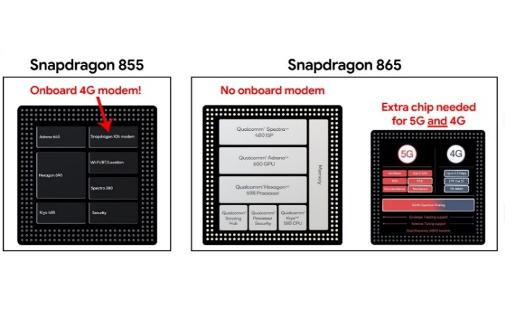

Fig. 2 Old Snapdragons

Qualcomm's Snapdragon 865 SoC and the company's unmatched dominance in the mobile market have reached a pinnacle with Snapdragon 865. Qualcomm is putting the pressure of 5G on everyone with this chip, which will raise the size, cost, and inconvenience of smartphones. Since Qualcomm's design of no LTE modem in the Snapdragon 865, practically every flagship Android phone will be a 5G phone by 2020, and placing 5G and 4G on a big additional chip means devices will require far more power than normal, regardless of which network one is connected to. While this occurs, it is vital to remember that 5G networks are still in their infancy.

The Snapdragon 660 is built on ARM'sbig. LITTLE idea, which combines a low-power CPU cluster (2x Kyro clocked at up to 1.8 GHz) with a performance CPU cluster (2x Kyro clocked at up to 2.2 GHz). The lowest clock speed is 310 MHz, and each cluster's clock speed may be modified separately (not per core) (unverified).

Production of Snapdragon in the United States. In 1978, it was 1.3% of total cut flower production (US Department of Commerce, 1982). this Increased to 1.7% of the total by 1987 (US Department of Commerce, 1991.) Snapdragon is included in various cut flower statistics and totals. This category is steadily increasing over time the last 10 years. [8]

V- UPCOMING SNAPDRAGON 8 GEN 1+

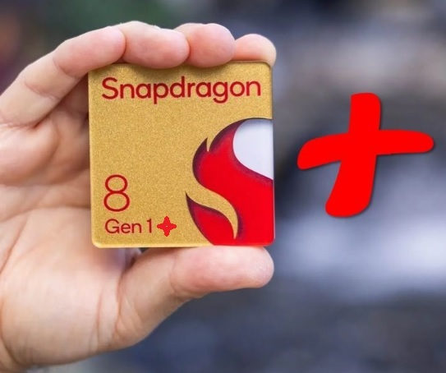

Fig. 3 Snapdragon 8 gen 1+

The Snapdragon 8 Gen 1+ processor will be released sooner than planned. According to an unnamed supply chain insider, the Plus variant of Android's main processor might arrive as early as June or as late as July. [3] The first Snapdragon 8 Gen 1+ smartphones will be released in China, although no names have been published as of now The rumored OnePlus 10 Ultra might be an early indication, however the smartphone could employ a Dimensity 9000 or the same Snapdragon 8 Gen 1 as the current 10 Pro. The Snapdragon 8 Gen 1+ will use TSMC's 4nm technology and will be quite comparable to the Snapdragon 8 Gen 1, but with significantly faster clock rates. [3]

Smartphone manufacturers have already seen the Snapdragon 8 Gen 1+, as well as forthcoming Snapdragon 700 series chipsets, which will be released around the same time. Starting in June 2022, the Snapdragon 8 Gen 1+ will be found in flagship devices like Lenovo, Motorola, OnePlus, and Xiaomi

In the introduction of new chips can be explained to a variety of causes, including performance difficulties, poor yields, and Qualcomm's battle with MediaTek. The MediaTek Dimensity 9000, Dimensity 8100, and Dimensity 8000 processors have all demonstrated substantial performance benefits at a cheaper cost than Qualcomm's solutions. Qualcomm is aware of issue and has taken steps to address it.

VI- SNAPDRAGON 8 GEN 1 BROUGHT TO DIGITAL WORLD.

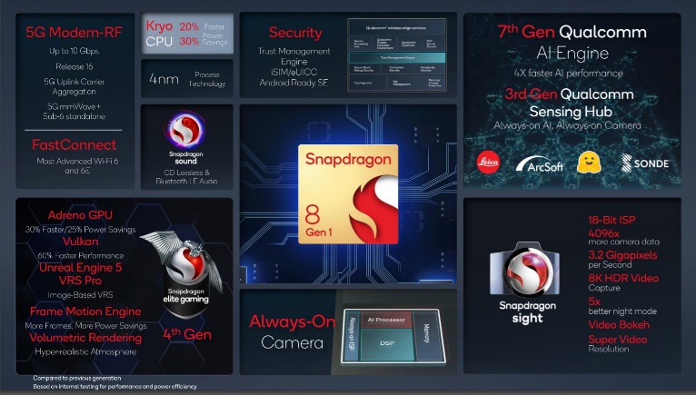

Fig. 4 New Snapdragon

This New 8 gen 1 had brought lot of things to digital world as given below.
- Connectivity
- Camera
- AI
- Gaming
- Sound
- Security

Connectivity: The new Snapdragon 8 is the most sophisticated 5G mobile platform and the world's first 5G modem-RF solution to deliver 10 Gigabit download rates, thanks to the Snapdragon X65 5G Modem-RF System. The Qualcomm FastConnect 6900 Mobile Connectivity System in the Snapdragon 8 supports the highest Wi-Fi speeds available—up to 3.6 Gbps—over Wi-Fi 6 and 6E, ensuring that games and apps even when several devices are linked to the same network, the programme runs efficiently.

Camera: With this new premium mobile platform, smartphone photography is elevated to a new level. Snapdragon Sight Technology includes the first commercial 18-bit mobile ISP, which captures over 4000 times more camera data than its predecessor at 3.2 gigapixels per second for exceptional dynamic range, color, and clarity. This is also the first 8K HDR video capture on a mobile device, and it can capture in the premium HDR10+ format, which has over a billion color.

AI: The Qualcomm AI Engine 7th Generation is powered by the Qualcomm Hexagon CPU, which offers a 2x faster tensor accelerator and 2x greater shared memory than its predecessor. By sorting and analyzing your alerts, Hugging Face's newest AI-based natural language processing can intelligently function as your personal assistant. We're collaborating with Sonde Health to leverage on-device AI to speed up their models that evaluate a user's speech patterns to see whether they're at risk for health issues like asthma, depression, or COVID-19. The 3rd Gen Qualcomm Sensing Hub also powers a new always-on AI system that processes additional data streams utilizing low-power AI.

Gaming: Snapdragon 8 delivers ultra-smooth responsiveness, color-rich HDR scenes at the greatest visual quality, and desktop-level capabilities that are mobile-firsts, due to over 50 Snapdragon Elite Gaming features. The new Qualcomm AdrenoTM GPU unlocks a new generation of mobile GPUs by providing a 30% gain in graphics rendering capabilities and a 25% improvement in power efficiency over the previous generation. The platform includes the Adreno Frame Motion Engine, which can produce twice as many frames while using the same amount of power. Another mobile-first feature is Variable Rate Shading Pro, which allows game developers to wonderful game experience. Fog, smoke, and particle effects that have been tuned for mobile by Qualcomm Technologies' in-house Snapdragon processors now offer unsurpassed realism thanks to desktop-level Volumetric rendering.

Sound: With integrated Bluetooth 5.2 and Snapdragon SoundTM Technology, users can enjoy a new level of crisp, crystal-clear voice and music, including Qualcomm aptXTM Lossless Technology for CD-quality lossless wireless audio. It's the first Snapdragon platform to offer new LE audio functions for videogames, including the broadcast audio, stereo recording, and voice back-channel.

Security: The Snapdragon 8 has vault-like security to secure users' data. This is the first Snapdragon platform to have a dedicated Trust Management Engine, which boosts security and adds another layer of trust to apps and services. In addition, the Qualcomm Secure Processing Unit supports iMIS, an integrated SIM card that allows users to connect to cellular networks quickly and securely without the necessity of a SIM card.

VII - CONCLUSION

The Snapdragon 888, Qualcomm's latest-generation top-end smartphone processor, was released in December.It's Qualcomm's first chipset built on a 5nm lithography technique, which means it has a greater transistor density and hence more computational power than the Snapdragon 865, which was built on a 7nm process.

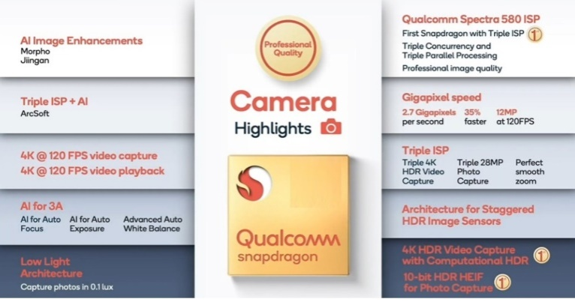

Fig. 5- All things about Snapdragon

It also means Qualcomm is catching up to Apple and Huawei, which have both used 5nm technology in their A14 Bionic and Kirin 9000 chipsets. The Apple processor was used in the iPhone 12 series, and Huawei's Kirin 9000 was used in the Mate 40 Pro and other Huawei smartphones. The Xiaomi Mi 11 and the Samsung Galaxy S21 Ultra are among the first Snapdragon 888 smartphones to be revealed (Snapdragon version).

When it comes to gaming, Qualcomm believes that the new Snapdragon 888 processor will provide faster response times. When compared to the Snapdragon 865, the 888 delivers a 10% gain at 120 frames per second and up to 20% at 60 frames per second, according to the firm. Because DXOMARK measures touch responsiveness as part of its Display methodology, it will be fascinating to see how 888-powered devices fare in this area.

The mobile processor [1] is a device on a chip designed to support applications that walk in mobile phones. A running device on your smartphone. The mobile processor provides a self-contained working environment that introduces all devices. The mobile processor can be used independently of other dedicated processors in the same tool. Phone baseband processor. Some services create their own processors for mobile utilities. For example, Qualcomm Snapdragon. The mobile application processor is included in many smartphones that do this using Qualcomm Snapdragon. Android phone control panel and Android mobile package. Integrate huge types of mobile devices. Characteristic mobile processors such as mobile phones, smartphones, tablets, e-readers, netbooks, car navigation systems, etc. Devices and game consoles. [1]

Snapdragon 888 smartphones will be able to collect computational HDR data for both video and photos thanks to the new chipset's support for staggered HDR sensors. In order to provide a deeper depth information stream in real time, staggered sensors take three separate exposures for each frame and analyze them. [8]Irrigation system consisting of three Individual irrigation lines were designed to meet the specific needs of this experiment. Or Snapdragon on the soil floor was watering beds tended to stay in place, so draw a line to yourself Saturates longer than individual shells. Or the small tray is in the second row on the third big tray. [8]

VIII- ACKNOWLEDGEMENT

I would like to express my very great appreciation to Prof. Sandhya Dahake, my research guide for her valuable and constructive suggestions during the planning and development of this research work. Her willingness to give her time so generously has been very much appreciated.

REFERENCES
- Dr. Lingam, D. G. S. (2021, December 12).“A Comprehensive Survey on Contemporary Mobile Phone Processors. Banglore”, International Journal of Innovative Research in Science, Engineering and Technology, Vol. 4, ssue 12, December 2015
- Wee, Alex. "More than 60 new gadgets will be powered by Qualcomm Snapdragon 820." Screen (2015)
- Gujral, S, “MOBILE COMPUTING and SNAPDRAGON”. International Journal of Computer Science and Moe Computing, IJCSMC, Vol. 5, Issue. 6, June 2016, pg.361 – 367
- FarinazKaushanfar, Vandana Prabhu, MiodragPotkonjak, Jan M. Rabaey: “Processors for Mobile Applications”Vol. 4, Issue 12, December 2015.
- Mahendra Pratap Singh, “Evolution of Processor Architecture in Mobile Phones” Volume 90 – No 4, March 2014.
- Shiv Chaturvedi: "The role of digital signal processors (DSP) for 3G mobile communication systems", International Journal on Emerging Technologies 1(1): 23-26(2010).

- Bhavya Bhargava,Youdh Chand Gupta, Priyanka Sharma, “Performance of Snapdragon (Antirrhinum majus L.) UnderProtected and Open Field Conditions in Himachal Pradesh”, Received: 25 March 2014 / Revised: 5 June 2014 / Accepted: 22 July 2014 / Published online: 28 August 2014

- K.Jacquemin Sullivan and C.C. Pasian, “Evaluation of Two Growing Systems for Cut Snapdragon Production: Tray vs. Ground Bed”, HORTSCIENCE, VOL. 35(1), FEBRUARY 2000

