**Performance Based Seismic Analysis and Design of RC Structures**

**Bhavesh Kuthe1, Prof. D.L.Budhlani 2**

*1M-tech student(Structural Engineering)*

*Guru Nanak Institute of Technology, Nagpur*

*Dahegaon, Nagpur-441501*

*2Associate Professor*

*Guru Nanak Institute of Technology, Nagpur*

*Dahegaon, Nagpur-441501*

***Abstract –*** *Analysis of damages incurred in moment resisting RC framed structures subjected to past earthquake show that failure may be due to utilization of concrete not having sufficient resistance, soft storey, beam column joint failure for weak reinforcements or improper anchorage, column failure causing storey mechanism. Beam-column connection is considered to be one of the potentially weaker components when a structure is subjected to seismic loading. In this study seismic analysis is carried out using response spectra method and its devastations are mentioned. Furthermore pushover analysis is mentioned to check safety against collapse and steel bracings are used in frames to provide sufficient stiffness. In this paper various figures are illustrated for beam column failure mechanism are also given.*

***Keywords-*** *Beam column joint, Response spectrum method, OMRF, SMRF, Pushover analysis, steel bracings.*

**INTRODUCTION**

**E**arthquake is a global phenomenon. Due to frequent occurrence of earthquakes it is no more considered as an act of God rather a scientific happening that needs to be investigated. During earthquake, ground motions occur both horizontally and vertically in random fashions which cause structures to vibrate and induce inertia forces in them. Analysis of damages incurred in moment resisting RC framed structures subjected to past earthquake show that failure may be due to utilization of concrete not having sufficient resistance, soft storey, beam column joint failure for weak reinforcements or improper anchorage, column failure causing storey mechanism. Beam-column connection is considered to be one of the potentially weaker components when a structure is subjected to seismic loading.

Objective:

This study aims to Special Moment Resisting Frame (Ductile Detailing) and Ordinary Moment Resisting Frame are considering as structural frame and Comparison are made for seismic load.

Scope of this study:

* To study Provisions of IS 1893 – 2016 (Part-I) for Earthquake.
* To study Provisions of IS 456-2000 for OMRF.
* To study Provisions of IS 13920-2016 for SMRF.
* Analysis of OMRF and SMRF by ETABS 2016 software.
* Design and Detailing of OMRF and SMRF
* Ordinary Moment-Resisting Frame(OMRF):It is a moment-resisting frame not meeting special detailing requirement for ductile behavior.
* Special Moment-Resisting Frame (SMRF): It is a moment-resisting frame specially detailed to provide ductile behavior and comply with the requirements given in IS 4326 or IS 13920 or SP 6 (6).
* Nonlinear static analysis is carried out.
* Suggestion for retrofitting.

**PUSHOVER ANALYSIS**

Pushover analysis is a nonlinear static analysis for a steel framed structure subjected to lateral loading. The gravity loads are applied, and then lateral loading is applied – first in X direction starting at the end of the gravity push, and next in Y-direction again starting at the end of the gravity push (Valles et al., 1996; CSI, 2000). The concept of plastic hinge is extremely important in the nonlinear analysis.

While a concrete element undergoes large deformations in the post-yield stage, it is assumed that all the deformation takes place at a point called “plastic hinge”, which has approximately a length of the order of the effective depth (also called as plastic hinge length, ld). The rotation capacity θ of a plastic hinge is taken as ld(φu − φy). A similar approach can be used for obtaining the rotation capacity of columns under axial force and bending moment in two directions. Similar plastic hinges with limit capacities on deformation can be defined for all six degrees of freedom, namely, axial force, transverse shear forces in X- and Y-directions, moments about Y- and Z-axes, and torsion (moment about X-axis). More details on evaluation of ductility, energy absorption, damage modeling, and detailing are available elsewhere (Lakshmanan, 2003a, 2005a). A typical response at a plastic hinge may be as shown in Figure 1.5. Here, Point A is the origin; B is the point of yielding; BC represents the strain-hardening region; C is the point corresponding to the maximum force; and DE is the post-failure capacity region. On the frame structure, the analyst identifies the possible locations for plastic hinge formation from his experience. Mathematically, nonlinear static analysis does not lead to a unique solution. Small changes in properties or sequence of loading can lead to large variations in the nonlinear response.

Fig. 1- Idealized force-deformation curve

The pushover analysis may be carried out using force control or deformation control. In the first option, the structure is subjected to an incremental distribution of lateral force, and incremental displacements are calculated. In the second option, the structure is subjected to a deformation profile, and lateral forces needed to generate those displacements are computed. Since the deformation profile is unknown, the first option is commonly used. For the displacement control the user specifies the target maximum displacement at a control point. In certain softwares, displacement control is not the same as applying displacement loading on the structure; displacement control is simply used to measure the displacement that results from the applied loads and to adjust the magnitude of the loading in an attempt to reach certain measured displacement value. The so-called displacement control in this case is essentially a modified form of the force control. The force control strategy can have following options: (i) uniform distribution, (ii) triangular distribution, (iii) generalised power distribution, and (iv) modal adaptive distribution with single or multiple mode participation.

**The Need For Seismic Retrofit**

Various different types of retrofits can be implemented on structures with regards to particular problems of existing building`s. The aim of this study is to analyze the implementation of a retrofit solution in computer software and examine the differences in strength capacity. The analysis of the structure is performed as described below;

_ Two-dimensional Nonlinear Static Pushover Analysis was performed in ETAB 2016 to evaluate load deformation characteristics of a ordinary moment resisting frame and special moment resisting frame of the building and examine the differences in strength capacity. The frame was subjected to monotonically increasing lateral load until target displacement described in ASCE 41-06 Table C1-3. This method provided useful information about structural performance by estimating the strength and deformation capacity that can’t be obtained through linear methods such as generation of plastic hinge mechanism as a function of lateral displacement.

**PROBLEM STATEMENT**

The building is analyzed is G+6 R.C framed building of symmetrical rectangular plan configuration. Complete analysis is carried out for dead load, live load & seismic load using ETAB 2016. Response spectrum method of analysis is used. All combinations are considered as per IS 1893:2016.

Site Properties:

Details of building:: G+6

Plan Dimension:: 24m x 20m , 4m span in each direction.

Outer wall thickness:: 230mm

Inner wall thickness:: 230mm

Floor height ::3 m

Parking floor height :: 3m

Seismic Properties

Seismic zone:: IV

Zone factor:: 0.24

Importance factor:: 1.0

Response Reduction factor (OMRF) R:: 3

Response Reduction factor (SMRF) R:: 5

Soil Type:: medium

Material Properties

Material grades of M30 & Fe500 is used for the design.

Loading on structure

Dead load :: self-weight of structure

Live load:: For G+15:: 2.5 kN/m²

Roof :: 1.5 kN/m²

Seismic load:: Seismic Zone IV

Table No. 1 shows design sections of column and beam. Size of columns designed by IS 13920:2016 is slightly higher than size of column designed by IS 456:2000. Whereas design size of beams are obtained to be same by both codes.

Table 1- Design Sizes of members

|  |  |  |
| --- | --- | --- |
|  | As per IS 456:2000 | As per IS 13920:2016 |
| Column size |  |  |
| Plinth to First floor | 500mmX300mm | 500mmX350mm |
| Second to Third floor | 400mmX300mm | 400mmX350mm |
| Fourth to fifth floor | 300mmX300mm | 350mmX350mm |
| Sixth floor | 250mmX250mm | 350mmX350mm |
| Beam size |  |  |
| Plinth to First floor | 400mmX250mm | 400mmX250mm |
| Second to Third floor | 350mmX250mm | 350mmX250mm |
| Fourth to fifth floor | 300mmX250mm | 300mmX250mm |
| Sixth floor | 250mmX230mm | 250mmX230mm |
| Slab thickness | 120mm | 120mm |
| Bracing section | ISMB 300 | ISMB 300 |

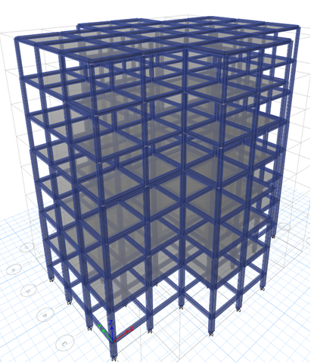

Fig.2- 3D view of G+6 RCC Bare Frame

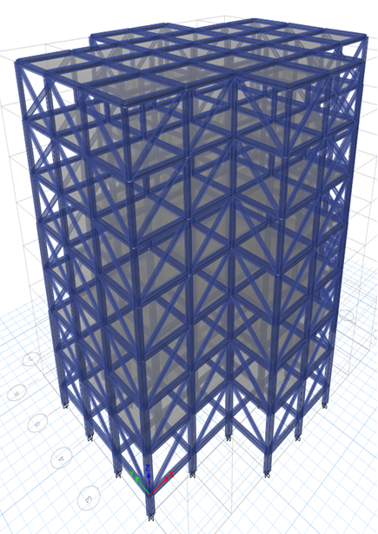

Fig.3- 3D view of G+6 RCC Bare Frame With Steel Bracing

**RESULTS**

The resulting pushover curve of base shear vs. roof displacement for ordinary moment resisting frame (OMRF) is shown below in Figure 4. This curve shows overall response of the structure against incremental loading. This load is increased monotonically until the failure occurs in the structure. As the loading is increased, a curve between the base shear and roof displacement is plotted. The curve is initially increasing linear but later begins to change from linearity as the components go through inelastic actions.

Pushover analysis were performed for X dir and Y dir. The pushover curves were not able to achieve the target displacement even for the Life safety acceptance criteria and therefore needs retrofit.

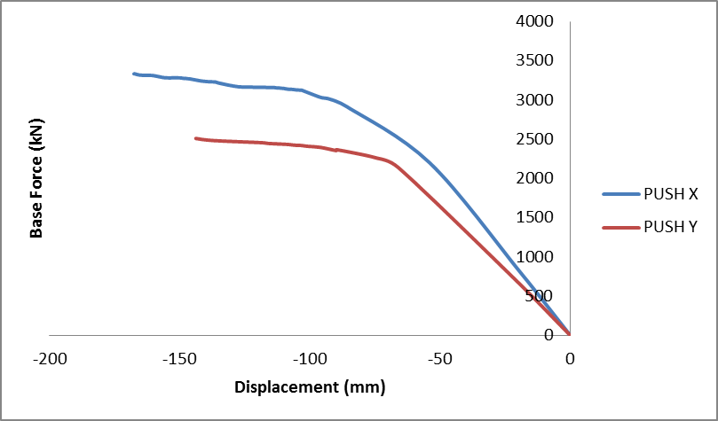

Fig 4- Base Shear vs Monitored Displacement for OMRF

The resulting pushover curve of base shear vs. roof displacement for ordinary moment resisting frame (SMRF) is shown below in Figure 5. This curve shows overall response of the structure against incremental loading. This load is increased monotonically until the failure occurs in the structure. As the loading is increased, a curve between the base shear and roof displacement is plotted. The curve is initially increasing linear but later begins to change from linearity as the components go through inelastic actions.

Pushover analysis were performed for X dir and Y dir. The pushover curves were not able to achieve the target displacement even for the Life safety acceptance criteria and therefore needs retrofit.

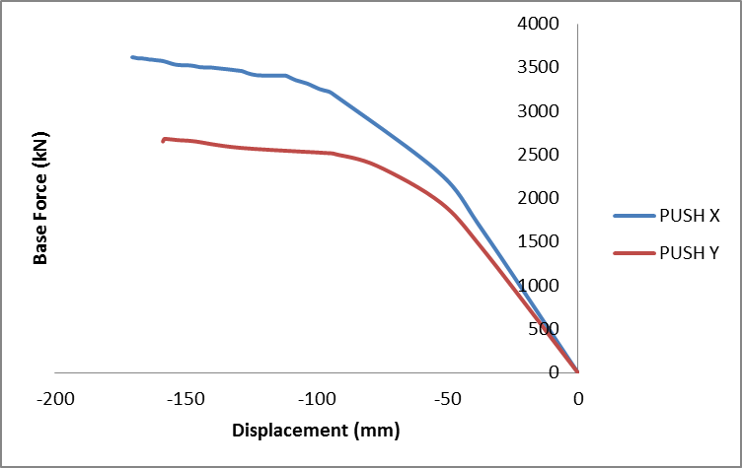Fig. 5- Base Shear vs Monitored Displacement for SMRF 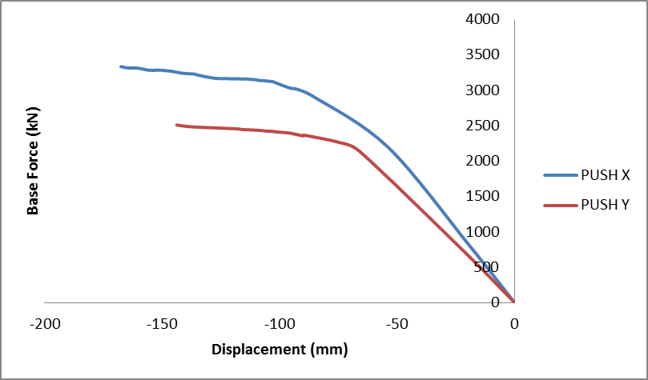

The Table No. 2 shows comparison of performance point shear by pushover analysis with base shear by response spectrum method for ordinary moment resisting frame (OMRF) and special moment resisting frame (SMRF).

Table No. 2 Comparison of performance point shear with base shear

|  |  |  |  |  |
| --- | --- | --- | --- | --- |
| Push load | OMRF | | SMRF | |
| Response Spectrum Analysis | Pushover Analysis | Response Spectrum Analysis | Pushover Analysis |
| X- Direction | 704.8554 | 415.393 | 446.1518 | 440.024 |
| Y- Direction | 624.8094 | 370.804 | 415.0328 | 410.335 |

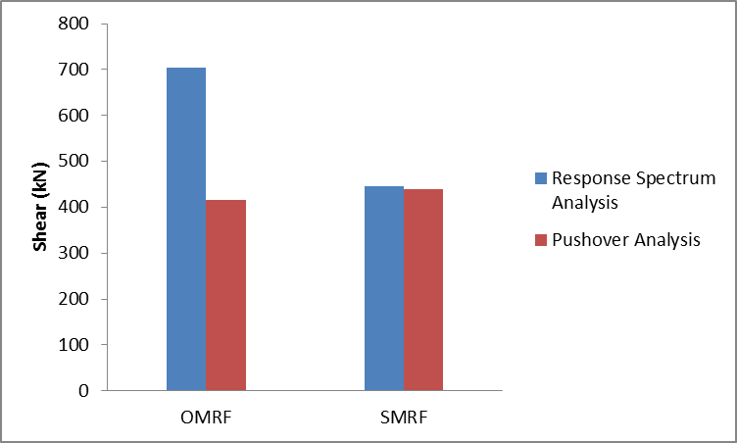

Fig. 6- Comparison of performance point shear with base shear in x-direction

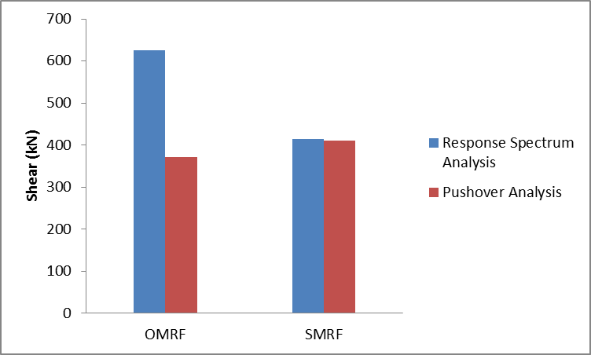

Fig.7- Comparison of performance point shear with base shear in y-direction

The Table No. 3 shows comparison of base shear by response spectrum method for ordinary moment resisting frame (OMRF) with and without steel bracing and special moment resisting frame (SMRF) with and without steel bracing.

Table No. 3 Comparison of base shear

|  |  |  |  |
| --- | --- | --- | --- |
| Type of Model | Base shear in X dir (kN) | Base shear in Y dir (kN) | Base shear in Z dir (kN) |
| OMRF | 704.8554 | 624.809 | 869.285 |
| SMRF | 446.1518 | 415.033 | 547.931 |
| OMRF with steel bracing | 989.4374 | 989.968 | 678.082 |
| SMRF with steel bracing | 949.0116 | 947.805 | 637.871 |

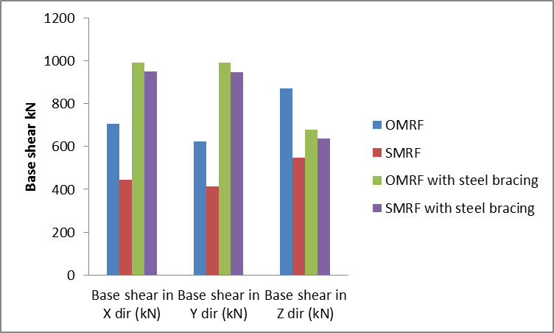

Fig.8 - Comparison of base shear

The Table No. 4 shows comparison of joint displacement by response spectrum method for ordinary moment resisting frame (OMRF) with and without steel bracing and special moment resisting frame (SMRF) with and without steel bracing.

Table No. 4 Comparison of joint displacement

|  |  |  |  |
| --- | --- | --- | --- |
| Type of Model | Ux (mm) | Uy (mm) | Uz (mm) |
| OMRF | 47.219 | 62.638 | 3.496 |
| SMRF | 27.385 | 35.296 | 2.862 |
| OMRF with steel bracing | 8.398 | 13.669 | 3.519 |
| SMRF with steel bracing | 7.849 | 12.338 | 2.893 |

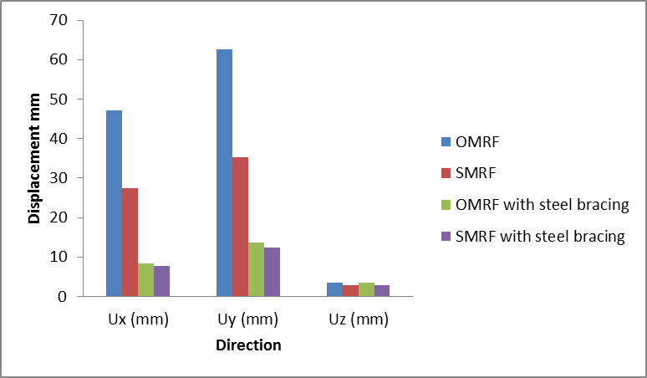

Fig. 9- Comparison of joint displacement

**CONCLUSIONS**

1. Ordinary moment resisting frame shows minimum values on Base shear Vs. Displacement curve than special moment resisting frame. It means that ordinary moment frame resisting is more susceptible to collapse mechanism.
2. The pushover curves were not able to achieve the target displacement even for the Life safety acceptance criteria and therefore needs retrofit.
3. Shear at performance point is less than base shear due to response spectrum method in every model shows no safety against ductility and collapse.
4. Base shear in OMRF and SMRF were increased by 50% using steel bracings.
5. Joint displacement in OMRF and SMRF were reduced up to 85% using steel bracings.

**REFERENCES**

1. *Swajit Singh Goud, Pradeep Kumar Ramancharla,(2014)”Seismic design provisions for ductile detailed reinforced concrete structures”,by in 15th Symposium on Earthquake Engineering (15SEE) Report No: IIIT/TR.*
2. *Dr. Valsson Varghese, YogeshRamakantBorkar,(2013) “Comperative Study Of S.M.R.F. Building Over O.M.R.F. Building With Seismic And Wind Effect” ,International Journal of Engineering Research and Applications (IJERA) ISSN: 2248-9622 www.ijera.com Vol. 3, Issue 3, May-Jun pp.1501-1503*
3. *Kaur S., Singh B., Singh S P, Lal R,(2007) “Analytical Investigation on the Strength and Deformation Characteristics of Reinforced Concrete Beams”, - IE(I) Journal- CV Volume 87, February.*
4. *Haselton1 C. B. and. Deierlein G. G,(2005) “Benchmarking Seismic Performance of Reinforced Concrete Frame Buildings” - ASCE Structures Congress – New York, NY – April .*
5. *Engr. Najif Ismail,(2013) “Comparative studies of IMRF and SMRF in moderate seismic zones” , International Journal of Engineering Research*
6. *T. A. Nelson, A.M.ASCE and E. M. Hines, P.E., M.ASCE “Performance of a 9-Story Low-Ductility Moment Resisting Frame Under Moderate Seismic Demands”*
7. *IS 456: 2000 Plain and Reinforced Concrete- Code of Practice*
8. *IS 1893:2016 Part-I*
9. *IS 13920:2016- Ductile Detailing of Reinforced Concrete Structure subject to Seismic Force- Code of practice*

|  |  |  |
| --- | --- | --- |
| Sr.No | Photo | Details |
| 1 | IMG-20180202-WA0001 | Bhavesh Kuthe is Mtech - student appearing (Structural Engineering) from Gurunanak Institute of Management and Technology, kalmeshwar road, Nagpur (RTM Nagpur University), Maharashtra State, India |
| 2 | IMG-20180202-WA0000 | Prof. D.L.Budhlani is working as Associate Professor, Department of Civil Engineering,Guru Nanak Institute of Technology (Formerly known as Guru Nanak Institute of Engineering & Management )Dahegaon, Nagpur and Dean,Research &Development,Guru Nanak Institutions,Nagpur, Maharashtra State, India. |

**Details of authors**