About Dealtodeals –
India’s Ultimate Online Shopping Destination Dealtodeals’s vision is to create India’s most impactful digital commerce ecosystem that creates life-changing experiences for buyers and sellers. Also Dealtodeals Promote the products of NGO or Social firm without any kind of commission, Free Platform for NGO and Social Firms. Dealtodeals comes with the new concept of customized Cables, Power Supply and with the Customized Machine Cables for New and Existing Business peoples and Personal Requirement also. In January 2016, Amit Phulsange, started Dealtoseals.in - India’s online marketplace, with the widest assortment of categories from regional, national, and international brands. Dealtodeals is the shopping destination for internet users across the country, delivering to 2000+ cities and towns in India. Dealtodeals is the preferred choice thousands of online shoppers. We provide quick delivery even to the remotest corners of the country, and daily deals, discounts & offers to make products available at slashed down prices to our valuable customers. Get Started! Shop Online Today at Dealtodeals. If you have been missing out on all the fun of online shopping thinking it requires one to be a technology aficionado then we have good news for you. Shopping online particularly at Dealtodeals is a child’s play; all you need is a mobile phone or laptop or tablet with Internet connection to get started. Simply log into Snapdeal.com and browse through the wide assortment of products across categories. Once you have zeroed in on your favourite products, simply place the order by filling in the details; the products will be delivered right at your doorstep. Fulfil Your Entrepreneurial Dreams! Sell Today at Dealtodeals Thanks to easy-to-understand, flexible policies and SD Advisors to help sellers at each step, anyone from a manufacturer to wholesaler to retailer can sell on Dealtodeals. Begin your entrepreneurial journey with Dealtodeals as a seller by filling a simple registration form here. Once the registration process is done, you can start selling your products to the entire country by sitting at your home or office. Doesn't it sound thrilling? Of course, it is and the excitement will build up with every order you receive! Start selling at Dealtodeals today and see your business reach staggering heights. experience how fun it is to shop with us !

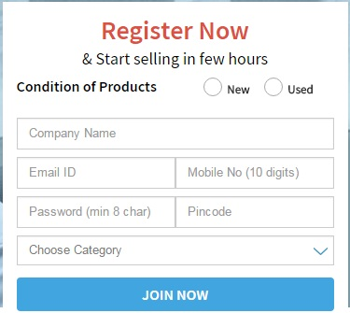

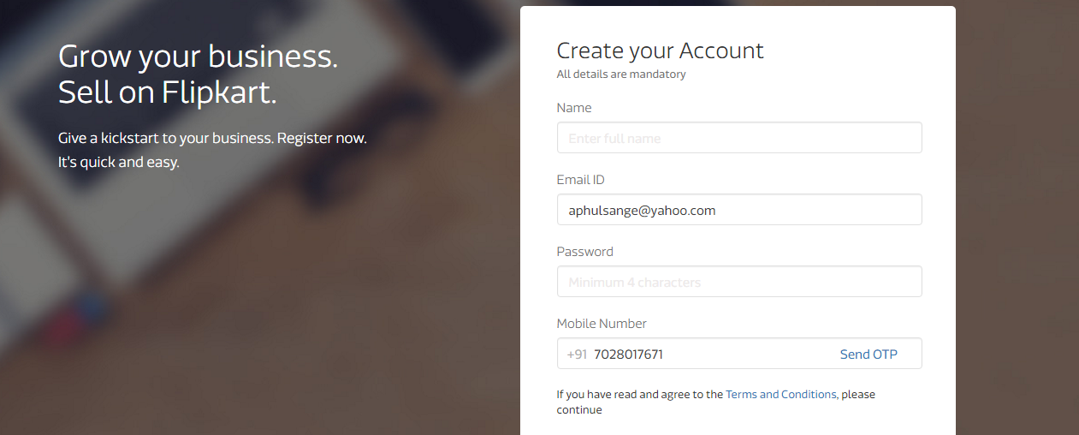
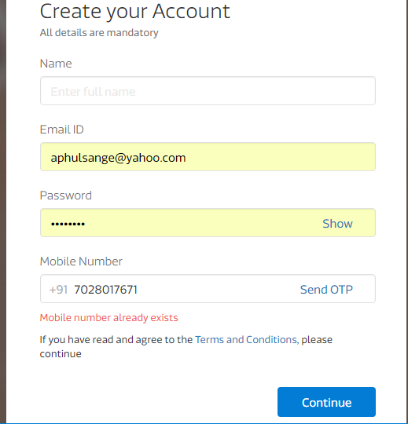
If already registered this type of error should come

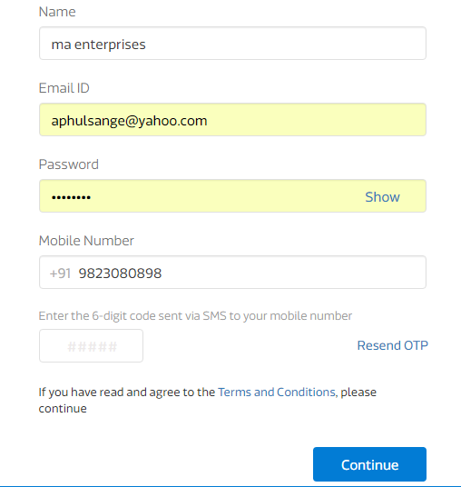

Next page will be like this
