Domestic Food Waste Cycler

Abhay Yadav¹, Gurudatta Tiwari¹, Syed Iliyas Qadri¹, Pankaj Shidhaye¹
Dr. Mrs. A. S. Bhalchandra²

¹ Student, B.E.ETC, Dept. Of ETC, Government College of engineering Aurangabad

²Professor, Dept. Of ETC, Government College of engineering Aurangabad

Abstract – From the daily collections of waste produced by individual homes and society, wet waste contributes major part. Wet waste or biodegradable waste requires at least four to six weeks to fully decompose into humus. During the period, due to atmospheric conditions, fungal growth starts on such waste which is harmful to human beings. Major efforts are being taken by government and non-government organizations to solve the ‘food waste’ issue. Food processing and serving industries, big societies are currently facing the problem of managing the food waste. Nowadays food waste is prohibited from being buried in the ground. Each municipal government is planning to install food waste treatment facilities which would be a very costly deal.
To overcome these issues regarding the management of food waste, an efficient method for disposing food waste is proposed here. This project aims to develop a domestic food waste cycler which converts household food waste into a dry biomass which is as good as homemade fertilizer that can be used in lawn, garden or outdoor potted plants.
The cycler removes all the moisture content and converts food scraps into a dry biomass whose volume is only 10% of the original food scrap and that too in 5-6 hours. Also, the system is compact and hence suitable for domestic purpose.
Keywords- Biomass, fertilizer, Carbon filter, food waste.

INTRODUCTION

Food waste is becoming a critical global problem due to the continuous increase in the world population. Recent Data shows that if food wastage were a country, it would be the third largest emitting country in the world (WRI’S Climate Data Explorer). It is stated that one-third of the food produced in the world for human consumption every year — approximately 1.3 billion tons — gets lost or wasted (UN reports).
While in India, around 67 million tons of domestic waste is generated per year (Clean India Journal Statistical reports, year 2018). Aside from the social, economic, and moral implications of that waste—in a world where an estimated 805 million people go to bed hungry each night—the environmental implications of food waste to climate change is catastrophic. Thus, there is an urgent need to take appropriate actions to reduce food waste burden by adopting new combating practices.
Food waste management is not a new issue, in fact there are many traditional disposal methods used, some of them are given below.
Waste Disposal Units:
Putting food waste down the drain is already illegal in Scotland, Northern Ireland and Wales. And no wonder, drains get blocked and must be cleared. Fat traps have to be installed and emptied – a particularly nasty job. Drains must be dosed with enzymes to reduce grease build up. Large supplies of water are required to flush macerated waste through the units and the drains. Huge costs are imposed on water companies to manage the additional strain on the network.
Compactors and Bins:
Food waste is messy and smelly. Rotting waste in compactors poses a major hygiene problem with the attraction of vermin and flies. Environmental Health Officers need to be satisfied and pest control measures put in place. Food waste corrodes compactors and increases maintenance costs. Bins needs to be washed frequently. All this requires extra money on top of the cost of transporting the 80% of food waste which is water. Have you worked out how much you are paying for this in your organization?
Grey Water Systems:
You will need to install an expensive holding tank outside and pipework to pump the macerated food waste. You will reduce the food waste disposed of but since you will need a specialist vehicle to collect the slurry, the cost saving is nullified. Food waste still goes down the drain, although in particle form. And the tanks need regular flushing out which costs money in water and time.
Composting:
It is a long process: six weeks normally, although some claim less. Wood chips need to be added daily and you will need an outside location and a strong constitution for the smell. It is a natural process but unless you have grounds to spread the product it is only for the eco-enthusiast or the gardener.
The aim of this work is to reduce the amount of wasted food at households in India.
The Objectives are:
- Explore the current used practices.
- Study the intended customers (Households) via conducting a survey.
- Design a solution to the problem.
- Build a prototype of the solution.
- Use behavioral science tools to raise the awareness of food waste reduction among people.

DESIGN
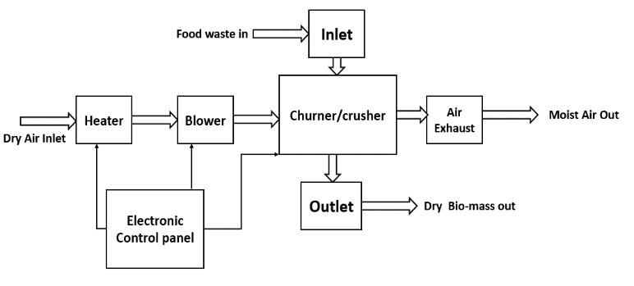
The Block diagram depicts the structure of Domestic Wet Waste Dryer. Here is brief explanation about its sections/blocks:
• Inlet: Inlet is an opening at the top of the system for pouring the waste inside.
• Crusher/Churner: The section immediate to inlet is crusher/churner. The crusher with sharp blades will rotate continuously and cut the waste material into smaller pieces. And the waste will be moved continuously by churner.
• Heater: Heating coil is used to generate heat to dry the wet waste. Heater will heat the surroundings air which will be blown through the wet waste to remove moisture from it.
• Blower: A fan which will pull the hot air inside and blow it on the wet waste to remove moisture from it.
• Air Exhaust: Adjacent to crusher cylinder there is a Air Exhaust System which will exhaust the humid air. There is a humidity sensor fixed near air exhaust, which will continuously sense the humidity of the air pushed outside. Output of humidity sensor is given to a microcontroller, when humidity of air will become lower than a certain level system will be turned off automatically.
• Outlet: After completion of process Dry bio mass (compressed and dried waste) will be taken out from outlet.
• Electronic Control Panel: This panel include ‘microcontroller’ and other required circuitry. This panel is used for speed control of motor, humidity sensor interfacing, exhaust fan and blower control etc.

CONCLUSION
All in all, this paper aim is to show the importance of recycling food waste and helping the environment by building a machine that converts food waste into dry biomass. This food waste cycler machine is to be built and used at home safely. Since the world is seeking sustainability, our machine aims to lessen the food waste that is thrown into the landfills, which pollute the environment by converting the food waste and turning it, in 5-6 hours, to a dry biomass that can be used in fertilizing the soil to plant healthy and organic food, and contributing in creating a safe and sustainable world.

REFERENCES
- The FoodCycler Food Recycler, Food Cycle Science, Available: https://www.nofoodwaste.com/foodcycler, 2017
- ZERA Food Recycler, Indiegogo, Available at: https://www.indiegogo.com/projects/zera-food-recycler-recyclin2#/.

