Analysis of Future Research Directions for the pinpoint Localization Algorithms towards Wireless Sensor Network
1.R.V.Bobate , 2.Dr G.M.Asutkar , 3. Dr. Soni Chaturvedi
1.Astt.Professor ,PIET, Nagpur,
2.Professor , E & C Engg and Vice-Principal , PIET, Nagpur
3. Associate Professor and Head E & C Engg , PIET, Nagpur

Abstract – Wireless sensor networks (WSNs) have as of late develops as promising technology in wireless communication field and increased unique consideration by research groups. It utilizes small and cheap devices with low energy requirements and restricted on board computing resources which speaks with each other's or base stations with no per-characterized infrastructure. The property of being infrastructure less makes it reasonable in particular application circumstances including remote monitoring, disaster management, military applications and biomedical health observing devices. The pinpoint node localization is unavoidably one of the vital framework parameters for instance in target tracking if the nodes are not ready to acquire the precise area data, the related assignment can't be performed. It is likewise useful in directing, quarry management and network coverage of sensors. When all is said in done the localization techniques are requested into two general classifications: extend based and go free. In this paper, we examined the different localization algorithms with their relevant zones, requirements and constraints. In addition, on conclusion we look at these localization algorithms and analyze the future research directions for the localization algorithms in WSNs.
Index Terms : Localization Techniques, Wireless Sensor Networks, Localization Algorithms.

INTRODUCTION
Ongoing advancements in semiconductor technology which makes practical to plan extensive complex circuits into a single integrated circuits (IC) with low power utilization and small frame factor opens up the new appropriate territories for wireless sensor networks. A Wireless sensor network (WSN) is organized by some little, cheap contraptions called sensors which have restricted memory, power and preparing capacities. These sensors are passed on to detect the physical attributes of the encompassing condition, for instance, temperature, light and pollution. Anyway relying on the requirements the detecting parameters of sensors can be changed for broad assortment of employments, for instance, remote detecting, disaster management, tolerant tracking, and military perceptions. In countless applications, region localization is useful or even principal necessity. Truth be told, without knowing the situation of sensor node, accumulated data is valueless. The localization of sensors can be executed by various conduct. A direct course of action is to equip each sensor node with a GPS recipient that can completely outfit the sensor nodes with their exact position. On the other hand, including the GPS to all nodes in the Wireless sensor network isn't ideal in view of its mind-boggling expense, high power utilization and condition obligation. Furthermore, the GPS flops in underground applications. In view of such restrictions other localization techniques are used one of them is self-localization, in which sensor nodes can evaluate their situation by using diverse localization disclosure algorithms. These algorithms use two or three extraordinary nodes, called guide nodes, which are relied upon to know their own specific area (through manual setup or GPS). These guide nodes (or anchor nodes) give position information, as reference point, for alternate nodes, which can utilize this position information from various near to reference signal nodes to gauge their own particular positions. The straggling leftover of this paper is dealt with as take after. In zone 2, request of localization calculations is given. In zone 3, relative examination of localization calculations is discussed. Territory 4 shuts the paper and blueprints future conceivable exploration.

TECHNIQUES OF LOCALIZATION
Generally all localization plans contains of two stages:

Angle/Distance Estimation
In angle/distance estimation, the most recognized range estimation procedures are used to estimate angle or distance between two sensor nodes are AOA (angle of entry), TOA (time of landing), TDOA (Time Difference Of Arrival), RSSI (Received Signal Strength Indicator)and Hop-tally.

Position Calculation
In position estimation, the situation of the obscure node is assessed centered around the open information of distance or angle and positions towards references nodes. Basically used procedures incorporate alteration, triangulation, jumping box, probabilistic approach and fingerprinting. Majority of literatures accessible on node localization centered around a couple of remarkable criteria, for instance, dependence of the range estimations (i.e. range-based localization or without range localization); appropriated or incorporated position estimation; with or without a base (anchor based localization or anchor free localization). According to the dependence of range estimation frameworks, localization calculations can be described into two primary classes: range-based techniques and range-free techniques.

RANGE-BASED LOCALIZATION TECHNIQUES
This gathering has a place with techniques which uses range estimation for area count. As showed by the method for using the range estimation strategies. Range-based techniques utilizes range estimations, for example, time of arrival (ToA), angle of arrival (AoA), received signal strength indicator (RSSI), and time difference of arrival (TDoA) to gauge the distances between the nodes in order to assess the area of the sensors. The range based method can additionally separated into anchor based or anchor less procedure.

Anchor Based Techniques
Anchor nodes are otherwise called reference nodes which have very much characterized information about its area. Henceforth in anchor based procedure different nodes use anchor nodes to evaluate their positions. In such calculations, a small measure of the nodes must be anchor nodes or potentially a base number of anchor nodes are required for satisfactory outcomes.

Time of Arrival(ToA)
Amid the localization procedure, the sensor identifies the time of arrival estimation of the anchor node signals at its collector based on specific signal highlights (e.g., introduction) transmitted by the source node. Given a LOS (line of sight) proliferation way, the time of arrival estimation at sensor node can be demonstrated as
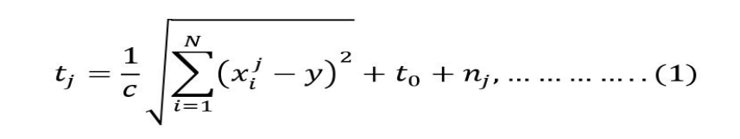
where c is the speed of light, N denotes the dimensions, t₀ is the unknown time instant at which the source transmits the signal to be measured, and n_{j}is the additive measurement noise (error) with zero mean for j^{th}anchor node. Note that the sensors just estimate the sign TOA t_{j}rather than the sign propagation time. Without such time synchronization or time stamp, the TOA estimation includes an additional obscure . With no other prior presumptions on the insights of the TOA estimations, a least square (LS) estimator can be utilized for the source localization issue, i.e.
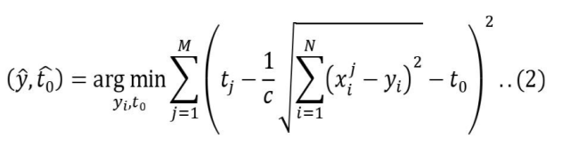
Utilizing optimization techniques, we can execute coordinate optimization via looking for the ideal coordinates of y and t0 that limit (2). A portion of the optimization techniques which can be proffered according to issue attributes are maximum likelihood (ML) and least square (LS) anyway as of late created transformative algorithms like hereditary algorithm (GA), artificial bee colony (ABC) optimization and practical swarm optimization (PSO) can likewise be used.

Time Difference of Arrival (TDoA)
Since The TOA display needs to assess both and together which makes the optimization issue fairly difficult as a multidimensional pursuit issue likewise that the obscure isn't of direct enthusiasm for source localization. Subsequently an adjusted approach is proposed in which the subsequent TOA estimation are preprocessed through pair wise subtraction to produce the estimation for time difference of arrival based localization, free of , and known as Time Difference of Arrival (TDoA).
In order to acquire the time-difference of arrival, a straightforward preprocessing calculations of the TOA estimation is given by
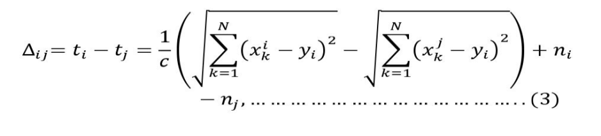
Anyway point by point investigation of condition (3) uncovers that there are two issues for this transforming. Initially, we take note of that the terms in (3) are not any more free, henceforth the terms and are connected since they have in like manner term . Additionally, in correlation with the uncorrelated clamor in the principal TOA show (1), the subtraction similarly strengthens the commotion in TDOA by precisely by factor of two. Subsequently, the preprocessing for getting TDOA may cause the performance debasement which ought to be kept away from.
3.1.3 Angle of Arrival(AOA)
The localization process are focused around a fundamental technique where sensor node noting the times and angle when it gets the signals from different anchor nodes, and then calculates their location by triangulation. Denote the times at which a sensor node S_{i} receives the beacons signals at instants t₁,t₂,t₃, and from anchor nodesA₁, A₂, A_{3,}A₄(since only four anchor nodes are sufficient for 3 dimensional space) respectively. The time difference of arrivals can be translated to angular values by using equation (4):
Where t₁=t₂-t₁, t₂=t₃-t₂ and t₃=t₄-t₃ are time differences. Any two angles chosen from , and can then be used to solve for the location of the S_{i}using trigonometry. For instance, we get:
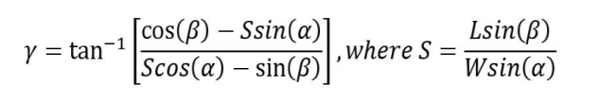
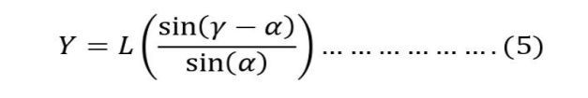
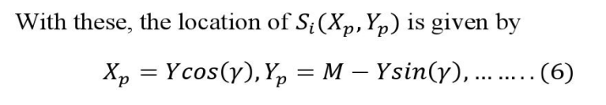
Note: In the displayed framework the anchor nodes are thought to be outfitted with turning transmission bar while the sensor nodes having Omni directional antenna anyway the inverse of supposition can likewise be utilized.
There are a few confinements with this area disclosure procedure, for instance if there is multipath reflection the gets distinctive multipath reflected signals from single anchor node. This demands for particular requirements with the end goal that exceptionally tight (preferably zero) bar width of the anchor antenna.

3.1.4 Received Signal Strength Indicator(RSSI)
In this procedure sensor nodes utilizes the Received Signal strength (RSS) for the estimation of distance from anchor nodes and then based on these estimations they evaluate their areas.
The connection between the RSSI and distance is exhibited by Log Distance Path Loss Model which is a major strategy for evaluating way misfortune as an element of distance between the nodes. The model is by and large communicated as following equation.
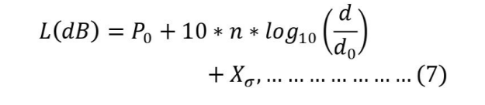
Where n is the path loss exponent, d is the distance between transmitter and receiver and P₀is the received power at reference distance d₀.
The RSSI is calculated by equation (8)
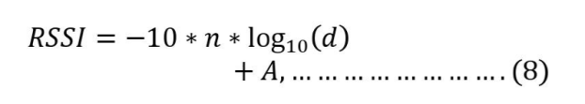
Where n is engendering type, d is the distance from the sender and An is the received signal strength at one meter of distance. Ones the distance is computed the node positions is evaluated by limiting the total of the errors between the assessed distance between the nodes and the deliberate one (Minimum Least Square algorithm).
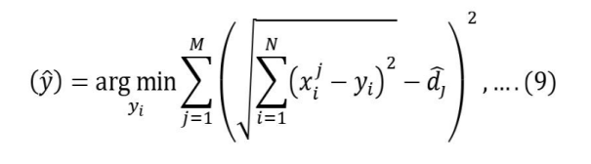
Where d_{j} is the distance from j^{th}anchor node and y_{i} is the coordinates of node to be estimated.
An inconvenience to anchor-based calculations is that an other situating framework is obliged to precisely characterizing the anchor node positions. Thus, if the other situating framework is out of reach, for instance, for GPS-based anchors seen in locales where there is no sensible point of view of the sky, the estimation may not work authentically. A substitute inconvenience to anchor-based calculations is that anchor nodes are exorbitant as they commonly oblige a GPS beneficiary to be mounted on them. In this way, algorithms that requires various anchor nodes are not monetarily best. On the non-GPS anchors where the area information is hard-coded into anchor nodes cautious situation of anchor nodes is fundamental, which might be extremely costly or even inconceivable much of the time.

3.2 Anchor Free Techniques
In order to compute the distances, this plot initially chooses four in range sensor nodes and doles out them coordinates. The coordinates of different nodes are incrementally figured utilizing the distances from at least four nodes with effectively ascertained coordinates. The ABC algorithm does not require entangle estimation, thus extensively more straightforward than Range-based algorithms anyway the localization precision is very low particularly for far reaching networks. Likewise the algorithm gathers the error in each cycle which brings about continuous debasement of situating exactness which diminishes from the node which began algorithm consequently in genuine network the entire chart acknowledgment isn't ensured. Furthermore, regardless of whether estimation is corrupted by clamor, the algorithm can prompt totally incorrect nodes localizations.

RANGE-FREELOCALIZATIONTECHNIQUES
Range-free techniques utilize availability information among neighboring nodes to appropriately gauge the node's area consequently range-free techniques don't require any extra equipment and utilize adjacent nodes information to evaluate the area of the nodes in the network, in spite of the fact that these techniques have constrained exactness. Like Range-based algorithm the range free algorithms likewise separated into anchor based or anchor less types.

4.1 Anchor Based Algorithm

4.1.1 Centroid
The Centroid scheme was proposed by Bulusu et al. in [2]. This localization scheme requires an arrangement of anchor nodes with the end goal that the transmission range of these nodes makes regular districts of accessibility, exist in the situation territory of the WSN. The primary thought is to ascertain the focal point of gravity of all anchor nodes by treating the anchor nodes. In the most broad form the coordinates of focus of gravity of the centroid of point masses are given by:
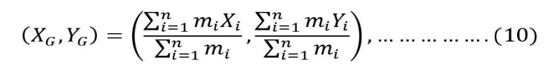
which, for equal mimasses simpliﬁesto:
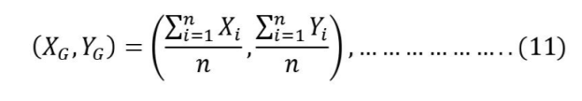
A nodeN_{k}computes its location as the average of all the anchor nodes A_{i} it has heard from with a connectivity higher than threshold.
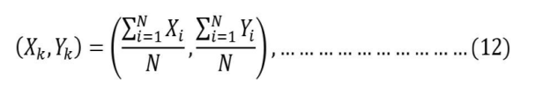
Where N is the number of anchors with a higher connectivity than the threshold.

Area Based
      - Area-Based Point-In-Triangulation Test (APIT) localization scheme
It expect that somewhat number of nodes, called anchors, are furnished with high-control transmitters and knows their zone, by methods for GPS or some other segment. Using signals from these anchors, it uses a locale based technique to perform region estimation by isolating region into triangular district between anchor nodes as demonstrated in Figure 1. A node's region inside or outside of these triangular district allows a node to confined down the locale in which it can possibly live. By utilizing diverse blends of anchors, the measure of the evaluated territory in which a node dwells can be diminished, to give a decent location estimate.
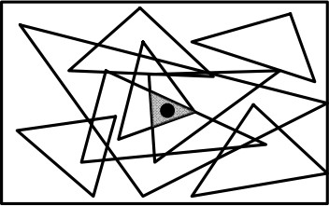

Figure 1: Area-based APIT Algorithm triangular region formation
The theoretical technique used to limit the conceivable region in which a target node dwells is known as the Point-In-Triangulation Test (PIT). For three given anchors:
A(a_{x},a_{y}), B(b_{x},b_{y}), C(c_{x},c_{y}), the Point-In-Triangulation test decides if a point M with an obscure position is inside triangle ABC or not. It rehashes this PIT test with various anchor mixes until the point when all blends are depleted or the required exactness is accomplished. Now, it computes the center of gravity (COG) of the crossing point of the greater part of the triangles in which a node lives to decide its evaluated position.

Secure range-independent localization (SeRLoc)
Serloc is a substitute approach for area based range-free localization. The algorithm utilizes two sorts of nodes: ordinary nodes and locators (i.e., anchors). Ordinary nodes are outfitted with unidirectional gathering antennas, while anchors are furnished with directional antennas and their areas are known. In Serloc, a sensor gauges it area based on information transmitted by the locators. Figure 6 shows the primary idea, with node inside radio range to locators and Serloc finds the sensor nodes in four stages. In the first place, a locator transmits directional reference points inside a portion. Every one signal contains the locator's position and the angles of as far as possible lines. An average node assembles the signals from all locators it tunes in. Second, it chooses a harsh inquiry locale inside which it is spotted by utilizing the directions of the locators tuned in. Third, it forms the covering portion district using an overwhelming part vote design. Finally, Serloc chooses a node territory as the center of gravity of the covering locale.

Ad-Hoc Positioning System
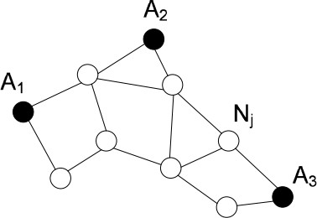
The Ad-Hoc Positioning System (APS) utilizes the bounce by-jump engendering of distances to known anchor nodes. In the wake of acquiring distance assessments to three or more anchors, a sensor node utilizes a multilateration for iteratively enhancing its area estimation. This algorithm chiefly vary from the past algorithms on the premise that how a sensor node evaluates its distance to an anchor .The means of the APS localization scheme algorithm are the accompanying:
Each anchor node starts a ﬂood of the network by broadcasting a parcel containing its position and a counter with the underlying worth set to one. Every sensor node monitors the shortest way (as far as radio bounce tallies, ) to an anchor from which it has received a reference point. The authors additionally propose four techniques for proliferating the distances from anchors to sensor nodes: DV-Hop, DV-Distance, Euclidian and Coordinate. The strategy that does not expect running, DV-Hop is portrayed beneath. A case of the DV-Hop scheme is appeared in Figure 3. Toward the finish of this stage, node realizes that it is 3 hops, 2 hops and 1 bounce from and , separately. Once an anchor node gets distances to Figure 3: The DV-Hop localization scheme different anchors, it registers a correction factor (the assessed 1 radio jump Euclidian distance), which it proliferates in the network. Corrections are engendered through controlled ﬂooding, i.e., after a node gets and forwards the ﬁrst correction, it will quit forwarding resulting corrections. The correction factor is figured as takes after:
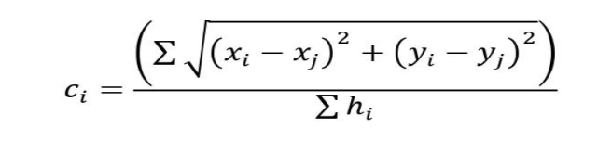
for all anchors from which it has received a beacon(anchor A_{j} is positioned at (x_{j},y_{j}) and h_{i} is the number of hops between the sensor node and anchor A_{i}).

Anchor-FreeSolutions

Spotlight
The principle thought of the Spotlight localization system is to produce controlled events in the ﬁeld where the sensor nodes are conveyed. An occasion could be, for instance, the nearness of light in a zone. Utilizing the time when an occasion is seen by a sensor node and the spatio-temporal properties of the produced events, spatial information (i.e. area) with respect to the sensor node can be gathered. The system design for the Spotlight localization system is appeared in Figure 4.
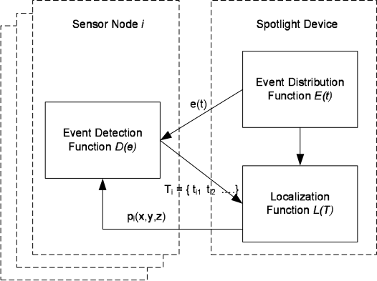
Figure 4: Spotlight system architecture
With the support of these three capacities, the localization procedure goes as takes after:
•A Spotlight gadget conveys events in the space over some stretch of time.
•During the occasion conveyance, sensor nodes record the time succession at which they recognize the events.
•After the occasion conveyance, every sensor node sends the location time arrangement back to the Spotlight device.
•The Spotlight gadget assesses the area of a sensor node , utilizing the time succession and the known capacity.

CONCLUSION
Notwithstanding the way that WSNs are a moderately new idea, there are various distinctive localization approaches, each with a consideration on specific circumstance and/or application has already introduced. In this paper, we look at and analyzed a portion of the ongoing localization algorithms, and reasoned that among every thought about technique, this relative examination drove us to derive that each computation has its own advantages and disadvantages and none is totally the best. All in all, the range-based systems are either no-savvy in regards to hardware cost, or restricted by to characteristic conditions. Curiously, the range-free procedures are indeterminate and viably impacted by node thickness. On the other hand, it has bring down exactness. As we known precision is the most basic key for localization execution. Among the plans dismembered in this paper, range-based techniques look empowering, considering that the cost of positioning gear's are diminishing ceaselessly making this procedure an effective response for the localization in wireless sensor networks. Anyway in future the range estimation procedures between anchor nodes and sensor nodes can be created.

REFERENCES
- Guoqiang Mao, Barıs¸ Fidan and Brian D.O. Anderson "Remote Sensor Network Localization Techniques", Computer Networks Volume 51, Issue 10, 11 July 2007, Pages 2529– 2553.
- AsisNasipuri and Kai Li "A Directionality based Location Discovery Scheme for Wireless Sensor Networks", WSNA '02 Proceedings of the first ACM universal workshop on Wireless sensor systems and applications Pages 105-111 ACM New York, NY, USA.
- Masashi Sugano, Tomonori Kawazoe, Yoshikazu Ohta, and Masayuki Murata "Indoor Localization System Using RSSI Measurement Of Wireless Sensor Network Based On Zigbee Standard", Wireless and Optical Communications, IASTED/ACTA Press, (2006).
- RongPeng and Mihail L. Sichitiu "Point of Arrival Localization for Wireless Sensor Networks", Sensor and Ad Hoc Communications and Networks, 2006. SECON '06. 2006 third Annual IEEE Communications Society on (Volume:1) 28-28 Sept. 2006 Page(s): 374 – 382
- MohitSaxena, Puneet Gupta, BijendraNath Jain "Trial Analysis of RSSI-based Location Estimation in Wireless Sensor Networks", Communication Systems Software and Middleware and Workshops, 2008. COMSWARE 2008. third International Conference on 6-10 Jan. 2008 Page(s): 503 – 510.
- Ravindra S and Jagadeesha S N "Time of Arrival Based Localization In Wireless Sensor Networks: A Linear Approach", Signal and Image Processing: An International Journal (SIPIJ) Vol.4, No.4, August 2013.
- Kuo-Feng Ssu, Chia-Ho Ou, and Hewijin Christine Jiau, "Confinement with Mobile Anchor Points in Wireless Sensor Networks", IEEE Transactions on Vehicular Technology, Vol. 54, No. 3, May 2005.
- F. Viani, L. Lizzi, P. Rocca, M. Benedetti, M. Donelli, and Andrea Massa "Protest Tracking through RSSI Measurements in Wireless Sensor Networks", May 2008, University of Trento.
- Jan Blumenthal, Frank Reichenbach, Dirk Timmermann "Negligible Transmission Power versus Flag Strength as Distance Estimation for Localization in Wireless Sensor Networks", International Workshop on Wireless Ad-hoc and Sensor Networks (IWWAN 2006), New York.
- Guoqiang Mao, BarısFidan, Brian D.O. Anderson "Remote sensor arrange limitation procedures", Computer Networks 51 (2007) 2529– 2553.
- Lingxuan Hu, David Evans "Limitation for Mobile Sensor Networks", MobiCom'04, Sept. 26.– Oct. 1, 2004, Philadelphia, Pennsylvania, USA.
- RaduStoleru, Tian He and John A. Stankovic "Range-Free Localization", Secure Localization and Time Synchronization for Wireless Sensor and Ad Hoc Networks Advances in Information Security Volume 30, 2007, pp 3-31.
- AsmaMesmoudi, Mohammed Feham, Nabila Labraoui "Remote Sensor Networks Localization Algorithms: A Comprehensive Survey", International Journal of Computer Networks and Communications (IJCNC) Vol.5, No.6, November 2013.
- A. Faheem, R. Virrankoski and M. Elmusrati "Enhancing RSSI based separation estimation for 802.15.4 remote sensor systems", Wireless Information Technology and Systems (ICWITS), 2010 IEEE International Conference on Aug. 28 2010-Sept. 3 2010 Page(s): 1 – 4.
- Hady S. AbdelSalam, Stephan Olariu "Towards Enhanced RSSI-Based Distance Measurements and Localization in WSNs", INFOCOM Workshops 2009, IEEE 19-25 April 2009 Page(s): 1 – 2.
- EnyangXu, IEEE, Zhi Ding, and SouraDasgupta "Source Localization in Wireless Sensor Networks from Signal Time-of-Arrival Measurements", IEEE Transactions on Signal Processing, Vol. 59, No. 6, June 2011.
- Khalid K. Almuzaini, Aaron Gulliver "Range-Based Localization in Wireless Networks Using Density-Based Outlier Detection", Wireless Sensor Network, 2010, 2, 807-814.

