Fabrication of Thermoelectric Refrigerator

**Shaikh Sahil1, Mohammad Fahim2, Gopal Naik3, Pushpa Gadage4**, **Sayyed Juned5**

**1,2,3,4,5** BE-Final Year , Mechanical Department Of GF’s Godavari College Of Engineering Jalgaon , 425001.

*ansariabsar12391@gmail.com*

*Abstract –The increase in demand for refrigeration globally in the field of air-conditioning, food preservation, medical services, veccin storages, and for electronic components temperature control led to the production of more electricity and consequently an increase in the CO2 concentration in the atmosphere which in turn leads to global warming and many climatic changes. Thermoelectric refrigeration is a new alternative because it can reduce the use of electricity to produce cooling effect and also meet today’s energy challenges. Therefore, the need for thermoelectric refrigeration in developing countries is very high where long life and low maintenance are needed. The objectives of this study is to develop a working thermoelectric refrigerator to cool a volume of 40 L that utilizes the Peltier effect to cool and maintain a selected temperature range of 5 0C to 25 0C. The design requirements are to cool this volume to temperature within a short time and provide retention of at least next half an hour. The design and fabrication of thermoelectric refrigerator for required applications are presented.*

*Key words : Thermo Electric Module , Heat Sink Fan , Battery , Thermal Casing*

1. **INTRODUCTION**

**D**ue to the increasing demand for refrigeration in various fields led to production of more electricity and consequently more release of harmful gas like CO2 all over the world which is a contributing factor of global warming on climate change.

Thermoelectric refrigeration is a new alternative method. The thermoelectric modules are made of semiconductor materials electrically connected in series configuration and thermally in parallel to create cold and hot surfaces. Although they are less efficient than the vapour compression system, they are very light, low in cost, silent in operation, and are environmentally friendly.

The design requirements are to cool the volume to a temperature within a short time and provide retention of at least next half an hour. And a thermosiphon cooling system is used for cooling the hot side of TEC module. It will be used in remote locations in the world where there is no grid electricity, and where electrical power supply is unreliable when a solar panel charger is added for battery charging.

A thermoelectric module thus uses a pair of fixed junctions into which electrical energy is applied causing one junction to become cold while the other becomes hot.[1]

1. **LITERATURE SURVEY**

Review of a number of patented thermoelectric refrigerator designs, a photovoltaic-direct/indirect thermoelectric cooling system, and research studies from the literature are described in the following section. A simple design was proposed by Beitner in 1978 consisting of thermoelectric modules directly powered by an external DC source and an external thermal sink to dissipate heat to ambient by using natural convection cooling. Reed and Hatcher in 1982 proposed an effective way to increase the heat dissipating capability at the hot end of thermoelectric modules by using the cooling fan. Park et al. in 1996 introduced the new design of thermoelectric refrigerator by combining the benefits of super insulation materials with thermoelectric system and phase change materials to provide an environmentally benign system that was energy efficient and could maintain relatively uniform temperature for the extended periods of time with relatively low electrical power requirements. Gillery and tex in 1999 proposed the design of a thermoelectric refrigerator by employing evaporating, condensing heat exchanger to improve heat dissipation at hot end of thermoelectric modules.[2]

**2.1 Problem Statement**

It is necessary to provide a comparative analysis of thermoelectric refrigeration system at this stage with the other parameters. The aim of this study is to provide an information to the researchers to select appropriate refrigeration system .suitable for the application. Hence one should compare TER.

1. **METHODOLOGY**

**3.1 Thermo Electric Module**

Although Peltier effect was discovered more than 150 years ago, thermoelectric devices have only been applied commercially during recent decades. Lately, a dramatic increase in the application of TE solutions.

**3.2 Battery**

Battery is used send current to the refrigerator it is of 6 volts and 7.5 amperes and is of rechargeable type.

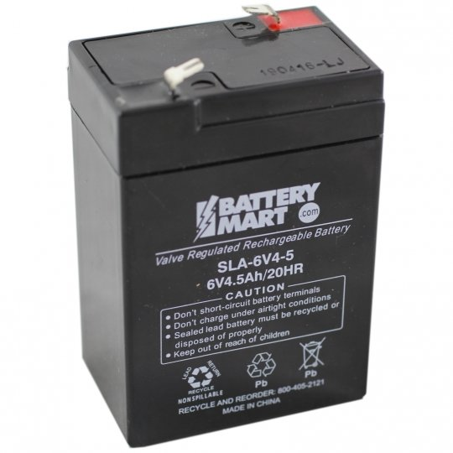

Fig. 1. Battery

**3.3 Thermal Casing**

Thermal casing is made of thermo coal and is used for keeping cool inside and to store the storage beverages and food stuffing’s in the refrigerator.



Fig. 2. Thermal Casing

**3.4 Heat Sink**

A heat sink is a passive heat exchanger that transfers.The heat generated by an electronic or a mechanical device into a coolant fluid in motion. Then-transferred heat leaves the device with the fluid in motion therefore allowing the regulation of the device temperature at physically feasible levels.



Fig. 3. Heat Sink

1. **Working Principle**

The figure 4 below shows the working of thermoelectric module. When a DC voltage is applied to the TE module, the positive and negative charge carriers in the pellet assemblage absorb heat energy from one of the surface and reject it to the other at the opposite side. The surface area where heat energy is absorbed gets cooler; the opposite surface where heat energy is released gets hotter. Reversing the polarity will result in reversed hot and cold sides.[3]

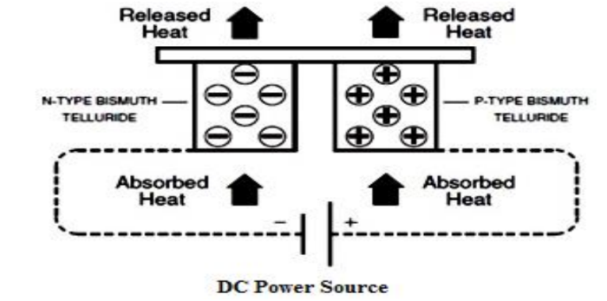

Fig. 4.Working of thermoelectric module

1. **CONCLUSION**

We have been successful in designing a system that fulfils the proposed goals. However we do realize the limitations of this system. The present design can be used only for light heat load to lower its temperature to a particular temperature. The system is unable to handle fluctuations in load. Extensive modifications need to be incorporated before it can be released for efficient field use. This is one of the advantageous project which uses low power to drive refrigerator. This project work has provided us an excellent opportunity and experience, to use our limited knowledge. Thermoelectric refrigeration is one of the key areas where researchers have a keen interest. Some of the recent advancements in the area surpass some of the inherent demerits like adverse COP. Cascaded module architecture has defined new limits for its application. Moreover recent breakthrough in organic molecules as a thermoelectric material assure an excellent future for TER. Integration of renewable energy as power source this refrigerator can be used for remote rural places where there is no electric supply.

**REFERENCES**

1. *"Thermoelectric cooling," [Online]. Available: www.wikipedia.org.*
2. *"RAC LECTURE 10 PDF," in Version 1, ME, IIT Kharagpur.*
3. *T. J. Seebeck , "MagnetischePolarisation der Metalle und ErzedurchTemperatur-Differenz. Abh. Akad. Wiss.," pp. 1820–21, 1822, 289–346.*
4. *J. C. A. Peltier, "Nouvellesexpériencessur la caloricité des courants* electric”