Feasibility Study for Establishing a Manufacturing Industry for Activated Carbon and Bio Oil Extraction Using Coconut Shell in Vidarbha Region
(A Review)
Rahul Sohani, Dr.Achal Shahare
M.tech student, Department of Mechanical Engineering
G.H. Raisoni Academy of Engineering & Technology, NAGPUR, INDIA 440016
Professor and Head of Department Mechanical Engineering
G.H. Raisoni Academy of Engineering & Technology, NAGPUR, INDIA 440016

Abstract – This paper shows the feasibility study for establishing a manufacturing industry for extracting activated carbon and bio oil using coconut shell particularly in Vidarbha region. As we are talking particularly about Vidarbha region so according to present scenario there are very less number of manufacturing industries in Vidarbha region and demand is more. Also as we are extracting it from coconut shells and coconut shell is considered as waste so we try to make best from waste. In the present scenario energy sectors and individual entrepreneurs can opt a new way of power generation using the most abundantly available renewable source of energy in the form of biomass wastes. Among the biomass resources coconuts are the abundant renewable resource of energy available all around the world. Literature review showed that limited research studies had been carried out on yielding the product from coconut shell. The objective of present work is to envisage the methodology of generating activated carbon and bio oil by activation & pyrolysis process to that potentially could be used as water purification agent and fuel or as feedstock to valuable chemicals.

Keywords – Coconut Shell, Activated Carbon, Bio Oil

Introduction

Coconut is a popular plantation and is grown in more than 90 countries worldwide. The world production of coconut sums up to around 55 million tons annually. Coconut production plays an important role in India. India accounts for 22.34 per cent of the world’s coconut production and is one of the major players in the world’s coconut trade. According to figures published in December 2017 by the Food and Agriculture Organization of the United Nations, India is the world's third largest producer of coconuts, producing 10,894,000 tons in 2017.Coconut in India is produced in 1894570 ha, and 15729.75 million nuts produced in 2016-2017.The coconut oil; apart from used as edible oil; has varied industrial applications. It is used in the manufacture of toilet soaps, laundry soaps, surface‐active agents and detergents, hair tonics, cosmetics, etc
. Here we are extracting Activated Carbon and bio oil using coconut shell. And also then establish a manufacturing industry in Vidarbha region. So we must take into consideration that
- How many Industries are currently working on that topic in Vidarbha region?
- What is the minimum amount of Activated carbon and bio oil should be manufactured so that industry will be in profit?
- In how much quantity raw material will be required?
- Which steps to be followed for production of Activated Carbon and Bio oil?
- How much quantity of land, man, machine will be required?
- How it should be sold and how the price should be calculated?
- How advertisement of product should be done? So that more and more people will be aware about it.
- What are the specifications of the Activated carbon and Bio oil should be?
These are the important points which are to be taken into consideration before establishing an industry. Also as we are establishing an industry so the main objective of it should be customer satisfaction and profit to be earn.
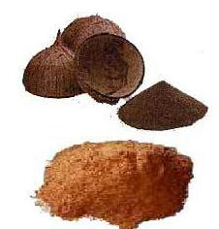

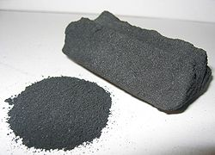

Literature Review
The main purpose of this literature review is to know about the project from reference books, journals, technical papers and web sites.

- (Susheela.P Radha.R ) (IJCBS RESEARCH PAPER VOL. 1 [ISSUE 10] JANUARY, 2015): This paper shows that Activated carbon is a non-graphite form of carbon which could be produced from any carbonaceous material. Activated carbons are increasingly used as the economic and stable mass separation agent for the removal of surfactants to raise the final product quality many industrial processes. Activated carbons also play an important role in many areas of modern science and technology such as purification of liquids and gases, separation of mixtures and catalysis. The main objective of the study is to produce activated carbon from dry coconut shell and to treat the domestic waste water and to recycle the treated water for home gardens. The higher purity, negative cost, high rate of production and strong carbonaceous structure of coconut shell proves to be a precursor for carbon production. This research will pave way for the recycle and reuse of waste water that could further reduce the level of water pollution.

- (Rahul G Karmankar) (IRJET VOL. 3 Issue 01-Jan-2016): This papers show the carbon black and its manufacturing process. Carbon black is produced by the incomplete combustion of hydrocarbon or thermal cracking. The black falls into three groups by method of manufacture: (1) channel (2) furnace, and (3) thermal. The average particle size of black ranges from about 15 - 275 millimicron. The finest black is channel black and coarsest is the thermal blacks, but there is some overlapping of the furnace blacks at both ends. Carbon blacks are not pure carbon but contain varying amounts of hydrogen and oxygen. The principal effect of this non-carbon material seems to be on the surface characteristics, specially the pH. The channel blacks are acid, while furnace blacks and thermal blacks are neutral or alkaline. The acid blacks are slower curing and generally require more accelerators for good cure. As a group, the carbon blacks have probably received the greatest amount of study both as to method of manufacture Carbonization (or carbonization) is the term for the conversion of an organic substance into carbon or a carbon-containing residue through pyrolysis or destructive distillation. The soot of a natural gas flame, used in paints; is fine carbon. Also called channel black.

- (Dipa Das, Debi Prasad Samal): Adsorption has appeared as one of the promising methods for CO2 capture and sequestration due to its low energy consumption, cost effectiveness, relatively simple technological process, non-corrosive to the equipments and it is applicable over a relatively wide range of temperatures and pressures. Development of new and high efficient solid adsorbents is crucial to enhance competitiveness of this process. Zeolites or activated carbons are good adsorbents that are used for capturing CO2 from flue gas through physical adsorption, due to its porous structure. The extensive use of activated carbon is used now days, due to its large micro porosity, large specific surface area. The activated carbon is seems to be black in color and have large micro porosity. Activated carbon adsorption also used for treating low concentrations of wastewater streams at extremely low cost. The removal efficiency of Activated carbon is very high for harmful pollutants. As environmental pollution is the major problem now a day’s so need of activated carbon is growing day by day. Its texture characteristics and surface properties depend on the raw material and on the method used for its preparation. For AC, the removal of moisture is not required and it is easy for regeneration and has a high CO2 adsorption capacity at ambient pressure and also its good adsorption properties. Activated carbons can be prepared by either a physical method or chemical method. It is produced from a large number of carbonaceous raw materials like coal, lignite, wood and some agricultural product like rice husk, nut shell, coconut shell, pea nut, sugarcane bagassage, tamarind wood, saw dust and industrial waste products. The cost of Agricultural wastes is very low so it is considered to be a very important feedstock for preparation of AC. To prepare activated carbon from chemical activation, the steps are carbonization step and activation step. Raw material is impregnated with an activating reagent before carbonization step in chemical activation method. The effect of different chemical reagents on the production and quality of activated carbon was studied extensively by different researchers.
- (Radhakrishnan C , Karunaraja Natarajan , Azhagendran K, Mohanlal K , Ponraj P, Nivas R) : The utilization of bio-mass materials as a renewable energy sources is attracting the global attention over the last two decades and this is much more predominant in countries where agricultural activities are abundant. A continuous type pilot plant for the production of bio-char and the down-stream products (bio-oil and synthesis gas) was designed, developed and analyzed. The pilot plant consists mainly of a rotary pyrolysis reactor, cyclone separator and a condenser assembly. Heating is done externally underneath the retort using an LPG stove, having provision for controlling the heating rate. The generated bio-oil is directly condensed in water condenser method. Experiments were conducted with different types of bio-masses, varying the residence times and pyrolysis temperatures. The recoveries of bio-oil products obtained under different treatment conditions along with their characterizations are reported.

Methodology
This chapter represents the activity of this project..Consideration made while planning the project
- Market Survey: Here we must first survey the present market situation and how many suppliers are presently working on this project. Also what is the demand of product produced and application of it.
The present suppliers near Vidarbha region and market requirement are,
Mainly the activated carbon is produced in Gujarat but as we are considering only Vidarbha region so suppliers near Nagpur are as follows,
Suppliers:
1. Shauren Valour (Vaishali Nagar, Bhilai)
2. Jai Hind Complete Water Solution (Saturna, Amravati)
3. Rai Energy Sources (Light Industrial Area, Bhilai)
4. Western Coalfield Limited (Yavatmal)
Market Requirement:
- Activated Carbon:
- Rite Water Solutions, Nagpur
- Nagpur Municipal Corporation (NMC), Nagpur
- Gorewada Water Treatment Plant, Nagpur
- Bio Oil:
- Reuse for heating of bio mass
- Furnace
2. Raw material: For the selection of an appropriate raw material for preparation of porous carbon, several factors are taken into consideration.
Industrially, inexpensive material with high carbon and low inorganic (i.e. low ash) content is preferred as raw material for the production of activated carbon. High density of the precursor and sufficient volatile content are of considerable importance.
Evolution of volatile during pyrolysis results in porous char, essential for making activated carbons, while high density contributes to enhanced structural strength of the carbon, essential to withstand excessive particle crumble during use.
We can collect coconut shells from,
- Nearest temples
- Caterers
- Hiring some farmers

- Processing Technology: 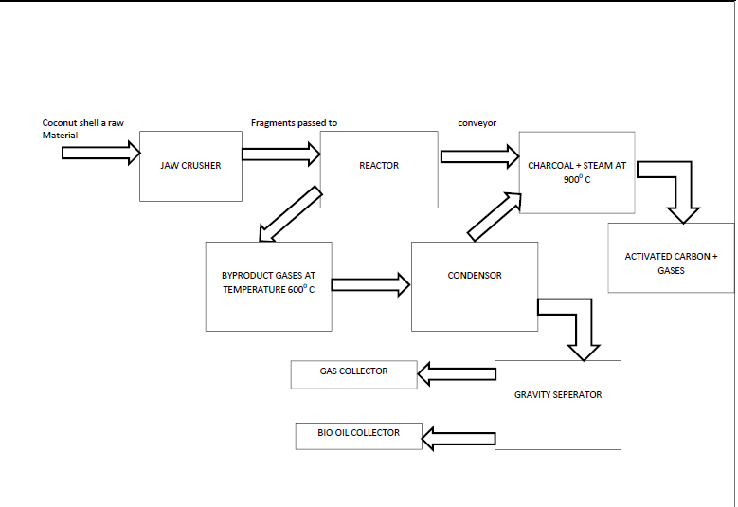4. Technical Specification:
 |  | TECHNICAL SPECIFICATION OF GRANULAR ACTIVATED CARBON
Appearance | Black Granular
Particle Size | Any sieve size viz. 4 / 8, 8 / 16, 12 / 30, 4 / 16, 8 / 30,16 / 30
Iodine Adsorption | 500 mg / gm ± 25 |  | 750 mg / gm ± 25 | 850 mg / gm ± 50 | 950 mg / gm ± 50 |  | 1100 mg / gm ± 50
pH | 9 to 10 |  | 9 to 10 | 9 to 10 | 9 to 10 |  | 9 to 10
Moisture | 5% |  | 5% | 5% | 5% |  | 5%
Total Surface Area | 500 m² / gm. |  | 750 m² / gm. | 850 m² / gm. | 950 m² / gm. |  | 1100 m² / gm.
Bluk Density | 0.55 ±0.05 gm. / CC |  | 0.53 ±0.05 gm. / CC | 0.51 ±0.05 gm. / CC | 0.50 ±0.05 gm. / CC |  | 0.48 ±0.05 gm. / CC
Ball Pan Hardness no. | 90 |  | 85 | 80 | 80 |  | 70
Ash Content | 5.% Max |  | 5.% Max | 5.% Max | 5.% Max |  | 5.% Max

Technical Specification for bio oil according to American Standard for Testing and Material (ASTM).
Sr. No. | Material Samples | Viscosity @ 40*C  Kinematic Dynamic | Calorific Value  (Kcal/Kg) | Moisture  (%)
1. | Coconut Shell | 17.6Cst/s 18.37mPa.s | 4456.6 | 21.3
2. | Coconut Front | 17.8Cst/s 18.48mPa.s | 4616 | 23

5. Preparation of Model: Now prepare the model for production of Activated carbon and Bio oil by Activation and Pyrolisis process respectively. Then test the product according to above specifications.
6. Execution of project: After testing the product for above technical specifications then
- Analyze the number of units required for production,
- Number of workers,
- Insurance of the components and workers
- Costing of the product
- Marketing
The price of activated carbon is about 34 to 40 per kg and generally sold per ton.
Reference
1. International Research Journal of Engineering and Technology (IRJET)
2. Coconut Board of India
3. International Journal of Innovative Research in Science, Engineering and Technology (IJIRSET)
4. PRODUCTION OF ACTIVATED CARBON FROM DRY COCONUT SHELL AND ITS EFFICIENCY IN TREATING WASTE WATER Susheela.P Department of Zoology PSGR Krishnammal College for Women Coimbatore, Tamilnadu, India. Radha.R Department of Zoology PSGR Krishnammal College for Women Coimbatore, Tamilnadu, India
IJCBS RESEARCH PAPER VOL. 1 [ISSUE 10] JANUARY, 2015
5. Extraction of carbon black from coconut shell Rahul G Karmankar (Asst. professor, Mechanical Engineering Department, RTMNU, Maharashtra, India)
IRJET VOL. 3 Issue 01-Jan-2016
6. Preparation of Activated Carbon from Green Coconut Shell
Dipa Das , Debi Prasad Samal , Meikap BC1,2* 1 Department of Chemical Engineering, Indian Institute of Technology (IIT) Kharagpur, West Bengal, India
7.International Journal for Service Learning in Engineering Vol. 7, No. 1, pp. 93-104, Spring 2012 ISSN 1555-9033
8. The University of Arizona Electronic Theses and Dissertations Reproduction and Distribution Rights
9. Department of Energy Engineering and Science, Graduate School of Engineering, Nagoya University, Furo-cho, Chikusa-ku, Nagoya-shi, Aichi 464-8603, Japan
10. Research Institute for Industrial Technology, Aichi Institute of Technology, 1247 Yachigusa, Yakusa-cho, Toyota-shi, Aichi 470-0392, Japan

