“Design of Proximal Humerus Plate using
Natural fiber reinforced polymer”: A Review
Nital Shinde¹,S.B.Jaju²

¹Student, M TECH CAD/CAM, Mechanical Engineering Department,
GHRCE, Nagpur, Maharashtra, India
²Deputy Director, Mechanical Engineering Department,
GHRCE, Nagpur, Maharashtra, India

Abstract: Bones are the essential portion of the human skeleton. Our bones are living tissue and continuously varying, consisting of minerals like calcium. They develop quickly through initial years and repeat themselves. It helps to maintenance the easier portions of the body. In industrialized and developing nations disturbance is a principalreason of demise and debility. The centuries 2020, World Health Organization, expects that disturbance will be the principal reason for years of lifecycle lost for both industrialized and developing nations. Nowadays owning to motorbike equestrian for the case of an accident this is maximum predominant between the youths. The project mostly contracts with the impairment to the shaft of cracked bone require for carefully fixed in location and reinforced insufficient to ensure weight. The aim was to compare the alloy plates and natural fiber plate used in Humerus cracked bone.
Introduction
Living muscles in our physique termed as bones. Bones are conjured of existing prison cell which requires their individual blood vessels.The bone is a composed of vitamins, natural resources, proteins kinds the bone. Bones provide structural support to the organization, bones protect the essential organs; the environmental key is provided by bones, bones provide the storage area for several raw materials like calcium. Trabecular Bone which remains a porous internal layer it is a smaller amount of compact and lighter as compared to bone. Bone creation, preservation, and modeling are performed through the one unit. Osteoblasts: resulting from a stem cell. It is accountable for bone medium synthesis and its consequent mineralization. In the mature frame, the bone coating cells line the bone exteriors that are not experiencing the formation of restoration. Osteocytes: Osteoblasts that turn into combined with the osteoid which converts solidified bone. Positioned deep in the bone medium they typically continue contact with the newly incorporated osteocytes in osteoid, along with osteoblasts andbone coating cells continuously bone, through an extensive web of cell processes. Collagen plus non-collagenous together comprise to form osteoid. Osteoid matrix is accountable for the stiffness and inelasticity of bone; the osteoid medium is a crystal-like compound of calcium. 25% carbon-based model 5% liquid and 70% minerals contained by calcified bone. Damage in the continuousness which remains a severe medical condition is termed as a bone cracks. It is typically caused due to high energy effect or tension. It is a nominal disturbance injury which is a result of a medicinal disorder that mainly weakens the bone. The break is osteoporosis, bone cancer, osteogenesis imperfect. The injury which occurs to the bone, upper limb is termed as a humerus bone. There are overall types of humerus fractures which are explained as follows occurring near the prod joint these are different injuries in adults. Surgical treatment is required except the bones are being lived in the correct position. Damages mainly occur in kids it is fairly difficult to perform treatment for this age group.Mid Shaft Humerus Fractures: Normally occur away from the shoulder and prod joints. Typically this kind of crack do not require any surgical treatment as they heal without surgery but a current number of situation where around remains are a requirement of surgical interference. These cracks arise on the radial guts which are unique of the higher nerves in the arm.
Cracks: The cracks which result close to carrying combined are proximal humerus break. The bear joint comprises of a sphere and opening joint. The location of the area is at the height of the bone the fractures which occur to this ball is considered to have a region crack. The connection of Turner irons ligaments can be concerned in these fractures. As these tendons are mostly important to the shoulder motion, the treatment is reliant on the intersection of the tendons. For design and analysis of humerus bone, we are considering only cracks. Break typically occur in elder individuals and nowadays the percentage is increased in the new generation, as the number of accidents occurring today are the youngsters due to the rough driving of vehicles. The greater parts of the cracks are non-displaced one, but nearly 20% of fractures of types can be displaced. The treatments of the crack are limited and the result obtained is either reduced. Mainly of the patients who sustain these kinds of cracks failed to regain their actual strength and working or mobility of shoulder even though they undergo proper treatment. Owing to improper alignment, the fracture is displaced. The main reason behind the displaced humorous crack is the kind of plate which is used as an implant. The conventional stainless steel plate which is used as an implant is a major reason for the crack to displace.
Basic Concept Of Humorous Plate with Natural Fiber: As there are considerable losses in the stainless steel plate so to overcome problem a natural fiber plate is introduced which has relatively fewer losses and low risk while implantation.
PROBLEM DEFINITION
- Less metal incompatibility
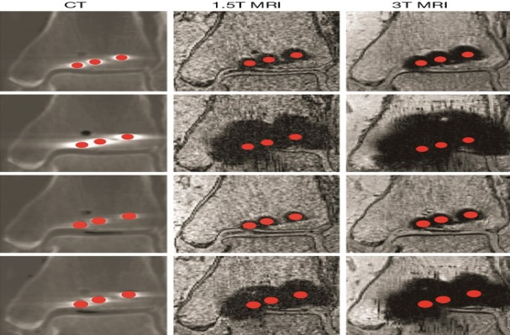

- Re-fractures after the eradication of the implant accurate deficient bone growth.
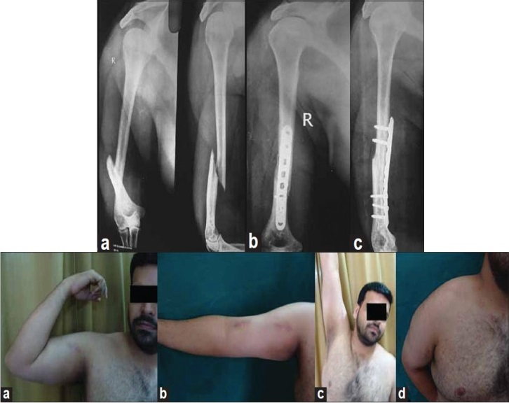

iii. Loosen of the implant is owing to the variation in the elasticity of a metallic implant.

OBJECTIVES
- To select alternative material for steel
- To design the plate with proposed material
- To evaluate the stress induced on the bone with a plate
- To evaluate the efficiency of metallic plates and composites on the bone.
Literature Review
By taking references from the previous study and various methods implemented for providing a perfect solution for crack analysis there are significant parameters which considered as designing a natural fiber plate.
The natural fiber and various biocompatible materials and polymers are used nowadays for the manufacturing and analysis of the plate.
[1]D. Chandra Mohan et al.
The natural fibers serve as an effective alternative for plate implant as it has less density, lower cost, lighter weight. Natural fiber is an environment-friendly attribute, and it indirectly serves as a basis for a green economy. The sources from which the usual fibers are obtained are natural and readily available such as plant life, the natural world, and natural resources.
Fibre type | Density  Kg/m3 | Water  Absorption % | Modulus of Elasticity  E(Gpa) | Tensile Strength  (Mpa)
Sisal | 800-700 | 56 | 15 | 268
Banana | 950-750 | 60 | 23 | 180-430
Roselle | 800-750 | 40-50 | 17 | 170-350

Composites: The composites may be defined as the multi-functional material systems which provide discrete assets which cannot maintain from several materials. The structure of composites is cohesive in nature which is made of a physical combination of doublecompatible materials.The difference between the composites of compound materials and alloys because when the individual components are used, tend to retain their characteristics but once they are recycled in mixtures the scenario is different as they take the benefits of the composition so as to obtain an improved material.Metal Matrix Composites: Owing to higher specific modulus, higher specific strength low coefficient of thermal expansion and better properties at elevated temperatures they are advantageous than monolithic metals.Types of composites find their application in housing, cables, combustion chamber nozzle, heat exchanger, etc.
[2] Suneel Kumar et al.The broadsheet provides an symptom of the modification in medicalcontrolling as the fixation techniques are varied and not a single one is an ideal which can be applied to all cases.Mature age group the cracks are relatively uncommon. It accounts to 4-5% fractures. About 85% are colonial or non-colonial, and the 15% are unstable having disrupted blood supply.Many authors prefer the primary hemiarthroplasty associated with substantial complications and functional results are disappointing.
[3]Dr. Rajneesh Garg et al.It accounts for cracks of increasing joint injury which interpretations for 4-5% of all cracks with 45% of humeral cracks which occur in people older than 66 years. Hip and distal radius cracks occur in women between the age of 81-87 years. Owing to the increase if bone porosity remains interconnected crack San increase in humerus cracks is projected.
[4]Lauren E Lamont et al.Proximal humeral cracks to osteoporotic females explained in this paper. Neurovascular, musculotendinous and bone anatomy requires a methodicalconsideration of restoration. In the commoncases, the cracks are treated non-operational.
[5]ArpitTiwari et al.According to this paper, all the operable humeral cracks in adults would require fixation with which the hospital affect the earning capacity of the person.in the case of the old patients where it is relatively harder to immobilize the greater limb which is directly related with the mechanical sympathetic dystrophy stiffness and shoulder hand.
[6]MagedAbouElsoud et al.: This research explains various techniques and devices implemented for cracks.The selection depends on the feature of bone, type of fracture also lenient muscle, age, and reliability of the patient. For moved three amount of cracks, open reduction is recommended.It can be used in some two parts as well as four-part cracks. The highest purpose is to stabilize the crack by open reduction.

References:-
[1] Sunil Kumar*1, Mukesh Parmar2, Alok Gupta3, Prateek Rastogi4, Vasudeva B5, Rakesh Vishwakarma6, Laxminath Mishra7 “Prospective Comparative Study of Proximal Humerus Fractures Treated Conservatively Versus Open Reduction Internal Fixation With Locking Plate” IOSR Journal of Dental and Medical Science(IOSR-JDMS) e-ISSN:2279-0853,p-ISSN:2279-0861.volume 15,Issue5 Ver.VII (may.2016).PP 49-59
[2] Dr Rajneesh Garg*, DrRenu Gupta**‘Internal Fixation of Proximal Humeral Fractures with Locking Proximal Humeral Plate (LPHP)’ International Journal of Scientific and Research Publications, Volume 3, Issue 12, December 2013 1 ISSN 2250-3153
[3] Lauren E. Lamont, Samuel A. Taylor, Dean G. Lorich, DavidM. Dines, and Joshua S. Dines “Evaluation and Management of Proximal Humerus Fractures’’ Volume 2012, Article ID861598, 10 pages
[4] Arpit Tiwari1 , Rahul Sinha2,*, Mustafa Johar3 , Akanchha4 “Evaluation of Different Modalities of Osteosynthesis of Proximal Humerus Fractures in Adults”1,2AssistantProfessor, 3Professor, 4P.G. Student, Dept. of Orthopaedics, Index Medical College, Hospital and Research Centre, Indore, M.P.
[5] MagedAbouElsoud “Biomechanical assessment of the NCB-PH plate in Proximal Humeral Fractures”Department for Trauma Surgery, Hand, and Reconstructive Surgery
[6] DurgalakshmiDhinasekaran and AsokamaniRajamanickam ‘Biomedical Implants: Corrosion and its Prevention - A Review GeethaManivasagam* International Journal of Innovative Research in Science, Engineering and Technology Vol. 2, Issue 6, June 2012
[7] Chandramohan, D. and K. Marimuthu, ‘’Materials science’’ International journal 2011 5: 445-463
[8] Ramakrishna, K., 2004. Design of fracture fixation plate for necessary and sufficient bone stress shielding. JSME Int. J., Series C: Mechanical Syst. Machine Elements Manuf., 47: 1086-1094. DOI: 10.1299/jsmec.47.1086.

