EFFECT OF SOIL STRUCTURE INTERACTION ON SEISMIC RESPONSE OF STRUCTURE-A REVIEW

Megha D. Waldey¹, Prof. H.G.Sonkusare²

¹M-Tech Student (Structural Engineering.), Department of Civil Engineering, G.H.R.C.E., Nagpur.
waldey_megha.ghrcemtechstr@raisoni.net
²Assistant Professor, Department of Civil Engineering, G.H.R.C.E.,
Nagpur.
hemantsonkusare@raisoni.net

Abstract

The reaction of superstructure to earthquake is influence by communication between three connected frameworks: The superstructure, the foundation and the geological soil media underlying the foundation. The
Relation of soil foundation and structure is characterized as soil-structure interaction. The idea of soil structure communication was presented and the research approach has been discussed. Primarily based on several documents, a scientific precis of the records would be perspective for researchers. In this survey, we portray the past examinations concentrating on the impact of soil structure communication on various modelling approaches and make efforts to assemble all the information related to modelling of the structure and the soil media present in the literature for this reasons.
Keywords: Soil Structure interaction (SSI), Winkler modelling, FEMA, Seismic

- Introduction

The seismic response of structure depends on the behaviour of foundation which is again depends on the type of soil beneath the foundation is interact with and vice versa. The SSI effect is found in all superstructures and substructures consequently should be taken into consideration while studying these problems. It has been notable that the earthquake ground movement comes about fundamentally from the three components nearby site condition, propagation direction of waves, source characteristics likewise; the soil structure interaction issue has turned into an essential component of structural engineering with coming of monstrous developments on soft soils for example, scaffolds, atomic power plants, Structures, cement and earth dams. Passages and underground structures may likewise require specific consideration regarding be given to the issues of SSI. If a lightweight structure is built on a hard rock foundation, a valid assumption is that the input movement at the bottom of the structure is the same as the free-field seismic movement. If the structure is very big and stiff, and the foundation is moderately soft, the movement at the base of the structure might be fundamentally not the same as the free-field surface movement. For design code of building it is important to considered SSI effect. Latest studies brings about the subject of soil structure interaction shows that the SSI importantly affects the dynamic reaction of the structure when the soil is soft.

Major influences of SSI are
a) Influences the stiffness and the mass of the structure
b) Influences the dynamic characteristics of the soil- structure framework such as damping factor and time period For example the fundamental frequencies and vibrating shapes mainly the fundamental frequency will significantly drop and the rigid body of the structure will enhanced or produce.
c) The damping factor of the modal damping will increase as some earthquake vibrating energy in the structure is transferred to the soil.
As per IS 1893 part1: 2016(Page no. 7) the SSI effect should not consider in the seismic analysis of the structures resting or supported on the hard rock.

In the soil the stresses and deformation are induced due to moment and base shear produces in the vibrating structure since truly structure is not fixed at base. Due to deformation and stresses in the soil further results in the modification of the structural response. In recent time it has received the researchers and engineer in the area of structural dynamics. For the beyond long several years efforts were made to develop a rational method so contain SSI effect within the structural layout.

- During an earthquake interaction among the ground and structure

Due to earthquake fault the seismic waves E₀ is generated reaches the base of the foundation
They are divided into two kinds as shown in fig below.
Transmission Waves E₁ and Reflection Waves F₀
At the point when the transmission waves E₀ enter into the structure they go upward way because of which the structure subjected to vibration and afterward reflection waves reflected at the top and travel reverse to the foundation of the structure as F₁ At this level SSI effect take place and vice versa for F_{2.}
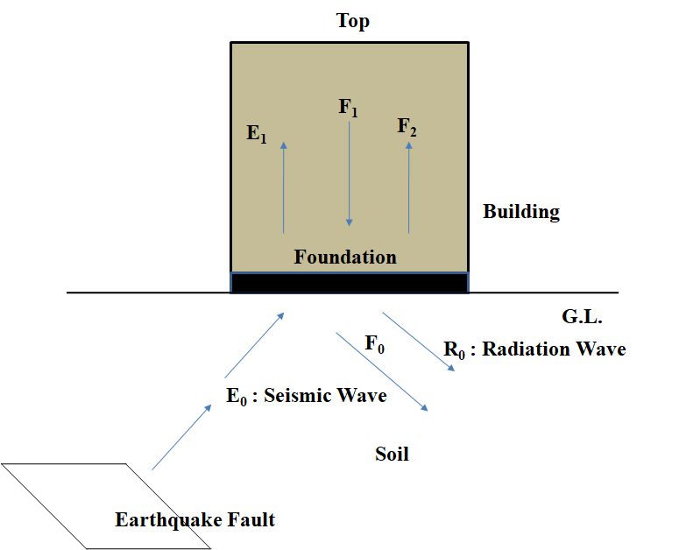
Figure 1: During SSI waves propagation

The wave which can be transmitted to the ground referred as radiation waves and the damping due to radiation waves is referred as radiation damping of the soil. As compared to the structure itself radiation damping increases the total damping of the soil structure framework and due to the SSI fundamental frequency of the soil structure framework is lower as compared to the fundamental frequency of the soil.
The overall displacement of the structural building is increase because of the interaction foundation can rotate and translate.
Basically there are two dynamic Soil structure interactions (SSI) namely kinematic and inertial interaction.

Inertial interaction: The inertial forces within the structure are transmitted to flexible soil. At the foundation level of the structure it refers to the translations and rotations which results from the inertial forces such as base shear and moment. Within the soil structure framework the Inertial displacements and rotations can be source of flexibleness and energy dissipation.

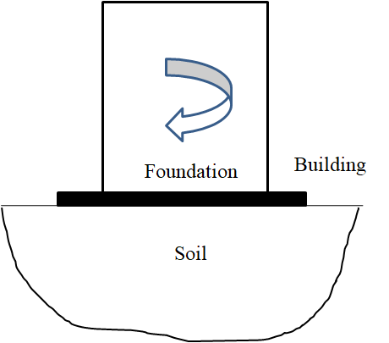

Figure 2: Inertial interaction

Kinematic interaction: The Stiffer foundation can not conform to the distortion of soil. The kinematic interaction comes about due to the presence of firm foundation components on or in soil which causes movement at the structure foundation to deviate from free field movements. Soil displacement causes due to earthquake ground movement which is known as free field motion. An embedded structure foundation into the soil does not follow the free- field movement causes the kinematic interaction.
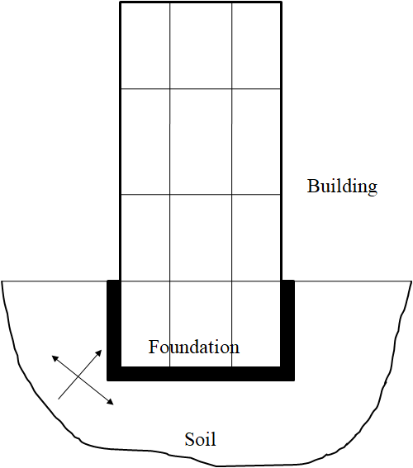

Figure 3: Kinematic interaction

- Soil behaviour modelling
Basically there are two classical approaches for modelling of soil media i.e. foundation flexibility

- Winklerian approach (Winkler model)

In Winklerian approach, the Winkler’s idealisation represents that the foundation model i.e. soil medium as system of identical but mutually independent, closely spaced, discrete, linearly elastic springs. In general soil behaviour is linear. In keeping with this idealization, deformation of foundation due to implemented load is limited does not affect beyond the loaded regions. At any point the pressure deflection relation is given by
P=k*w
Where, P is the load (pressure), k is modulus of subgrade reaction ( coefficient of sub-grade reaction), and w is the settlement (defelection)
Engineers have been using a basic classical mathematical model called the Winkler’s model
For examination of beams and slabs resting on a soil medium, in which the behaviour of the soil is simplified by springs which is placed continuously underneath the structure. Where springs constant K is called the modulus of the sub-grade reaction of soil or the coefficient of sub-grade reaction
There are alternative approaches to obtained the value of sub-grade modulus
- California bearing ratio test (CBR)
- Plate load test
- Triaxial test and,
- Consolidation test

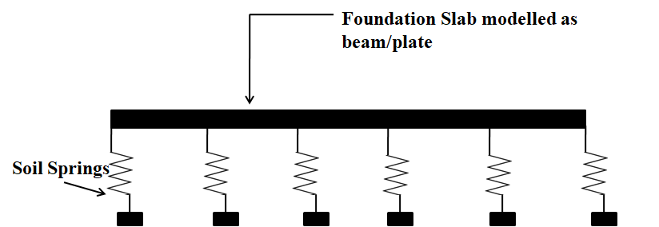

Figure 4: Foundation resting on equivalent spring bed

So far based on this concept, by the engineers numerous computer codes have been developed for the examination of the beams/slabs on linear elastic spring foundation; the user of the code has to determine the value of K to represent the soil medium. There is no other simple way to determine the value of K because its value is not particular for a given sort of soil medium (as counselled in a few textual content books of foundation engineering). ). Typically the soil is stratified, having distinctive thickness, even when its material properties remain same the value of an equivalent K needs to be at the least a characteristic of the thickness of the soil layer .The bigger the thickness, the less is the K value. If the analysis is achieved for a uniformly distributed load on a slab, there is no provision for differential settlement or bending moments or for shear forces in the structures in dismiss of fact. Many researchers have proved this lack of uniqueness of K within the past.
The BOWLES have recommended that the vaue of k must be augmented on the rims of the slabs and feature emphasised the requirement for more research on this topic therefore the value of k varies in the area of the slab for distinctive material and geometric properties of the soil. To avoid this circumstance, a two parameter version has been suggested through or recommended by Pasternak in 1954 and later by Vlasov and Leontiev in 1966 but to get the constant results, one has to carry out the few iterative methods by Vallabhan and Das in 1998; Rionero and Straughan in 1990
Those procedures are nevertheless no longer very famous among practical engineers.

Figure 5: Winkler’s foundation

In the area of SSI a number of studies have been conducted for its simplicity on the basis of Winkler’s hypothesis. The fundamental problem with the usage of this model is to determine the stiffness of elastic springs used to replace the soil underneath foundation.
The value of sub-grade reaction is not only depends on the sub-grade but also on the dimensions of the loaded area, the only parameter is the sub-grade stiffness in the Winkler model to idealize the physical behaviour of the sub-grade, for the use of it’s in a practical problem care must be taken to determine it numerically by different approaches.
However the fundamental limitation of this Winkler model or Winkler hypothesis lies within the fact that this Winkler model cannot account for the dispersion of the load over progressively influence area with increase in depth, furthermore it considers linear stress strain behaviour of the soil media.

The most critical demerit of Winkler’s model is the one relating to the independence of the springs. So the eﬀect of the externally implemented load receives localized to the sub-grade most effective to the point of its application. This implies no cohesive bond exists among most of the particles comprising soil medium. Therefore, several attempts had been made to developed modiﬁed Winkler’s model to overcome those bottlenecks.

- Elastic continuum model

This is the conceptual technique of the physical representation of the limitless soil media or the elastic half of space will generate an elastic continuum version. Soil mass basically constitutes of discrete particles compacted through some in-tergranular forces. Homogeneous, linear elastic stable semi-unbounded, isotopic subjected to concentrated acting normal to the plane boundary will constitute such elastic continuum model. In this situation, a few continuous functions is assumed to symbolize the behaviour of soil medium. This approach offers a lot more facts on the stresses and deformations within soil mass than Winkler model. It has also the essential benefit of simplicity of the input parameters, viz., modulus of elasticity and Poisson’s ratio.
The troubles normally dealt in soil mechanics involve boundary distances and loaded regions, very huge as compared to the scale of the individual soil grains. Subsequently, in eﬀect, the frame composed of discrete molecules receives transformed into a ‘statistical macro-scopic equivalent’ amenable to mathematical evaluation. As a result, it seems very reasonable to invoke to the concept of continuum mechanics for idealizing the soil medium. One of the significant drawbacks of the elastic continuum method is Inaccuracy in responses figured at the peripheries of the foundation. It has also been discovered that, for soil in reality, the floor displacements far from the loaded vicinity decreased more hastily more quickly than what is anticipated by this approach than what is predicted by using this approach so accordingly, this idealization is not most effective computationally difficult to workout however regularly fails to symbolize the physical behaviour of soil very closely, too.

- Foundation stiffness and strength (Soil springs stiffness)

FEMA 356 marks these outcomes with the aid of considering the stiffness and strength of the underlying soil. These results lead to the growth of damping ratio of structures and vibration duration.
The motion of foundation is commonly taken into consideration by three translations and three rotations in which one vertical translation in which vertical deformation of footing talks place and footing can pound up and down, two horizontal translations at which the sliding and elastic deformation of soil takes place and footing can slide side to side, in and out, for rotation; two rocking it moves back and forth, in and out, and one torsion at which the sliding and elastic twisting happened around the vertical axis of the footing. For the structural building with isolated footing, beneath each column, three translation and tree rotational springs approximately those are mutually perpendicular axes need to put together to get the impact of soil flexibility, as recommended in properly well-known literature i.e. Gazetas,1991
The stiffness of these springs for footing resting on homogeneous elastic half of space was computed as explained inside the literature. It has been found the stiffness o the springs are depending on the frequency of the forcing function even though stiffness house are frequency independent. Therefore this dependence is included by means of multiplying the equal spring stiffness vai a frequency dependent element. However a few researches recommend that this stiffness can be considered as frequency independent with right effect or with good results, the effect of such multiplication aspects isn’t always in preferred, considered in research.
In this first stiffness of foundation at surface is calculated i.e. the stiffness term and then this calculated stiffness are modified by correction factor for embedment depth i.e. the embedment correction factor is calculated for these each stiffness term and the product of these two terms are the stiffness of embedded foundation.
The calculation part is given in the FEMA 356 page no.4-20

- Finite element method

The scope of numerical methods is wider than the analytical method; therefore the use of finite element method has attained an unexpected spurt to study the complex interactive behaviour. The method is so standard that its far possible to model many complicated conditions with high degree of realism, inclusive of nonlinear stress-strain behaviour, non- homogeneous material condition, changes in geometry and so on. However, care need to be taken about the possibilities of inaccuracy arising up out of numerical limitations while interpreting the results. Nevertheless this apparels to be the maximum effective and versatile tool for solving SSI problems.
A ﬁnite element procedure detail manner for the overall trouble of three-dimensional soil–structure interaction concerning nonlinearities because of material behaviour, geometrical changes and interface behaviour is likewise provided in the literature. The viscoelastic behaviour of soil will also be without difficulty modelled in this approach. this kind of suitable scheme has been provided in huge details within the literature. Discontinuous behaviour can also occur on the interface of soil and shape structure. several studies were made to develop interface elements, use of that is proved to be beneficial to take care of this discontinuity. The stiﬀness matrix for the interface detail has been explicitly offered within the literature

- Review of available literature

Dutta et.al[8] explains the various approaches for the modelling of SSI structures so that the strengths and the limitations of the models or various approaches may help to the civil engineers to choose a suitable one for the estimation of the soil structure interaction effect for their examine(study) and design. Tabatabaiefar et.al [4] explains the impact of flexibility of the foundation support and different design parameters affected by it, the ratio of the base shear of the flexible base to the fixed base is one for both elastic and inelastic cases and the natural time period is increased from fixed to flexible. LIU et.al [5] provides the use of nonlinear method for seismic analysis i.e. pushover analysis for SSI and provides SSI can decreases the capacity curve. As the soil flexibility increases underneath the foundation the more curves get reduced, the structural time period, vibration and damping, mode shapes of the SSI are different to that of fixed base. Taylor et.al [17] explains the inﬂuence of structural rigidity aside from soil ﬂexibility on the amount of load distributions due to soil–structure interaction. A suitable iterative technique for estimation of the eﬀect of soil– shape interaction is outline in. Roy et.al [9] provides an idea approximately about the eﬀect of defferential settlement on design force quantities of various building frames with isolated footings. Remedial measures to reduce this eﬀect are likewise recommended in this literature. Smith BS et.al [16] Provides the methods for accounting the contribution of the brick walls to the lateral stiffness of the buildings. Kerr et.al [18] provides detailed information about various important approaches or models are Filonenko-Borodich Foundation model, Hetenvi’s Foundation model. Pasternak Foundation model, Kerr Foundation model, beam column analogy model and new continuum model can be obtained. Gazetas et.al [13] presents the dynamic stiﬀness as well as damping traits of soil medium helping any arbitrary shaped foundation. Including the eﬀect of the frequency of the forcing characteristic in dynamic stiﬀness of soil medium, it will become a benchmark literature inside the vicinity of dynamic soil–structure interaction. Roger P et.al [11] modelling required dealing with the soil structure interaction of pile foundation in dynamic condition finds the depth remedy in this literature. Chandrasekaran et.al [19]
The foundation differential settlement influence the weight transmitted from one column on the stiffness and subsequently the redistribution of forces within the superstructure members. The significance of the load redistribution is dependent on the stiffness of the factors of the superstructure as well as magnitude of differential settlement. Chandra et.al [6] provides the lateral natural period, seismic base shear and fundamental torsional to lateral period ratio considering SSI on raft foundation.

- Conclusions

The overview of the modelling of soil as carried out in the soil- structure interaction analysis leads to the following extensive conclusions
- Winkler speculation, regardless of its obvious limitations, yields reasonable overall performance and its miles very easy to exercising. So for realistic purpose, this idealization need to, at least, be employed in preference to carrying out an analysis with fixed base idealization of structures.
- To accurately estimate the design force quantities, the eﬀect of soil structure interaction is wanted to be taken into consideration under the inﬂuence of each static and dynamic loading. To acquire the same, sensible yet simpliﬁed modelling of the soil– structure- foundation system is prescribed.
- The eﬀect of soil structure interaction on dynamic behaviour of structural building may comfortably be analyzed by using of Lumped parameter technique. however, lodge to the ﬁnite element modeling may be taken for the crucial structure in which more rigorous evaluation is important.
- The consolidation phenomenon of clayey soil follows a nonlinear stress–settlement relationship. For this reason, to achieve a extra realistic evaluation of the soil–structure interaction behaviour related to clayey soil, nonlinear modelling of soil is preferred. To perform such an evaluation, incremental iterative technique appears to be the most suitable and popular one.
- The paper can also help to arrive at a suitable approach of evaluation with the aid of properly weighing the strength and limitation of the identical against the unique characteristics and want of the problem to hand. The similarly information of a way can be obtained from selecting the proper reference from the exhaustive list provided within the paper.

- References

- IS1893, B. I. S. "Indian Standard criteria for earthquake resistant design of structures (part 1): general provisions and buildings (sixth revision, Bureau of Indian Standards, New Delhi." Google Scholar (2016).
- Shanmugam, Janardhan, P. A. Dode, and H. S. Chore. "Analysis of Soil Structure Interaction in Framed Structure." Young 1000 (2015): 40.
- Jancy, F., et al. "Finite Element Modeling of Ground-Structure Interaction Considering Non-Linear Response of the Ground." (2011): 923-926.
- Reza Tabatabaiefar, S. Hamid, Behzad Fatahi, and Bijan Samali. "Seismic behavior of building frames considering dynamic soil-structure interaction." International Journal of Geomechanics 13.4 (2012): 409-420.
- LIU, Hong-shuai, De-dong LIU, and Jing-shan BO. "Effects of Maximum Shear Modulus on Soil Dynamic Properties and Seismic Response of Soil Layer." (2008): 541-54.
- Dutta, Sekhar Chandra, Koushik Bhattacharya, and Rana Roy. "Response of low-rise buildings under seismic ground excitation incorporating soil–structure interaction." Soil Dynamics and Earthquake Engineering 24.12 (2004): 893-914.
- Li, Peizhen, et al. "Computer simulation on dynamic soil-structure interaction system." 13th World Conference on Earthquake Engineering. No. 3233. 2004.
- Dutta, Sekhar Chandra, and Rana Roy. "A critical review on idealization and modeling for interaction among soil–foundation–structure system." Computers & structures 80.20-21 (2002): 1579-1594.
- Roy, R. "DIFFERENTIAL, SETTLEMENT AMONG ISOLATED FOOTINGS OF BUILDING FRAMES: THE PROBLEM." Int. J. of Applied Mechanics and Engineering 6.1 (2001): 165-186.
- Federal Emergency Management Agency, Washington, DC, Prestandard and commentary for the rehabilitation of buildings, FEMA-356 2000.
- West, Roger P., and Milija N. Pavlović. "Finite‐element model sensitivity in the vibration of partially embedded beams." International journal for numerical methods in engineering44.4 (1999): 517-533.
- Council, Building Seismic Safety. "NEHRP guidelines for the seismic rehabilitation of buildings." FEMA-273, Federal Emergency Management Agency, Washington, DC (1997).
- Gazetas, George. "Formulas and charts for impedances of surface and embedded foundations." Journal of geotechnical engineering 117.9 (1991): 1363-1381.
- Bowles, J.E., 1988. Foundation Analysis and Design, McGraw-H II, San Franciso, California
- Fleming, W. G. K., Weltman, A. J., Randolph, M. F., Elson, W. K. (1985), Piling Engineering,
John Wiley & Sons, Inc., New York, 1985.
- Stafford Smith, Bryan, and C. Carter. "A method of analysis for infilled frames." Proceedings of the institution of civil engineers44, no. 1 (1969): 31-48.
- Taylor DW. Fundamentals of soil mechanics. New York: John Wiley and Sons; 1964.
- Kerr, Arnold D. "Elastic and viscoelastic foundation models." Journal of Applied Mechanics 31.3 (1964): 491-498.
- King, G. J. W., and V. S. Chandrasekaran. "An assessment of the effects of interaction between a structure and its foundation." Proceedings, Conference on Settlement of Structures, Cambridge, Penteck Press, London. 1974.
- Tanabashi R, Ishizaki H. Earthquake damages and elastic properties of the ground. Bulletin No.4, Disaster Preven- tion Research Institute, Koyoto University. 1953.
- Poulos, H. G. (1971), Behavior of Laterally Loaded Piles, Proceedings of the American Society of Civil Engineers.

