Review on Voice Based E-Mail Assistant

for Visually Blind People

Dr. (Mrs.) Snehal S. Golait¹, Sahil Chalkhure², Sagar Balamwar³, Rohit Shinde⁴,

Rohit Turkar⁵, Shruti Gaikwad⁶

¹⁻⁶Priyadarshini College of Engineering, Nagpur

Abstract: One of the most used forms of communication between people is e -mail. Lots of secrets and urgency Information is exchanged via e-mail today. Have about 253 million visually impaired people worldwide, that visually impaired people face a communication problem. Since then, technology has been developing day by day these types of visualization difficult people find it harder. So the authors proposed an AI-powered voice-based messaging system that would create a messaging system that is very accessible to people with reduced mobility and also help society. Accessibility is the most critical feature taken into account when developing this system. Any system is accessible only if the person with the ability and the person with a disability can use it easily. Keywords: Speech recognition, speech synthesis, voicemail, visually impaired.

Keywords: Speech recognition, Text to speech, Voice mail, visually challenged people.

I. INTRODUCTION
Technology is developing speedily day by day has made everyone 's lifestyle so easy that most of the time any job is possibly done in less time with accuracy and efficiency. Communication is one field that has become a degree with the advancement of technology and the availability of the internet. Technology has made communication easy. This distance has become an insignificant parameter in communication [9]. When we think about communication via the Internet, the first thing that comes to mind is communication via e-mail. Email is one of the most trusted things important means of exchanging information and also email is used all over the world, but to access the internet , a person must be able to see . Millions of people are blind or visually impaired and cannot see the screen; or keyboard so they can 't access the Internet [12]. This way, they are far away from email media and the internet world. These blind people cannot use the existing messaging system, they cannot send, receive email and cannot read information shared via email; therefore, current systems are not easily access there. To access the Internet, the person must be able to read what is written on the screen like that, which renders the internet useless technology for the visually impaired .Only one means by which the visually impaired can send emails must tell all the contents of the message to the third party a person so that a third person can compose a message and send it on behalf of the visually impaired [10 ]. But this approach does not lead us to the solution to the problem. Whenever finding a third person is not possible for people with reduced mobility and sometimes content may staff, to maintain the integrity of specifications. So to help these people and develop society

The authors came up with this idea to help with visualization of people with reduced mobility by providing the ability to send and receive email launches voice commands without using the keyboard and intuitive . Artificial intelligence for speech recognition: Artificial intelligence (AI) is a technology used to create systems and machines that simulate human intelligence. Some artificial intelligence applications consist of different expert systems, natural language processing (NLP), and artificial vision and voice recognition
. Understanding and analyzing people languages like English by extracting metadata from keywords, feelings, relationships and concepts are natural language processing. Only one means by which the visually impaired can send emails. e. must tell all the contents of the message to the third party a person so that a third person can compose a message and send it on behalf of the visually impaired [10]. But this approach does not lead us to the solution to the problem.
Whenever finding a third person is not possible for people with reduced mobility and sometimes content may staff, to maintain the integrity of specifications. So to help these people and develop society. The authors came up with this idea to help with visualization of people with reduced mobility by providing the ability to send and receive email launches voice commands without using the keyboard and intuitive . Artificial intelligence for speech recognition: Artificial intelligence (AI) is a technology used to create systems and machines that simulate human intelligence. Some artificial intelligence applications consist of different expert systems , natural language processing ( NLP ), and artificial vision and voice recognition . Understanding and analyzing people languages like English by extracting metadata from keywords, feelings, relationships and concepts are natural language processing.

II. LITERATURE SURVEY
The number of email accounts climbed from 4.1 billion in 2014 to over 5.2 billion in 2018, making email one of the most popular ways of communication, according to a report on email data from 2014 to 2018 by technology market research organization PALO ALTO , CA, USA. There are 253 million visually impaired persons world- wide, according to studies by the vision reduction specialist group (LEG ), who are un- able to use email or the internet because of their visual impairments. Because current email systems lack voice commands or audio features, they are inaccessible to people who are blind or visually impaired . Traditional search engines also rely on text-based queries, which are inaccessible to those with visual impairments. Web browsers can play audio and video files, but doing so requires the user to start the search with text- based inputs, and the search results are presented in text -based format. Because existing email systems lack this feature, it is challenging for those who are visually impaired to access the system. As a result, a totally new system is required to deal with this problem .
Lots of research has been conducted in the literature . Research has been done by Pranjal Ingle et al.(2016 ) [1], used the three different types of technologies for the voice based technology to convert the message from voice to text. They also uses the IVR(interactive voice response )which explains the connection between user and technology.
In another research, Dr.S.Biruntha et al.[2], proposed technology with text -to -speech to read and record symbolic linguistic representations like phonetic transcriptions. The technology covers a two main points such as interface selection and mailing option, in the first element it takes the user which is blind and the second element includes simple mail options to perform tasks.
In another research, Jain. V. et al., (2021) [3], explains the use of voice based email system for visually challenged people so that they can use the email, with the use of the technology for the visually impaired people.

In 2020, Vedant Chidgopkar et al. in [04] explain a system where there is no need to use the keyboard and everything can be done with the help of mouse. Also, this system can be helpful for illiterate peoples who not able to read.
In 2017, K. Jayachandran et.al. in [05] presented a voicemail system architecture that can be used by a blind person to access emails easily and efficiently. The
contribution made by this research has enabled the blind people to send and receive voice based e-mail messages in their native language.
In 2018 ,Milan Badigar et al, in [06] presented an application that will not let the user make the use of a keyboard instead will work on text to speech and vice versa to facilitate sending, reading, forwarding and replying to emails using an android smartphone.
In 2015, T. Shabana et al. in [07] described the development of an email system that will help even a naïve visually impaired person to use the services for communication without previous training.
In 2019,Rohit Rastogi et al.in [08] described an application that will work solely on voice commands spoken by the user which will enable them to communicate with the world.

III. PROPOSED SYSTEM
The recommendation system will make the email system very easily accessible to the visually impaired and also help the company. The authors propose a system that keeps an idea in Remember that it should be easily accessible to everyone. Any designed web application must be perfectly accessible if used by anyone, blind or inefficient.
It is as important as the current system to be a priority traditional user-friendly, recommended system emphasizing the friendliness of all types of individuals, with traditional people and blind people than illiterate people. In this system, the PC will ask the user to perform specific activities to benefit from various services and if the user must access different services then he must perform this operation.
First, users will need to register in application system through the registration form. The user will be supported by voice commands while saving all required fields to be completed and scanned by the website; once the user will speak, he will receive write automatically.
After successful registration, the user can log in with say a username and password when prompted by the system , this username and password will then be converted from speech to text , and then the user will be authenticated by verifying credentials with the database . Users can access different sections like Compose, Inbox and Mail Sent Later Successful connection.
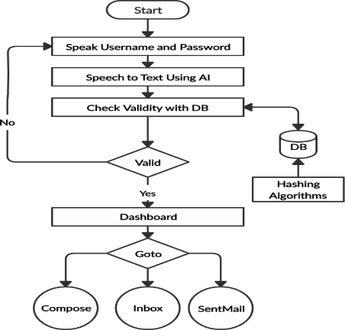

Fig. 1. Flow chart of User login and accessing system

The main advantage of this system is the use of a keyboard is completely removed; the user must Voice response only.
This application is completely voice based allowing blind people easily send and receive email. It converts users voice
- to - text and text - to - speech and done Act in the consequences.

IV. DESIGN OF PROPOSED SYSTEM
This project is designed by dividing it as follows three stages:
- User interface design: During this phase, the user interface or user interface of the project is developed. That is the design of the website in that the user will use to interact. The user interface is designed with HTML5 and CSS3.
- Database Design: A database is very important in every project because it is responsible for storing user data and credentials. I.e. a database mainly for user authentication and storage user emails. Database design will include many create a table to store emails.
- System design: The system will include all modules such as TTS (Text to Speech) and STT (Speech to Text) modules, mail programming module (Components, Inbox and emails sent).
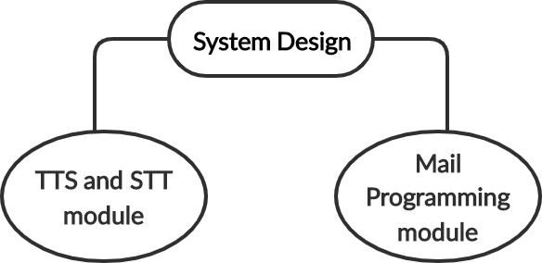

Fig. 2. System Design Modules

Email emerges as one of the most valuable services in the world Internet today. Many Internet systems use SMTP such as a method for transferring messages from one user to another . SMTP is one sending protocol and is used to send mail while POP (posting office Protocol) or IMAP (Internet Mail Access Protocol ) is used to retrieve these emails from the recipient side.

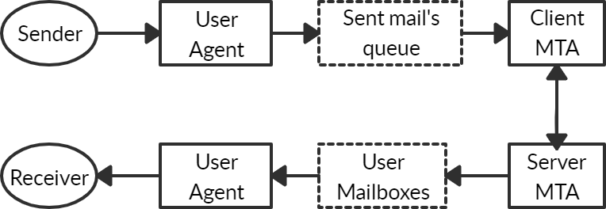

Fig. 3. Model of SMTP system

Sending Email: When an email is distributed across, it will contain certain things like header and its own body. A sequence of responses requested message is line up between shopper and server in sending an email.
How the title and content different, title are will end when a null line is found in it. The body of the message contains specific data approved by the front desk. In everybody, data is taken after the null line.
Receive email: For a specific period, the user agent to the server aspect checks the mailboxes. If in this timeframe while data receiving it will immediately alert the user. When the user opens an e-mail, it is used to analyze e-mails containing information in its subject line.

V. EXPERIMENTAL SETUP
- Speech to Text by using Artificial Intelligence Audio to text can be converted by applying simple-to-use way APIs related to powerful neural network models provided for the developers of Google Cloud Speech to Text. Recognise one hundred and twenty languages and variations to support a global user base. You will change the voice command and management, and audio transcription from decision centres, and then. It will use periodic streams or pre-recorded audio, Google's machine learning technology [4].

Text-to-speech unification
It is an automatic conversion of text to speech. This technique resembles, as closely as possible , a verbal expression device of language to read this text . Text -to- speech synthesizer (TTS)is the technology that allows the laptop to talk to you. with some good pre-service TTS math modeling tool word processing and synthesizing it. TTS . engine usually generates audio information in AN audio format do to the output.

Text-To-Speech unification System Structure
It is an automatic conversion of text to speech . This technique resembles , as closely as possible , a verbal expression device of language to read this text . Text -to- speech synthesizer (TTS)is the technology that allows the laptop to talk to you. with some good pre-service TTS math modelling tool word processing and synthesizing it. TTS. engine usually generates audio information in an audio format to do the output.:

Processing of Natural Language module
It produces a written text of the scanned text, at the side of prosody.

Processing of Digital Signal module
It transforms representative data it be subject from information science into hearable and comprehensible speech.
The operations of Processing of Natural Language module are as follows:

- Text Review: First, the text is split into tokens. The token- to-word conversion produces the writing style of the token. For the "Mr" token, "Mister” writing is done by extension , token "11" has the writing style "eleven " and "1979 " was redesigned as "1979".

- Application of Pronunciation Rules: Pronunciation rules applied after completion of text analysis. Mail can't rework 1
: 1 of the following phoneme correspondence is not forever parallel. In some environments, a letter will match or have no sound (e.g. " in "learned ") or some phoneme ("n" in” known"). Also, some letters will correspond to a sound ("wh" in "which").

- Prosody Generation The prosody was created after the accent is determined . The openness of a TTS system is based on speech elements such as inflexion patterns ( expression and stress ), amplitude and length modelling ( including the length of the sound and thus break time, decide the duration of the unit and thus the tempo of discourse) [3].

VI. AUTHENTICATION & SECURITY
Authentication includes providing the user with credentials , such as username and password , and verifying that the user provides the correct username and password every time whenever the application needs to be accessed . So this login information should be stored in the database for future comparison . Authentication will be used in our system for user verification.

Storing Password directly can be Risky: A simple way to store passwords is to simply map them by creating a table in the database. Whenever a user login request comes in, the server will be called to authenticate with a payload containing a username and password. Then these identifiers will be matched with the password stored in the database. If the match gives a positive result, the user will get access to the application.

When the password is stored in plain text format, it can be tricky and will open the door to attackers. If the attacker can steal the password, then he can access the user's account. one way to store passwords securely is to store them by converting a form that cannot be converted to the original centre of the password. This process is called hashing.

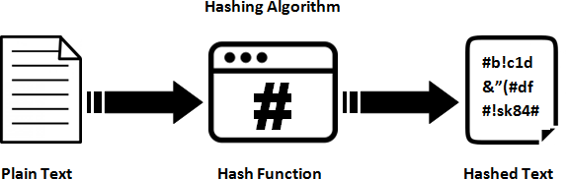

Fig. 4. Hashing Algorithm

There are various algorithms for hashing mostly used are Message Digest Algorithms (MD5) and Secure Hash Algorithms (SHA) [5].

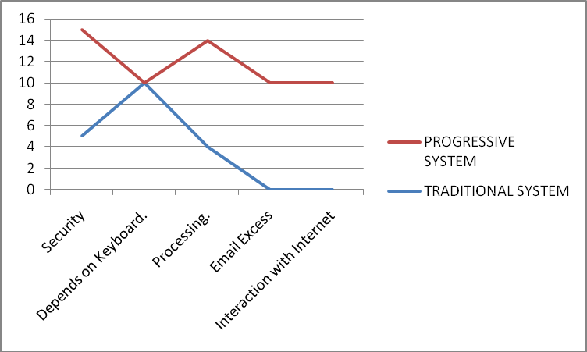
On 10 scales there parameters are taken in comparison.
Fig. 5. Result with comparison study

VII. CONCLUSION
Unlike traditional methods used in this application system previously ,our methods projects use of optimized predefined A I libraries that upscale the perform ance of the system and provides seamless experience which will cater visually impaired individuals.

This article proposes a system that will benefit society by enabling people with disabilities to grow up with the company . This project allows visually impaired people enough to be a part of the growth of digital India by enabling them to communicate over the Internet and also make their lives of these people much easier . This system overcomes many disadvantages that visually impaired people face such as sending and receiving emails . The success of this project can have an impact on developers by motivating them to do something useful that can help blind or blind people.

VIII. COMPARISON & RESULT ANALYSIS

SR.  NO. | TRADITIONAL SYSTEM | PROGRESSIVE SYSTEM
1. | Less security. | High Security provided.
2. | Depends on Keyboard. | The entire structure is  based on IVR- interactive voice response.
3. | Slow processing. | Faster and more efficient
4. | The disables cannot use  the normal mail system. | The disables can use the  normal mail system.
5. | Blind people are not being able to interact  with the web based email system. | They will be able to interact with the web based email system.

IX. REFERENCES
- Ingle, P., Kanade, H. and Lanke, A., 2016. Voice based e-mail System for Blinds . International Journal of Research Studies in Computer Science and Engineering (IJRSCSE), 3(01), pp.25-30.
- Biruntha, S., Priya, M.G., Kiruthika, R., Indupriya, N. and Ashwini, R., 2021. Voice Based Email for Blind People Using Speech Recognition through Artificial Intelligence. International Journal of All Research Education and Scientific Methods (IJARESM), 9(04).
- Jain, V., AK, K., Shenoy, R.N. and Ahmed, M., 2021. Voice Based Email for the Visually Impaired.
- Vedant Chidgopkar et al. in “An Application of Voice Mail: Email Services for the Visually Challenged Individual”. [Online].Available: https://zenodo.org/record/2683677#.YDFUyfszbEy.
- K. Jayachandran and P. Anbumani, “Voice Based Email for Blind People”. [Online]. Available: https://www.ijariit.com/manuscripts/v3i3/V3I3- 1462.pdf
[6 ] M. Badigar, N. Dias, J. Dias, and M. Pinto, “Voice Based Email Application for Visually Impaired”. [Online]. Available: http://www.ijste.org/articles/IJSTEV4I12068.pdf.
[7] T.Shabana, A.Anam, A.Rafiya, and K.Aisha, “Voice based email system for blinds”. [Online]. Available: https://ijarcce.com/wpcontent/uploads/2015/02/IJARCCE5C.pdf.
[8] R. Rastogi, A. Rajput, Archana, and Komal, “An Application of Voice Mail: Email Services for the Visually Challenged Individual”. [Online]. Available: https://zenodo.org/record/2683677#.YDFUyfszbEy
[9] A. Verma, “Voice based Electronic Mail System for Visually Challenged Individuals”. [Online]. Available: https://www.ijitee.org/wpcontent/uploads/papers/v8i12S/L103010812S19.pdf.
[10] A. A. Nikose, A. Sheikh, B. Masurkar, P. Kumari and P. Mohadikar, "Voice Based Mail System For Blind", Ijics.com, 2019. [Online]. Available: http://ijics.com/gallery/12-mar-960.pdf
[11] A. MULAGUND, A. B N, S. P KALYANI and S. PATIL, "VOICE MAIL APPLICATION FOR BLIND PERSONS", Kscst.iisc.ernet.in, 2021. [Online]. Available: http://www.kscst.iisc.ernet.in/spp/41_series/SPP41S/01_Seminar_Projects/091_41S_BE_2790.pdf
[12] A. Suresh, B. Paulose, R. Jagan and J. George, "Voice Based Email for Blind", Academia.edu, 2016. [Online]. Available: https://www.academia.edu/26662847/Voice_Based_Email_for_Blind

