**Optimization of MRR Using Fuzzy Logic in Micro- Drilling Process**

**Ranadhir R Landge1, Dr. Atul Burade2**

*1Ph.D. Research Scholar and Workshop Superintendent, Government College of Engineering, Karad, Maharashtra, India*

*2Principal Government Polytechnic, Gadchiroli, Maharashtra, India*

***Received on****: 11 December, 2020,* ***Revised on****: 11 January, 2021 , Published* ***on****: 16 January, 2021*

***Abstract -*** *Material removal rate is usually considered as a serious manufacturing goal in machining operations in many of the prevailing research. Taguchi method , an experiment design method, has been widely applied to many industries. It cannot only optimize quality characteristics through the setting of design parameters, but also reduce the sensitivity of the system performance to sources of variation. Fuzzy logic systems are widely used for control, system identification, and pattern recognition problems. It achieves the deduction in optimization, which describes the dynamic behaviour of the system to be controlled. Because of the amount, complexity and unclear, vague nature of the variables of the dynamic systems which will influence the choice maker’s decision, symbolic logic is that the best suited solution. Most of automotive components are manufactured employing a conventional machining process, like turning, drilling, milling, shaping and planning, etc. Out of this conventional process Drilling originates hole on any metal. Micro Drilling is high precision process for smaller holes below 1mm.It is used for the purpose increasing quality of special parts and items during goal in machining operations This research aims to investigate the effect of the cutting speed, feed rate and depth of hole on material removal rate (MRR) and Machining time in micro drilling were analyzed. Experiments were conducted based on the Taguchi design of experiments (DOE) with orthogonal array, with optimization of the Fuzzy parametric deduction to Optimize MRR.*

***Keywords - Micro-drilling, Cutting tool, Material removal rate, Fuzzy logic, Taguchi.***

# **i-Introduction**

**M**icro-drilling refers to the drilling of holes but 0.5 mm (0.020 in). Drilling of holes at this small diameter presents greater problems since coolant fed drills can't be used and high spindle speeds are required. High spindle speeds that exceed 10,000 RPM also require the utilization of balanced tool holders. Micro drilling is one among the foremost fundamental machines technologies and it's moving high precision and high spindle speed application in manufacturing field and increasing productivity and quality. Now a day’s micro drillings have a great use for manufacturing to apply special parts and items. Micro hole drilling is that the precision hole drilling technology to use in manufacturing and work shop. The micro drill tools play a critical role is increasing the productivity of a cutting process. Although the worth of a cutter itself is comparatively low, the prices caused by tool failures are considerably higher. Therefore, from the point of view of cost and productivity, modeling and optimization of drilling processes are extremely important for the manufacturing industry. The poor removal of chips in deep drilling of small diameter is usually the explanation for tool breakage and poor quality surface. High speed machining technology, the smaller the tools, the upper the spindle speed you'll got to efficiently machine quality parts and avoid tool breakage. High-frequency spindles with speed ranges.[3] Cutting tools are used of mostly of the fabric Tungsten Carbide which are available in wide selection of micro mm sizes , longer flute length, Improves wear resistance for long tool life, Better chip evacuation and lowers friction during drilling process and Enables deeper drilling.

Fuzzy sets are sets whose elements have degrees of membership. Fuzzy sets were introduced by [Lotfi A. Zadeh](http://en.wikipedia.org/wiki/Lotfi_Asker_Zadeh) and Dieter Klaua in 1965 as an extension of the classical notion of [set](http://en.wikipedia.org/wiki/Set_(mathematics)). At the same time, defined a more general kind of structures called *L*-relations, which were studied by him in an abstract algebraic context. Fuzzy relations, which are used now in different areas, such as linguistics decision-making (Kuzmin, 1982) and clustering, are special cases of *L*-relations when *L* is the unit interval [0, 1]. System performance can be improved by undertaking design optimization process in fuzzy system in which the adjustable parameters are tuned to maximize a given performance criterion some and are tuned to minimize. Fuzzy linguistic models permit the translation of verbal expressions into numerical ones. Therefore, the input output relationship of the process is described by the collection of fuzzy control rules involving linguistic variables rather than a complicated dynamic mathematical model[1].

**II--PERFORMANCE OF EXPERIMENT**

An Experiment was carried out on a CNC micro drilling processes(fig no.1) in order to find the best quality of drilling for Brass material. Drill bit size was 0.3mm and 0.5mm.Experiments were performed by different high spindle speed (12,000-24,000 rpm) and feed at three different levels. The results were analyzed using optimization of process parameters, MRR.[3] In order to efficiently reduce the conventional experimental tasks, the orthogonal array by using design parameters will be proposed and adopted[4]. Using Minitab 17 for Taguchi Design of Experiment considering three input parameters, three level orthogonal arrays is constructed as given below in table no 1. Taguchi Orthogonal Array Design ,L9(3^3),Factors: 3,Runs: 9,Columns of L9(3^4) Array,1 2 3 and respective Machining time and Material Removal Rate was calculated by using below formula in equation no.(1) and (2)with their Signal to noise Ratio, and Signal to Noise Ratio is calculated as mentioned in equation no.(3) and (4).

Machining time = DOH/Speed /Feed. ---------------------(1).

MRR=Initial weight-Final weight/ density/machining time.-----(2)

S/N=-10 ﴾ log sum y2/n) ------lower the better. ------------(3)

S/N=-10 ﴾ log sum (1/ y2)/n)---- higher the better.--------(4).

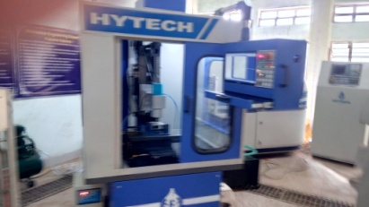

*Fig..1 – Drilling Machine*

The performance measure, signal-to-noise ratio(S/N) can be used to obtain the optimal parameter combinations. In the Taguchi method, a loss function will be defined to calculate the deviation between the experimental value and the desired value. Usually, there are three categories of the performance characteristics in the analysisofthe signal-to- noise ratio, i.e., th etter .To obtain optimal machining performance, the minimum Machining time and the maximum MRR are desired. Therefore, the lower the-better MT and the higher-the better MRR should be selected. This method, the S/N ratio is used to determine the deviation of the performance characteristic from the desired value. .The S/N ratio is found by using Taguchi Analysis in Minitab 17[6]

Taguchi Analysis: MRR versus Speed, Feed, DOH

*Table 1- Analytical Data*

|  |  |  |  |  |  |  |  |
| --- | --- | --- | --- | --- | --- | --- | --- |
| Drill Dia | Speed | Feed | DOH | MT | MRR | SNRA1 | SNRA2 |
| 0.3 | 12000 | 0.0003 | 2 | 0.555556 | 0.25434 | 5.10545 | -11.8917 |
| 12000 | 0.0004 | 2.5 | 0.520833 | 0.33912 | 5.666025 | -9.39293 |
| 12000 | 0.0005 | 3 | 0.5 | 0.4239 | 6.0206 | -7.45473 |
| 18000 | 0.0003 | 2.5 | 0.462963 | 0.38151 | 6.689075 | -8.36988 |
| 18000 | 0.0004 | 3 | 0.416667 | 0.50868 | 7.604225 | -5.87111 |
| 18000 | 0.0005 | 2 | 0.222222 | 0.63585 | 13.06425 | -3.93291 |
| 24000 | 0.0003 | 3 | 0.416667 | 0.50868 | 7.604225 | -5.87111 |
| 24000 | 0.0004 | 2 | 0.208333 | 0.67824 | 13.62482 | -3.37233 |
| 24000 | 0.0005 | 2.5 | 0.208333 | 0.8478 | 13.62482 | -1.43413 |
| 0.5 | 12000 | 0.0003 | 2 | 0.555556 | 0.7065 | 5.10545 | -3.01776 |
| 12000 | 0.0004 | 2.5 | 0.520833 | 0.942 | 5.666025 | -0.51898 |
| 12000 | 0.0005 | 3 | 0.5 | 1.1775 | 6.0206 | 1.419218 |
| 18000 | 0.0003 | 2.5 | 0.462963 | 1.05975 | 6.689075 | 0.504069 |
| 18000 | 0.0004 | 3 | 0.416667 | 1.413 | 7.604225 | 3.002843 |
| 18000 | 0.0005 | 2 | 0.222222 | 1.76625 | 13.06425 | 4.941043 |
| 24000 | 0.0003 | 3 | 0.416667 | 1.413 | 7.604225 | 3.002843 |
| 24000 | 0.0004 | 2 | 0.208333 | 1.884 | 13.62482 | 5.501618 |
| 24000 | 0.0005 | 2.5 | 0.208333 | 2.355 | 13.62482 | 7.439818 |

**III- FUZZY LOGIC**

MATLAB is a convenient Software to perform fuzzy logic methodology. Considering Signal to noise ratios for MRR and MT within the intervals of 34 to 46 and 57 to 72 respectively as input variables and to get OPI i.e. Optimal performance Index form 0 to 1 intervals. [7] It is carried out by Defining the Input /Output variables Fig no.2 a & b then the Member functions were Selected for 0.3mm and 0.5mm.Fig.no.3 a,b,cand d.Then fuzzy rules were developed as shown in Table no.2.Then centroid for each combination of SNR was found as a value of Optimal Performance Index(OPI), which is called Defuzzification. Shown in fig 4 a,b, c and d and value of OPI is given in Table no.3

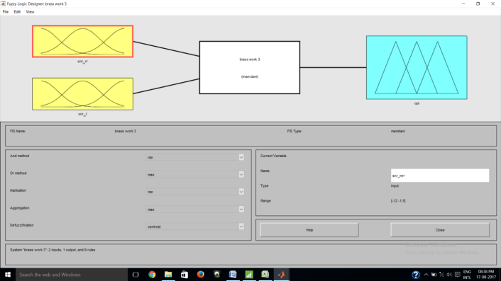

*Fig.2 a-. Defining Input Output variables for drill dia 0.3 mm*

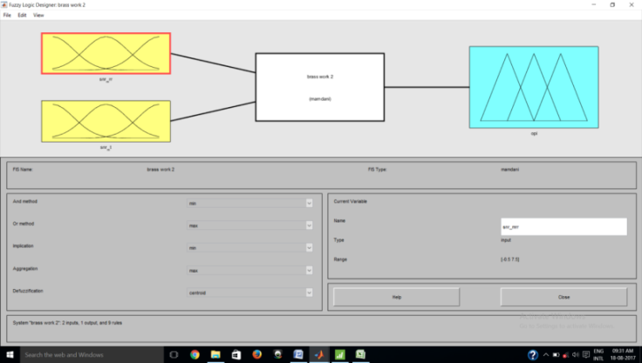

*Fig 2 b- Defining Input Output variables for drill dia 0.5 mm*

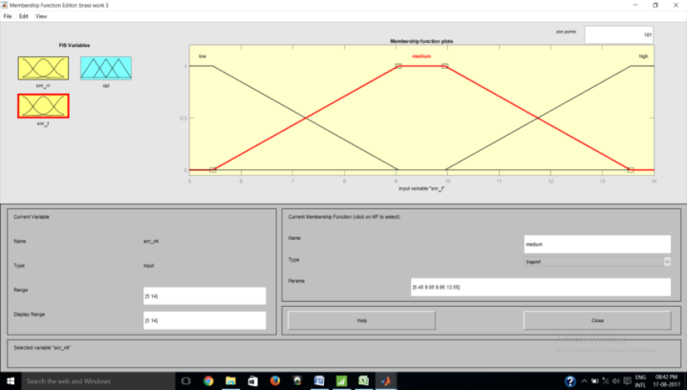

*Fig .3 a-. Membership function for input variables for drill dia 0.3mm*

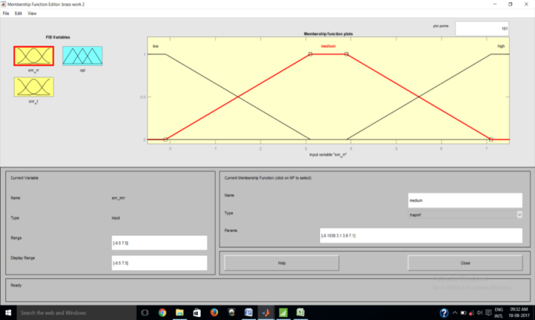

*Fig 3 b.-Membership function for input variables for drill dia 0.5mm*

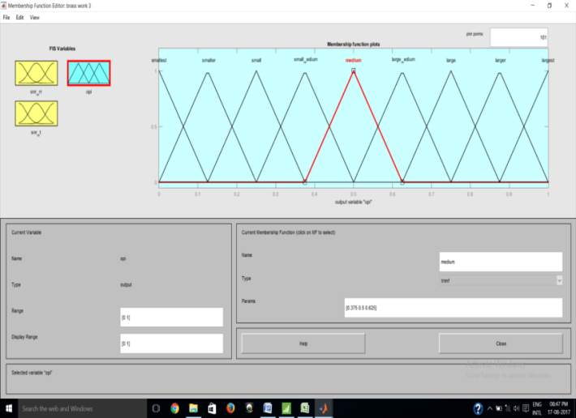

*Fig.3 c- Membership function for output variables for drill dia 0.3mm*

*Table 2- Details of Reading*

|  |  |  |  |
| --- | --- | --- | --- |
| Sr. | SNR MRR | SNR MT | OPI |
| 1 | Low | Low | Small |
| 2 | Low | Medium | Smaller |
| 3 | Low | High | Smallest |
| 4 | Medium | Low | Larger |
| 5 | Medium | Medium | Largest |
| 6 | Medium | High | Large |
| 7 | High | Low | Small Medium |
| 8 | High | Medium | Large Medium |
| 9 | High | High | Medium |

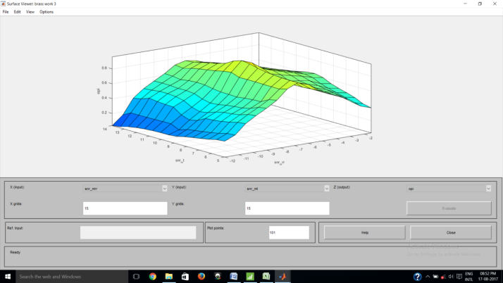

*Fig. 4 a -Surface Plot for 0.3 dia*

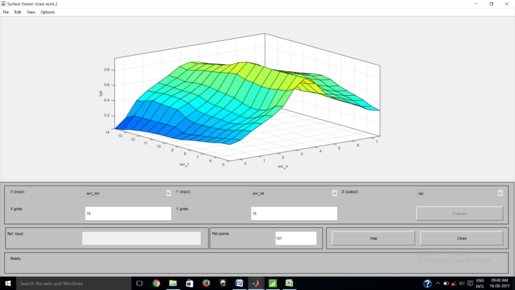

*Fig 4 b-Surface plot for 0.5 dia*

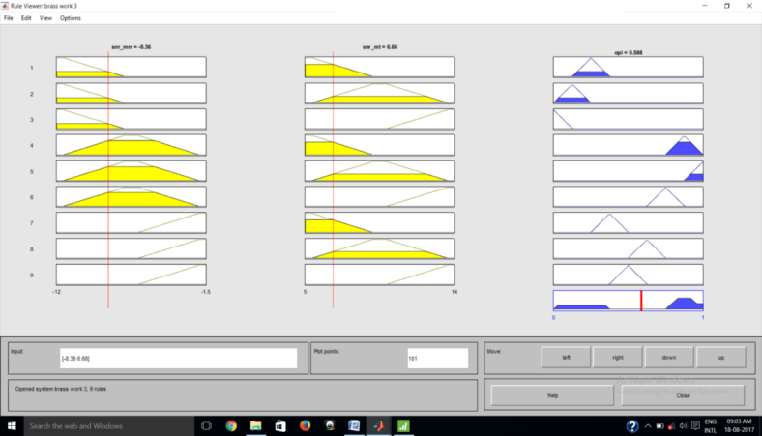

*Fig. 4 c- Defuzzification for 0.3 dia*

*Table 3-Taguchi Analysis: OPI 1 versus Speed, Feed, DOH*

|  |  |  |  |  |  |  |  |
| --- | --- | --- | --- | --- | --- | --- | --- |
| Drill dia | Input value | | Ouput value | Drill dia | Input value | | Output value |
| SNRA1 | SNRA2 | OPI | SNRA1 | SNRA2 | OPI |
| 0.3mm | 5.10545 | -1.8917 | 0.25 | 0.5mm | 5.10545 | -3.01776 | 0.25 |
| 5.666025 | -.39293 | 0.544 | 5.666025 | -0.51898 | 0.461 |
| 6.0206 | -.45473 | 0.801 | 6.0206 | 1.419218 | 0.732 |
| 6.689075 | -.36988 | 0.588 | 6.689075 | 0.504069 | 0.474 |
| 7.604225 | -.87111 | 0.789 | 7.604225 | 3.002843 | 0.812 |
| 13.06425 | -.93291 | 0.644 | 13.06425 | 4.941043 | 0.648 |
| 7.604225 | -.87111 | 0.789 | 7.604225 | 3.002843 | 0.812 |
| 13.62482 | -.37233 | 0.5 | 13.62482 | 5.501618 | 0.6 |
| 13.62482 | -.43413 | 0.5 | 13.62482 | 7.439818 | 0.5 |

*Table 4- Comparative Analysis*

|  |  |  |  |  |  |  |  |
| --- | --- | --- | --- | --- | --- | --- | --- |
| Response Table for Means 0.3 | | | | Response Table for Means 0.5 | | | |
| Level | Speed | Feed | DOH | Level | Speed | Feed | DOH |
| 1 | 0.5317 | 0.5423 | 0.4647 | 1 | 0.4810 | 0.5120 | **0.4993** |
| 2 | 0.6737 | **0.6110** | **0.5440** | 2 | 0.6447 | **0.6243** | 0.4783 |
| 3 | **0.5963** | 0.6483 | 0.7930 | 3 | **0.6373** | 0.6267 | 0.7853 |
| Delta | 0.1420 | 0.1060 | 0.3283 | Delta | 0.1637 | 0.1147 | 0.3070 |
| Rank | 2 | 3 | 1 | Rank | 2 | 3 | 1 |



*Fig.5- Mean for drill dia 0.3 mm*



*Fig.6- Mean for drill dia 0.5 mm*

**IV- RESULTS**

By considering the parameter combinations of the nine sets of experiment based on the L9 orthogonal array, the quantified results from fuzzy deduction for the MRR are determined in the form Optimal Performance Index and shown as Table 4. Introducing the deduction results as the Mean for MRR under larger-the-best expectation, the results of factor responses are calculated and listed in Table 5. The mean effects for Means are then drawn by MINITAB 17 and shown as Fig. 7. Results of OPI are recorded and response table for analysis of mean is done in TAGUCHI Analysis

**V- CONFIRMATION TEST**

The optimum result is achieved by our proposing deduction optimization technique, the machining operations under both fuzzy TAGUCHI optimization parameters and benchmark parameters; Speed(medium), Feed (medium), DOH (medium),which are often introduced into the confirmation experiment in many of the studies for comparison to the optimum parameters, are performed on the CNC Micro-drilling. It is observed that the MRR under fuzzy deduction parameters meets the benchmark parameter which is slightly more than benchmark parameters.

*Table 5- Benchmark Analysis*

|  |  |  |  |  |
| --- | --- | --- | --- | --- |
| Drill Dia | Bechmark | level | Fuzzy | Level |
| 0.3 mm | 18000 | A2 | 24000 | A3 |
| 0.0004 | B2 | 0.0004 | B2 |
| 2.5 | C2 | 2.5 | C2 |
| MRR | 0.50 |  | 0.66 |  |
| 0.5mm | 18000 | A2 | 24000 | A3 |
| 0.0004 | B2 | 0.0004 | B2 |
| 2.5 | C2 | 2 | C1 |
| MRR | 1.41 |  | 1.8 |  |

**VI -CONCLUSIONS**

This parametric deduction scheme was proposed parameters under the considerations of MRR. Optimum deduction parameters was calculated to indicate the effectiveness of the proposed fuzzy TAGUCHI optimization method which was understood by confirmation test also by this experimental results validate the potency that the MRR meets the benchmark parameters obtained from average value of parameters This type optimization will suggest the manufacturers to go fuzzy logic analysis through TAGUCHI prior to manufacturing. This gives economically excitement to manufacturing industry through the proposed development in this study.

**VII- ACKNOWLEDGEMENT**

The authors would like to express sincere thanks to SantGadge Baba Amravati University for registration of this research work and also express thanks to College of Engineering and Technology, Akola for availing necessary laboratories facilities. The authors also gratefully acknowledge for necessary financial support of Government College of Engineering, Jalgaon and also grateful to Jawaharlal Darda Institute of Engineering and Technology,Yavatmal for their time to time help.

**REFERENCES**

1. *A. Zadeh, “Outline of a New Approach to the Analysis of Complex Systems and Decision Processes,” IEEE Transactions on Systems, Man, and Cybernetics, SMC- 3(1), 28-44, January 1973.*
2. *Tian-SyungLan,(2011). Fuzzy Parametric Deduction for Material Removal Rate Optimization, Journal of Mathematics and Statistics,7(1), pp.51-56*
3. *B.Y. Lee, H.S. Liu and Y.S. Tarng, (1996). Modeling and Optimization of Drilling Process. Department of Mechanical ManufactureEngineering, National Huwei Institute of Technology, Huwei, 632, pp. 1-9*
4. *Sahoo P., Barman T. K. and Routara B. C., (2008), “Taguchi based practicaldimension modeling and optimization in CNC turning”, Advance in ProductionEngineering and Management, Volume 3, Number 4, pp. 205-217.*
5. *B.K Hinds, G.M Treanor ,(2011)” Analysis of stresses in micro-drills using the finite element method” International Journal of Machine Tools and Manufacture.*
6. *Singh H. and Kumar P., (2006), “Optimizing Feed Force for Turned Parts throughthe Taguchi Technique”, Sadhana, Volume 31, Number 6, pp. 671–681.*
7. *S.Prasad,P.Rajkhowa,N.Lahon,I.Shivkoti,P.M.Pradhan(2014),”Modelling and Optimization od EDM Process:A Fuzzy based Approach”,Volume 4,Issue 3,pp34-38*