**Piled Raft Foundation: Case study Review**

**Mr. J. M. Raut1**, **Dr.S.R.Khadeshwar2, Dr.S.P.Bajad3**

*1* *Assistant Professor, YCCE, Dept. Of civil engineering, Nagpur(Mah.)India , jmrv100@gmail.com*

*2 Professors and Head, YCCE, Dept. Of civil engineering, Nagpur (Mah),Khandeshwar333@yahoo.com*

*3 Head, Government Polytechnic, dept. of civil engineering, Amravati (Mah.) India, spbajad@gmail.com*

***Abstract*** *– A piled raft foundation emerging as an most efficient and economical foundation. The pile –raft foundation is raft foundation supported with piles where load bearing capacity of both is taken into consideration while designing. There were some constructions based on this piled raft foundations and in some countries are promoting this foundations. Still use of piled raft foundation is not generalized and common. The reason may be due to lack of information about piled raft foundation. This paper is focused on review of the structure based on piled- Raft foundation*.

***Keywords-*** *Pile, Raft, Pile Raft, foundation*.

**INTRODUCTION**

A piled raft foundation emerging as an most efficient and economical foundation. In most of the situations, pile foundation does not used as single pile but pile foundations always used in group to bear the heavy loads. Even distribution of loads to the individual piles and to avoid unequal settlement use of pile cap is necessary. The load bearing capacity of the pile cap is not considered in the traditional design of pile group foundation. Making the pile group foundation uneconomical. Neglecting the bearing capacity of pile cap for the group of few pile is considerable but if the pile group is bigger and size of pile cap is also large is very much uneconomical. Still majority of the construction is based on this traditional based design methodology. When we consider the load bearing capacity of raft then the foundation is called piled Raft foundation. The applied load is transferred by means of a load sharing mechanism between pile and raft, which is generated through a process of interaction between the pile, soil and the raft. Unlike the conventional pile foundation design in which the piles are designed to carry the majority of the load, the design of a piled-raft foundation utilizes the load carrying capacity of both raft and piles. For most piled raft foundations, piles are provided to act as settlement reducers. In that case, raft may be designed to withstand the major loads and piles may be designed for the additional loads which cause excessive settlement. Raft foundations are generally provided where the soils stratum at shallow depth is weak and high stress is applied by superstructures to soil. Due to large dimension, the raft is able to withstand high pressure of superstructure. The settlement of raft can be brought within permissible limits if it is supported by group of piles of various configurations. The major advantages of using a piled raft foundation are the reduction in uniform and differential settlements, increase in overall stability of foundation, reduction in number of piles compared to conventional pile foundation and reduction in bending stress for the raft. It is also suitable in stiff as well as soft clays. This may be due to unavailability of well established and generalized design methodology and also the literature. This paper is focused on the review of the literature based on case histories piled raft foundation.

**MAJOR PILED – RAFT FOUNDATION BUILDINGS**

**1.** **Messe–Torhaus, Frankfurt, Germany (1983-85):**

This building is called the beginning of piled raft foundation in the Germany. The building is 30 m high and there are 6- story apartment blocks and near the railway bridge. So there is more possibility of settlement and designer is looking for the foundation having less settlement. This building had two rafts each having 42 board piles having 20 meter length and 0.9 meter diameter. The piles are arranged 6 x 7 sizes having the spacing of 3 to 3.5 of the diameter. The raft size is 17.5 m x 24.5 m in plan and foundation is 3m below ground surface having effective structural load of 200 MN.

As this was the first building in the Germany so building was designed according to the conventional approach suggested by German codes for fully Piled Raft foundations. Here it was assumed that piles will be utilized at their ultimate bearing capacity and the remaining part of the structural load taken by raft foundation to subsoil. The building was carefully monitored by inserting instruments during the construction. The six piles are instrumented with strain gauges and a load cell at the pile base. Also 11 earth pressure cells have been installed beneath the raft and the three extensometer lead down to depth of 40.5 m below the raft.

Load settlement curve is drawn and the total structural load is divided into load carried by raft (R raft ) and by the piles ( R piles ) . The above observation shows that the only smaller amount of load is carried by the raft as shown by following fig.1.0

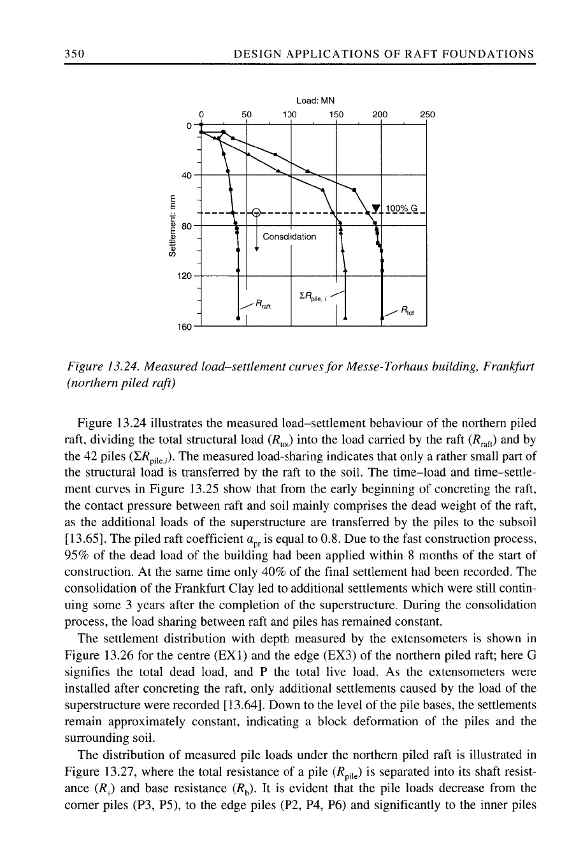

Fig. 1.0 Load Settlement curves

Because of the load eccentricity, the load distribution within the pile group is not symmetric. This is because of dependency of the mobilised skin friction on the position of pile within the group. The corner pile mobilised an average friction of 140 kPa and the inner pile takes the takes the mobilised friction of only 60 kPa in the lowest third of the pile shaft. The pile raft load bearing coefficient was equal to 0.8 .

1. **Messeturm building Frankfurt Germany (1988-91)**

The total height of the building is 256.5 m was the tallest building in the Europe and obliviously the tallest building in the Frankfurt. The Estimated load of the building is 1880 MN. The soil profile of the site was up to the 8 meter there was gravels and sand. Below the 8 meter layer of gravel and sand there is 100 m thick clay layer. Due to such soil condition there is risk of providing fully piled foundation. The raft size of 58.8 m x 58.8 m with 6 meter thick at centre & 3 meter at the edges and having total piles of 64 ( 16 piles of 34.9 meter length , 20 piles of 30.9 meter length , 28 piles of 26.9 meter length ) . The main objective of the providing piled raft foundation is to reduce settlement and avoid rick of excessive tilt of the raft on inhomogeneous Frankfurt clay. Due the limitations of unavailability of generalised design methodology and also the experience, the simplified approach for the determining of size of raft and the diameter of the pile. The piled Raft was designed with two cases. In the first case piles are assumed to carry the 30 % of the building load and the remaining load by the raft foundation. In the second case piles are assumed to take the 55% of the total load and remaining load by raft foundation. During the construction process the load sharing coefficient progressively increased from αpr = 0.35 to αpr = 0.55 till the building finished. This means 55 % load is taken by the piles and the 45 % of the remaining load is taken by the raft foundation.

The field measurement of the building shows that as compared to Messe -Torhaus building, there was better optimisation of piled raft foundation. However according to the design assumption that piles shall take full load up to their ultimate bearing capacity and the additional load will be taken by raft. This assumption is not proved by the field observation. Also the observed piled load show that group piles taken higher loads as compared to the single pile.

1. **DG- Bank ( Westend stress I ) Building ( 1990-1993 ) :**

The total height of the building is 208 meter with 53 storeys and the raft size is 2940 sqm and the number of piles are nearly 40 having diameter of 1.3 m . The structural load of building is exactly and equally shared by piles and raft means load sharing ratio of the building was 0.5. This means out of total load 50 % load is taken by piles and remaining 50 % load is taken by raft. One of the well-measured and well-documented piled raft application examples is Westend Tower Building which was constructed in financial building district of Frankfurt/Germany in 1993. Building consists of office tower and side building. Foundation of the office tower and side building was separated by a settlement joint in order to avoid high raft bending moments at contour line of the office tower. In this example, only foundation of the office tower will be investigated. Plan and elevation view of Westend Tower are given in Figure 2.0

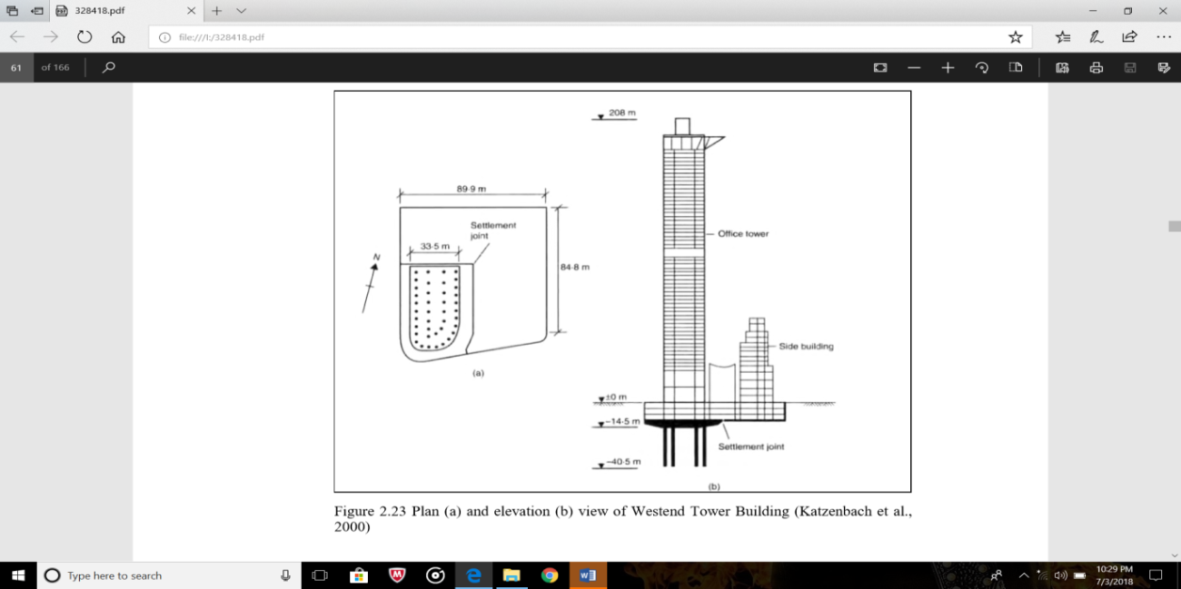

Fig. 2.0 Westend Tower

The Westend Tower Building has a weight of nearly 1420 MN. It has three basement floors and foundation level of the building is 14.0 meters below the ground surface. Groundwater level is about 9.5 meters above the foundation level. The plan area of the foundation is approximately 3000 m2. Due to excessive foundation contact pressure, settlement, existing limitations on the foundation depth and high slenderness ratio of the structure (H/B=4.7), piled raft option was preferred by the designers (Franke et al., 2000). Thickness of the raft is 4.65 meters at the center of the raft and 3.0 meters at the edge. There are 40 piles with diameter of 1.3 meters and length of 30 meters placed at the strategic points in the foundation plan. fter the performed measurements, following values were obtained for piled raft.

Table 1.0 Measurement results for Westend Tower Building (Katzenbach et al., 2000)

|  |  |
| --- | --- |
| **Results** | **Value** |
| Observed Piled Raft Coefficient, αpr | 0.5 |
| Observed Pile Loads (MN) | 9.2-14.9 |
| Observed Maximum Settlement, w (mm) | 110 mm |

According to observation of the results, the load sharing coeeficient is 0.5 means 50% of structural load is shared by the raft and the 50% load is carried by pile. The pile loads are in a range of 9.2 and 14.9 MN depending on pile’s location.

A study done by Poulos (2000), he investigated the “Westend Tower Building Using different analysis techniques and obtained results were compared by each other and measurement data. Used analysis techniques are: 3D Finite Element Method (Ta & Small, 1996), approximate “plate on springs” method named as “GARP” (Poulos, 1994), approximate “strip on springs” method named as “GASP” (Poulos, 1991), two different simplified methods which were already introduced in the previous sections (Poulos & Davis, 1980) and (Randolph, 1994)” Poulos also used two different hybrid Methods by Sinha (1997) and Franke et al. (1994). Obtained results are shown in the figure 2.14.

When Figure 2.14 is examined, it can be said that different analysis techniques were matching the results with each other method as well as with observed values. Only there is a deviation from measured results for the minimum pile loads. Load carrying function of the raft is clearly seen again in this application example. Proportion of the load carried by the raft is relatively high in this case study and this situation indicates that, the pile capacity is nearly fully mobilized. This situation can be seen in the Figure 2.15:



Figure 3.0 Observed load-settlement behaviour of raft, piles and total foundation system of Westend Tower Building (Katzenbach et al., 2000)

In Figure 2.15, if ΣRpile,i curve is investigated it is seen that slope of the curve is getting lower and lower by increasing load and slope is almost zero at the design load. So, piles are fully mobilized and it can be said that the foundation design of the Westend Tower Building is similar to “piles are settlement reducers” approach. This situation was also reported by Poulos (2000).In addition, in this application example, the main settlement reducing function of piled raft foundation was also observed by performing complex geotechnical measurements.

1. **Frankfurt Welle building Complex ( 1998-2001)**

The construction of this building started in the 1998 summer and having the raft area of 25000 sqm and supported by 101 piles . The diameter of the pile is 0.9 m and the length of the pile is around 20 m to 25 m.

**5) Hous der Wirtschaft building Complex Offenbach (1997-99)**

Offenbach is located at the 20 kilometre east of Frankfurt. The soil profile present below this building is tertiary rupel clay with an over consolidated silty clay of semi-solid consistency and having the thickness of more than 100 meters. There is the existing subway besides this building due to which building is more sensitive to settlement.

**6) Taunustor – Japan Centre Building Frankfurt (1994-96)**

The height of this building is 115.3 meter and is located in the centre of the financial district of Frankfurt . The building having four basement floors and 29 floors over the basement eccentrically placed. The Raft of having the size 36.6 m x 36.6 m & the totally structural load of having 1050 MN is supported on. The raft thickness of 3.0 m at centre and 1.0 meter at the edges, having major eccentricity of in the building load of 7.5 m. So 25 numbers of piles are so placed that so that there must be constant or equal settlement over the entire foundation. According to the load settlement observation there is load sharing ratio of 0.4. This shows that 40 % load is taken by the piles and the 60 % load is taken by the raft foundation. This is because limestone is located below the 43 meters below the ground surface which is only 5m below the base level of the piles.

1. **Forum Building Complex , Frankfurt Germany**

The height of this building is 94 meters. The raft of this building is very eccentric and designed as single structure having area of 14000 sqm and having board piles of length of 20 m & 30 m of diameter 1.3 m. The thickness of the raft below the tower is 3.0 m and at parking basement 1 m. The load sharing ratio of this building is to be 0.35-0.4 means the 35% load is taken by the piles and 65 % load is carried by the raft foundation.

1. **Main Tower building, Frankfurt Germany (1996-99)**

The total height of this building is 198 m means having 57 storeys above ground and having five basement floors. The raft area is 30 m x 50m and the total load on this building is about 2000 MN. The thickness of the raft at centre is 3.8 m and 3.0 meter at the edge of the raft. There are 112 number of piles having large diameter of 1.5 m and having length of 30 m. The load bearing ratio of this building .85 means the out of total load of this building 85% is taken by the piles and very less 15 % load is taken by the raft.

1. **Eurothum Building Frankfurt (1997-99)**

The total height of this building is 110 m and having the area of 1830 sqm in plan. The thickness of the raft is 2.5 m at middle and 1.0 m at the edges. The total number of piles is only 25 having length of 30m for inner piles and 25 m at outer piles. The load bearing coefficient is about 0.3 means only 30% of the load is taken by the raft and 70 % load is taken by the piles only.

1. **Frankfurter Welle Building Complex (1998-2001)**

The building of height of 55 m and the plan area is about 25000 sqm. The number of piles used in this building is about 101 having diameter of 0.9 m and pile length of 20 to 25 m.

1. **Commerzbank tower Frankfurt Germany (1994-1997)**

The height of this building is 299 m . The 111 number of piles are provided of having larger diameter and having the length of 45m. The soil stratum below the raft is very soft clay layer and for more depth there is stiff layer of lime stone soil present below that soft layer. The entire building load is transferred by piles means 96 % load is taken by piles & only 4 % load is taken by the raft. The main reason behind the maximum load share taken by piles is due to difference in stiffness and strength between Frankfurt limestone and Frankfurt clay.

1. **Petronas Twin Towers, Malaysia (1993-1998)**

The of the building is 450 m and the towers stands 55 meter apart . The soil below the building is 10-20 m is water bearing alluvium after this there is varying thickness of residual soil of meta –sedimentary formations, namely siltstone, sand stone ,shale and occasionally available phyllite which is locally called “Kenny hill formation” . Due to high slenderness ratio of the structure the designer and also the developer has theoretically decided to keep the zero differential settlement. But the soil profile present there make this task very difficult and challenging. To accomplish this task pile raft foundation is proposed.

Each tower is provided with deep piles of 104 concrete piles for each tower and the raft thickness of about 4.6-metre.

1. **Burj Khalifa’ Dubai (2004-2009)**

Total height of the building was 600 m, at present it is the world’s tallest building. In plan its shape is just like Y having 160. The Burj The soil profile below this structure is a horizontally stratified subsurface profile. This subsurface profile is complex in nature and highly variable, because the nature of deposition and the hot climatic conditions. The upper layer of the soil profile is medium dense to very loose granular silty sands or may call marine deposits. After this layer, there is very weak to weak sandstone, interbedded with vey weakly cemented sand, gypsiferous fine-grained sandstone or siltstone and weak to moderately weak conglomerate/calcisiltite. Ground water levels were at 2.5 m below ground level. The tower stands on a piled raft foundation, consisting of a 3.7 m thick raft supported on 1.5 m dia.192 bored piles extending to a depth of nearly 47 m placed 3.75 meters below the base of the raft.

1. **Piled raft foundation in Niigata City, Japan (1994)**

The total height of the building is 125 m having 21 stories above ground and 4 basement stories. The raft thickness varies from the 2.0 m to 3.7 m and the 157 m concrete piles of diameter 1.0- 1.8 meter . The settlement of this building is 22mm very low compared its height.

1. **Bibliotheca Alexandrina, Egypt (1995-1999)**

This is the world’s famous ancient library having 8 million books is newly constructed on the same site based on piled raft foundation. This library building is having 160 m diameter and having the 10 floors out of which 4 are underground and below the water. The building is asymmetric in nature Heavy load occurs in south direction making the piles in compression. In the north side there is a uplift pressure due to water so tension piles are provided. And in the middle part piles may be tension or in compression depending upon the location. There are total 599 piles provided 131 piles ( 1.5 m diameter with single under-ream for compression loads ) 143 piles ( 1m in diameter with two under –ream for compression as well as tension) 325 piles ( 1.2 m diameter with two under-ream for tension load ) The length of the piles are more than 45m . The soil profile for this site includes silty sand up to 12 .5 meter after that sandstone up to 19.5 meter then silty fine sand up to 24 meter then here is sand stone up to 44.5 m.

**CONCLUSION**

It is observed from the case studies of piled raft foundation that pile raft foundation is not new but most of the old foundations are based on piled raft. Raft is used over the pile foundation as pile cap or pile are used as settlement reducers . But, while designing the combine load bearing capacity of pile and raft is not considered. Around 1980 decade when there are some constructions based on pile raft foundations in Germany where load bearing capacity is considered. The load is shared by raft and pile simultaneously depending upon their individual capacity . The use of pile raft foundation is very economical . Considering bearing capacity of raft number of piles, length of pile also diameter of piles can be reduced .

**REFERENCES**

1. *H S W Chow, J C Small (2008), “Case Histories for Piled Rafts”, 2nd BGA International Conference on Foundations, Dundee, 24 - 27 June 2008, the conference is organized by British Geotechnical association.*
2. *Kyung Nam Kim, Su-Hyung Lee, Ki-Seok Kim (2001), “Optimal pile arrangement for minimizing differential settlements in piled raft foundations” Elsevier, Computers and Geotechnics 28 (2001) pp 235–253.*
3. *J.C. Small and H.H. Zhang (2002), “Behavior of Piled Raft Foundations Under Lateral and Vertical Loading” The International Journal of Geomechanics Volume 2, Number 1 pp 29-45(2002).*
4. *Lisa J. Novak, Lymon C. Reese, and Shin-Tower Wang (2005), “Analysis of Pile-Raft Foundations with 3D Finite-Element Method”, Structures Congress 2005 April 20-24, 2005 New York, New York, United States © 2005 American Society of Civil Engineers*
5. *Luca de Sanctis and Alessandro Mandolini(2006) “Discussion on Bearing Capacity of Piled Rafts on Soft Clay Soils” December 2006, Vol. 132, No. 12, pp. 1600–1610.DOI: 10.1061/ASCE1090-0241(2006)132:12(1600).*
6. *G. Vasquez, S. T. Wang, and W. M. Isenhower (2006) ”Estimation of the Capacity of Pile-Raft Foundations by Three-Dimensional Non-Linear Finite Element Analysis” Geo Congress 2006 Copyright @ ASCE 2006*
7. *Bengt H. Fellenius, “Unified Design Of Piled Foundations With Emphasis On Settlement Analysis” Deep Foundations 2004 @ Copyright ASCE 2004.*
8. *G.Hassen and P. De.Buhan(2006) “Fine Element Elastoplastic analysis of piled raft foundation based on use of multiphased model” VIII International conference on Computational Plasticity Complas VIII @Copyright CIMNE Barcelona,2005.*
9. *Rolf Katzenbach,Gregor Bachmann,Christian Gutberlet (2006) “Soil structure Interaction by high- rise buildings in Megacities” IGC 2006 14-16 December 2006, Chennai, India.*
10. *Bengt H. Fellenius (2006) ”Unified Design Of Piled Foundations With Emphasis On Settlement Analysis” ASCE Geotechnical Special Publication (GSP 125) Honoring George G. Goble "Current Practice and Future Trends in Deep Foundations"Geo-Institute Geo-TRANS Conference, Los Angeles, July 27-30, 2004.*
11. *B. V. Bakholdin (2003) “Piled-Raft Foundations. Design And Characteristics Of Construction Procedures” Soil Mechanics and Foundation Engineering, Vol. 40, No. 5, 2003*
12. *A. Mandolini & G. Russo & C. Viggiani (2002)”Pile foundations: Experimental investigations, analysis and design Foundations” Soil Mechanics and Foundation Engineering, Vol. 25, No. 6, 2002*
13. *F.M.Abdrabbo, H.M,Abouseeda and K.E.Gaaver (2004)“Performance of raft with piles -Settlement Reducers” International Conference: Future Vision and challenges for Urban Development Cairo Egypt 20-22 December 2004*
14. *H. G. Poulos (2006) “Pile Group Settlement Estimation – Research To Practice” GeoShanghi Int. Conference on foundation analysis and design*
15. *H. G. Poulos (2001) “Piled raft foundations: design and applications” Geotechnique 51, No. 2, 95-113 Coffey Goesciences Pty Ltd; University of Sydney, Australia*
16. *O. Reul And M. F. Randolph (2003) “Piled rafts in over consolidated clay: comparison of in situ measurements and numerical analyses” Geotechnique 53, No. 3, 301–315*
17. *Alessandro Mandolini , Gianpiero Russo, Carlo Viggiani (2005) “Pile foundations: experimental investigations,analysis and design” International Conference on Soil Mechanics and Geotechnical Engineering September 12-16, 2005, Osaka, Japan*
18. *H.G. Poulos (2001) “Methods Of Analysis Of Piled Raft Foundations” A Report Prepared on Behalf of Technical CommitteeTC18 on Piled Foundations*
19. *Harry G. Poulos, (1993) “Piled Rafts In Swelling Or Consolidating Soils” Journal of Geotechnical Engineering, Vol 119 No.2 February 1993 ASCE, ISSN 0733-9410 Paper no. 3097.*
20. *Chun-Yi Cui, Mao-tian Luan, Ying-hua Zhao (2009) “Time-dependent Behaviour of Piled-raft on Soil foundation with Reference to Creep and Consolidation” EDGE Vol.14 Bund A.*
21. *Kim Hong “Optimal Design of piled Raft foundations using a Genetic Algorithm” Journal of the KGS Vol.16, June 2000, pp 47-55*
22. *R. P. Cunha, H. G. Poulos, and J. C. Small (2001) “Investigation Of Design Alternatives For A Piled Raft Case History” Journal of Geotechnical and Geoenvironmental Engineering, Vol. 127, No. 8, August, 2001. ASCE, ISSN 1090-0241/01/0008-0635–0641/ Paper No. 22359*
23. *Li W.W., Cheng M.L. (2006) “Foundation Design And Construction” book published copy right @ The Government of the Hong Kong Special Administrative Region*
24. *Ramasomy G, V.N.Poondla (2006) “Settlement Analysis of Piles Raft foundations” IGC 2006, 14-16 December 2006 Chennai, India.*
25. *M. F. Randolph (2003), “Science and empiricism in pile foundation design” Geotechnique 53, No. 10, 847–875*
26. *Y.C.Tan, S.W.Cheah, M.R.Taha (2006)“Methodology for design of piled raft for 5-story building on very soft clay” Foundation Analysis and Design: Innovative Methods (GSP 153) Copyright ASCE 2006*