An IoT based Moisture Controlled Smart Drip Irrigation System

Ankita A. Kuthe

Electronics and Telecommunication engg Nagpur India

ankitaakuthe@gmail.com
9405909948

Abstract— Irrigation and farming have been the core of our economy and over the years the technology has influenced it in a very big way. Right from motorized ploughing to automated seed sowing and many more advancement have been carried and have been put to use efficiently resulting in improved production and better management of the crops. The significant contribution in changing the way in which irrigation has been employed and executed over the years .This work presents an implementation of a customized system which monitors the moisture level of the soil and waters the plants as per the requirement.
Keywords—Drip Irrigation; Android; Rasberry Pi;Wi Fi;IoT

- INTRODUCTION

This Agriculture plays a vital role in India’s Economy. The history of agriculture in India dates back to Indus Valley Civilization Era and even before that in some parts of Southern India. Today, India ranks second worldwide in farm output. Agriculture and allied sectors and fisheries accounted for 13.7% of the GDP (gross domestic product) in 2013, about 50% of the workforce.

The economic contribution of agriculture to India's GDP is steadily declining with the country's broad-based economic growth. Still, agriculture is demographically the broadest economic sector and plays a significant role in the overall socio-economic fabric of India. Many smart irrigation systems have been devised.

A smart irrigation system, contrary to a traditional irrigation method, regulates supplied water according to the needs of the fields and crops. The feedback mechanism of a smart irrigation system is a moisture sensor. Evapotranspiration (ET), thermal imaging, capacitive methods, and neutron scattering method and gypsum blocks are some of the technologies that enable moisture sensing. Capacitive sensors, however instantaneous, are costly and need to be calibrated often with varying temperature and soil type. Neutron probe based moisture sensors are very accurate but present radiation hazards, calibration difficulty and are costly. Gypsum blocks are however less expensive but they dissolve in water and change their response with passage of time .Thermal imaging is an effective method but is prohibitively expensive. Due to the above reasons, an alternative, low cost sensor must be

Kanchan Mankar

Electronics and Telecommunication engg.
Nagpur India

kanchan.mankar@raisoni.net
7588749114

produced enabling the use of smart irrigation systems in the third world countries.

A large agricultural field presents an additional problem in the sense that different parts areas of it may have different evaporation rates due to foliage, the presence of rocks at different heights underground, parts of the field being in close proximity to canals or ponds, etc. Hence, moisture measurement at a single location in the field does not make much sense. Consequently, what is required is a distributed number of sensor nodes and some scattered pumping units to pump water to those specific locations covered by the sensor units. The need for multiple sensors further emphasizes the need for an in expensive moisture sensor. Furthermore, the requirement of multiple sensors spread out over the field means the presence of many wires in it. This will create a lot of problems to ploughing, harvesting, etc. and isn’t practical. Wireless connectivity to the sensors is a novel idea in this context. In this regard, this work proposes a low-cost wireless device for data communication. Drip irrigation system makes the efficient use of water and fertilizer.

Water is slowly dripped to the roots of the plants through narrow tubes and valves. Water is fed directly to the base of the plants which is a perfect way to water plants. There should be proper drainage in the fields or pot plants to avoid any water logging which in case may affect the productivity. There already exist automatic drip irrigation systems which water plants based on soil humidity, pH value of soil, temperature and light. These parameters are required in big agricultural fields where productivity of the crop matters. In small areas like office premises, buildings, house gardens etc. where watering plants at regular interval matters, our proposed irrigation system will be very efficient.

This work intends to presents an Implementation of IoT based moisture controlled smart drip irrigation using raspberry pi and Android Application .Raspberry pi with edimax-wifi dongle and android mobile will be connected to the same wifi network.

The User can set the threshold value by the android app from the locally connected Android device.

The soil moisture sensor is placed in the pot. As soon as the moisture level changes from the threshold level, raspberry pi will turn on the pump hence water will be supplied to the pot until the moisture value reduces to its threshold value. It is expected that the present scheme turns out to be more advantageous than the traditional agriculture technique.

- SOME IRRIGATION SYSTEMS

First, Deficiency in fresh water resources globally has raised serious alarms in the last decade. Efficient management of water resources plays an important role in the agriculture sector. Unfortunately, this is not given prime importance in the third world countries because of adhering to traditional practices. Work has been done on a smart system that uses a bespoke, low cost soil moisture sensor to control water supply in water deficient areas.

The sensor, which works on the principle of moisture dependent resistance change between two points in the soil, is fabricated using affordable materials and methods. Moisture data acquired from a sensor node is sent through XBEE wireless communication modules to a centralized server that controls water supply. A user-friendly interface is developed to visualize the daily moisture data. The low-cost and wireless nature of thesensing hardware presents the possibility to monitor the moisture levels of large agricultural fields. Moreover, the proposed moisture sensing method has the ability to be incorporated into an automated drip-irrigation scheme and perform automated, precision agriculture in conjunction with de-centralized water control.

Work has been done to develop a transducer network framework that supports the amalgamation of multiple transducers into single wireless nodes. This approach is aimed at decreasing energy consumption by reducing the number of wireless transceivers involved in such networks. To make wireless nodes easily reconfigurable, a plug and play mechanism is applied to enable the clustering of any number of transducers. Furthermore, an algorithm is proposed to dynamically detect added and removed transducers from a node. Lastly, an XML based protocol is devised to allow nodes to communicate a description of their layout, measured data and control information.

To verify the proposed framework, multiple reconfigurable wireless nodes are used to monitor the dynamic condition of a multiple rooms during a period of24 hours in order to emulate a smart home scenario.

Similarly work has been done to develop an Automated Irrigation and Fertigation System for the automation in the agriculture. The traditional irrigation system as well as the fertilizer application system is modified to achieve modern approach of automation. Automation provides the less human interference, reduced cost as well as the remote access. This system uses mainly the ARM7 (LPC2148), Raspberry-pi and zigbee modules. The humidity, soil moisture and temperature sensors are used in this system. The sensor part is controlled by the ARM7.

There is function of the controlling the fertigation pump via E-mail, this part is organized by the Raspberry-pi. The zigbee

modules which are known for the short range communication are used for the communication between the raspberry and the controller. There are mainly two sections one is the field section which consists ARM7, zigbee and sensors whereas the second section is the control section which includes the raspberry pi and the zigbee. This scheme we are going to design is helpful not only for the small/ big farms but also for the greenhouses and the home gardening systems.

An application of a wireless sensor network for low-cost wireless controlled and monitored irrigation solution has been developed which removes the need for workmanship for flooding irrigation. Efficient water management plays an important role in the irrigated agricultural cropping systems. In the past couple of decades, there has been a rapid growth in terms of technology in the field of agriculture. Different monitoring and controlled systems are installed in order to increase the yield. The yield rate may deceases due to numerous factors. Disease is one of the key factors that cause the degradation of yield. So the developed monitoring system mainly focuses on predicting the start of germination of the disease.

Microcontroller wirelessly transmits different environment conditions across the farm to central unit where data is stored, and analysed. Central unit checks the present data with disease condition and if matches then it commands microcontroller to operate relay. Sensor module is tested for different temperature range and it is found that there are little variations in recorded values. Wireless data transfer is tested with the introduction of various obstacles like wall, metal body, magnet, etc. and it is found that same data is transferred to central unit but with some amount of delay in it. The developed system nearly predicts the start of germination of disease.

- RESEARCH MEHTODOLOGY
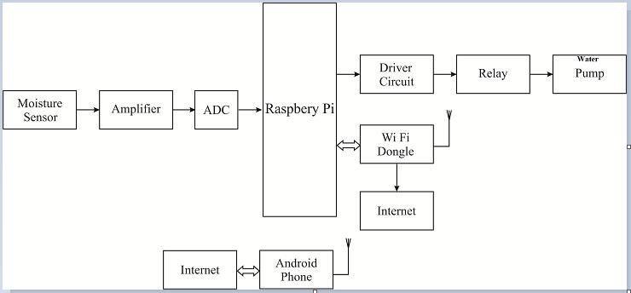

Fig. 1 Block Diagram

This work intends to presents an Implementation of IoT based moisture controlled smart drip irrigation using raspberry pi and Android Application .Raspberry pi with edimax-wifi dongle and android mobile will be connected to the same wifi network.

The User can set the threshold value by the android app from the locally connected Android device.

The soil moisture sensor is placed in the pot. As soon as the moisture level changes from the threshold level, raspberry pi will turn on the pump hence water will be supplied to the pot until the moisture value reduces to its threshold value. It is expected that the present scheme turns out to be more advantageous than the traditional agriculture technique. The proposed work we will be able to monitor a drip irrigation system. The proposed system successfully employs IOT to provide information about the moisture level of the soil and on the basis of the moisture level the system is able to adjust itself i.e. it is able to start or stop watering the plant.

Raspberry Pi:

Model B of Raspberry has been used in this work. As soon as the email is received, one of the GPIO is turned high. A program written in Python programming language has been used to receive email and turning a GPIO pin high for the requested duration. The same program also sends the status updates to user's email address. Software libraries used in Python programming are:

  - SMTP library to send status email

    - IMAP library for email polling

- BCM for GPIO control in Raspberry Pi

Relay:

One-channel relay board which operates on 5-6V is used here. The circuit is used to control one 240V power appliance directly from microcontrollers or low voltage circuits.”

Power Supply:

The device to be switched, here, is an electrical water pump which runs on 240V supply. It’s one end is connected to the 240 V AC supply and the other end is connected to NO pin of the relay board.

Water Storage Tank and Water Pump:

Two water storage tanks are used for testing purpose. Each tank has submersible water pumps with the rating of 220V/50Hz. It draws the current of 0.23A and power of 18W. The main water pipe is fed back to the water tank to avoid any water wastage. Water tank has ultrasound distance sensor which keeps a track of water depth in the tank. As soon as the water level falls below a threshold level, a signal is sent to microcontroller to open solenoid valve which is attached to the water tap and thus the water can be refilled into the water tank.

Wi Fi:

A device that can use Wi-Fi (such as a personal computer, video-game console, Smartphone, tablet, or digital audio player) can connect to a network resource such as the Internet

via a wireless network access point. Such an access point (or hotspot) has a range of about 20 meters (65 feet) indoors and a greater range outdoors. Hotspot coverage can comprise an area as small as a single room with walls that block radio waves or as large as many square miles — this is achieved by using multiple overlapping access points.

In future it may be possible to create a big grid of such wireless sensor nodes which are able to monitor may more parameters relevant to agriculture.
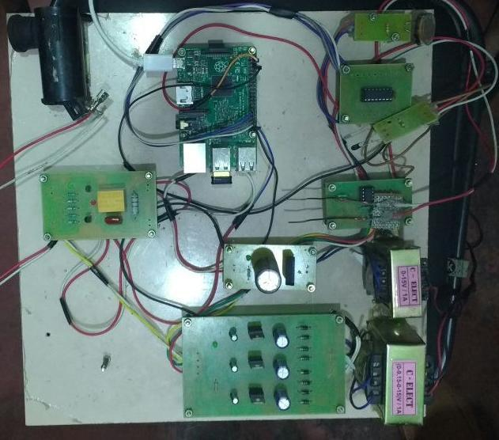

Fig. 2 The Hardware Implementation

IV. CONCLUSION

Thus we conclude that we have been able to develop a system which is able to monitor a drip irrigation system. We have been able employ IOT to provide information about the moisture level of the soil and on the basis of the moisture level the system is able to adjust itself i.e. it is able to start or stop watering the plant. We have been able to develop a fully functional hardware. The android functionality is able to show the status of motor and the moisture level. In the further work to be carried out the android functionality would be improved to allow to start and stop the motor through the android app.

In future it may be possible to create a big grid of such wireless sensor nodes which are able to monitor may more parameters relevant to agriculture.

Acknowledgment

The author would like to thank her guide , the head of the department and the principal for providing the necessary support and guidance to carry out the presented work.

References

- Saad-ul-Haque, B. Ghauri, and M. R. Khan, “Short Term Drought
Monitoring using Remote Sensing Technique: A Case Study of Potohar

Region, Pakistan” in International conference on Aerospace Science & Engineering (ICASE), Islamabad, 21-23 August 2013.

- F. S. Zazueta, and J. Xin “Soil Moisture Sensors” Bulletin 292;
University of Florida: Gainsville, FL, USA, 2004

- ]C. C. Shock, J. M. Barnum, and M. Seddigh “Calibration of Watermark Soil Moisture Sensors for Irrigation Management”, in Proceedings of the 1998 Irrigation Association Technical Conference, The Irrigation Association, Falls Church, VA, USA, pp. 123–129, 1998.

- A. H. Kioumars, and L. Tang "ATmega and XBeeBased Wireless

Sensing" in 5th International Conference on Automation, Robotics and Applications (ICARA), IEEE, Wellington, 6-8 December 2011

[5] Xbee datasheet solutions XBee-rf-modules/point-

multipointrfmodules/xbee-series1-module C. Tatsiopoulos, and A. Ktena "A smart XBee”

- Zhiyong Lai, Yongli Dai, “An Irrigation Control System Based On An FPGA” 2012 Second International Conference on Instrumentation & Measurement, Computer, Communication and Control.

- Mahir Dursun and Semih Ozden, “A wirelessapplication of drip irrigation automation supported by soil moisture sensors” Scientific
Research and Essays Vol. 6(7), pp. 1573-1582, 4 April, 2011.

- R. AI-Ali, Murad Qasaimeh, Mamoun AI-Mardinia, Suresh Radder and
I. A. Zualkernan, “ZigBee-Based Irrigation System for Home Gardens”

Department of Computer Science and Engineering, American University of Sharjah, UAE 978-1-4799-6532-8/15/$31.00 ©20 15 IEEE

- G. Nisha , J.Megala, Velammal institute a/technology ,Chennai,India, “Wireless sensor network based automated irrigation and crop field monitoring system”, 2014 Sixth International Conference on Advanced Computing (ICoAC) 978-1-4 799-8159- 5114/$31.00©20 14 IEEE

- PravinaB. Chikankar, Deepak Mehetre, Soumitra Das, “An Automatic Irrigation System using ZigBee in Wireless Sensor Network,” 2015
International Conference on Pervasive Computing (ICPC)

- HemaN., Krishna Kant, “Local Weather Interpolation Using Remote
AWSData with Error Corrections Using Sparse WSN forAutomated

Irrigation for Indian Farming”, 978-1-4799-5173-4/14/$31.00 ©2014 IEEE.

- A. R. AI-Ali, Murad Qasaimeh, Mamoun AIMardinia, Suresh Radder and I. A. Zualkernan, “ZigBee-Based Irrigation System for Home
Gardens” Department of Computer Science and Engineering, American
University of Sharjah, UAE 978-1-4799-6532-8/15/$31.00 ©20 15 IEEE

