Online Search and Buying Behavior in Consumer Markets
Abstract:

Online search behavior is analyzed using a novel methodology based on an international panel of two million users. Consumer search is measured by the size and distribution of online consideration sets and the use of price comparison engines in a range of US and UK consumer markets. It is shown that most online researchers who are considering competing suppliers only view two or three competitor websites, which results in an average online consideration set of between 2.1 and 2.8, regardless of the use of price comparison websites. Consumer perceived risk is negatively correlated with the size of online consideration sets and online price competition intensity. Using international data from fifteen countries it is shown that online research and online purchasing are negatively correlated with shop density. The implications for managers are outlined, in particular the importance of branding and advertising to improve the likelihood of inclusion in online consideration sets.

Existing System:

There have been several approaches to model user interaction with search engines. For example, Lau and Horvitz introduce a probabilistic Bayesian network in order to predict query-query topic transitions, by examining the context of the query along with inter-query time period. Radlinski and Joachims identify sequences of queries on the same topic using features based on shared words in the queries; see Spink et al for the problem of topic switching and multi-tasking in query sessions. Downey, Dumais, and Horvitz introduce an expressive language for describing searching and browsing behavior on the client side. The language is based on a state-machine representation and provides a unified framework for analyzing general models of user behavior, including many server-side models that were studied earlier. They also construct machinelearned models to predict the next action of the user using features derived from their behavior thus far. Very recently, Guo et al and Chappelle and Zhang propose Bayesian click models to infer relevance of search results.

Problems on existing system:
- There is no privilege maintenance system to maintain the customer logs.
- It will not fetch the product which is related to the customer’s previous search.
- Admin can’t get the detailed search and purchasing items list of the customer.

Proposed System:
In this system we have developed the online search that will fetch the items related to customer’s previous search. It will be depending upon the privileged customer’s interest and previous purchases. The recommended and offered items are getting into the customer’s home if he is a privileged one.
Advantages:
- It will be used to get the customer’s buying behavior to make the business development.
- Depending upon the customer’s interest and purchasing it will get the recommended items and offered items for that particular customer.
- Admin can get the detailed search and purchasing items list of the customer.

Architecture:-

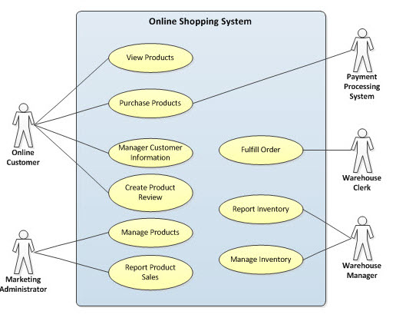

Problem Statement:-
There is no privilege maintenance system to maintain the customer logs. It will not fetch the product which is related to the customer’s previous search. Admin can’t get the detailed search and purchasing items list of the customer.
.
Scope:-
The scope of the project is to maintain the privileged customer’s details such as their interest and also their purchase history. After logged in if he is a privileged customer, get him to another search space which having his recommended items and offers.

Implementation:

Implementation is the stage of the project when the theoretical design is turned out into a working system. Thus it can be considered to be the most critical stage in achieving a successful new system and in giving the user, confidence that the new system will work and be effective.
The implementation stage involves careful planning, investigation of the existing system and it’s constraints on implementation, designing of methods to achieve changeover and evaluation of changeover methods.
Main Modules:-
- User Module:
In this module, Users are having authentication and security to access the detail which is presented in the ontology system. Before accessing or searching the details user should have the account in that otherwise they should register first.
- Admin Module:
In this module, Users are having authentication and security to access the detail which is presented in the ontology system. After logged in, admin can view the customer upload the product, offer the products and also he can view the customer’s interest and purchasing details.

- Searching Module :
The customer home contains various search tags. Depending upon the customer’s wish he can use any of that tags to search his expected items. Either he can use category vice search or he can use brand vice search or he can use price vice search to get his expected item.
- Related Content Fetching Module:
If he is a privileged customer it get him to another home after he logged in. The home contains recommended items and also the offered items for that particular customer related to his interest and his previous search.

System Configuration:

H/W System Configuration:

Processor - Pentium –III

Speed - 1.1 Ghz
RAM - 256 MB(min)
Hard Disk - 20 GB
Floppy Drive - 1.44 MB
Key Board - Standard Windows Keyboard
Mouse - Two or Three Button Mouse
Monitor - SVGA

S/W System Configuration:

Operating System : Windows95/98/2000/XP
Front End : Core Java
Database : Mysql 5.0
Database Connectivity : JDBC.

