Design and Development of Solar Grass Cutter

Shaikh Ejaz Shaikh Aman¹, Syd Shoeb Ali Habib Ali², Ajaj Esak Shaikh³, Mansuri Taufik Taslim⁴, Mohd Fahad Mohd Ashfaque Shaikh⁵, Yogesh P.Vanjari⁶
¹ UG student, GF’s Godavari College of Engineering, Jalgaon, India, 425001, shaikhaj1788@gmail.com
² UG student, GF’s Godavari College of Engineering, Jalgaon, India, 425001, shoebali4443@gmail.com
³ UG student, GF’s Godavari College of Engineering, Jalgaon, India, 425001, shaikhajaj59421@gmail.com
⁴ UG student, GF’s Godavari College of Engineering, Jalgaon, India, 425001, Mansuribablu17@gmail.com
⁵ UG student, GF’s Godavari College of Engineering, Jalgaon, India, 425001, skfahad47@gmail.com
⁶Asstt. Professor, GF’s Godavari College of Engineering, Jalgaon, India, 425001, ypvanjari@godavaricoejal.ac.in

Received on: xxxx,20xx, Revised on: xxxx,20xx, Published on: xxxx,20xx

Abstract –
Due to the continuous increase in the cost of fuel and the effect of emission of gases from the burn fuel into the atmosphere, this necessitated use of the abundant solar energy from the sun as sun of power to drive a lawn mower .a solar powered lawn mower was designed it rechargeable battery, Solar panel, Stainless steel blade and control switch. Moving is achieved by the D.C Motor which provides the required torque needed to drive the stainless steel blade which is directly coupled to the shaft of the D.C Motor. The solar powered lawn mower is operated by the switch on the board which closed the circuit and allows the flow of current to the motor which in turn drive the blade used for moving. The battery recharges through the solar charging controller. Performance Evaluation of the developed machine was carried out with different type of grasses. The main objective in pollution control is attained through this unskilled operation easily and maintain the lawn very fine and uniform surface look.

Keywords: Smart Grass Cutter, Solar Grass Cutter, Smart Solar System.

I. INTRODUCTION
Grass cutter or lawn mowing with a standard motor powered lawn mower is an inconvenience, and no one take pleasure in it. Cutting grass cannot be easily accomplished by elderly, younger, or disable people. Motor powered push lawn mower and riding lawn mowers create noise pollution due to the loud engine, and local air pollution due to the combustion in the engine. Also, a motor powered engine requires periodic maintenance such as changing the engine oil.

II. LITERATURE REVIEW

For the manufacturing of a solar grass cutter we referred various literature, papers etc. The review of previous method used given below: In this lawn mower uses an solar based energy source, which is easier to use, more advantageous comparing to other energy source especially for gas based source of power .But our lawn cutter is based on solar because this energy is a renewable energy source and it is easy to work. So we made solar powered lawnmower. In today's climate of growing energy needs and increasing environmental concern, alternatives to the use of non-renewable and polluting fossil fuels have to be investigated. One such alternative is solar energy. In this solar based lawn mower, the advantage of powering a lawn mower by solar rather than by gasoline is mainly ecological. We manufactured this lawn cutter because it is very easy method and many overcome produced from this type lawn cutter.
The self-powered objective is to come up with a mower that is portable, durable, easy to operate and maintain. It also aims to design a self-powered mower of electrical source; a cordless electric lawn mower. The heart of the machine is battery powered dc electric motor. It is also useful method for our lawn mower. It is similar to our lawn cutter using display and keypad. The present technology commonly used for trimming the grass is by using the manually handle device. In this project we have automated the machine for trimming the grass. The device consists of linear blade which is operated with the help of the motor the power supply for the motor is by using battery. The battery can be charge by using power supply or by solar panel.

III. METHODOLOGY
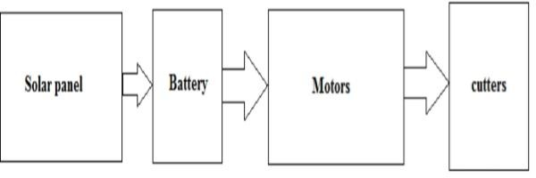
Fig. 1- Block Diagram of System

In this proposed system we have used four DC motor and driver circuits. In this project the system is been totally operated by solar energy. The main aim of solar based grass cutter is to cut the grass in which farmer take too much hard working so we can reduce all that. In above block diagram there is one ultrasonic sensor which we have used for obstacle sensing when obstacle is detected the robot is stop and vice versa.
In this proposed system we have used DC motor and driver circuits. In this project the system is been totally operated by solar energy. The main aim of solar based grass cutter is to cut the grass in which farmer take too much hard working so we can reduce all that. In above block diagram there is one ultrasonic sensor which we have used for obstacle sensing when obstacle is detected the robot is stop and vice versa
Solar Panel: - Solar energy is an important, clean, cheap and abundantly available renewable energy. The sun radiates heat and light. The heat, light received from the sun supports the environment on the earth through the following well known natural effects.

Fig. 2 - Solar Panel
- Temperature balance on the earth
- Photo-synthesis by biological plants production of oxygen and organic materials, production of organic chemicals and biomass.
- Wind due to unequal heating of water, land surfaces.
- Heating of ocean water: ocean thermal energy (OTEC)
- Waves in ocean: ocean wave energy
- Tides in ocean: ocean tidal energy (due to gravitational forces)
Battery: - The device consists of linear blade which is operated with the help of the motor the power supply for the motor is by using battery. The battery can be charge by using power supply and solar panel.
Fig. 3 - Battery
A single solar module can produce only a limited amount of power; most installations contain multiple modules. A photovoltaic system typically includes a panel or an array of solar modules, a solar inverter, and sometimes a battery and/or solar tracker and interconnection wiring.

Dc Motor: - Almost every mechanical movement that we see around us is accomplished by an electric motor. Electric machines are means of converting energy. Motors take electrical energy and produce mechanical energy. Electric motor is used to power hundreds of devices we use in everyday life. An example of small motor applications includes motors used in automobiles, robot, hand power tools and food blenders. Micro- machines are electric machines with parts the size of red blood cells and find many applications in medicine.
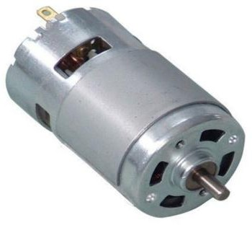
Fig. 4 – DC Motor

System Costing: - Cost is mentioned in below table 1.

Table 1 – Cost of Component

Component Name | Quantity | Cost
1*1SquarePipe(20fitlong) | 1 | 1100
Wheels | 4 | 400
Solar panel 10w | 1 | 1500
Battery 12v/7.5Ah | 1 | 1000
DC motor 15w | 1 | 450
Motter Attachment | 1 | 100
On-off switch | 1 | 30
Wire | 3m | 60
Labor cost | - | 1500

The working principle of solar grass cutter is it has a panel arrangement at an in such a way that can receive solar radiation with high intensity easily from the sun. The solar panel converts solar energy into electrical energy. This electrical energy is stored in batteries by using a solar charger. The system uses 12V batteries to power the vehicle movement motors as well as the grass cutter motor. We also use a solar panel to charge the battery so that there is no need of charging it externally.
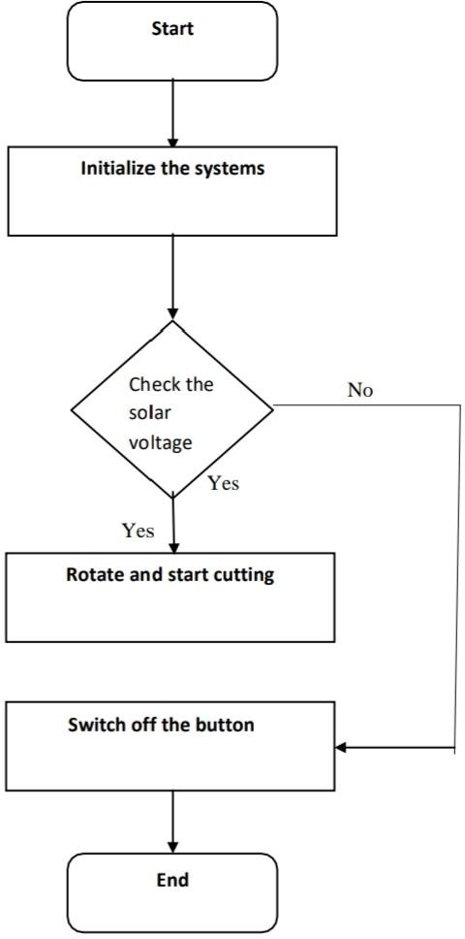
Fig. 5 - Flowchart

The grass cutter and vehicle motors are interfaced to an microcontroller that controls the working of all the motors. The microcontroller moves the vehicle motors in forward direction in case no obstacle is detected. On obstacle detection, IR sensor monitors it and the microcontroller thus stops the grass cuter motor so as to avoid any damage to the object/human/animal. Microcontroller then turns the vehicle until it gets clear of the object and then moves the grass cutter in forward direction again.

IV. DESIGN

Calculations and Result:-
We have,
Solar Panel=10W / 12V Battery=7.5Ah / 12V
DC Motor=12V / 15W.RPM=3000-3500
Current Consumption by Motor, (I) =0.60A. (no load current) =2A. (With load)

P = 2πNT 60 watts
P = Power
N = Speed of motor
T =Torque
Then P=V*I
V = voltage
I = current
Torque and Power of Motor with No Load Conditions:
P=V*I
=12*0.6
=7.2W
N= 3500 RPM
Then
P = 2πNT/60
7.2=2 * π * 3590 * T/ 60
T=0.019N-m
Torque and Power of A Motor With Load Conditions:
P=V*I
=12*2
=24W
N=3000 RPM
Then
P = 2πNT/60
24=2 * π * 3000 * T/ 60
T=0.076 N-m

Battery Backup Time Calculations:

Backup time = Battery Ah*12V*N*Efficiency of battery/load in Watts
Where, Battery Ah = Amp.hr Capacity of battery N = no. of 12V battery needed Efficiency of battery = generally it is taken as 0.8.
So, Backup time = 7.5*12*1*0.8/15
= 4.8hr = 4hr48min But, we use only 50% charging
Backup time = 4.8*50% = 4.8*50
=2.4hr = 2hr24min
Battery Charging Time Calculations,
T=Ah/A
Where, T= Charging Time in hr
Ah= Amp.hr rating of battery A=Charging current in amp
10W solar Panel will Charge theI7.5Ah battery at a charge rate of 0.6A.
T=7.5/0.6
=12.5 hr
But battery is only 50% discharge. So we need to charge only 50% battery.
T=12.5*50%
=12.5*50/100
=6.25 hr
=6 hr15 min

V. RESULT & DISCUSSION

Based on the calculated design value, the whole prototype body is numerically analyzed by using Solid Works software to analyze the stress-strain of the selected material for this part which is MS Plate. To perform the simulation, a fixed geometry is set at the bottom (green arrow). Then an estimated 10N external force is applied on the top of the roof of the grass cutter. The value is based on the mass of the solar panel and weight of the roof material. Since the prototype is able to withstand all the forces in the stress-strain analysis, it can be concluded that the prototype is mechanically reliable. However there are few red colors on the wall of the body due to the weight of the solar panel. It is important to conduct a further stress-strain analysis to smoothen the process of the prototype fabrications without having any possible failure. Due the high intensity of the sunlight, the grass cutter may consume the solar power directly instead of the battery which led to extend the operating time. Other than that, the charging time is affected by the intensity of the sunlight. High sun light intensity might lead to less charging time. However, the battery itself also can be considered as one of the factors. For example, the drained battery which is 10% capacity might take longer charging time compared to 30% capacity battery. Based upon the theoretical value, the total time for 12V 7.5Ah battery to be fully charge is 12.5 hours. In conclusion, the proposed prototype is taking shorter time to be full recharged according to the three sets of experiments.

VI. CONCLUSION

A workable smart solar grass cutter prototype is focusing on the renewable energy as the primary sources of energy have been successfully fabricated with high working efficiency. Therefore, it can be concluded that the developed design of the proposed Smart Solar Grass Cutter has achieved the main objectives and it can be further developed by industry. Smart Solar Grass Cutter is able to reduce the air pollution and also it is a user- friendly device. The grass cutter is suitable to be used for small application due to the shortest operating time, but it is not suitable for tall height grasses. For future work, there are few recommendations can be made to develop a better device. Instead of using polycrystalline solar panel, it is better to used mono-crystalline solar panel due to the high efficiency. The motor for the blade should have both high speed and torque. Higher capacity of rechargeable battery can lead to more operating time. Lastly, few type of blade to be considered to cut different types of grasses.

ACKNOWLEDGMENT

We take this opportunity to thank our project guide Y.P. Vanjari sir and head of the department Prof. T. A. Koli sir for their valuable guidance. We are also thankful to all staff members and friends for their valuable time, support, comments, suggestion and persuasion.

REFERENCES

- P.Amrutesh, B.Sagar, B.Venu “Solar Grass Cutter with Linear Blades by Using Scotch Yoke Mechanism” Int. Journal of Engineering Research and Applications, ISSN: 2248-9622, Vol. 4, Issue 9(Version 3), September 2014, pp.10-21.
- Mallikarjun Mudda, VishwaTeja, Srujan Kumar, Praveen Kumar, “Automatic Solar Grass Cutter”, International Journal for Research in Applied Science & Engineering Technology (IJRASET), ISSN: 2321-9653; Volume 6 Issue IV, April 2018, pp.1148-1151.
- Firas B. Ismail, Nizar F.O. Al-Muhsen, Fazreen A. Fuzi, A. Zukipli,” Design and Development of Smart Solar Grass Cutter” International Journal of Engineering and Advanced Technology (IJEAT), ISSN: 2249 – 8958, Volume-9, Issue-2, December 2019, pp. 4137-4141.
- Mr. Shubham S. Dalal, Mr. Vaibhav S. Sonune, Mr. Dipak B. Gawande, Mr.SharadB.Shere, Mr.Shrikant A. Wagh,” Manufacturing of Solar Grass Cutter”, IJRAT, (E-ISSN: 2321-9637), “CONVERGENCE 2016”, 06th-07th April 2016.

