STRES ANALYSIS OF SEAT BACKREST
Prof. Mohan D. Karambe, Prof. S.V. Gulhane, Prof. K.D. Raut
Abstract
This project deals with the analysis of seat backrest of car. Computer aided design and finite element analysis are essential in order to predict accurately for the safety performance of automotive seat in an event of crash. In this work, finite element analysis is used to evaluate the strength, deflection and maximum stress characteristics of a reference automotive seat in an event of vehicle rear impact. The safety function is measured based on a backrest moment test in accordance with (ECE R-17) regulations and FMVSS 2O7 regulations which is particularly for rear impact.
In first stage, the bending moment test of the reference seat backrest frame is done by using a complete model formed on CATIA V5R17 by integrating the major structural components including the connector, vertical side flange, top cross member and supporting plates and the maximum pressure to be apply on top cross member of the seat back frame of seat as per regulation of bending moment test. In order to confirm the strength requirements, bending moment deflection characteristics of the seat are studied in accordance with ECE R17.
In second stage, as per the regulation of FMVSS 207 for rear impact condition, the maximum pressure to be apply on the all part of the seat back frame including seat backrest and to evaluate the various stresses and deflection on various part of the seat backrest of seat. Further finite element analysis of seat backrest, on the basis of result obtained in stage second, the free- optimization is done to reduce the stresses and deformation on backrest.

INTRODUCTION
Car seat research is related to comfort, quality and mainly to human safety as the passengers are in the permanent contact with seat. Material characteristics of applied material are important for level of comfort and safety. Pressure distribution in contact between human body and seat determine the seating quality. The design of seat backrest, however, is primarily based on safety requirements which give support to spinal cord of the body. In the present work, stress analysis is done to increase the functional requirements of safety, comfort and other factors for automotive seats to increase the complexity of designing optimized seats. Increased safety requirements to prevent injury during crash events from government regulations have increased the number and severity of strength tests which automotive seats must pass before production. As part of this work, a reference seat backrest frame is considered for optimization under the load requirements of FMVSS 207 regulation.

BUILDING THE MODEL
The functions of the vertical members are to support the backrest in bending. Vertical members are tapered and run from bottom to top of the 700 mm long backrest on either side. They are made from stamped low carbon steel sheet metal formed in the shape of a C-Section. The tapered vertical members have 120 mm depth at the bottom and 50 mm depth at the top having 2 mm thickness. The two vertical members are separated by a distance of 450 mm and connected by two cross members at the top and bottom of the back rest frame forming a rectangular open boxed structure along with the connector are 4 mm thick has to be attached at the vertical member on bottom side by providing a proper stamp on vertical member. The top cross member has a 1 mm thick rectangular cross section joint to the vertical members at the top. The bottom cross member is a 1 mm thick near C-section jointed to the vertical members at the bottom. Finally after determined the strength and factor of safety of seat back frame, the central rectangular open box structure has been covered by rectangular plate which gives the complete support to spinal cord having thickness 1 mm with proper size and shape.

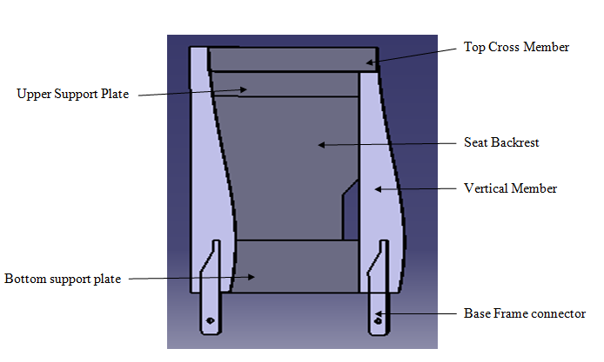
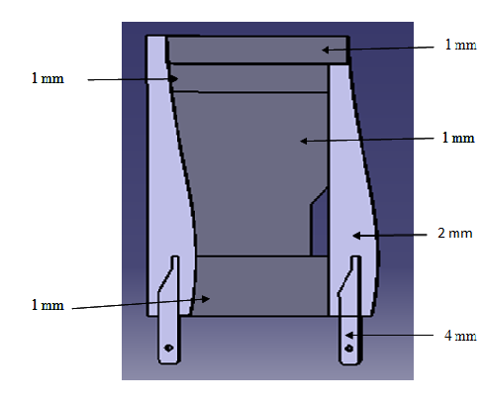
Fig.1 Nomenclature of Seat Backrest Frame Fig. 2 Shell Thickness of Seat BackresFrame

Materials for Parts of Seat Backrest Frame
For the analysis in ANSYS, an elastic material model with work hardening is used for the components of the seat backrest frame. Low strength steel is used for the vertical members, horizontal cross members and backrest of the seat backrest frame. High strength steel is used for the connector component that connects the backrest frame with the base frame of the automotive seat. Since the connectors must withstand large bending moments and bearing contact at its surfaces, high strength steel with its extended plastic region and increased yield and ultimate stress limits, provides the necessary strength for this critical component.

Table: Properties of Materials
Material | Density ρ (g/cc) | Young’s modulus  E(Gpa) | Poisson’s Ratio υ | Yield Strength (MPa) | Ultimate Strength (MPa)
Low-Strength Steel | 7.85 | 210 | 0.29 | 305 | 485
High Strength Steel | 7.85 | 210 | 0.29 | 365 | 784.4

FEM ANALYSIS OF SEAT BACK REST OF CAR

A) FEM ANALYSIS OF SEAT BACK FRAME UNDER BACKREST MOMENT TEST (STAGE-I)

Finite Element Meshing along with Loading and Boundary Conditions
Fine Meshing for the seat back frame is performed in ANSYS having an element size 1 mm is used. As per the ECE R-17 backrest moment test ^{[8]}, a moment of 530 N-m is to be applied longitudinally and rearwards to the upper part of the seatback frame about the H-point or fix point with the absence of backrest support plate, the required moment is applied as a distributed pressure along the front surface of the top cross member. For the reference seat back frame, the boundary conditions are defined on bottom surface of the connectors, as they are the components in contact with the base frame, through the backrest adjustment mechanisms. A fixed boundary condition is defined on the leading half of the bottom edge of the connector, the region of the connector that meshes with the gear of the backrest adjustment mechanism.

1) Maximum Bending Stress for ECE R-17 Backrest Moment Test on Connector of Seat Back Frame
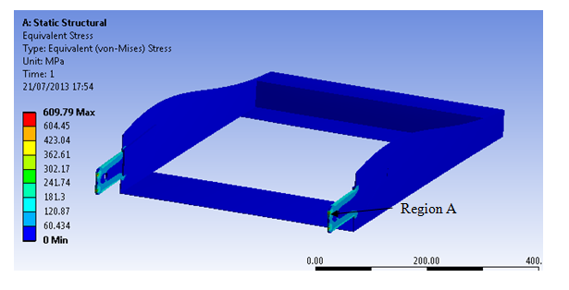

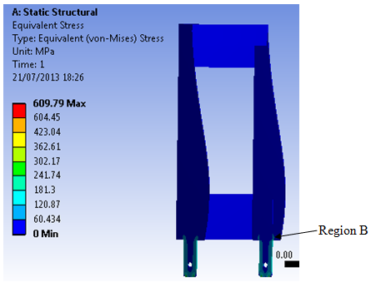
2) Maximum Bending Stress for ECE R-17 Backrest Moment Test on Contact between the Vertical Member and Connector of Seat Back Frame

3) Maximum Deformation on the Top Cross Member of the Seat Back Frame
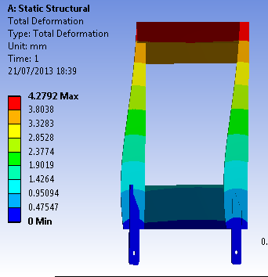

2) FINITE ELEMENT ANALYSIS OF SEAT BACKREST OF CAR (STAGE-II)
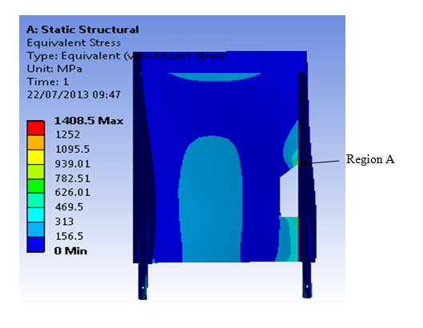
A) Maximum Bending Stresses on Backrest

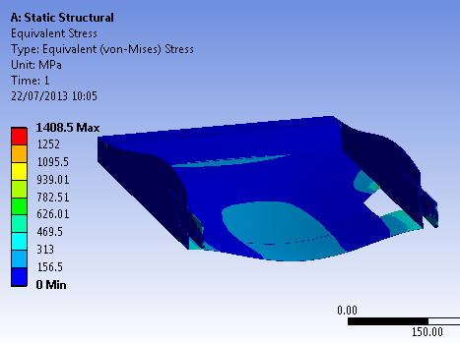
B) Maximum Bending Stresses on Connector

C) Maximum Deformation on Backrest
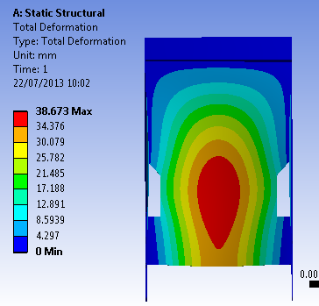

3) FINITE ELEMENT ANALYSIS OF OPTIMIZED SEAT BACKREST OF CAR (STAGE- III)
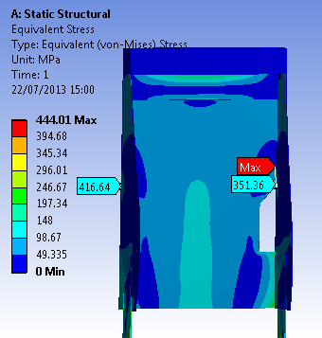
A) Maximum Bending Stress on Backrest

B) Maximum Bending Stress on Connector
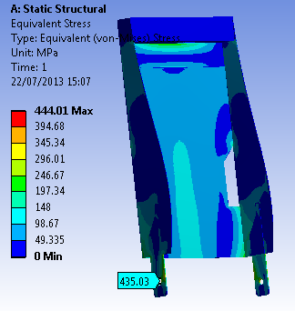

C) Maximum Deformation on Backrest
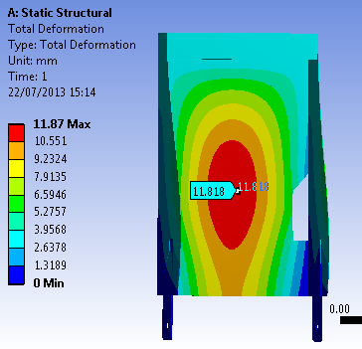

4) FINITE ELEMENT ANALYSIS OF SEAT BACKREST WITH SLIDER (STAGE-IV)
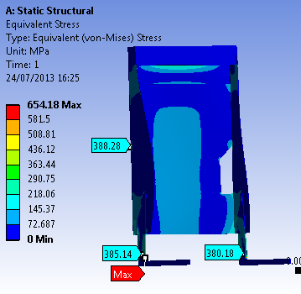
A) Maximum Bending Stress on Backrest and connector

B) Maximum Deformation on Backrest
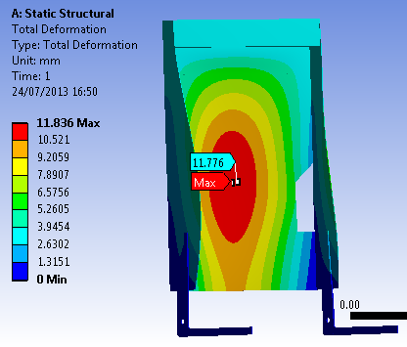

CONCLUSIONS
In stage I, after doing stress analysis, the maximum bending stress produced on the connector is less than ultimate stress and maximum deflection is also less after applying the pressure as per ECER-17 backrest moment test. From this concluded that the reference seat back frame is safe in rear impact condition.
In this stage all the stresses which is develop on backrest and connector are higher than the ultimate stress. In this stage, the seat back frame failed at a backrest moment of 949.068 N-m. At the point of failure, the maximum bending stress on connector is 790.91 Mpa (higher than the ultimate stress $σ_{ultimate }=784.4 Mpa$ for high strength steel whereas the maximum bending stress on the backrest is 1328 Mpa more than the ultimate stress $σ_{ultimate }=485 Mpa$ for low strength steel. The maximum deformation on seat backrest is 38.673 mm which is very high. From this finite element analysis finally concluded that the reference seat backrests failed under the rear impact condition.
In stage III, free-size optimization is done by changing the thickness of backrest parts. After finite element analysis, the maximum stress produced on seat backrest is 416.64 Mpa which is lower than the ultimate strength of backrest and the maximum stress developed on connector is 435.03 Mpa which is also lower than the ultimate strength of the connector. Along with this stress the maximum deformation produced on backrest of seat is 11.818 mm which is permissible as per the FMVSS 207 regulation which is used for rear impact condition.

FUTURE SCOPE
This gives rise for better analysis of reference backrest under various load cases like side impact, offset impact and buckling impact etc.
In future free size optimization of seat frame can be done to reduce the weight which may increase the efficiency of car.
In present thesis, the finite element analysis is performing only on the seat backrest part. This work can be extended by integrating the backrest frame and base frame also in FEA.

REFERENCES
1) Hodges, J. and Grujicic, M., 2005. “A Finite Element Analysis of the Functional Performance of the Mercedes SLK Automotive Seat Backrest Frame”.
J. Latchford, E. C.Chirwa, T. Chen, and M. Mao, “The relationship of seat backrest angle and neck injury in low-velocity rear impacts”.
3) Chelikani, A., 2007, “Simulation of a Backrest Moment Test for an Automotive Front Seat using Non-Linear Contact Finite Element Analysis”.
4) Molino, L., "Determination of Moment-Deflection Characteristics of Automobile Seat Backs". 1998, NHTSA Technical Report, DOT Docket Management Systems.5) FMVSS NO. 207 seat backrest frame for Passenger Vehicles, Office of Regulatory Analysis and Evaluation Plans and Policy, December 2000

