Quantitative Risk Assessment Using Aloha Tool in Sulphuric Acid Manufacturing Plant: a Systematic Review

Arpita Paliwal ¹, Praveen Badodia ²

¹ Students ²Assistant Professor, IPS Academy Institute of Engineering & Science,
Department of Fire Technology & Safety Engineering, Indore MP India
arpitapaliwal07@gmail.com

Received on: 07 May ,2022 Revised on: 3June ,2022, Published on: 5 June,2022

Abstract- Industrial injuries bring about great personal and economic loss. Managing this unintentional danger and in today surroundings is the priority of each industry. Technological and social improvement has brought about an growth with inside the length and complexity of chemical plant on the equal time the existence of such plant contain certain dangers that want to be managed and minimized. In this, we're focusing at the prevention of Fires, explosions and unintentional chemical releases at sulphuric acid plant by, The Consequence Assessment. The result evaluation is one of the essential techniques with inside the method protection engineering fields to decide and quantify the danger sector derived at the respective chemical plant and this approach will manual the designer concerning the maximum appropriate safety measure to keep away from the catastrophe of a chemical plant. Beginning of those injuries wherein leaks or spills is the maximum not unusual place source of primary incidents main to fire and explosion. The method concerned on this project is identifying, studying and comparing the risk at sulphuric acid plant. All feasible unsafe chemical for each system has been recognized and the result evaluation approach specializing in danger sector distance became advanced via the six steps of method to estimate the worst-case scenario..

Keywords: Modeling simulation, ALOHA, sulphuric acid, Threat zone
I –INTRODUCTION
India It's estimated that further than 10 million chemicals are used commercially. Artificial chemicals comprise nearly 2/3 of these chemicals. Technological and social development has led to an increase in the size and complexity of chemical factory at the same time the actuality of similar shops and the transport of their products in what certain threat that need to be controlled and minimized. In recent decades interest in the safety of chemical artificial factory has greatly increased. Chemical process safety focuses on the prevention of fires, explosions, and accidental chemical releases during large scale manufacturing of chemicals. The Indian chemical industry produces different chemical products one of them is SULPHURIC ACID. Sulphuric acid is one of the most produced chemical in the world it's a strong inorganic acid that's substantially used in the product of phosphate toxic sulphuric acid is listed as the poisonous substance. Toxic assiduity is one of the most dangerous diligence and their veritably critical section which passes hazard it's fire, poisonous gas release, over pressurization which leads to explosion.

1.1 Background and Motivation
Industrial accidents result in great personal and financial loss. Managing these accidental risks in today’s environment is the concern of every industry including chemical fertilizers, because either real or perceived incidents can quickly jeopardize the financial viability of a business. Many facilities involve various manufacturing processes that have the potential for accidents which may be catastrophic to the plant, work force, environment, or public.
Past Incidents
Collapse of a storage tank (Sweden, February 2005)
On 4 February 2005, a tank of sulphuric acid collapsed in a chemical plant with inside the harbour region of Helsingborg, with inside the south of Sweden. An anticipated 11,000 tonnes of acid escaped from the garage tank. Part of the acid unfold out into the sea, inflicting an exothermic response with the water and forming a cloud over the plant. An exclusion region turned into installation and a shelter-in-location turned into ordered, affecting the 110,000 neighbourhood habitants. In all, thirteen human beings have been stricken by moderate respiratory problems and eye irritation. The wind, blowing with inside the course of the sea, promoted the dispersion of the cloud. It later have become obvious that the coincidence turned into resulting from a burst pipe flooding the floor on which the acid garage tank turned into standing, weakening the floor and hence inflicting the tank to collapse. Sulphuric acid spill in Texas, (USA, August 2005) On 15 August 2005, a barge containing 1,572 m3 of sulphuric acid grounded in a marshy bay in Texas. Measurements of the pH taken across the grounded vessel indicated the presence of sulphuric acid with inside the water: round 1,three hundred m3 of acid have been spilt into the estuary. On 19 August, the acid and water aggregate last with inside the barge become pumped out of the tanks. The ecological effect of this incident stays to be established, bearing in thoughts that the bay constitutes an critical herbal reserve. Fortunately, there have been no casualties.
Environmental – Release ( February 18, 2015)
Days after leakage of sulphur dioxide brought about suffocation to employees and those living with inside the area, Tamil Nadu Chemical Products Ltd, a manufacturing unit production dyeing substance, in Kovilur changed into nowadays ordered to be closed down via way of means of the country pollutants manage board. Three college kids had fainted upon breathing in sulphur dioxide from the manufacturing unit on February 12. The leak additionally brought about suffocation to manufacturing unit employees and those residing around. On inspection of the 35-year-vintage manufacturing unit, officers of the Tamil Nadu Pollution Control Board observed that main units had not been maintained properly leading to the gas leakage.

II -METHEDOLOGY

To quantify and analyses the consequence assessment associated with the production plant of sulphuric acid, the Hazard Identification, must be done first. Objectives of this research are to identify the potential hazard that will arise from every processing chemical install in each piece of equipment of sulphuric acid production plant and to assess and quantify the consequence derives from the sulphuric acid production plant using threat zone analysis that involves the evaluation of the distance in the red zone of the area affected.

2.1 Steps of Risk Assessment
The step of risk assessment consists of collecting data, hazard identification, list of scenarios, simulation using ALOHA and Google Earth, result and consequence effect.

Collecting data for sulphuric acid production plant
Hazard Identification
Scenario
Equipment leakage
Unburned chemical exposed to atmosphere
Simulation
Aloha Google Earth
Selection of disperse model
ALOHA Gaussians
Results
Area affected Downwind concentration
Duration
Consequence effect
Explosion overpressure Toxic dispersion

2.2 Data Collection
The research is carried out below the site situation of the manufacturing sulphuric acid plant. The plant location is surrounded via way of means of an industrial plant. The gathered information regarding the site situation of sulphuric acids manufacturing plant which include surrounding location humidity and topography, sulphuric acid manufacturing plant layout, places of all of the equipment concerned for the sulphuric acid manufacturing, processing situations and parameters, all of the chemical substances used with inside the sulphuric acid processing, and effects modeling, resulting to fire, explosion overpressure and poisonous exposures.
Physical Properties
Sulphuric Acid | _{H2SO4}
Molar mass | 98.08 g/mol
Boiling point at 1 atm | 335°C (98%) (ARKEMA MSDS, 2003)  290°C (92%)
Freezing point | 15°C (94 to 96%)  -10°C / +5°C (97%)  +5°C (98%)
Relative density (water = 1) | 1.84 at 20°C (93 to 100%)
Vapour density (air = 1) | 3.4
Solubility of fresh water | Soluble in water at 20°C (with heat production)
Vapour pressure | <.001 hPa at 20°c
Ph of the solution | very acidic < 1 (94 to 98%)

Explosive limits
Non-flammable product
Flash point
Non-flammable product
Self-ignition point
Non-flammable product
Dangerous products of decomposition
Formation of flammable hydrogen by corrosion of metals
Breakdown by fire into sulphur oxides (sulphur trioxides and dioxides), which are toxic gases.
Behaviour when in contact with other products
Sulphuric acid is non-flammable, however it causes:- violent reactions with a risk of explosion with many organic matters, powdered metals (zinc, iron, certain cast irons, copper), carbides, chlorates, chromates, permanganates, nitrates, fulminates and fluosilicon.
- a violent and dangerous reaction if water is added to concentrated sulphuric
acid causing spray
- a violent reaction with strong anhydrous bases or concentrated alkaline solution.

2.3 Hazard Identification
Identification of major hazards specifically associated with the design in operation unit
In order to identify the hazards present systematically in the design the process flow can be divided into sections and analysed individually. Each sections would contain multiple units in the process the analysis focuses on the equipment involved, conditions and the composition of the process material involved and their means of transfer and divided such that it includes one of the
Following major units in the process.
- Burning of molten Sulphur to produce Sulphur Dioxide
- Catalytic conversion of Sulphur Dioxide into Sulphur Trioxide, absorption
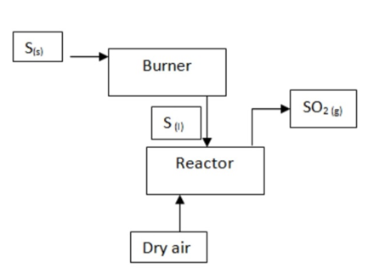
Fig. 1- Burning of Sulphur
When identifying safety hazards and process issues that could lead to operability faults in this section, the following has been taken into account:
Table 1: Key process information in the burning of sulphur.
Key equipment | Sulphur melter, molten Sulphur storage tanks, Sulfur transfer pumps, Sulfur burner
Key operations | Melting of Sulfur at ~120°C  - Storing Sulphur at above molten condition  - Pumping of molten Sulphur maintained at above condition to burner  - Atomization and subsequent burning of molten Sulphur at temperatures up to 1120°C
Type and nature of process material/s | Molten Sulfur , Filtered and dried air
Significant conditions in Process | High operational temperatures (Melter, tanks and pumps at ~120-150°C; Burner at temperatures beyond 1000°C)

Taking the above features into account, along with the inherent hazards associated with the process materials involved the following hazards could be identified.
Table 2-Hazards identified in the Sulfur burning section
Location of  possible hazard | Description of risk and feasible consequences.
Sulfur melter | Fire risk: As in our case, Sulfur is particularly acquired from desulfurization methods in petroleum refining and for this reason unconverted quantities of Hydrogen Sulphide can also additionally nevertheless be entrapped with inside the raw material. The melting system also can produce vapours of Hydrogen Sulphide and Carbon Disulphide, that may shape ignitable air/vapour mixtures upon contact with warm surfaces. H2S is classed as a flammable gas and may exceed its decrease flammability limit at low concentrations with inside the tank headspace in the air.
General areas of  storage tanks,  melter and burner | General dangers to employees because of Hydrogen Sulphide, Sulfur dust: Contact with pores and skin or eye, or inhalation could reason difficulties. Can end result from a leak in transfer lines to or from storage tanks to melter. Burn dangers to employees from molten Sulfur.
Molten Sulfur  storage tanks | - Flammable surroundings in tank headspace: Hydrogen Sulphide liberated at some stage in Sulphur melting can be carried over at some point of moving of molten Sulphur from melter to tank through pump.  - Explosive surroundings in tank headspace: If venting of headspace is incorrect and the stagnant situations cause the improvement of an anaerobic surroundings which promotes the response of H2S with iron with inside the Carbon Steel tank shape and forming FeS. This layer is taken into consideration to be a corrosion barrier and could continue to be strong if the situations continue to be anaerobic. However, while the distance is opened for the duration of maintenance, FeS being pyrophoric (can go through spontaneous combustion in presence of O2) along side the presence of Sulphur which is likewise flammable can produce a unsafe surroundings that could cause injuries if now no longer taken account of before hand.
Burner unit | General manageable for a hazard: The excessive temperatures concerned in extra of 1000°C in this unit itself presents a hazardous environment specifically to personnel.  - Overpressure hazard: The unit help a gas gas reaction. Thus a change in pressure can easily appear by adjustment in gas flow rates of air or atomised vaporized sulphur where malfunctioning of flow control  (Eg: failing open) may want to lead to overpressure situations and subsequent pressure relief- relieving flammable vapours into the surroundings.

Similar to the previous unit, when identifying hazardous elements in the design the following aspects have been taken into account.
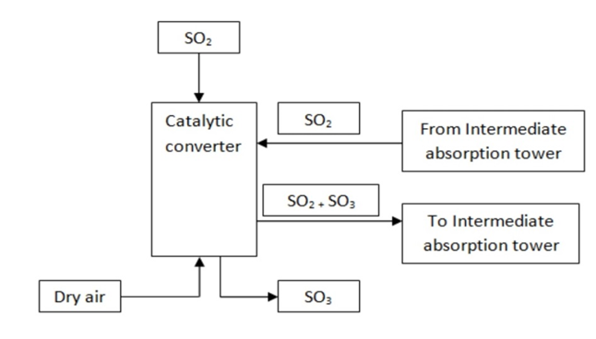
Fig. 2- Catalytic Conversion of SO₂ to SO₃

Table 3- Key process information of the catalytic conversion section
Key equipment | Gas cleansing unit-Electrostatic precipitator, Boiler, Precooler, Catalytic reactor, air blower, packed absorbers, coolers
Key operations | - Reduction of temperature of Sulfur Dioxide flow from >1000oCto under 500oC via way of means of improving system heat to generate steam  - Maintaining SO2 inlet flow to converter at 450°C via way of means of precooling.  - Maintaining inner of catalytic reactor at 450°C for excessive productivity  - Cooling of SO2+SO3 intermediate movement earlier than being sent to intermediate absorber.  - Reheating of above flow (now stripped of SO3) to 450°C previous to being reentered to converter.  - Significant situations in system High operational temperatures (Electrostatic precipitator, boiler, switch pumps, precooler in contact with ~1000°C streams; converter outlet streams at 450°C)
Type and nature of  process material/ | High temperature gaseous flow of Sulfur Dioxide, Gas aggregate movement of oxides of Sulfur, Filtered and dried.
Significant conditions in  Process | - High operational temperatures (Electrostatic precipitator, boiler, switch pumps, precooler in contact with ~1000°C streams; converter outlet streams at 450°C)

The principal styles of risks identifiable with inside the converter phase address excessive operational temperatures and substances present with inside the phase in question. Hence they will be determined as each chemical and physical risks. For example the excessive temperature streams concerned with inside the system gives an inherent burn risks to employees. The response being one in which all species are gases and that the excessive sensitivity of gas loading to pressures imply that the unit is tremendously greater at risk of overpressure and next strain comfort than different units. If strain relief have been to occur, a bulk of oxides of Sulfur could occur, which has dire outcomes to employees and the environment.
Table 4- Mitigation measures of burner and converter sections
Hazard identified | Means of mitigation
Fire hazard in Sulfur melter due to  presence of Hydrogen Sulphide vapours | Blanketing of vapour segment with Nitrogen: Eliminates the supply of ignition even though the H2S present may want to exceed the LEL. Alternatives consist of sparging of air or the use of steam eductors along side retaining proper venting to vent the contaminated air.
Overflow hazard in melter due to failure  of control valve controlling discharge  pump | Constructing proper bunding (dyking). Implement excessive degree alarm in melter.
Overflow hazard in molten Sulfur storage tanks due to malfunction of tank  discharge pump | Bunding, High degree alarm, incorporating a spare tank with a right valve association in order that the float will be diverted to this tank with inside the occasion of a likely overflow
Burner unit | Enforcement of PPEs and different engineering controls, common inspection of integrity of float control apparatus,
Converter | Enforcement of PPEs which include eye goggles.  - Careful tracking of precooler to manipulate temperature- redundancies have to bincorporated to make sure that temperature is constantly at 450°C.  - Periodic inspection of strain comfort devices which include strain relief valves, bursting discs of the converter have to be done, considering that each excessive temperature and the being gas-gas increase possibility of overpressure than different Situation.
2.4 Modeling and Simulation
Study is conducted using the ALOHA and Google Earth simulation software, a process flow diagram (PFD) for sulphuric acid production is shown in fig. 3. The ALOHA is simulated to determine the distance, radius, area affected and downwind concentration of the chosen location, diameter leakage of the equipment and four different wind direction. Source model determines the rate of chemical material released to the atmosphere and also finds form of chemical release & duration till chemical releases The severity effect from the area affected threat zone can be depicted through the simulation from the Google Earth software. The coordinate location is Latitude 4°31’25.0” N Longitude 103°25’28.0” E and has an elevation of about 3 meters. The parameter of the location has a wind speed of 6 miles/hour, air temperature of 28 °C, urban or forest roughness, stability class C, no inversion height and has a relative humidity of 83%.
2.5 Process Condition

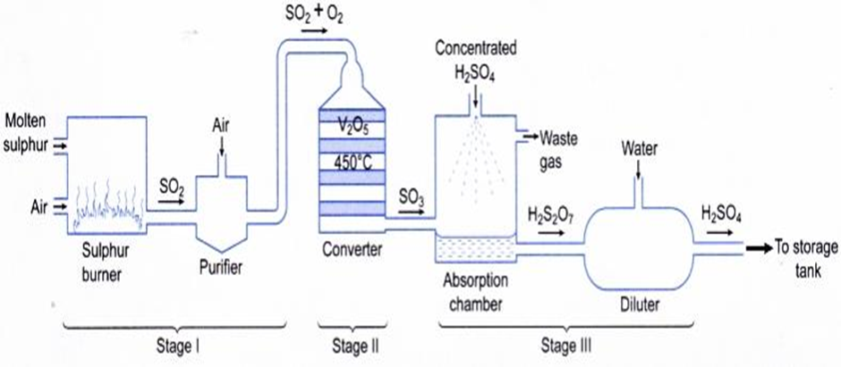

Fig. 3: Process Flow chart of manufacturing of Sulphuric Acid through contact process
By referring to the method format of the sulphuric acid manufacturing, the method flow diagram that suggests each processing flow of system and additionally the processing circulation beginning from the feed of raw material up till the manufacturing circulation of sulphuric acid. Based at the PFD and the material circulation table in addition to the composition circulation table, essential chemical established in every essential system that can be taken into consideration unsafe may be identified. Table 1 lists essential chemical compounds which are established and method situations for each essential system concerned with inside the manufacturing of Sulphuric Acid.
Driscription on Operation
Table 5- Chemical installed and process condition of each major equipment
Major Equipment | Major Chemical | Temperature (°C) | Pressure (kpa)
Sulphur Burner | S | 137 | 230
Multibed Reactor | SO₃ | 450 | 114
Absorber Tower | H₂SO₄ | 220 | 140
Electrostatic Precipitator | H2S | 420 | 210

III-RESULT AND DISCUSSION
3.1 Sulfur Burner
The major chemical installed in the sulphur burner equipment is sulphur. The operating pressure of this sulphur burner equipment is 230, kPa and the temperature within the sulphur burner equipment is 137 °C. Based on the ALOHA simulation, this chemical sulphur installed in the sulphur burner equipment shows no result of threat zone thus no threat zone was plotted on the Google Earth map to determine the severity of the area affected.
3.2 Multibed Reactor
The area affected by sulphur trioxide installed in the multi-bed reactor equipment at 150 mm diameter leakage simulated at four wind direction which is SSE, NNE, ESE, and N, respectively. The operating pressure of this multi-bed reactor equipment is 114, kPa and the temperature within the multi-bed reactor equipment is 422 °C.
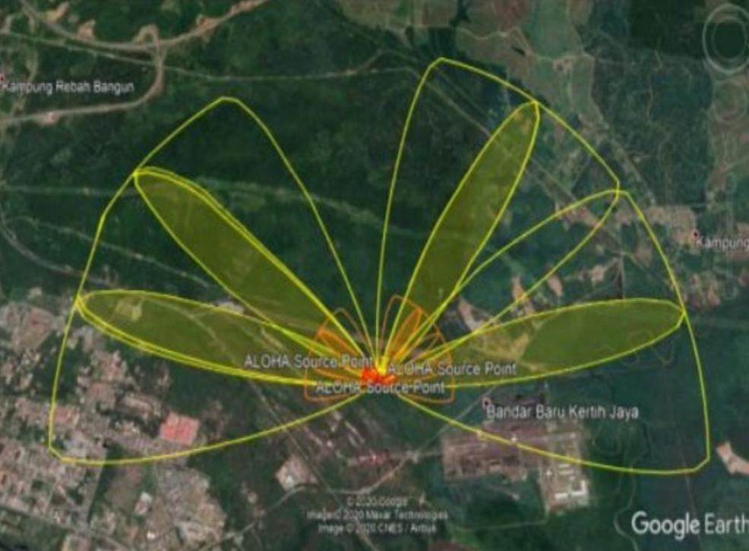
150 mm has the distance of area affected which the distance affected of the red zone area is 185 meters, orange zone area is 820 meters while yellow zone area is 3,600 meters. The distance of the area affected observed is increasing from 10 mm diameter leakage until 150 mm diameter leakage. The bigger the diameter leakage of the equipment, the higher the distance of area affected by the simulation. The maximum severity of the area affected is achieved when the diameter leakage reaches 150 mm.
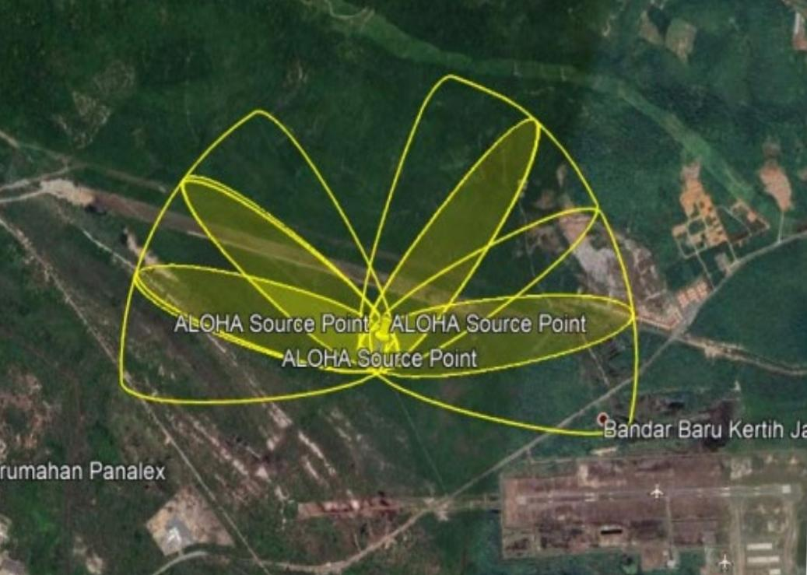
Fig. 4: Area affected from 150 mm diameter leakage (multibed reactor)

3.3 Absorber Tower
The area affected by sulphuric acid installed in the absorber tower equipment. the affected area of sulphuric acid at 150-mm diameter leakage simulated at four wind direction which is SSE, NNE, ESE, and N, respectively. The operating pressure of this absorber tower equipment is 140, kPa and the temperature within the absorber tower equipment is 207 °C.
The biggest diameter leakage which is 150 mm has the highest distance of area affected which the distance affected of red zone area is greater than 10,000 meters with 130 mg/m3, orange zone area is greater than 10,000 meters with 7.3 mg/m3 while yellow zone area is greater than 10,000 meters with 0.17 mg/m3. The distance of the observed area affected is increasing from 10 mm diameter leakage until 150 mm diameter leakage. The bigger the diameter leakage of the equipment, the higher the distance of area affected by the simulation. The maximum severity of the area affected is achieved when the diameter leakage reaches 150 mm.

Fig. 5- Area affected from 150 mm diameter leakage (absorber tower)
3.4 Electrostatic Precipitator
The toxic area affected by the leaking hydrogen sulphide installed in the electrostatic precipitator equipment that is not burned and escape to the atmosphere at 150-mm diameter leakage simulated at four wind direction which is SSE, NNE, ESE, and N, respectively. The operating pressure is 210, kPa and the temperature within the electrostatic precipitator equipment is 420 °C.
The diameter leakage (150 mm) has the highest distance of toxic area affected which the distance affected of red zone area is 224 meters , orange zone area is 305 meters , while yellow zone area is 1,500 meters. The distance of the toxic area affected observed is increasing from 10 mm diameter leakage until 150 mm diameter leakage. The bigger the diameter leakage of the equipment, the higher the distance of the toxic area affected by the simulation. The maximum severity of the toxic area affected is achieved when the leaking hydrogen sulphide reaches 150 mm diameter leakage.
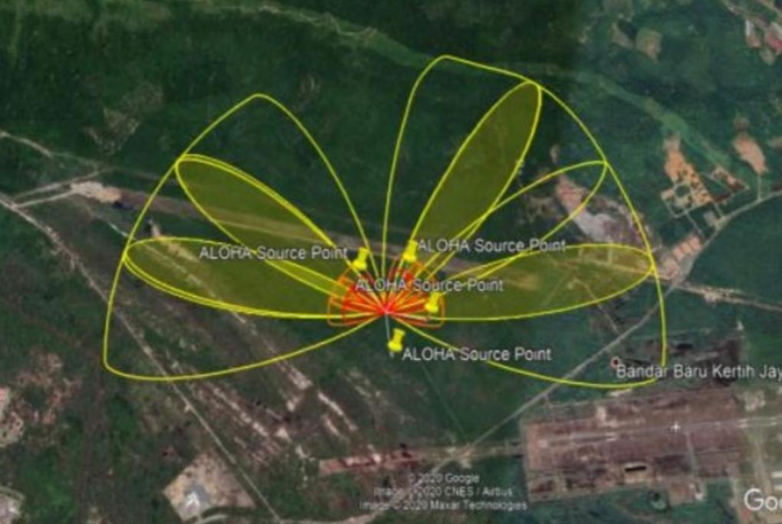
Fig. 6: Area affected from 150 mm diameter leakage (electrostatic precipitator)
Table 6: Distance of Area Affected of the worst case scenario for each equipment
Equipment | Chemical | Diameter  Leakage (mm) | Distance of Area Affected - Red  Threat Zone
Sulphur Burner | Sulphur, S | 150 | No threat zone
Multibed Reactor  (Toxic dispersion) | Sulphur Trioxide, SO₃ | 150 | 185 meters  (160 mg/(m3)
Absorber Tower  (Toxic dispersion) | Sulphuric Acid, H₂SO₄ | 150 | greater than 10 kilometers (130  mg/(m3)
Electrostatic Precipitator  (Jet fire explosion) | Hydrogen Sulphide, H2S | 150 | 10 meters  (10 kW/(m2) =

Based on the comparison of the worst-case scenario of each piece of equipment as stated in Table 2, it can be concluded that the equipment of absorber tower with the major chemical installed of sulphuric acid (H2SO4) would produce the most severe scenario at 150 mm diameter severity of the toxicity scenario may lead to fatality and injury to the workers and people nearby. The multi-bed reactor, which contains sulphur trioxide produce the second-worst case as the distance of the red threat zone reach 185 metres, followed by a drying tower (100 metres), electrostatic precipitator (10 metres) while no threat zone produces for the sulphur burner.
III -CONCLUSIONS
This study analyses the consequences of every major chemical installed, namely sulphuric acid, sulphur, sulphur trioxide and hydrogen sulphide in each of the major equipment including the sulphur burner, multi-bed reactor, absorber tower and electrostatic precipitator in the production of the sulphuric acid plant. From the findings, the toxic release of sulphuric acid from the absorber tower is considered as the most severe as it has the longest red threat zone towards the surrounding whereas another major equipment only causing the red threat zone limited within 185 meters. However, this study not highlight frequencies per year of the scenario for fire, explosion overpressure and toxic. Therefore, future works will focus on the determination of frequencies, which will contribute to the quantification of risk in term of individual risk.
ACKNOWLEDGMENT
This review was done for the M.Tech. research project of Industrial Safety Engineering. It is our great pleasure to express our profound gratitude to our esteemed guide Mr. Preveen Badodia Assit. Prof. and Dr. Pravin Patel Head FT & SE, IPS Academy, Institute of Engineering & Science Indore for their valuable inspiration, able guidance and untiring help, which enabled me to carry out and complete this work
REFERENCES
- Ahmad, M. A., Badli, W. N. A. N. W., & Rashid, Z. A. (2021). Consequence assessment using threat zone analysis on sulphuric acid production plant. Malaysian Journal of Chemical Engineering and Technology (MJCET), 4(1), 58-66.
- Bhattacharya, R., & Ganesh Kumar, V. (2015). Consequence analysis for simulation of hazardous chemicals release using ALOHA software. International Journal of ChemTech Research, 8(4), 2038-2046.
- Crawley, F., & Tyler, B. (2015). HAZOP: Guide to best practice. Elsevier.
- Ernest Cook (March 20, 1926) "Peregrine Phillips, the inventor of the contact process for sulphuric acid," Nature, 117 (2942) : 419–421.
- Kumareswaran, S. (2013). Design of a Plant to Manufacture Sulfuric Acid from Sulfur (Doctoral dissertation, University of Moratuwa).
- Noriyati, R. D., Rozaaq, W., Musyafa, A., & Soepriyanto, A. (2015). Hazard & operability study and determining safety integrity level on sulfur furnace unit: A case study in fertilizer industry. Procedia Manufacturing, 4, 231-236.
- Shao, H., & Duan, G. (2012). Risk quantitative calculation and ALOHA simulation on the leakage accident of natural gas power plant. Procedia Engineering, 45, 352-359.
- Patal, P., & Sohani, N. (2015). Hazard evaluation using ALOHA tool in storage area of an oil refinery. International Journal of Research in Engineering and Technology, 4, 203-209.
- Villa, V., Paltrinieri, N., Khan, F., & Cozzani, V. (2016). Towards dynamic risk analysis: A review of the risk assessment approach and its limitations in the chemical process industry. Safety science, 89, 77-93.

