IoT Based Smart Energy Monitoring System

Payal Wadichar ^{1,a} Ankita Khandait ^{2,b)} Yuvraj Chavhan^{3,b)}
Bhavesh Bohra^{4,b)}
^{1,a)} MTECH Student in Electrical Engineering, Wainganga College of Engineering And management Nagpur, Maharashtra, India,
^{2,3 b),} Assistant Professor in Electrical Engineering, Wainganga College of Engineering And management Nagpur, Maharashtra, India,

^{4,b)} Assistant Professor in Mechanical Engineering, Wainganga College of Engineering And management Nagpur, Maharashtra, India,

Abstract-In this paper a power system device integrated is smart based on Internet of things technologies. This paper provides the explanation of proposed system design and their implementation and also experimental result of validation. Here suggest the techniques of sinking of cost for HEMS (Home Energy Management system) with different perspectives on system or network and middleware architectures And to maintain in grid operations reliability it is important to examine at a times transformers health here we know of importance of transformers in electricity distribution and transmission It is the main components and continued the sizable portion of capital investment of distribution grid. Now due to COVID 19 mostly industry affected the power utility and employees risk to take meter readings individually each and every house. Our main aim of the proposed idea is to take meter readings online and maintain social distance.

INTRODUCTION

Now COVID time the safely work is most important for each and every employee and the drawback for electric meter reading system the ongoing ,has to go home by home , is that a person and person has to read the meter. Many times have created human errors like extra units generated or bill amounts came. Many times such things happens like homes are locked or/and people don't know if the home area is quarantined and may lead to risk of infection and make risky situations. With the help of this project our aim is to make a receive the monthly energy utilization from a remotely located area and directly to centralized o of offices. According to this way mostly we can reduce human efforts and risks needed to record readings which are till now recorded by taking records every home individually. Smart energy meter is an electronic device that measures the most accurate amount of electricity consumed by a residence, business or any electrically-powered device. A smart meter is reliable source for most accurate information of consumed energy that reduces the chance of error in the existing billing system to minimal.
The Internet of Things IOT is the set-up of physical items or things surrounded with electronics, software, sensors and network connectivity, to assemble records which allow these objects.

METHOLOGY
This paper presents a technical explore wattmeter based on the conception of the Internet of Things. Our plan, we use the Internet of Things idea to debug the energy meter. The whole program is mainly based on Arduino. The Internet of Things is built by linking the Internet activities of body units through the Internet of Things, which allows items to transmit records as of the current meter of the device to the Internet. Therefore, there is a way to adjust and maintain electricity use over time so that buyers can discount their expected electricity use. The machine is suitable for buyers and suppliers. This method eliminates the tasks associated with changing the billing process. It plays an important role in notifying suppliers about sensor theft.

BLOCK DIAGRAM

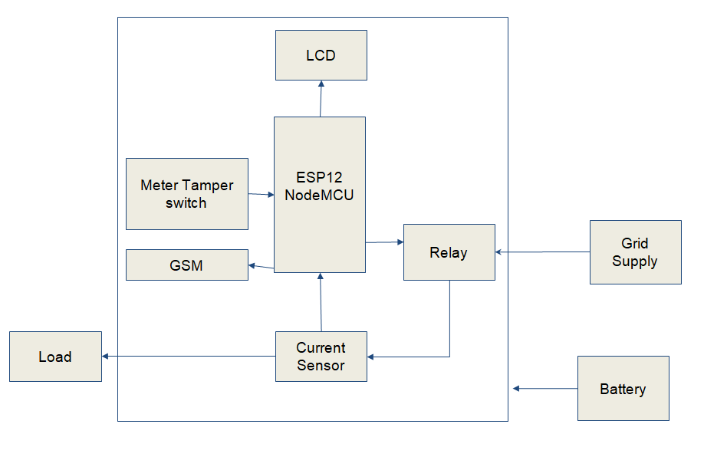
Fig- Block Diagram

The Current sensor is use to detect the utilization of current be the load Voltage sensor use to detect AC voltage provide by grid supply NodeMCU is use to sense the records by the programming Calculate the power and KWH in programming NodeMCU is connected to internet by programming and send the records calculated KWH The records send to cloud server by using PHP and MySQL There is the switch on the box cover of the meter that use when someone try to open the meter box then relay will turn off and so the power supply to home / industry is shut down Immediately the SMS to the grid company for meter tampering occur.

HARDWARE

Hardware - Esp12
Purpose - Used to send the records of power to the cloud server, if meter happen like tampered control the relay.

Hardware - LCD
Purpose – Used to display the readings

Hardware - Power Supply
Purpose - 3.7V battery for ESP12, GSM and LCD power

Hardware - Current Transformer
Purpose – To Measure the current supply to load.

Hardware - Relay
Purpose – Used to Control Load ON OFF function.

Hardware - GSM
Purpose – Used for mostly SMS purpose

SOFTWARE

Software - Arduino IDE
Purpose – Used to program ESP12 controller

Software - Cloud Server
Purpose – Used to program MySQL and PHP for recordsbase

WORKING

On the basis of current sensor records the meter works. The Current sensor sense AC current and NodeMCU receive the current records on analog pin. The current records is converted to power consumed by load in programming The records of power in KWH is send to the cloud server recordsbase via internet The internet is connected to nodeMCU wifi which is inbuilt in it the meter tampering switch is open if the door is open and SMS is send to the respective authority To get the reading records online the cloud server is use 000webhost.com which is free version and can us.

ESP12: ESP12 is having 2.4 GHz 802.11b/g/n connectivity, 32 bit wifi based microcontroller for IoT. It is programmed by the open source Arduino compiler and has to install the board library which is online and open source.

CURRENT TRANSFORMER: Transformer ratio 1000:1 so 1000 secondary coil and 1 primary coil. The primary coil in series with circuit. The secondary such that generate current due to induce emf in analog form and to detect the signal the terminal of this coil is fed to the analog pin of ESP12. This signal is then used to find the load and power. Max 5 Amp it will detect for this project.

RELAY: Here Relay is use SPDT (Single pole Double throw) relay and used to turn ON and OFF the load supply and by ESP12 nodemcu relay is controlled if meter occurs like tampered. It works on 5V dc supply.

GSM: It works on 4.3V supply and it is a SIM800L device compatible for 4G SIM and also it used to send SMS to the concerned person's mobile number.

LCD: LCD 16x2 of 16 columns and 2 Rows LCD uses I2C protocol and 32 character displays for communication Used to display the power unit on LCD. It works on 5V supply

CIRCUIT DIAGRAM

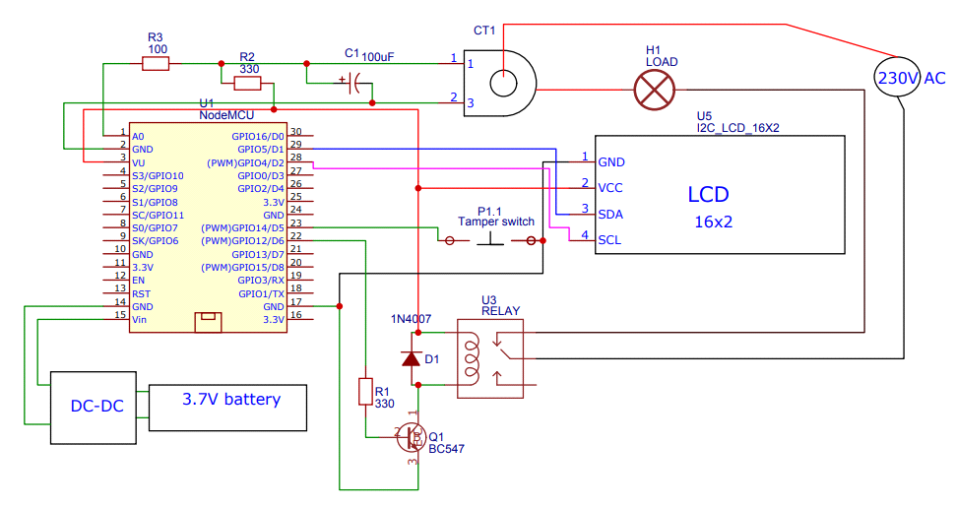

Figure- Circuit diagram

Final Hardware

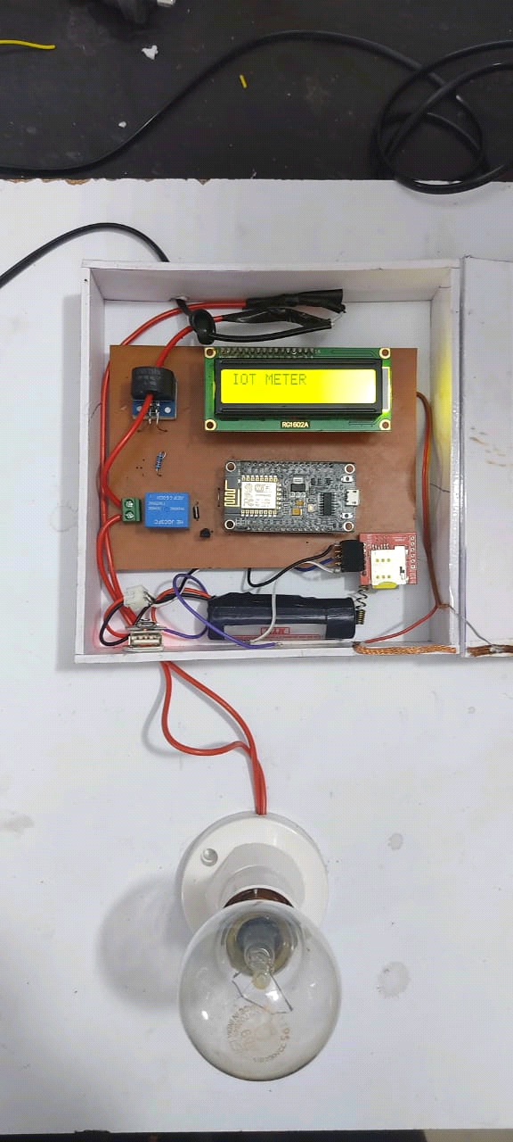

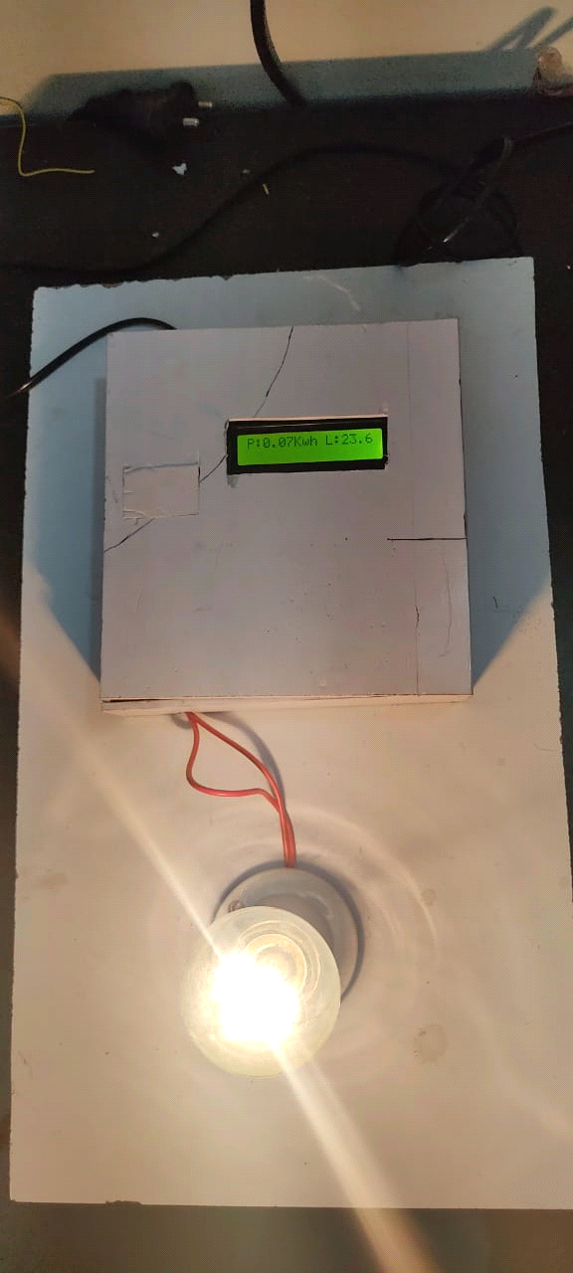

In above structure setup, here mostly PIR (Passive infrared) sensor is used to senses the human activity and Arduino application information. The working mostly sends signal to relay and then will cut of the power. Software application system operated consists of API read, read with the user will interact. IoT speak is an open source and API is used store the records and retrieve that records.

PROBLEM STATEMENT

Since IOT (Internet of Things) is cost effective compared to traditional methods, at lower cost of usage energy monitoring is easy and possible. Daily utilization of usage energy reports are generated and can be monitored by the user through an Android and/or web-portal. It shows accurate reading values and it is a more reliable system is fetch from energy meters using such devices. Device’s live readings can be viewed using an Android appliances. Also, the readings can be viewed online. Human interference is avoided and everyone's values in the central serve are kept maintained. The communication medium is secure and easy and tampering of energy meters or theft of electricity can be identified very easily. If any mistake occurs within the system, the value in the central server will not be updated. Since the values are stored within the central recordsbase, the reports are made accessible from anywhere on the world. Also, the server is online 24x 7 available.

CONCLUSIONS

Smart energy system includes WIFI, Arduino, energy meters. The system automatically reads the energy meter records and through an app developed it provide home automation and also the power management done through this application. It will reduce manual work load and also the proposed system consumes less energy. From a remote location area directly to centralize office we can receive monthly energy utilization In such a way we can reduce human effort needed to record the meter reading which are till now recorded by visiting the home individually

REFERENCES

- A. Kurde, “IOT Based Smart Power Metering,” vol. 6, no. 9, pp. 411–415, 2016.
- K. Chooruang, “Design of an IoT Energy Monitoring System,” 2018 16th Int. Conf. ICT Knowl. Eng., pp. 1–4, 2018.
- W. Hlaing, “Implementation of WiFi-Based Single Phase Smart Meter for Internet of Things ( IoT ),” no. March, pp. 8–10, 2017.
- E. Engineering, “IoT BASED POWER UTILIZATION MONITORING AND CONTROLLING SYSTEM,” no. July, pp. 2211–2218, 2018.

- Dr. Aditya Tiwary, “Design and Implementation of an Innovative Internet of Things (IOT) Based Smart Energy Meter” International Journal on Future Revolution in Computer Science & Communication Engineering ISSN: 2454-4248 Volume: 4 Issue: 4
- Maha Aboelmaged, Yasmeen Abdelghani “Wireless IoT based Metering System for Energy Efficient Smart Cities ”, 2017 29th International Conference on Microelectronics (ICM)
- A.Subba Rao, Sri Vidya Garage“IOT Based Smart Energy Meter Billing Monitoring and Controlling the Loads”,International Journal of Innovative Technology and Exploring Engineering (IJITEE) ISSN: 2278-3075, Volume-8 Issue-4S2 March, 2019
- Birendrakumar Sahani1, Tejashree Ravi, “IoT Based Smart Energy Meter”, International Research Journal of Engineering and Technology (IRJET) e-ISSN: 2395 -0056 Volume: 04 Issue: 04 | Apr -2017
- Prathik.M, “Smart Energy Meter Surveillance Using IoT”, IEEE International Conference on Power, Energy, Control and Transmission Systems (ICPECTS). 2018

