Design and Development of Maize Reaper Machine

¹Prof.C.K.Tembhurkar, ²Mr. Avinash Kumar Singh, ³Mr. Prakash Kumar Singh
¹Assistant Professor, 2,3 Final Year students
Department of Mechanical Engineering, Priyadarshini College of Engineering, Nagpur,(India)
chetantembhurkar@gmail.com

Abstract: In India, maize is the third most important crop after wheat and rice. It is grown throughout the year and also is an important raw material for many industries like alcohol, oil, starch, beverages, pharmaceutical, and others. But most of the land in India is uneven and in small pieces and irregular. Hence people still use sickle for harvesting the crop instead of heavy machines because they are costly in operation and complex in maintenance. They are less popular in India, but on introducing a small, cheap and light weight motor/engine operated reaper the harvesting of crop can be done efficiently and effectively. In this paper, the design and development of maize reaper machine is developed. By using these reaper machine we can save a large amount of time and money on each season and can be spent on other crops.

Keyword—Agriculture,Crop,Maize,Reaper machine.
- Introduction
Maize commonly known as corn is a large grain plant first domesticated by indigenous peoples in Mexico about 10,000 years ago. The leafy stalk of the plant produces separate pollen and ears which are fruits, yielding kernels. The maize plant is often 3 m (10 ft) in height, though some natural strains can grow 12 m (39 ft).The stem is commonly composed of 20 internodes of 18 cm (7.1 in) length. A leaf, which grows from each node, is generally 9 cm (4 in) in width and 120 cm (4 ft) in length. Ears develop above a few of the leaves in the midsection of the plant, between the stem and leaf sheath, elongating by ~3 mm/day, to a length of 18 cm (7 in) with 60 cm (24 in) being the maximum alleged in the subspecies. The apex of the stem ends in the tassel, an inflorescence of male flowers. When the tassel is mature and conditions are suitably warm and dry, anthers on the tassel dehisce and release pollen. Maize pollen is anemophilous (dispersed by wind), and because of its large settling velocity, most pollen falls within a few meters of the tassel. Elongated stigmas, called silks, emerge from the whorl of husk leaves at the end of the ear. They are often pale yellow and 18 cm (7 in) in length, like tufts of hair in appearance. At the end of each is a carpel, which may develop into a "kernel" if fertilized by a pollen grain. The pericarp of the fruit is fused with the seed coat referred to as "caryopsis", typical of the grasses, and the entire kernel is often referred to as the "seed”. The cob is close to a multiple fruit in structure, except that the individual fruits (the kernels) never fuse into a single mass. The grains are about the size of peas. It lacks the protein gluten of wheat and, therefore, makes baked goods with poor rising capability.
- GLOBAL MAIZE DISTRIBUTION
Globally, maize is known as queen of cereals because it has the highest genetic yield potential among the cereals. It is cultivated on nearly 150 million hectare in about 160 countries having wider diversity of soil, climate, biodiversity and management practices that contributes 36 % (782 m t) in the global grain production. Maize is widely cultivated throughout the world, and a greater weight of maize is produced each year than any other grain. The United States produces 40% of the world's harvest; other top producing countries include China, Brazil, Mexico, Indonesia, India, France and Argentina. Worldwide production was 817 million tonnes more than rice (678 million tonnes) or wheat (682 million tonnes). Over 159 million hectares (390 million acres) of maize were planted worldwide, with a yield of over 5 tonnes per hectare. The average productivity in India is 2.43 thousand hectare. According to advance estimate its production is likely to be 22.23 M Tonnes, mainly during Kharif season which covers 80% area. In India, maize contributes nearly 9 % in the national food basket. In addition to staple food for human being and quality feed for animals, maize serves as a basic raw material as an ingredient to thousands of industrial products. It includes starch, oil, protein, alcoholic beverages, food sweeteners, pharmaceutical, cosmetic, film, textile, gum, package and paper industries etc.
The maize is cultivated throughout the year in all states of the country for various purposes including grain, fodder, green cobs, sweet corn, baby corn, pop corn in peri-urban areas.The predominant maize growing states that contributes more than 80 % of the total maize production are Andhra Pradesh (20.9 %), Karnataka (16.5 %), Rajasthan (9.9 %), Maharashtra (9.1 %), Bihar (8.9 %), Uttar Pradesh (6.1 %), Madhya Pradesh (5.7 %), Himachal Pradesh (4.4 %).Apart from these states maize is also grown in Jammu and Kashmir and North-Eastern states. Hence, the maize has emerged as important crop in the non-traditional regions. State like Andhra Pradesh which ranks 5th in area (0.79 m ha) has recorded the highest production (4.14 m t) and productivity (5.26 t ha ) in the country although the productivity in some of the districts of Andhra Pradesh is more or equal to the USA. Maize can be grown successfully in variety of soils ranging from loamy sand to clay loam.
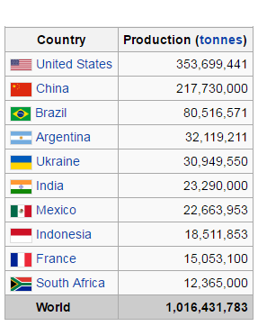
Fig 1.Global Maize Distribution

- MAIZE REAPER MACHINE

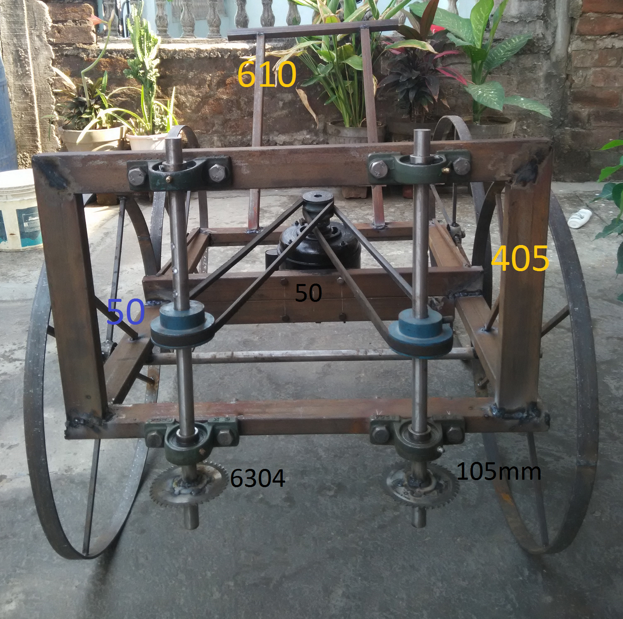

Fig.2.Maize Reaper Machine
- COMPONENTS OF MAIZE REAPER MACHINE
Sr No | Description | Quantity | Material
1 | Frame | 1 | Mild steel
2 | Ground wheel | 4 | Mild steel
3 | Wheel axle | 2 | High carbon steel
4 | Cutter | 2 | High carbon steel
5 | Handles | 1 | Rubber
6 | V-Belt | 2 | Rubber
7 | Shaft | 2 | High carbon steel
8 | Bearing | 8 | 6304
9 | Motor | 1 | 0.5 HP
10 | Pulley | 3 | Mild steel

- DESIGN CALCULATIONS

1. Power Required
The total power required for cutting, equation is

P_{wt}= (P_{kz}+E_{sc}V_{f}) W_{c} (Srivastava et al., 1993)

Where ,P_{wt} is total powered required (kW)
P_{kz} is idling power (kW/m of cutting width)
E_{sc} is specific cutting energy (kJ/m²)
V_{f} is forward speed (m/s)
W_{c} is cutting width (m)

The area under the curve is equal to required cutting energy for cutting of one stalk (Persson S, 1987)

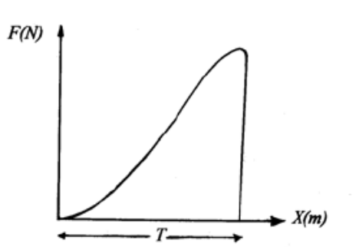

Fig 3- Cutting force v/s blade movement (x) in stalk diameter (t) (person s, 1987)

E_{o}= F_{max}*d/2
Where F_{max} is maximum cutting force (N) & d is stalk diameter (m).

According to authors quoted by Johnson and Lamp (1986) suggested static cutting forces ranging from 215 N to 570 N for 30mmdiameter corn stalks

So, F_{max} =570N and d=30mm

E_{o} =570*30/2* 10⁻³ J
=8.55 J

Specific cutting energy obtained by dividing cutting energy by width cross sectional area of stem.

E_{sc}= (8.55*10⁻³)/{π/4*(30*10⁻³)²} KJ/m²
=12.09 KJ/m²
V_{f} =1 m/s

Saw idling power consumption can be expressed as:

P_{k}= Jω^{2/}/2
Where J is mass moment of inertia for
circular blade (Kgm2)
ω is its angular velocity (rad/s)
Mass moment of inertia for a rigid disc with radius of r, mass of m about axis of rotation z
J_{Z} =mr²/2
= (0.06*0.07²⁾/2 Kg m²Where m is mass of disc
and r is radius
= 0.00147 Kg m²
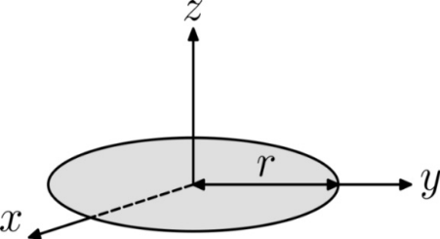

Fig 4 - Rotating Disc About Axis Rotation of Z
With due attention to rotary inertia forces for maize stalks rotational speed must be low (900-1100 rpm). So we take N=1100 rpm

ω = (2πN)/60
= (2π1100)/60 rad/sec
= 115.19 rad/sec

P_{k}= (0.00147*115.19²)/2 watt
= 9.7525 watt
= 0.00975 KW

P_{ks}= P_{k}/cutting width (cutting width=30mm)
= (0.00975/30*10⁻³) KW/m
=0.325KW/m

Now, putting the value of P_{kz,} E_{sc,},V_{f} and W_{c} in equation given below
P_{wt}= (P_{ks}+E_{sc}V_{f})x W_{c}
= (0.325 + 12.09*1)30*10⁻³ KW

=0.372 KW
=1/2 H.P

2:- Design of V-Belt

Design power

P_{d}=Pr*K_{l}
Where,
Kl=load factor
Pr=rated factor
For electric factor line shaft propeller
K_{l}=1.1 (design data book)

Selection of belt

We select shaft” A” section for power range of 0.35 to 3.5kw
Power=0.41 KW
Width=13 mm
Thickness=8mm
Minimum pulley diameter =65mm
Centrifugal tension factor K_{c}=2.52
Assume D1=D_{min} = 65 mm

Vp is within the range
So design is safe.
Assume no slip
N₂D₂= N₁ D₁
N2*80=1400*65
N2=1137.5rpm
Centre distance
C=600mm
Angle of lap
For smaller pulley
Θ₁= /600=3.116radian
For larger pulley
Θ₂=
Coefficient of friction=0.3

Belt tension ratio
For smaller pulley
F1/F2=17.66
For larger pulley
F1/F2= 18.49

Length of belt(L)
L=1.4 mm

3:- Double v belt pulley groove
We select groove section “A” for power range of 0.35 to 3.5 kw (table xv -8)
L_{p} =11 mm
b=3.3 mm
h=8.7 mm
f=9 to 12
Minimum pitch diameter (D_{p})
D_{p}= 125 mm =12.5 cm
- WORKING
The operation is very simple here the power is generated by electric motor of ½ H.P. It is of induction type single phase electric motor. Smaller double grove V belt pulley is mounted on the motor shaft and larger pulley is mounted on the cutter shaft of diameter 20mm.There are two cutter shafts of diameter 20 mm and it supported by Pillow block bearings. On the two cutter shaft, cutter blade is mounted which is made up of alloy metal. For the transmission of power from smaller pulley to larger pulley V belt is used. Initially we need electricity connection in the field which is mostly available in most of the places. When the machine is connected to the power supply power is generated by the motor. It transmits power to smaller pulley via motor shaft and the smaller pulley transmits power to larger pulley via V-belt. There are two V-Belts which are connected to the pulley connected to the motor and have negligible chance of misalignment. Then, the larger pulley transmits power to cutter shaft and cutter shaft will rotate and blade connected to cutter shaft will rotate. When there will be rotary motion of the blade the driver will push the reaper. The rotary and forward velocities will be applied on the maize stalk as there will be contact between the stalk and the blades. This will result in cutting of the stalk and then the stalks will fall on ground.There is a separator provided on the front of the machine to provide maize stalk entering the mechanism or the belts. As they will stop the working and even damage the belts or cause misalignment.
- ADVANTAGES

1. This machine reduces the human effort as only human effort is in pushing the reaper. Other cutting work is done by the blades automatically.
2. It reduces the time consumed in whole process making it efficient.
3. It increases the agricultural productivity of maize.
4. It reduces the number of labour as well as labour hours to cut down the stalk.
5. Most of the machine part is simple and easy to fabricate. Even by a small fabricator.
6. Reaper is portable. We can carry it to distant places without much problem.
7. It reduces the cost of cutting maize.
8. V-belts minimize the slippage and alignment problem. It is a basic belt for power transmission now a day. They provide the best combination of traction, speed of movement, load of the bearings, and long service life.
9. These provide easy installation and superior environmental resistances compared to rubber belts and are length adjustable by disassembling and removing links when needed.

10. We can recover the price of reaper in almost two seasons.
11. This machine uses electricity which is clean source of energy hence it is environmental friendly.
12. Cost of operation as well as maintenance is very low due to cheap and easily available parts.
13. Blades can be replaced and can be resharpened making it affordable for farmers and any other blades with alloy metal tip can be used.
14. Machine is light in weight as hollow pipes are used and extra arrangement or joints, links are avoided.
15. We don’t need special training to operate this machine and also its maintenance is quite easier.

- RESULT

Sr.No. | Description | Units
1. | Idling power | 0.352KW
2. | Specific cutting energy | 12.09kJ/m²,
3. | forward speed | 1 m/sec
4. | cutting width(for single cutter) | 30 mm
5. | Power consumption

CONCLUSION

1. Cutting system has cutting disc (dia.14cm) with two blades that cut the maize stalk. It is expected that the developed cutting system will be able to work under different farm conditions.
2. This simple reaper has performed well in harvesting maize grown in small forms.
3. By result of field experiment in a very small field, Machine showed that the loss of harvesting is lower than the manual harvesting and operation was done faster.
4. This machine is easily operated by a single worker, so it does not require more workers for operating this reaper machine.
5. This reaper required very less maintenance as compared to reapers which is available in the market.
6. The cost of the reaper is very less as compared to the other reapers machines, so farmers can easily afford this simple reaper machine.

References

[1] Bosoi, E.S., Verniaev, O.V., I.I. Smirnov and E.G.
Sultan- Shakh “Construction and Calculations of
agricultural Machines”, Volume II. Russian translation
Series 83. Rotterdam: Balkema 1991.
[2] Linn Zea mays, “Maize in India Publications &
Information Directorate”, CSIR, 1977 P-62
[3] Berger Josef, “Maize Production and the Manuring of
Maize”, Centred & Étude del & Azote, 1962, P-315.
[4] Colman, G.P., “Innovation and Diffusion in
Agriculture, Agricultural History” pp173-188,1968.
[5] Bosoi, E.S., Verniaev, O.V., I.I. Smirnov and E.G.
Sultan- Shakh “Construction and Calculations of
Agricultural Machines”, Volume II. Russian
Translation Series 83. Rotterdam: Balkema 1991.
[6] Sitkei G.,” Mechanics of Agricultural Materials”, New
York 1986, pp11-13, pp 439-458.
[7] Linn Zea mays, “Maize in India Publications &
Information Directorate”, CSIR, 1977 P-62
[8] Berger Josef, “Maize Production and the Manuring of
Maize”, Centred & Étude del & Azote, 1962, P-315.
[9] Colman, G.P., “Innovation and Diffusion in
Agriculture, Agricultural History” 1968, P 173-188

