Environmental Impact Assessment Of Sand Mining At Wainganga River With Special Reference To River Replenishment Rate

Prof. Shahid Sheikh¹
Tipesh Hadge², Nisha Bhonde³ , Rajat Bais⁴, Devhid Bhaladhare⁵, Fazal Rahman⁶,Kajal Gharde⁷

¹Asst. Professors, Dept. of Civil Engineering, M.I.E.T. Shahapur, Bhandara, India
^{2,3,4,5,6} B.E. Department of Civil Engineering, M.I.E.T. Shahapur, Bhandara, India

ABSTRACT:-Modified Universal Soil Loss Equation (MUSLE) application study is undertaken in order to estimate the sediment yield of the Wainganaga River (Keolari-Ashti) in Bhandara district. The runoff factor of MUSLE is computed using the measured values of runoff and peak rate of runoff at outlet of the watershed. Topographic factor (LS) and crop management factor(C) are determined using geographic information system (GIS) and field-based survey of land use/land cover. The conservation practice factor(P) is obtained from the literature.
This paper present’s an overview of environmental impact of river by sand mining in Wainganga with special reference to ground water streams. It has been observed from discharge-concentration relationships that there is a fall of suspended sediment concentration of all fractions at Ashti as compared with that of Pauni station. Hence, the total sediment transport at Pauni is more than that of Ashti which gives the rate of aggradations of 5.996 t /m / yr between Pauni and Ashti stations. The possible reason of higher sediment load at Pauni than Ashti may be lithological controls and land cover of the basin and hydrological characteristics and changes in gradient along the river. The reaches at Pauni station are dominated by alluvial soils yielding with large quantity of sediment while the reaches at Ashti region are covered by granite gneisses (hard rock’s) resulting lower sediment yield at downstream side than those of upstream side. The comparison of the sediment transport of the Wainganga River at Pauni and Ashti with other Indian rivers shows that the Waingangā River is not significantly active in terms of sediment transport.
Keywords— MUSLE, Sediment yield, storm event, etc.
INTRODUCTION:-
The Wainganga river is one of the major tributaries of Godavari river in peninsular India with a catchment area of about 51,000 sq. km and total length of 606km spread in the state of Maharashtra and Madhya Pradesh. The Waingangā river is confined between latitude of 19041' 0" and 220^34'5”and longitude of 7801510" and 80038' 50". Along the Waingangā River there are four hydrological stations of the Central water commission (CWC) at Keolari and Kumhari in Madhya Pradesh and at Pauni and Ashti in Maharashtra. The meteorological stations of the Indian meteorological Department (IMD) are located at Sakoli (Bhandara), Pauni (Bhandara) and Mul (Chandrapur).
The Wainganga river basin has varied rock formations including Precambrian rocks (granite gneisses) and Deccan traps covering the major portion of the basin and alluvial soils, laterite, shale, dolomite, mica, granite, sandstone, schist, etc.
Sand is most important mineral for our society in protecting our environment, but the practice of sand mining is becoming an environmental issue as the demand of sand increasing rapidly in industry and construction. Sand is in high demand in construction sector by 2020; 1.4 billion ton of sand will be required in India. Sand mining is regulated by law in many places, but it is often done illegally.
Soil erosion is an important item of consideration in the planning of watershed development works. It reduces not only the storage capacity of the downstream side reservoir but also deteriorates the productivity of the watershed. Globally, more than 50% of pasturelands and about 80% of agricultural lands suffer from soil erosion. Water and soil losses are the processes which potentially reduce water quality. Soil erosion in this area strongly influences the ecological health of the surrounding area.
METHODOLOGY:-
There are many sediment transport equations which are suitable for use in the prediction of the rate of replenishment of river. Some of the famous sediment equations are:
- Modified universal soil loss equation(MUSLE)
- USLE (universal soil loss equation)
- RUSLE
- Dandy- Bolton Equation
We used Modified universal soil loss equation (MUSLE) for estimation of sediment yield. In the present study, MUSLE is used to estimate sediment yield from the Wainganga River (Keolari-Ashti). Runoff factor is a major input into the MUSLE model. The sediment yield model like MUSLE is easier to apply because the output data for this model can be determined at the watershed outlet.
Sand Availability, its production and consumption (Last 3 years data 2015-16 to 2017-18)
In Bhandara district near about 1459544 brass sand was available out of which near about 854613 brass sand was mined i.e. near about 58% of total available sand was mined. The year wise availability of sand and its production consumption is tabulated below:-
Sr. no. | Year | Sand availability unit | Production | Consumption
1 | 2015-16 | 523378 | 395640 | 395640
2 | 2016-17 | 674516 | 293609 | 293609
3 | 2017-18 | 261650 | 165364 | 165364
 | Total | 1459544 | 854613 | 854613

Modified universal soil loss equation(MUSLE):-
Y=11.8*(Q*qP).56 *K*Ls*C*P
Where,
Y=sediment yield of stream (t/yr/km²), Q=average annual runoff (m³), K=soil erodibility factor=0.1, qP=Highest discharge recorded (m³/s), Ls=gradient/slope length, C=cover management factor=0.1043, P=erosion control practice=0.8

LONGITUDINAL PROFILE OF THE WAINGANGA RIVER:-
The longitudinal section of the river valley from its source to mouth is known as longitudinal profile. It is gradually formed due to the erosion and deposition along the course of the river. Longitudinal profile of the Wainganga River consists of 4 major segments and all four segments are differing from each other in respect of length and gradient. The figure shows the longitudinal gradient of the river is smoothly decreasing from Pipariya to Kumhari and from Pauni to Ashti where as a drastic change in gradient is observed from Kumhari up to mouth.
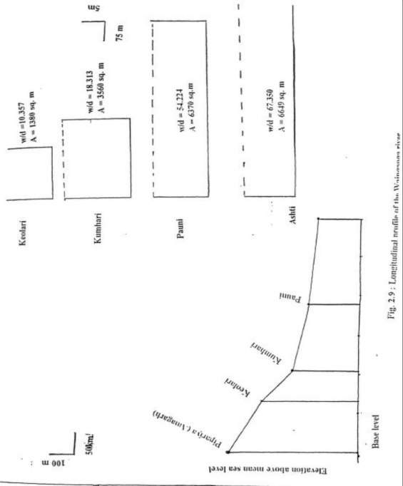Fig: Longitudinal profile of river reaches
GRADIENT OF THE RIVER REACHES:-
REACH | VALLEY LENGTH(KM) | GRADIENT
Keolari-Kumhari | 83 | 1:602
Kumhari-Pauni | 175 | 1:2663
Pauni-Ashti | 220 | 1:2688

The longitudinal profile is concave upward but it is rarely smooth because there is sharp change in the gradients of reaches keolari-kumhari and Kumhari-Pauni. The downstream reaches Kumhari- Pauni and Pauni-Ashti have equal gradients. Hence it can observe from the figure and table that longitudinal profile of the Wainganga River is steep in the upstream part and that of flat in the downstream part.
- Peak discharge: Maximum discharge (m³/s) observed on a particular day during the whole year.
- Bankfull discharge: The discharge corresponding to danger level obtained from the flood hydrograph of discharge against water level.
Average monthly discharge at CWC stations
Stations months | Keolari | Kumhari | Pauni | Ashti
January | 1.88 | 1.598 | 34.44 | 37.52
February | .826 | 1.054 | 24.92 | 27.15
March | 0.306 | 0.750 | 20.83 | 75.78
April | 0 | 0.615 | 13.46 | 22.48
May | 0 | 0.325 | 14.51 | 15.09
June | 6.59 | 18.683 | 170.49 | 210.12
July | 42.275 | 212.385 | 811.2 | 1324
August | 129.828 | 454.875 | 1178.66 | 3241.83
September | 42.04 | 138.163 | 702.17 | 1254.43
October | 10.543 | 19.737 | 311.05 | 576.73
November | 2.657 | 6.268 | 57.00 | 100.62
December | 1.515 | 2.463 | 25.26 | 38.00
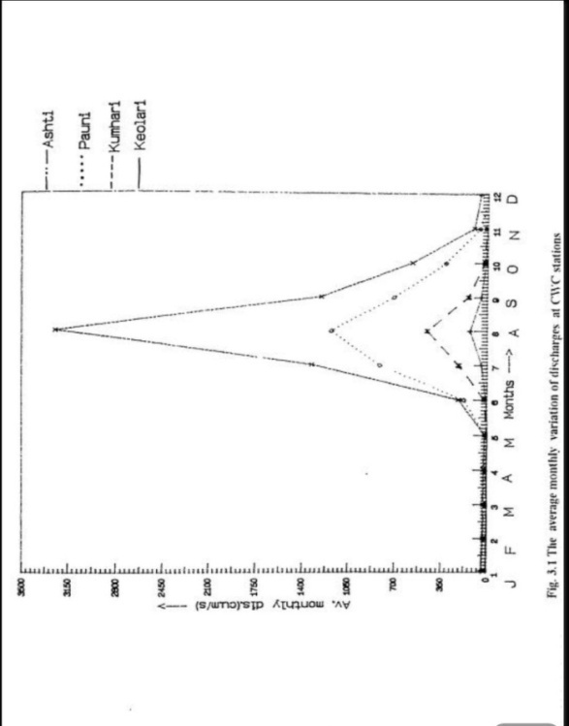The variation of the average monthly discharge throughout the year corresponding to Keolari, Kumhari, Pauni, & Ashti stations is shown in above figure and table. It is observed from the plot that the Wainganga River is truly monsoonal river, discharge approaching to non monsoon months. The unit model distribution is observed at all stations along the Wainganga River and peak discharges occurred in August only. It is also observed that there is much difference in vast discharges of upstream stations and downstream stations reflecting the huge feeding of discharge by confluence tributaries in the downward direction.
Hydrological characteristics of the Wainganga river:-
Stations | Av. Annual discharge (m³/s) | Av. Annual runoff (m³/m) | Bankfull discharge (m³/s) | Highest discharge recorded (m³/s)
Keolari | 19.872 | 736 | 3125 | 1670
Kumhari | 71.410 | 1930 | 7887 | 3000
Pauni | 280.330 | 12160 | 13524 | 18250
Ashti | 572.146 | 19725 | 22560 | 28650

All discharges are based on the rate measured once per day. The peak discharge varies year wise at all CWC station. The systematic increase in peak discharge at all station up to 1991 and then it is decrease. Hence, during the period of five years (1988-1992) at all stations the highest peak discharge occurred in 1991. It is also revealed that in the last five years, the river has not exceeded the bankfull discharge. Further, at the upstream station (Keolari & Kumhari) bankfull discharge significantly exceed the highest discharge recorded in the history of river reflecting that no major flooding history at this stations. On the other hand bankfull discharge is significantly lower than the highest distance discharge recorded for the downstream station (Pauni & Ashti) reflecting the occasional over bank spilling.
Sediment Budgeting:
The total annual suspended load has been computed for upstream (Pauni) and downstream station
Ashti and the data is presented in the table. Further, the comparison of annual suspended load for both station for the period 1988-1992. The total suspended load and the coarse plus medium fraction of the suspended load have been plotted separately, which provide interesting observations. Table clearly indicates that the total suspended load is extremely variable over the years and between the stations perhaps reflecting successive aggradations and degradation phases. Interestingly the (coarse medium) fraction of the suspended load is higher at upstream station (Pauni) than that the downstream station (Ashti). Sediment yield (sediment load transferred per unit area) has also been computed for both stations. Once again the sediment yield for the upstream station is higher than that of the downstream station, which support the popular belief that small river basin contribute higher sediment load (subramanium et. al.....1989).
Year | Total load at Pauni (mt/yr) | Total load at Ashti(mt/yr)
1988 | 11.955906 | 5.740880
1989 | 2.742397 | 3.911744
1990 | 13.270510 | 12.869566
1991 | 9.085237 | 6.0392925
1992 | 4.055135 | 5.951426
Total | 41.109185 | 34.513207
Avg. Annual sediment load (mt/yr) | 8.2218837 | 6.902641
Sediment yield (t/km²/yr) | 231.47 | 135.37

Although there is no regular pattern of variations in the annual suspended load between the two stations, the total suspended load to transfer at the upstream.
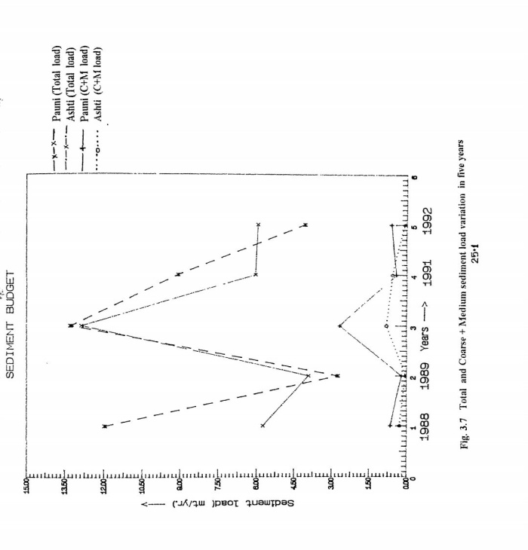

Summary of anticipated environmental impacts:
Impacts | Mitigation measures
Land environment
- Creation of temporary pits after excavation of sand. These pits will be filled by natural process of replenishment in due to course of time.  - Very little possibility of soil erosion as working depth will be confined to only 3m below ground level.  - Some adverse visual impact due to formation of the mining pits. | - Regular monitoring of sand replenishment in mined pits and reduction of working depth if replenishment rate is found inadequate.  - No excavation within a distance of 30m from the river bank.  - Factor of slope stability to be taken into consideration while excavating sand from the pit.  - Tree planting along the approach road to minimize adverse visual impact.

Air environment
- Since the mining will be done without blasting. Dust generation during excavation will be insignificant. However, there will be some deterioration in air quality as a result of generation of dust during loading and transportation.  - Air born dust particles may cause diseases of respiratory system. | - Regular sprinkling of water on haul roads for dust suppression.  - Compaction of haul roads.  - Planting on both sides of haul roads.  - If sand is dry, water will be sprayed over it to make it wet.  - Transport vehicles will be covered with tarpaulin.  - Regular maintenance of vehicles.  - Regular maintenance of roads fortnightly scraping of road surface.

Water environment
- No adverse impact on ground water regime is anticipated as there is no proposal of stream bed mining or diversion of any stream and the depth of mining is to be restricted to 3m or the ground water table, whichever is less.  - The water drawl is estimated to the only 89.6KLD from the river and 0.8KLD from the nearby ground water sources. Since the river has sufficient water flow throughout the year & there is not much ground water drawl, the impact of water. | - Use of temporary portable toilets at the project site.  - No mining activity during rainy season.  - Periodic monitoring of water quality.

Noise environment
- Generation of noise and vibrations from the machines and transport vehicles may cause some impact on the health of workers. | - Regular maintenance of vehicles and machines.  - Plantation along approach roads.  - Regular health checkups.  - Only trained workers to be allowed to operate machines.  - Regular maintenance of smoke silencers.  - Creation of awareness among truck drives not to unnecessarily blow loud horns.  - Periodic monitoring of noise levels.

Biological environment
- No adverse impact on forest resources and economically or medicinally important plant species is anticipated. There is no threat to terrestrial or aquatic fauna, biodiversity or wild life. However, there may be some retardation in growth of plants due to deposition of dust on foliage. Dust generated during transportation of sand may cause some harm to people and animals. | The following green areas are proposed to be developed:-  - Road side plantation over length of 0.089 km on both sides of the approach road.  - Road side plantation over a length of 1.520 km on both sides of the existing road to be used in transportation of sand.  - Planting over a length of 1.860 km along the river side above highest flood level.  - Free distribution of 3125 no. of saplings to villagers in Bhikampura and Ruhera villages for planting on field bunds and homesteads.  - Rehabilitation of 31.25 ha. Of degraded forest in the impact zone.

Socio economic environment
- Direct employment to about 164 persons in mining and other related activities and indirect employment to hundreds of people.  - Improvement in economic status due to increase in income. | - Engagement of locally available workers on priority.  - Organisation of regular health check up camps for workers and villagers twice in a year.

Calculation of total sediment yield by different method:
Station | As per Dendy-Bolten method  Total load in( t/km²/yr) | As per calculation by MUSLE method in ( t/km²/yr)
- Keolari | 134.50 | 153.396
- Kumhari | 315.478 | 206.088
- Paoni | 231.47 | 235.56
- Ashti | 135.37 | 892.857
CONCLUSSION:-
In the present study, we used MUSLE model for estimation of the sedimentation yield for Wainganga River (from Keolari-Ashti).
Replenishment rate i.e. sedimentation yield is much more than permitted sand mining quantity. Hence, the sand mining is safe and environment friendly.
REFERENCE
- Revenue department, Bhandara
- Irrigation department, Bhandara
- http://archive.org/details/in.ernet.dli.2015.194753/page/n34

