EVALUATION OF GROUND WATER ARTIFICIAL RECHARGE SCHEMES IN CHANDIGARH (U.T.)
Lokmitra Meshram¹, Dr. Sanjay Sharma², Dr. Dwarkinath Ratha³
- Research Scholar in Department of Civil Engineering, NITTTR, Chandigarh
- Professor & Head in Department of Civil Engineering, NITTTR, Chandigarh
- Associate Professor Thapar University, Patiala

ABSTRACT
Chandigarh is a rapidly growing city with a population growth rate of 40 percent in the last decade. The density of population is 7900/sq.km which is one of the highest in the country and the demand for water is estimated to grow steeply. It is estimated that by 2025, the water demand will be 800 mld, thereby indicating and increase of 58% over the present requirement. There is also a great demand of water for horticulture purpose as one third of the total area of city is under green spaces.
Bhakra Main Canal is the main source of water supply and already there is a dispute concerning distribution of water for the next two phases of supply. Deep confined aquifers in this city are not naturally recharged thus leading to steep decline in ground water level. Hence there is an urgent need for augmenting the ground water supply by means of artificial recharge using injection wells and also to evaluate the effect of this process on ground water table and its quality. Ground water samples were collected from four different locations during pre-monsoon and post-monsoon season and tested for various physical and chemical parameters. The study revealed that the ground water is more turbid in post-monsoon than in pre-monsoon which may be due to some colloidal and other fine impurities present in the incoming surface water.
INTRODUCTION
Ground water is an essential and vital component of our life support system. The ground water resources are being utilized for drinking, irrigation and industrial purposes. However, due to rapid growth of population, urbanization, industrialization and agriculture activities, ground water resources are under stress. Chandigarh widely known as City Beautiful is already having a population more than double the planned capacity of the city. In addition there is large floating population and a slum population that is being rehabilitated. Several new initiatives and large scale projects such as IT Park, Shopping malls etc. have also been undertaken in recent years. All these factors have led to severe water shortage and the residents used to protest against this problem especially during peak summers. Conjuctive use of surface and ground water is the need of the hour to face this problem to acute shortage. It is therefore very important to improve the ground water level by adopting to artificial recharge. The process should take care of the quality of recharge water and also provide long term benefits. The present study was conducted to determine the infiltration rate of filter media and the extent of ground water contamination.
The following were the objectives of study :
- To investigate the changes in the water table of recharge wells in the study area.
- To determine lithological composition, drainage characteristics of the surrounding soil and hence infiltration rate of filter media.
- To collect ground water samples from the recharge wells and test for various physical, chemical and biological parameters.
- To analyse the samples for possible contamination on the basis of performed tests.
- To evaluate the effect of changing seasons on ground water quality.

METHODOLOGY AND EXPERIMENTAL PROCEDURE

Ground water samples collected from different sources/places were tested for different parameters as per codal provisions to determine the level of pollutant. Undisturbed soil from these sites were also collected and tested to determine the permeability characteristics and infiltration rate of filter media.

Sampling Sites :

National Institute of Technical Teacher Training Institute is situated in Sector 26 of Chandigarh and office compound has total catchment area of 1.84 ha. National Annual rainfall of the area is 1074 mm. Total available water for recharge to ground water is 17276 m³. This available water can be utilized for recharging the aquifer system of Chandigarh where ground water is being tapped through tubwells indiscriminately.

Location – 1 : Near Gate no. 1 of NITTTR
Location – 2 : Near Gate no. 2 of NITTTR
Location – 3 : Near Canteen of NITTTR
Location – 4 : Near basic medical science block of Panjab University

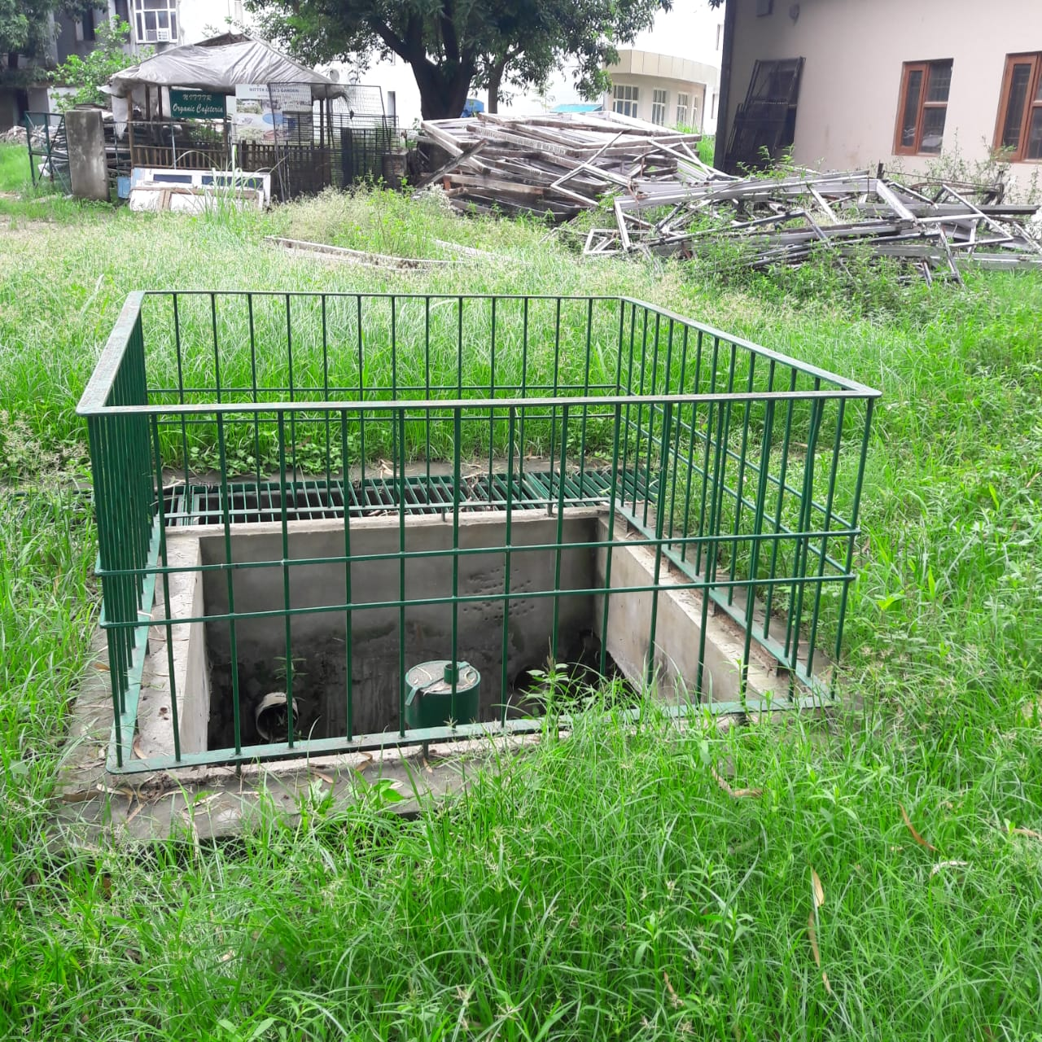

Fig.1 Recharge Well in NITTTR Campus

Before Cleaning the Well
S.No. | Parameters | Results | Limits of IS : 10500 - 2012 |  | Test method
 |  |  | Requirement (Acceptable Limit) | Permissible limit in absence of alternate source
1 | pH | 6.90 | 6.5 - 8.5 | No relaxation | IS : 3025 (Part - 11) 2002/APHA 22nd Edition
2 | Total Dissolved Solids mg/Max | 220 | 500 | 2000 | IS : 3025 (Part - 16) 2006/APHA 22nd Edition
3 | Alkalinity (as CaCO₃)mg/l, Max | 120 | 200 | 600 | IS : 3025 (Part - 23) 2003/APHA 22nd Edition
4 | Chloride (as Cl), mg/l, Max | 14 | 250 | 1000 | IS : 3025 (Part - 32) 2003/APHA 22nd Edition
5 | Sulphate (as SO₄) mg/l, Max | 38 | 200 | 400 | IS : 3025 (Part - 24) 1992/APHA 22nd Edition
6 | Nitrate (as NO₃) mg/l, Max | 4.2 | 45 | No relaxation | IS : 3025 (Part - 34) 2003/APHA 22nd Edition
7 | Fluoride (as F) mg/l, Max | 0.30 | 1. | 1.5 | IS : 3025 (Part - 60) 2008/APHA 22nd Edition
8 | Calcium (as Ca) mg/l, Max | 51 | 75 | 200 | IS : 3025 (Part - 40) 2003/APHA 22nd Edition
9 | Magnesium (as Mg) mg/l, Max | 9.2 | 30 | 100 | IS : 3025 (Part - 46) 2003/APHA 22nd Edition
10 | Total Hardness (as CaCO₃) mg/l, Max | 164 | 200 | 600 | IS : 3025 (Part - 21) 2002/APHA 22nd Edition 2012
11 | Sodium (as Na) mg/l, Max | 8.4 | - | - | IS : 3025 (Part - 45) 2003/APHA 22nd Edition
12 | Potassium (as K) mg/l, Max | 3.2 | - | - | IS : 3025 (Part - 45) 2009/APHA 22nd Edition
13 | Dissolved Oxygen mg/L | 5.3 | - | - | IS : 3025 (Part - 38) 2003/APHA 22nd Edition
14 | Chemical Oxygen Demand, mg/L | 150 | - | - | IS : 3025 (Part - 58) 2006/APHA 22nd Edition

Bacteriological Examination :
S.No. | PARAMETERS | TEST RESULTS | TEST METHOD
1 | E.coli | Present | IS 5887 (Part-I)
2 | Coliform | Present | IS 5401 (Part-I)

After Cleaning the Well
S.No. | Parameters | Results | Limits of IS : 10500 - 2012 |  | Test method
 |  |  | Requirement (Acceptable Limit) | Permissible limit in absence of alternate source
1 | Color, Hazen Unit, Max | <5 | 5 | 15 | IS : 3025 (Part - 4) 2002/APHA 22nd Edition 2012
2 | Turbidity, NTU Max | <1 | 1 | 5 | IS : 3025 (Part - 10) 2006/APHA 22nd Edition 2012
3 | pH | 7.82 | 6.5 - 8.5 | No relaxation | IS : 3025 (Part - 11) 2002/APHA 22nd Edition 2012
4 | Total Dissolved Solids mg/l, Max | 270 | 500 | 2000 | IS : 3025 (Part - 16) 2006/APHA 22nd Edition 2012
5 | Alkalinity (as CaCo₃) mg/l, Max | 147 | 200 | 600 | IS : 3025 (Part - 23) 2003/APHA 22nd Edition 2012
6 | Chloride (as Cl), mg/l, Max | 21 | 250 | 1000 | IS : 3025 (Part - 32) 2003/APHA 22nd Edition 2012
7 | Residual free chlorine mg/l, Min | NIL | 0.2 | 1.0 | IS : 3025 (Part - 26) 2003/APHA 22nd Edition 2012
8 | Sulphate (as SO₄) mg/l, Max | 34 | 200 | 400 | IS : 3025 (Part - 24) 2003/APHA 22nd Edition 2012
9 | Nitrate (as NO₃) mg/l, Max | 14 | 45 | No relaxation | IS : 3025 (Part - 34) 2003/APHA 22nd Edition 2012
10 | Fluoride (as F) mg/l, Max | NIL | 1.0 | 1.5 | IS : 3025 (Part - 60) 2008/APHA 22nd Edition 2012
11 | Calcium(as Ca) mg/l, Max | 44 | 75 | 200 | IS : 3025 (Part - 40) 2003/APHA 22nd Edition 2012
12 | Magnesium (as Mg) mg/l, Max | 13 | 30 | 100 | IS : 3025 (Part - 46) 2009/APHA 22nd Edition 2012
13 | Total Hardness (as CaCO₃) mg/l, max | 162 | 200 | 600 | IS : 3025 (Part - 21) 2002/APHA 22nd Edition 2012
14 | Sodium (as Na) mg/l Max | 22 | - | - | IS : 3025 (Part - 45) 2009/APHA 22nd Edition 2012
15 | Potassium (as K) mg/l Max | 5.4 | - | - | IS : 3025 (Part - 45) 2009/APHA 22nd Edition 2012

Bacteriological Examination :
S.No. | PARAMETERS | TEST RESULTS | TEST METHOD
1 | E.coli/100 ml | PRESENT | IS 5887 (Part-I)
2 | Coliform/100 ml | PRESENT | IS 5401 (Part-I)

Courtesy :- Environ Tech Laboratories S.A.S. Nagar Mohali,Punjab
CONCLUSIONS
There is an urgent need for water quality management to monitor the quality of ground water recharge schemes regularly. Recharge wells should be properly constructed and provided with appropriate wellhead protection measures. Maintenance of these wells should also be carried out at regular intervals. Slit of upper layer should be removed in pre-monsoon and post-monsoon season and gravel should be changed in every four years. Wells should be located in areas where there is minimum potential for contamination so as to prevent instusion of saline water in aquifers. Disinfection of water supplies should be carried out as it not only kills existing bacteria, but also take care of future contamination. It is obeserved from the present study that their is a significant change in different parameters after cleaning the wells.
REFERENCES
1. K.R. Karanth, “Ground water Assessment Development and Management”, Tata McGraw Hill
Education Private Limited, New Delhi.
2. CGWB (1994) manual on artificial recharge of groundwater.
3. EPA Guidance Manual (1999), Importance of Turbidity
4. Patel Pratima, M.D. Desai, J.A. Desai (2011) “Need to overcome the inadequacy of water to meet
our demands by artificial ground water recharging”, International Journal of Earth Sciences and
Engineering, PP 972-977
5. Martin Rygaard, Philip J. Binning, Hans-Jorgen, Albrechtsen, “Increasing urban water self
sufficiency : New era, new challenges:, Journal of Environment Management (2011), pp 185-194.
6. Satyendra Kumar, S.K. Kamra, R.K. Yadav, J.P. Sharma (2012), “Evaluation of sand-based storm
water filtration system for groundwater recharge wells”, Current Science, Vol. 103, No.4,
25 August 2012.
7. S.Selvam, Department of Geology, V.O. Chidambaram College, Tuticorin, “Groundwater quality
to change impact of Climate change : a case study from Tuticorin, South Tamilnadu, India”
8. Chaudhari, K.S., Walke, P.V., Wankhede, U.S. and Shelke, R.S., 2015. An experimental investigation of a nanofluid (Al2O3+ H2O) based parabolic trough solar collectors. Current Journal of Applied Science and Technology, pp.551-557.
9. Chaudhari, K. and Walke, P., 2014. Applications of nanofluid in solar energy–a review. Int J Eng Res Technol, 3(3).
10. http://ga.water.usgs.gov/edu/qa-usage-gw.html
11. http://edugreen.teri.res.in/explore/water/ground.htm

