Solar Powered Seed Sowing Machine

Dhruvaraj Kishor Baviskar1, KunalLaxmanChaudhari2,PranavGopikrushnaSonawane3, Sagar VijayTawade4, RamkrushnaChandrashekharJadhav5, Prasad Y. Marathe6

^{1,2,3,4,5}DIPLOMA final yearMechanical Engg. student,⁶ Assistant Proessor
^{1,2,3,4,5,6}GF'S Godavari college of engineering and polytechnic, ,Jalgaon, INDIA, 425001.

baviskardhruvaraj39025@gmail.com¹, kunalchaudhari301@gmail.com^{2,} pranavgs002@gmail.com³, tawadesagar52@gmail.com⁴, chandrashkerjadhav@gmail.com⁵, prasadmarathe08@gmail.com⁶

Received on: xxxx,20xx, Revised on: xxxx,20xx, Published on: xxxx,20xx

ABSTRACT- The backbone of Indian economy is ruled by agricultural sector. In today’s era there is need to improvement in farming technology like seed sowing , digging ,etc. The ideal purpose of this machine is to make the farming process automated. For reducing human efforts agriculture robot is made for farming. In India agriculture sector is considered in most important economical activities, In India most of the people in rural area depends on agriculture. This machine is used for overcome the wastage of seeds also reduces the human efforts. The main purpose of this Robot is to make the farming technology more easy as well as comfortable. Seed sowing robot machine saves farmer’s time, efforts. Seed sowing robot machine is not harmful for environment as well as humans also. Seed sowing robot machine is pollution free. It increase production rate in farming process. This robot is easy to carry anywhere in farm easily. This is the purpose of solar power seed sowing machine.

Keywords- DC Motor, Seed Hopper, Solar Energy, Water Tank , Solar panel , Mechanism

I.INTRODUCTION

At present era, In agricultural sector many countries have skilled labourshortage . This cause effect on growth of country to be a developing nation .
India is also a part of it .In India most of people in rural area is dependent on the farming. Seed Sowing machine will make work fast and easy as well as save time and requirement of labour.

II.LITERATUREREVIEW

Mahesh R. Pundkar:Many varities of crops have been developed by pneumatic planters. Seed size for a wide range in seed spacing resulting to uniform seed distribution along the travelled path.[1]
Swetha S. et.al:- For capturing solar enery in this machine solar panel is used to store the energy and the stored energy is converted into useful work. [2]
P.P Shelke:-In India growth of agriculture sector is going very fast. Even the seed planting have the crops spread and have defined depth .[3].
Khanna, A;Rajan:-To cover the seed , Seed Sowing and burrowing the seed. The agribot is created for it.[4]
Trupti A. Shinde. et.al:- The system of seed sowing machine is the battery power which is used to operate the device and the battery will charged from solar panel.Device detect alarm when the seed storage is empty.At the every single rotation of wheels device sawn aSeed.[5]

III.METHODOLOGY

To consume solar energy ,Solar panel is used in this machine. The solar energy is stored in 12v battery.
The stored electrical energy is converted into useful work to operate the device.
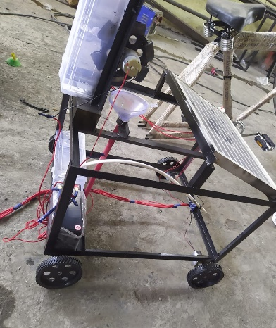
Fig.1 Set up

The main purpose of Seed Sowing Mahine is to get desired depth and put the seed in row.To cover the seed with soil an soil adjuster is used for itAfter putting soil back on seed water is spread for water tank.

IV. DESIGN

Themachineconsistsofthefollowingcomponents:
    - Solar Panel- Solar panel provided solar energy to battery for storing energy.
It provides eco-friendly and renewable energy.
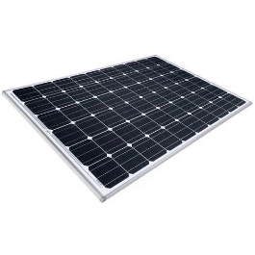
Fig.2Solar Panel

Specifications- RatedPower-40W
Cost- INR 750- 900

    - Battery- For operating the machine and storing energy the 24v battery is used in the machine.
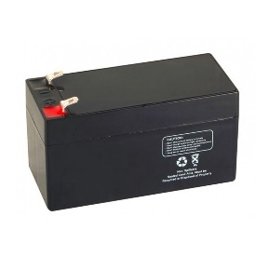
Fig.3Battery

RatedVoltage-24v
Capacity-7.5AmpHour Cost- INR 700- 800

    - DCMotor- A DC motor is used to rotate the wheel(tyre) of the machine and Sowing the seed in soil.
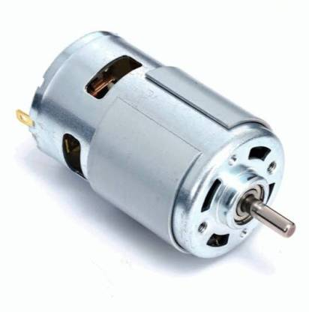
Fig.4DCMotor

Specifications-
RatedVoltage-24v
Cost-INR600-800.

    - Seed Hopper- Seed hopper is a device which is used for sowing the seed into soil as well as stored the seeds for sowing into land.

    - Water Tank- It is used for spraying water after sowing the seeds in soil.A small 12v-24v water pump is used for spraying water.

V. FUTURESCOPE

      - In future using Arduino chip we can make it fully mobile operated.
      - In future we can add direction control system in this machine.
      - Seeds spacing senser will use for seed sowing distance.
      - Multi-seed sowing hopper can be attached in future.

VI.ADVANTAGES

- It have less maintenance.
- It save money and time of any farmer.
- It is cost efficient.

VII. CONCLUSION

Thus after implementation of this syste,, we hope few outcomes like, Rate of seed sowing can be controlled, different type and size of seed can be sow, the required manual power is less and the system will be pollution free.

REFERENCES

- Mahesh R. Pundkar, “A seed sowing machine: A review” IJESS volume 3, Issue 3. ISSN: 2249-9482, International journal of engineering and social science.
- Swetha S. and Shreeharsha G.H., “Solar Operated Automatic Seed Sowing Machine”, Cloud Publications International Journal of Advanced Agricultural Sciences and Technology 2015, Volume 4, Issue 1, pp. 67-71, Article ID Sci-223, 26 February 2015.
- P.P. Shelke, “frontline demonstration on bullock-drawn planter enhances yield of soya bean crop. International journal of farm science 1(2):123-128, 2011.
- KHANNA, A;Ranjan, “Sun oriented controlled Andriod based speed Control of DC engines through Secure Bluetooth, “ Communication frameworks and system advances CSNT worldwide gathering (IEEE Publication), pp 1244-1249,2015.
- Ms. TruptiA.Shinde, Dr. Jayashree. S. Awati., “Design and Development of Automatic Seed Sowing Machine”, SSRG International Journal of Electronics and Communication Engineering - (ICRTESTM) - Special Issue – April 2017.

