CASE STUDY OF ARTIFICIAL RECHARGE OF GROUND WATER

^{[1]}DR.P.S.Lanjewar,^{[2]}Rupal Baban Hatwar,^{[3}]Suraj Bhaudas Sukhadeve,^{[4]}Sanket Rajendra Wasekar ^{[5]}Prabuddha Sanjay Bansod , ^{[6]} Purushottam Hemraj Atalkar
^{[1]}Principal,^{[2]}Student B.E(civil),^{[3]}Student B.E(civil),^{[4]}Student B.E(civil),^{[5]}Student B.E(civil)
^{[6]}Student B.E(civil)
^{[1,2,3,4,5,6,]}Department Of Civil Engineering, SRPCE,Nagpur,India-440009

ABSTRACT: The principle objective of this project is to analyze the working of artificial recharge of ground water. Artificial recharge of groundwater is accomplished through placing surface water in basins, furrows, ditches, or different centers wherein it infiltrates into the soil and actions downward to recharge aquifers. Synthetic recharge is an increasing number of used for short- or lengthy-term underground garage, where it has several blessings over floor storage, and in water reuse. artificial recharge requires permeable surface soils. in which these are not available, trenches or shafts in the unsaturated sector can be used, or water can be at once injected into aquifers via wells. To design a machine for artificial recharge of groundwater, infiltration rates of the soil have to be determined and the unsaturated area among land floor and the aquifer ought to be checked for good enough permeability and lack of polluted regions. The aquifer should be sufficiently transmissive to keep away from excessive buildup of groundwater mounds. Know-how of those conditions calls for area investigations and, if no deadly flaws are detected, check basins to predict machine overall performance.
Index Terms – Artificial recharge, water reuse.
1. INTRODUCTION
The artificial recharge to ground water aims at augmentation of ground water reservoir by modifying the natural movement of surface water utilizing suitable civil construction techniques. Artificial recharge is the process by which the ground water is augmented at a rate much higher than those under natural condition of percolation. In most low rainfall areas of the country the availability of utilizable surface water is so low that people have to depend largely on ground water for agriculture and domestic use. So in order to improve the ground water situation it is necessary to artificially recharge the depleted ground water aquifers. In 2007, the Indian government allocated ₹1,800 crore (equivalent to ₹44 billion or US$610 million in 2019) to fund dug-well recharge projects (a dug-well is a wide, shallow well, often lined with concrete) in 100 districts within seven states where water stored in hard-rock aquifers had been over-exploited. Pollution in storm water run-off collects in retention basins. Concentrating degradable contaminants can accelerate biodegradation. However, where and when water tables are high this affects appropriate design of detention ponds, retention basins.

2.0 Artificial Recharge Techniques And Design:
A wide spectrum of techniques are in vogue to recharge ground water reservoir. Similar to the variations in hydro geological framework, the artificial recharge techniques too vary widely. Besides above, the ground water conservation structures like ground water dams, sub-surface dykes or locally termed as Bundara’s, are quite prevalent to arrest sub-surface flows. Similarly in hard rock areas rock fracturing techniques including sectional blasting of boreholes with suitable techniques has been applied to inter-connect the fractures and increase recharge.

Cement sealing of fractures, through specially constructed bore well has been utilised in Maharashtra to conserve sub-surface flow and augment bore well yield.

a. Direct surface techniques
•Flooding
• Basins or percolation tanks

b. Combination surface – sub-surface techniques
• Basin or percolation tanks with pit shaft or wells.

c. Direct sub surface techniques
• Injection wells or recharge wells
• Recharge pits and shafts

d. Indirect Techniques
• Induced recharge from surface water source.
• Aquifer modification.

3.0 Methods of Artificial Recharge
3.1Direct Surface Techniques:
3.1.1 Flooding:
This method is suitable for relatively flat topography.The water is spread as a thin sheet.It requires a system of distribution channel for the supply of water for flooding. Higher rate of vertical infiltration is obtained on areas with undisturbed vegetation and sandy soil covering.

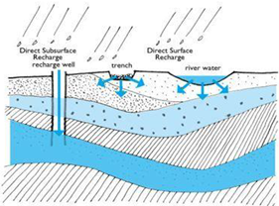

3.1.2 Percolation Tanks (PT) / Spreading Basin:
These are the most prevalent structures in India as a measure to recharge the ground water reservoir both in alluvial as well as hard rock formations. The efficacy and feasibility of these structures is more in hard rock formation where the rocks are highly fractured and weathered. In the States of Maharashtra, Andhra Pradesh, Madhya Pradesh, Karnataka and Gujarat, the percolation tanks have been constructed in plenty in basaltic lava flows and crystalline rocks. The percolation tanks are however also feasible in mountain fronts occupied by talus scree deposits. These are found to be very effective in Satpura Mountain front area in Maharashtra.

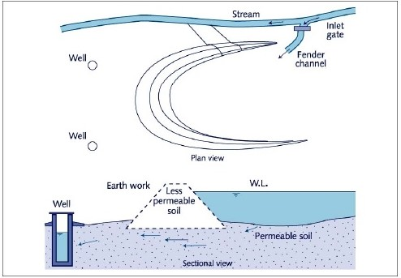

These are the most prevalent structures in India as a measure to recharge the ground water reservoir both in alluvial as well as hard rock formations. The efficacy and feasibility of these structures is more in hard rock formation where the rocks are highly fractured and weathered. In the States of Maharashtra, Andhra Pradesh, Madhya Pradesh, Karnataka and Gujarat, the percolation tanks have been constructed in plenty in basaltic lava flows and crystalline rocks. The percolation tanks are however also feasible in mountain fronts occupied by talus scree deposits. These are found to be very effective in Satpura Mountain front area in Maharashtra.

3.1.3 Stream Augmentation:
Seepage from natural streams or rivers is one of the most important source of recharge of the ground water reservoir. When total water supply available in a stream / river exceeds the rate of infiltration, the excess is lost as run off. This run off can be arrested through check bunds or widening the steam beds thus larger area is available to spread the river water increasing the infiltration. The site selected for check dam should have sufficient thickness of permeable bed or weathered formation to facilitate recharge of stored water within short span of time. The water stored in these structures is mostly confined to stream course and height is normally less than 2m. To harness maximum run off, a series of such check dam may be constructed.

3.1.4 Ditch and Furrow Method:
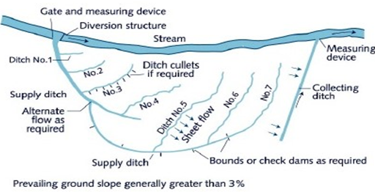
In areas with irregular topography, shallow, flat bottomed and closely spaced ditches or furrows provide maximum water contact area for recharge water from source stream or canal. This technique requires less soil preparation than the recharge basins and is less sensitive to silting. Fig. shows typical plan or series of ditches originating from a supply ditch and trending down the topographic slope towards the stream. Generally three patterns of ditch and furrow system are adopted. This technique required less soil preparation and is less sensitive to silting.

Direct Sub-Surface Method:
3.2.1 Recharge Well:
(a) Injection well- Injection wells are structures similar to a tube well but with the purpose of augmenting the groundwater storage of a confined aquifer by pumping in treated surface water under pressure. The injection wells are advantageous when land is scarce. This techniques was successfully adopted at temple town of Bhadrachallam in A.P. during 1987 to provide safe drinking water to about 2 to 3 lakh pilgrims on the festival of Shriramanawami. In alluvial areas injection well recharging a single aquifer or multiple aquifers can be constructed to normal gravel packed pumping well. An injection pipe with opening against the aquifer to be recharged may be sufficient.
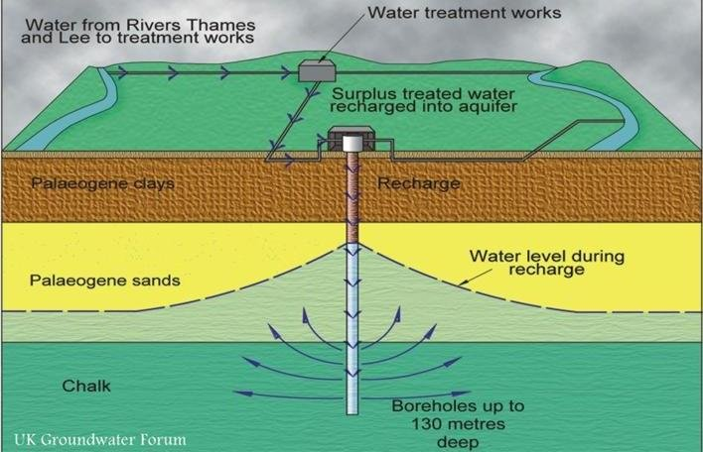
b) Recharge Well (water flows under gravity)- The recharge well for shallow water table aquifers up to 50 m are cost effective because recharge can take place under gravity flow only. These wells could be of two types, one is dry and another is wet. The dry types of wells have bottom of screen above the water table. In such wells excessive clogging is reported due to release of dissolved gases as water leaves the well and on other hand redevelopment methods have not been found effective in dry type of wells. The wet type of wells are the wells in which screen is kept below water table. These wet type wells have been found more successful.

3.2.2 . Pits & Shaft:
In area where impervious layer is encountered at shallow depth the pits and shafts are suitable structure for artificial recharge. These structures are cost effective to recharge the aquifer directly. There are practically no losses of water in form of soil moisture and evaporation like other methods of spreading. The vertical recharge shaft can be further improvised with injection well at the bottom of the shaft. Copious water available can be easily recharged due to large storage and recharge potential. The advantage of shafts / pits structure is that they do not require large piece of land like percolation tank & other spreading method.
3.2.3 Dug wells:
In alluvial as well as hard rock areas, there are thousands of dug wells which have either gone dry or the water levels have declined considerably. These dug wells can be used as structures to recharge . The ground water reservoir, storm water, tank water, canal water etc. can be diverted into these structures to directly recharge the dried aquifer. By doing so the soil moisture losses during the normal process of artificial recharge, are reduced. The recharge water is guided through a pipe to the bottom of well, below the water level to avoid scoring of bottom and entrapment of air bubbles in the aquifer.
3.3 Indirect Techniques:
3.3.1Induced recharge from surface water source:
It is an indirect method of artificial recharge involving pumping from aquifer hydraulically connected with surface water such as perennial streams, unlined canal or lakes. In such methods there is actually no artificial build up of ground water storage but only passage of surface water to the pump through an aquifer. In this sense, it is more a pumpage augmentation rather than artificial recharge measure. In India such wells have been installed in Yamuna Bed at Delhi and other places in Gujarat, Tamil Nadu and Orissa. The large discharges and lower lift heads make these wells economical even if initial capital cost is higher as compared to tube well. In areas where the phreatic aquifer adjacent to the river is of limited thickness, horizontal wells may be more appropriate than vertical wells. Collector well with horizontal laterals and infiltration galleries can get more induced recharge from the stream collector wells constructed in seasonal nala beds these can be effective as induced recharge structures for short periods only.
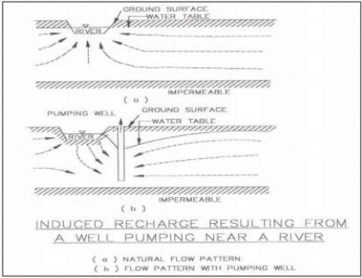
4.0 Monitering Mechanism For Artificial Recharge
PROJECTS
The monitoring of water levels and water quality is of prime importance in any scheme of artificial recharge of Ground Water. The monitoring data speaks for the efficacy of structures constructed for artificial recharge and greatly helps in taking effective measures for Ground Water Management on scientific lines.

4.1 Water Level Monitoring
During the feasibility study stage the monitoring of surface water and ground water levels greatly help in identifying the method of artificial recharge. Net work of observation wells is used to study the ground water flow pattern and temporal changes in potentiometric head in the aquifer. Theobjective of monitoring system is to study the effect of artificial recharge on the naturalground water system. Depending on the method of artificial recharge and thehydrogeology of the area, the observation well net work has to be designed. The periodic monitoring of Water Levels can demarcate the zone of benefit.

The observation well net work during feasibility stage is generally of low well density but spread over a large area with the primary aim of defining the boundary zonation of the aquifer to be recharged and to know the hydraulic characteristics of the natural ground water system. If the recharged aquifer is overlain by confining/semi-confining layer, piezometers should be installed to monitor the water levels of overlying and underlying aquifers which helps in the study of leakages etc. Where the surface water bodies are hydraulically connected with the ground water aquifer which is being recharged, it is advisable to monitor the water level profiles of both Surface water and Ground water.
Method a network of observation wells is following observations are made: -
1. In the zone benefitted, the water levels be observed to the whether the well hydrographs have a flat apex during the time when there is water in the recharge structure.
2. Wells situated outside the zone of influence normally show an angular apex for the period when the recharge is taking place, while these situated within the zone of influence have a flatter area.
3. The recession limbs of wells close to a recharge structure normally have a gentle gradient as compared to those located far off.
4. Crops in the zone of influence will be healthy compared to those outside such an area. , In the zone of influence there is a tendency to grow crops with high water requirements.

5. Well yields in the zone of influence should be greater than those outside it. The wells in benefitted zones may have more sustainability in lean period than those outside. The above criteria can be used to define the zone of influence and thereby, a real and temporal demarcation of the effectiveness of recharge structures.

4.2 Tracer Technique For Demarcating Zone Of Benefit
The tracers are useful in demarcating the area benefitted by artificial recharge, Tritium; Rodhomine B, fluorescent dye and environmental isotopes etc. are quite useful in assessing the extent of recharge and efficiency of recharge structures.
4.3 Water Quality Monitoring
The monitoring of water quality during the implementation of artificial recharge schemes is essential to maintain the quality standards for specified uses of the augmented resource. In case of injection wells the composition of native water in the aquifer and the recharged water is important to prevent clogging of well and aquifer due to excessive precipitation of salts. The data on the chemical quality of native water and the changes which take place during the artificial recharge schemes should be collected by regular sampling from observation well net work. Where treated wastewater is used for recharge a careful monitoring is required to detect and preclude any possibility of contamination through a network of monitoring wells. Thus, the type of water quality monitoring programme depends on the specific problem being studied i.e. changes in ground water quality, effect of soil salination, and prevention of any contamination etc.

4.4 IMPACT ASSESSMENT
The impact assessment of Artificial Recharge schemes can generally be enumerated as follows: -
a) Conservation and harvesting of surplus monsoon runoff in ground water reservoir which otherwise was going un-utilised outside the watershed/ basin and to sea.
b) Rise in ground water levels due to additional recharge to ground water. In case where continuous decline of ground water level was taking place, a check to this and/or the intensity of decline subsequently reduces.
c) The ground water structures in the benefitted zone of artificial structures gains sustainability and the wells provides water in lean month when these were going dry.
d) The cropping pattern in the benefitted zone will undergo marked change due to additionality of ground water and cash crops will start growing. Orchards which went dry earlier due to ground water scarcity may rehabilitated and new plantation be grown.
e) Green vegetation cover may increase in the zone of benefit and also along the structures due to additional availability of soil moisture.
f) The quality of ground water may improve due to dilution.

5.0 CASE HISTORIES OF ARTIFICIAL RECHARGE IN INDIA
5.1 Artificial Recharge In Urban Areas, Nagpur, Maharashtra
Considering the overall physiographic, hydrogeological, hydrological, demographic and socio-cultural set up of the Nagpur Metropolitan Region, following schemes are feasible for ground water augmentations.
a. Roof top rainwater harvesting.
b. Run off rainwater conservation.
c. Recharge through percolation tanks and check dams.
The first two schemes are feasible for the densely populated pockets of the city are aunderlain by basaltic terrain, where land availability for construction of surface reservoir is non-existent. The third scheme of construction of percolation tanks and check dam is feasible for the peripheral and outskirts region which are rural areas with plenty of open space available
5.2 Artificial Recharge in Sikheri, Mandsaur Block, Mandsaur District, Madhya Pradesh
In Mandsaur block, depletion of water levels is taking place due to over development of ground water. Water levels have declined in the range of 1.25- 4.60 m in last 20 years. Level of ground water development is about 119%. A percolation tank is proposed to be constructed.
5.3 Artificial recharge to ground water in NSG Campus, Manesar, District Gurgaon, Haryana
Due to heavy withdrawal of ground water in the campus there is steep decline in water level with the rate of about 40 cm per year causing failure of existing tube wells. Gabbion structures are proposed to arrest surface runoff which will seep naturally.Besides this, treated sewage water will also be recharged to ground water through vertical recharge shafts with inverted filter. It is expected that 0.66 mcm water will be recharged.
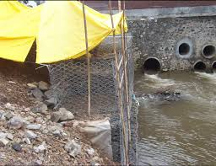

6.0 Research needs for groundwater quality management:
An understanding of the processes that affect the movement and degradation of contaminants in the subsurface environment is essential for effective groundwater quality management. The state of knowledge concerning these processes is, in many ways, insufficient to ensure protection of groundwater quality without excessive restrictions on other surface and subsurface activities.
The research needs for groundwater quality management and outlines research strategies based on the type of processes that affect pollutant movement in the subsurface environment: hydrologic, abiotic ,and biotic. These processes act to influence the movement of water, the physical and chemical interactions that cause the pollutants to move at rates different from those of the water, and the decomposition (chemical or microbial) that removes the pollutant from the subsurface. In view of resolving the uncertainties related to the health effects of groundwater recharge with reclaimed wastewater.

7.0 Incentives to artificial recharge of groundwater:
The increased demand for water will necessitate a more efficient use of present water supplies. Groundwater will probably be called on to take an increasing role in water supply if the past trend continues. The size of groundwater storage (aquifers) is fixed and the amount of precipitation is uncontrolled.
The only tools left to groundwater managers are,
(1) To optimally design and locate pumping wells and recharge facilities.
(2) To manage pumping and recharge over time more optimally.
The objectives of an artificial recharge project may be increased water supply, groundwater quality control, or low flow augmentation. First of those objectives—increasing water supply—pertains to both surface reservoirs and aquifers. Artificial recharge provides more water for the underground reservoir, so more may be pumped during dry periods. Groundwater quality control, however, may involve issues quite different from surface water quality objectives. One of the primary purposes for using recharge wells is to prevent seawater intrusion. The barrier in Orange County, California, for example, was constructed for that purpose.
Groundwater quality control may be to restore an aquifer polluted from industrial wastes or improperly constructed land disposal sites. Normally these programs use artificial recharge, pumping, and treatment to restore groundwater quality.
8.0 OPERATION AND MAINTENANCE:
Periodic maintenance of artificial recharge structures is essential because infiltration capacity is rapidly reduced because of silting, chemical precipitation, and accumulation of organic matter. In the case of injection wells and connector wells, periodic maintenance of the system consists of pumping and / or flushing with a mildly acidic solution to remove encrusting chemical precipitates and bacterial growths on the well tube slots. By converting the injection or connector wells into dual-purpose wells, the time interval between one cleansing and another can be extended, but, in the case of spreading structures, except for sub-surface dykes constructed with an overflow or outlet, annual de-silting is necessary. Unfortunately, because the structures are installed as a drought-relief measure, periodic maintenance is often neglected until a drought occurs, at which time the structures must be restored (the 5 to 7 year frequency of droughts, however, means that some maintenance does take place). Several agencies and individuals normally carry out structural maintenance.

Conclusion:
Thus it can be concluded that artificial recharge give the reduction of runoff, increased availability of ground water especially in summer month, increase in irrigation, revival of springs, improvement in ground water quality. Yet even with full development of artificial recharge, ground availability would remain limited. Though ground water recharge scheme either naturally or artificially may not be the final answer, but they do call for the community effort and create the spirit of co-operation needed to subsequently manage sustainably ground water as a community resource.
Artificial recharge the use of source waters of impaired quality is a legitimate alternative wherein recharge in intended to govern saltwater intrusion, lessen land subsidence, maintain flow baseflows, or comparable in-ground functions. it's far specially nicely acceptable for nonpotable functions, including panorama irrigation, because fitness risks are minimum and public popularity is excessive. where the recharged water is to be used for potable purposes, the health risks and uncertainties are more.
References:
1. Manual on artificial recharge of ground water 1994. Technical series – M, No. 3, Central Ground Water Board, Faridabad, March 1994, 215 p.
2. National Drinking Water Mission and Department of Rural Development 1989. Rain Water Harvesting. Government of India, New Delhi.
3. Nayantara Nanda Kumar and Niranjan Aiyagari 1997. Artificial Recharge of Groundwater.
4. O'Hare, M.P., Fairchild, D.M., Hajali, P.A., Canter, L.W. 1986. Artificial Recharge of Groundwater. Proceedings of the Second International Symposium on Artificial Recharge of Groundwater.
5. Phillips, Steven P. The Role of Saturated Flow in Artificial Recharge Projects. U.S. Geological Survey, Placer Hall, 6000 J Street, Sacramento, California 95819-6129.
6. Sophocleous, M.A. and J. A. Schloss. Estimated Annual Groundwater Recharge. http://www.kgs.ukans.edu/HighPlains/atlas/atrch.htm

