Impact Factor Value 4.046 e-ISSN: 2456-3463
National Conference on “Emerging Trends In Engineering & Technology” Organized by Manoharbhai Patel Institute Of Engineering & Technology Shahapur, Bhandara

International Journal of Innovations in Engineering and Science, Vol. 4, No. 5, 2019 www.ijies.net

ACE PANEL: College Interaction Application

Gnihotri1, Lucky Satija2, Shivani Nipane3, Ashwini kapse4, Ali Wajahat5

1Assistant Professor,2-5Students
Department of Computer Engineering ,MIET,Bhandara -441904

Abstract: Mobile applications can be one of the best ways to keep consumers engaged with a brand as they are on the move. With the increase in demand for Smartphone and efficiency of wireless networks, the demand for mobile applications has increased incredibly. Android is one of the most popular open source platforms that offers the developer’s full access to the framework API’s so as to build innovative applications.In a real world scenario, such as college campus, the data is within the sort of notice, hand-written manual, verbal message, is being unfold among the users. The main aim of this project is to build an Android application that helps the users to know about our branch and also is to implement robot primarily based collage Management application for advancement of establishment and academic system. During this paper we tend to develop associate degree application that provided info like assignments, result and attending, notices and also the department details.The main features provided by the ACE PANEL is basic search application where the user can get whole information about the branch. The users can write a review, see the reviews. Student’s attending is additionally monitored by the applying. We tend to conjointly propose the notification that send notification of recent activity to the users.

Keywords-- Notification module, Academics module.

    - INTRODUCTION

Today, mobile devices became a crucial part of human life. Users access their e-mails, social networks, bank accounts, and varied alternative websites via mobile devices. However still some areas that don't seem to be upgrade with mobile devices. ancient approach employed in faculty wherever college use board to share any info and teacher dictates the notes ahead of scholars and students conjointly write notes in their notebook. This method is time overwhelming for teacher and students. Just in case any pressing notices by higher management like box or

principal take time to achieve everybody. These days it's of the necessary to not solely use the certain sorts of statement, however conjointly new forms like telephone technology, for quicker and easier communication among the scholars. The approach of communication is humanoid. During this paper we tend to develop AN application that provided info like assignments, timetables of examinations, result and group action, notices and therefore the department details. Student’s group action is additionally monitored by the applying. We tend to conjointly propose the notification that send notification of recent activity to the scholars, workers or box whether or not line or offline. It is being developed for AN engineering faculty to keep up and facilitate quick access to data. For this the users should with the system when that they'll access still as modify information as per the permissions given to them. It assists in automating the present manual system. This is often a paperless work. It may be monitored and controlled remotely. It reduces the person power needed. ACE PANEL is an Android application that helps the users to know the more about our college and campus. The main aim of the project is to provide the users an easy to use application that helps them to understand and know more about our branch. It works not only as a simple app , but also it can works as a small college interactive software .Our multipurpose program is considering the user as student , faculties or office staffs individually.

    - RELATED WORK

In existing system, there was an Android application which was presented. The project was basically about branch itself. It contained information about the branch. It was basically invented to reduce the manual work. It provides various aspects that covers notice board that was replaced notifications, paper, syllabus, gallery was also included. The teacher has access to upload and view the content but students has restrictions to view the content only. There were major drawbacks in our existing system that no direct communication was taking place in

Impact Factor Value 4.046 e-ISSN: 2456-3463
National Conference on “Emerging Trends In Engineering & Technology” Organized by Manoharbhai Patel Institute Of Engineering & Technology Shahapur, Bhandara

International Journal of Innovations in Engineering and Science, Vol. 4, No. 5, 2019 www.ijies.net

between faculty and students. To overcome this problem, we proposed this project.
    - PROPOSED METHOD

We proposed an android App for branch activities. This innovative system permits Faculty to share vital information additionally as notifications with students through our App. It consists of Teacher login in conjunction with student login. Since faculty teacher operates through Mobile App and document uploading is less complicated through a mobile, the teacher login is to be performed through a mobile App. Teacher might transfer documents of subject information, notifications, and e notes and update attendances etc. through their provided logins. Here students solely read group action and transfer information of their specific semester. Teacher might access and upload/edit documents to any semester or add any Post as desired. Teacher additionally updates student group action by exploitation mechanical man Application. Additionally login through its mobile device, his role is to observance specific division activities and share document, notes like timetable document.

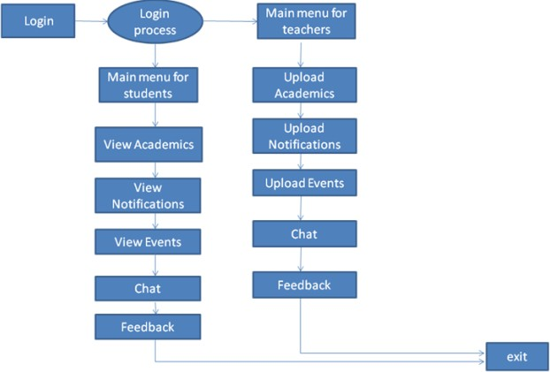

Figure1. Block diagram of ACE Panel.

REGISTRATION AND LOGIN: Given that the user has downloaded the application, then the user should be able to register through the application by maintain the details required for registration. After registration the user can login into the system by providing the user id and password.
User Module: In this module we are authenticating the users by providing user name and password. If user name and
password is valid then they will be taken to their static screens. When they get matched with each other, system checks their status and transfer the control to respective user-interface.
Staff Module: This module is designed for staff, which use mobile phone to take attendance, upload result and upload college notifications as well as discussion forum. The entered admin details are encrypted and sent to server for verification. Only after successful authentication the operations are performed. If username and password cannot match, he/she can enter in to next static screen.
Notification Module: This module allows the department HOD to update students about any college related information through notifications. The students can view notifications provided by the interface provided by application. HOD can send message to only available options like all student, all faculty, specific faculty and to all.
News and Event Service: The news service is for all students and staff. As soon as news about the university/college is released on the university/college website, a notification is sent to all the students and staff.
Academic Module: It contains four modules:

» Timetable

» Attendance

» Syllabus and Paper

» Notes And Marks

Timetable Module: This module allows the students to view timetables and the faculty to upload the respective timetables as per their respective semesters.
Attendance Module: this module helps to keep the track on student’s punctuality and regularity.
Syllabus and paper module: this module contains syllabus and papers. The teachers can upload /update syllabus and papers to their respective semesters and students can view their syllabus and paper as per their respective semesters.
Notes and marks Module: This service is for both the staff and students, however both have diff errant usage of the feature. Students - will be able to view the following information which is critical about the Assignment and Notes; the number of assignments given, upon the analysis using this data, the system will inform the students if they have got the new assignments and notes uploaded by the faculties. Staff - will be able to

Impact Factor Value 4.046 e-ISSN: 2456-3463
National Conference on “Emerging Trends In Engineering & Technology” Organized by Manoharbhai Patel Institute Of Engineering & Technology Shahapur, Bhandara

International Journal of Innovations in Engineering and Science, Vol. 4, No. 5, 2019 www.ijies.net

upload the notes helpful for students and the new assignments using the mobile device.
Chat Module: This module is a feature where students and teachers can discuss the queries from the students.

- RESULTS AND DISCUSSION
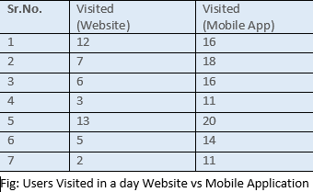

Lots of users might be visiting websites now a days also but not finding an experience as in fast and reliable android app. Also Active user per day chart changed with drastic change in increase in number of users due to faster access to app.

SCREENSHOTS

- LOGIN PAGE:
- SIGNUP PAGE:
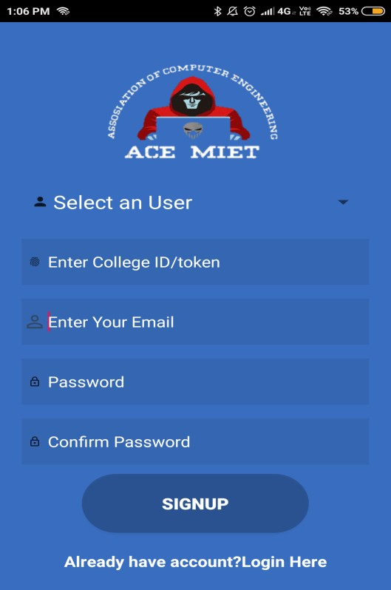

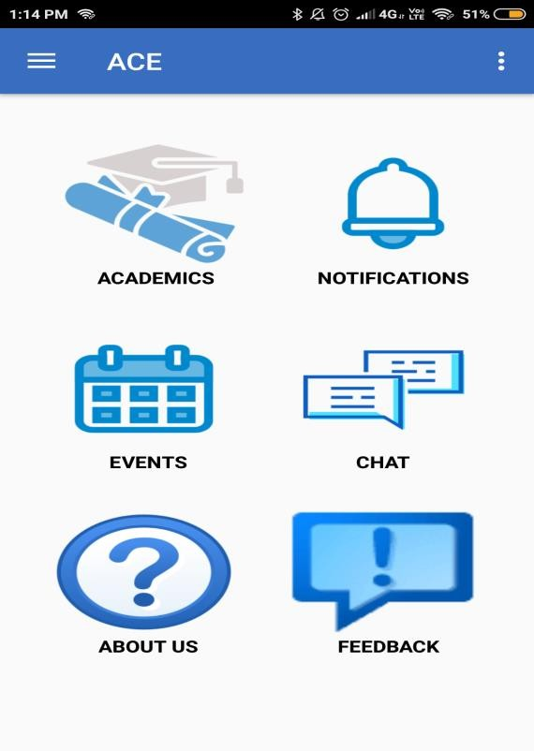
- MAIN MODULE:

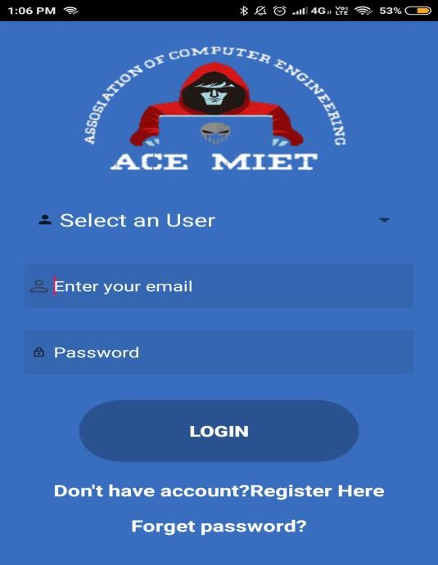

Impact Factor Value 4.046 e-ISSN: 2456-3463
National Conference on “Emerging Trends In Engineering & Technology” Organized by Manoharbhai Patel Institute Of Engineering & Technology Shahapur, Bhandara

International Journal of Innovations in Engineering and Science, Vol. 4, No. 5, 2019 www.ijies.net

- ACEDMICS MODULE:

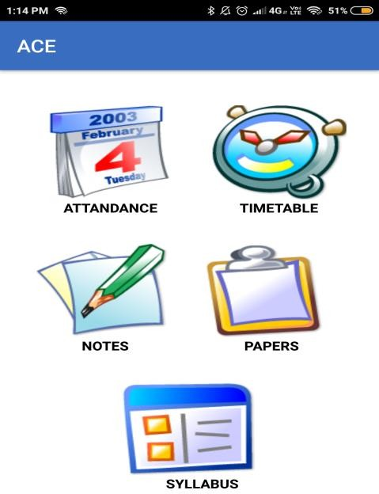

- NAVIGATION DRAWER:

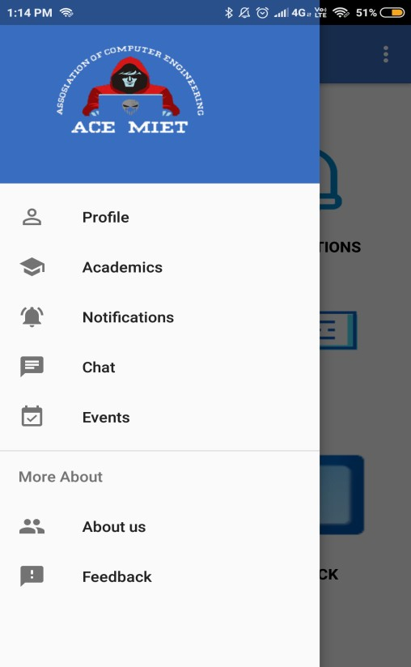
- CONCLUSIONS AND FUTURE WORK

This application offers reliability, time saving and easy control. The proposed system provides the new way of computing and monitoring the operations with responsive and attractive user interface. It will also help to digitize app and help to deploy resources efficiently.

We proposed system on online database enables teacher to transfer notes, notifications, events and academic information. These information are shared with student directly. We offer secure authentication to unauthorized access. In future we introduce, Parent Teacher Communication may additionally be developed. Assignments are often submitted through on-line and mail etc. Online library system can also be introduced.

References

- Alit Mohan Joshi, “A Research Paper on College Management System”, International Journal of Computer Applications (0975–8887) Volume 122 – No.11, July 2015.

- Shiplap Hamale,Thakur Ganesh singh,Syed Arshad Husain “Android College Campus ”,International journal of ethics in Engineering & Management Education,ISSN:2348-4748, 2014.

- S.R. Bharamagoudar, Geeta R.B., S.G.Totad (2013 "Web Based Student Information Management System”,International Journal of Advanced Research in Computer and Communication Engineering Vol. 2, Issue 6, June 2013.

- Zhi-gang YUE, You-wei JIN, “The development and design of the student management system based on the network environment”2010 5. A.J.Kadam, Aradhana Singh, Komal Jagtap, Srujana Tankala,”Mobile Web Based Android Application for College Management Sysytem”2017

- Priyanka Jichkar1,Kalyani Gawande2, Arshadkhan Pathan3, Prof. Gangotri Nathaney, “Android Based Department App – Using Smart Phone” 2017

- Vishwakarma R Ganesh,”Android College Management System”,2016

- Siti Aisah Mohd Noor, Norliza Zaini, Mohd Fuad Abdul Latip, Nabilah Hamzah “Android Based Smart Learning and Attendance Management System”2015

Impact Factor Value 4.046 e-ISSN: 2456-3463
National Conference on “Emerging Trends In Engineering & Technology” Organized by Manoharbhai Patel Institute Of Engineering & Technology Shahapur, Bhandara

International Journal of Innovations in Engineering and Science, Vol. 4, No. 5, 2019 www.ijies.net
- Hsuan-Che Yang,Wen-Ying Wang “Facilitating Academic Service-Learning with Android-based Applications and Ubiquitous Computing Environment ”, Published in 978-0- 7695-4493-9/11 2011 IEEE.

- Cia Zhongxi,"Campus Employment Information Network Development based on Android Platform” International Conference on Intelligent Transportation, Big Data Smart City 2016 IEEE .

