**Performance Investigations on CI Engine Using Ethanol-Diesel Blends With EGR**

**Girish bhiogade1 Dilip borkar 2, shifan biag mirja3, vaibhav faye4**, **pawan lanjewar5 ,vijaykumar kapgate6 ,rakesh rajgire7**

*2Assistant professor, scholars5*

*Dept. of mechanical Engineering, Rastrasant Tukadoji Maharaj Nagpur University, Nagpur*

**ABSTRACT**- *An experimental investigation is to evaluate the effects of blends of ethanol and conventional diesel fuel on the performance and exhaust emissions on a single-cylinder, direct injection (DI), which installed at the workshop of our college. The tests will be conducted using ethanol-diesel fuel blends varying in 10 to 30%, with the engine working at constant speed and no loads to variable load. Fuel consumption, thermal efficiency, exhaust smoke and exhaust regulated gas emissions such as nitrogen oxides, carbon monoxide and total unburned hydrocarbons will be measured. The differences in the measured performance and exhaust emissions of the ethanol–diesel fuel blends from the baseline operation of the engine, i.e. when working with neat diesel fuel, will determined and compared. Theoretical aspects of diesel engine combustion combined with the widely differing physical and chemical properties of the ethanol against those for the diesel fuel, are used to aid the correct interpretation of the observed engine behavior.*

**Keywords**—exhaust gas recirculation, ethanol, diesel, blends, nitrogen oxides, carbon mono-oxide

**I- INTRODUCTION**

**I**ncreased fissile fuel consumption decreases the limited reserves of the world energy. About 71 barrels are burnt everyday throughout the world. And this consumption rate goes on increasing by 2% every year. The 2% doubles the quantity every 34 years. Somewhere between 1000 to 1600 billion barrels of fuel consumption are assumed to be in formation where economic recovery is possible. The current rate of consumption 1600 billion barrels would be depleted in 60 years. There were many attempts made to use bio-fuels in compression ignition engine. Jincheng Huang et al.(2008)[15]carried out tests to study the performance and emissions of the engine fuelled with the ethanol diesel blends. They found it feasible and applicable for the blends with n-butanol to replace pure diesel as the fuel for diesel engine. Bhattacharya and Mishra(2002)[16]evaluated the feasibility of preparing diesel-ethanol blends using anhydrous ethanol and ethanol and found ethanol blends indicate power producing capability of the engine similar to that of diesel. Hansen et al.(2001)[14]found that the properties of ethanol –diesel blends have a significant effect on safety, engine performance, durability and emissions[11]. Wang et al.(2003)analyzed that the most note worthy benefits of E-diesel use lie with petroleum fuel reductions in urban particulate matter and CO emissions by heavy vehicle operation. Coming to output of an IC engines i.e the emissions which have an adverse effect on environment by causing air pollution. Exhaust emissions of an automotive IC engine constitutes of oxides of Nitrogen (NOx),oxides of sulphur (SOx) oxides of carbon (CO and CO2),un-reacted oxygen, un-reacted Nitrogen, Un burnt Hydro carbons, particulate matter and water vapours etc., each of them have a specific indication on performance of the engine and effect on the environment. Diesel exhaust contain several pollutants that contribute to the formation of ground level ozone, acid rain, and are harmful to public health alone or in combination with other substance. So to control emissions and to prolong the reserves of petroleum products experiment conducted using diesel and ethanol blends with EGR on Diesel engine.

**3. EXHAUST GAS RECIRCULATION**

EGR is commonly used to reduce NOx in S.I engines as well as C.I engines. The principle of EGR is to re circulate about 10% to 30 % of the exhaust gases back into the inlet manifold[6] where it mixes with the fresh air and this will reduces the quantity of O2 available for the combustion. This reduces the O2 concentration and dilutes the intake charge, and reduces the peak combustion temperature inside the combustion chamber which will simultaneously reduce the NOx formation. About 15% recycle of exhaust gas will reduce NOx emission by about 80%. It should be noted that most of the NOx emission occurs during lean mixture limits when exhaust gas recirculation is least effective. The exhaust gas which is sent into the combustion chamber has to be cooled so that the volumetric efficiency of the engine can be increased.EGR ration is defined as the ration of mass of recycled gases to the mass of engine intake. The exhaust gas for recirculation is taken through an orifice and passed through control valves for regulation of the quantity of recirculation. Normally exhaust gas recirculation is shutoff during idle to prevent rough engine operation. EGR is a very useful technique for reducing the NOx emission. EGR displaces oxygen in the intake air and dilute the intake charge by exhaust gas re-circulated to combustion chamber. Re- circulated exhaust gas lower the oxygen concentration in the combustion chamber and increase the specific heat of the intake air mixture, which results in lower flame temperature. It was observed that 15% EGR rate is found to be effective to reduce NOx emission substantially without deteriorating engine performance in terms of thermal efficiency, Break specific fuel consumption (BSFC) and emissions .thus, if higher rate of EGR can apply at lower loads and lower rate of EGR can be applied at higher loads. EGR can applied to diesel engine fueled with diesel oil the diesel oil, bio diesel , LPG , Hydrogen etc., without sacrificing it efficient and fuel economy and NOx reduction can be thus achieved .EGR is useful technique for reducing NOx formation in combustion chamber. Exhaust consists of CO2 .N2 and water vapors mainly. When a part of this exhaust gas is re circulated to the cylinder, it acts as diluents to the combusting mixture. This also reduces the O2 in the combustion chamber. This specific heat EGR is much higher than the fresh air, hence EGR increase the heat capacity (sp.heat) of the intake charge, thus decreasing the temperature rise for the same heat release in the combustion chamber.

**3.1 CONTROL VALVE**

A control valve is a valve used to control fluid flow by varying the size of the flow passage as directed by a signal from a controller. This enables the direct **control** of flow rate and the consequential control of process quantities such as pressure, temperature, and liquid level.

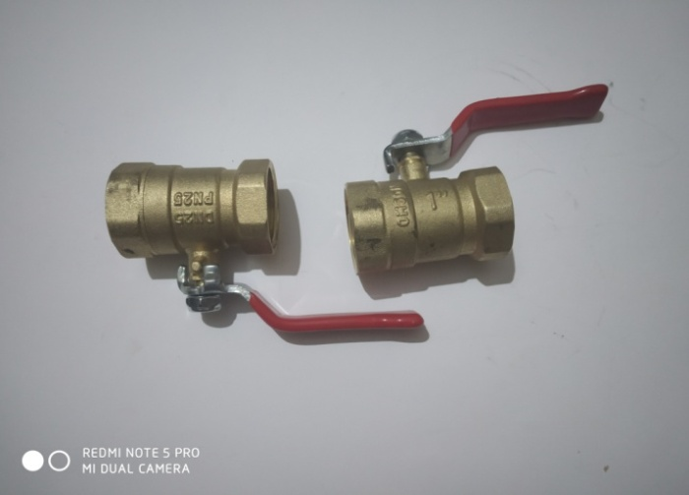

**3.2 DAMPER**

A means of controlling the flow ofair into a stove. Usually, a damper was a plate that could be slide a cross air openings, but thedamper in a stovepipe was a metaldisk mounted inside the pipe thatcould be turned from being parallelto theair flow to perpendicular, completely cutting off air flow.

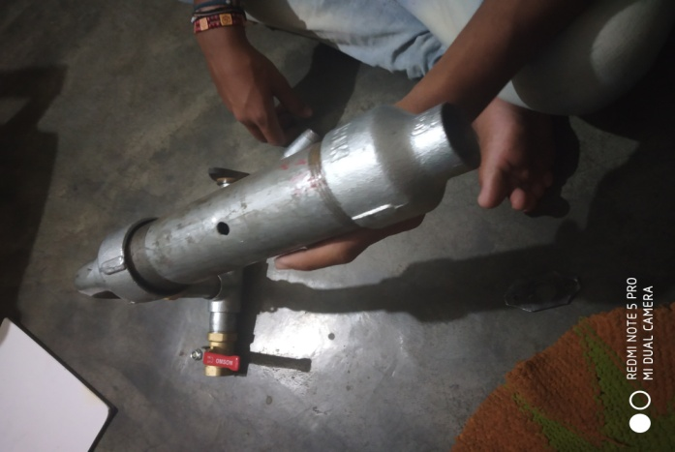

**5.3 ORIFICE METER**

An orificeMeter is a device used for measuring flow rate, for reducing pressure or for restricting conditions.



**3.4 Ethanol fuel:-**

Ethanol is alternative fuel. There is increasing of use of “E-10 Unleaded” gasoline because the fuel performs well in automotive engines and the priced with “conventional” gasoline.

Reasons for using of ethanol. dependence

1. Ethanol can reduce country’s on imported oil, it should foreign supplies be interrupted.

2. Farmers has increased demand of grain, which helps to stabilize prices.

3. The ethanol is improving quality of the environment. It reduced Carbon monoxide emissions, lead and other carcinogens (cancer causing agents) which removed from gasoline.

4. Ethanol-blended fuels can clean the fuel system also absorb moisture.

**4. ETHANOL AND DIESEL FUEL PROPERTIES**

These are a number of fuel properties that are essential to the proper operation of a diesel engine. The addiction of ethanol diesel fuel affects certain key properties with particular reference to blend **stability, viscosity** & **lubricity**, energy content and **cetane** number.

|  |  |  |  |
| --- | --- | --- | --- |
| **SR .** | **PROPERTIES** | **DIESEL** | **ETHANOL** |
| 1. | Density (kg/m3) | 820-850 | 880-900 |
| 2. | Calorific value (kj/kg) | 46500 | 44120 |
| 3. | Cetane number | 45-55 | 5-8 |
| 4. | Auto-ignition | 235 | 423 |
| 5. | Specific gravity | 0.84 | 0.60 |
| 6. | Octane number | 03 | 113 |
| 7. | Color | Light brown | Colorless |

**5. EXPERIMENTAL SETUP**

This experimental work is to investigate the performance of single cylinder 4-stroke diesel engine connected to eddy current dynamometer fuelled with diesel oil with ethanol blends with EGR (10%, 20%, 30%) diesel fuel with blends under different load conditions and constant engine running speed. The emissions at normal and excess cooling rates are studied with varying cooling rates in the experiment.

**6. ENGINE SPECIFICATION:**

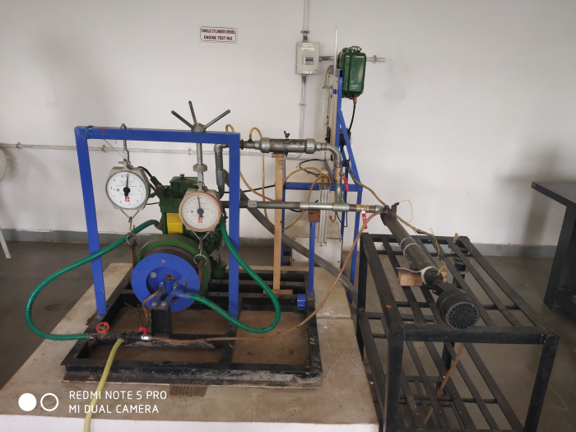

**6.1 SPECIFICATION OF SINGLE CYLINDER DIESEL ENGINE**

|  |  |
| --- | --- |
| **Specification** | **Parameters** |
| Method of cooling | Water cooling |
| No. of cylinder | 1 |
| Rated power- BHP/kW | 5/3.7 |
| Bore x Stroke (mm) | 85 x 80 |
| Dynamometer | A rope, brake pulley of diameter 270 mm |
| Belt thickness | 6 mm |
| Effective radius of brake | 141 mm |
| Orifice diameter | 20 mm |
| Rpm | 1500 |
| Cubic capacity | 0.454 |
| Compression ratio | 18:1 |

**6.2 exhaust GAS ANALYZER**



The exhaust gas temperature is measured by thermocouple and the exhaust analyzer analyzes the emissions like HC, CO, NOx, CO2 and O2. Exhaust gas analyzer is of MN-05 multi gas analyzer (5 gas version) is based on infrared spectroscopy technology with signal inputs from an electrochemical cell. Non dispersive infrared measurement technique uses for CO, CO2 and HC gases. Each individual gas absorbs infrared radiation absorbed and it can be used to calculate the concentration of the sample gas. Analyzer uses an electrochemical cell to measure the oxygen concentration. it consists of two electrodes separated by an electrically conducted liquid or cell. The cell is mounted behind a poly tetra-fluro-ethane membrane through which oxygen can diffuse. The device therefore measures oxygen partial pressures. If polarizing voltage is applied between electrodes the resultant current is proportional to the oxygen partial pressure.

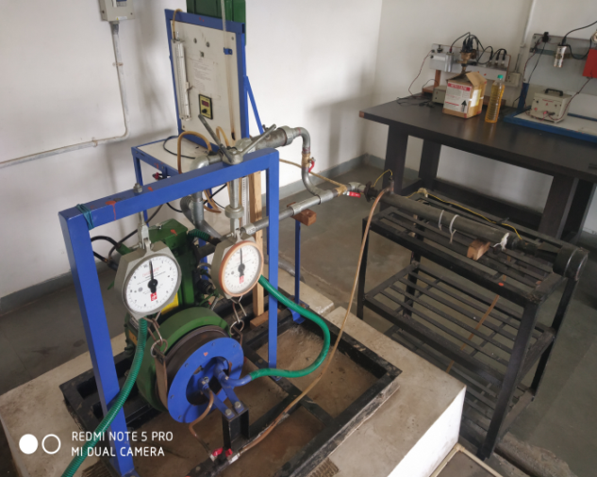

**6.3 EXPERIMENTAL RESULT AND DISCUSSION**

Exhaust gas emissions are studied with exhaust gas analyzer at peak load (3KW) for both diesel fuel and biodiesel fuel, with and without EGR and values are recorded as follows: Biodiesel blended with diesel fuel in concentration of 10%, 20%, 30%, and in 100% by volume on single cylinder engine. At high loads using single injection, particle and CO2 (carbon dioxide) and NOx (Nitrogen oxide) emission were decreased. A slight increase in CO was observed as the Cotton seed oil concentration is increased. HC (Hydrocarbons) at diesel-ethanol blend will be decreased after blend 2 and 3 will be increased and O2 (Oxygen) percentage will be increased. The performance, emission and combustion characteristics of biodiesel blends were evaluated on a single cylinder, four strokes, water cooled diesel engine.

**GRAPH 1**. B.S.F.C. VS B.P

B.S.F.C (X-axis)

B.P (Y-axis)

**GRAPH** **2**.B.T.E. VS B.P

B.T.E (X-axis)

B.P. (Y-axis)

**GRAPH** **3**.H.C VS B.P

BP (X-axis)

H.C (Y-axis)

**GRAPH** **4**.NOX VS BP

B.P (X-axis)

NOX (Y-axis)

Table 1: Emission Characteristics for Pure Diesel

|  |  |  |  |  |
| --- | --- | --- | --- | --- |
|  | 0% EGR | 10% EGR | 20% EGR | 30% EGR |
| CO in vol% | 0.100 | 0.066 | 0.066 | 0.074 |
| O2 in vol% | 8.3 | 8.47 | 8.46 | 8.44 |
| CO2 in vol% | 7.67 | 7.47 | 7.52 | 7.59 |
| NOx in PPM | 00750 | 00764 | 00764 | 00754 |
| HC in PPM | 0131 | 0131 | 0128 | 0128 |

Table-02:- Emission Characteristics for diesel-ethanol blend(90%diesel+10%ethanol)

|  |  |  |  |  |
| --- | --- | --- | --- | --- |
|  | 0% EGR | 10% EGR | 20% EGR | 30% EGR |
| CO in vol% | 0.212 | 0.174 | 0.154 | 0.136 |
| O2 in vol % | 7.93 | 8.20 | 8.02 | 8.30 |
| CO2 in vol% | 9.01 | 8.45 | 8.28 | 8.01 |
| Nox in PPM | 00622 | 00671 | 00697 | 00729 |
| HC in PPM | 0004 | 0030 | 0062 | 0084 |

**7. Conclusion and future scope**

Nitrogen oxide (NOx) emissions decreased by 17% by using ethanol-diesel blend as fuel at 0%EGR compared to pure diesel There was a reduction of 77 % of hydro carbon (HC) emissions by using ethanol-diesel blend as fuel when compared to pure diesel. The minimum carbon dioxide (CO2) emission was observed for ethanol-diesel blend with the introduction of 20 % EGR At excess flow rate (6 LPM) for engine having pure diesel as fuel, the nitrogen oxide (NOx) emission got reduced by 6% compared to normal flow rate (4LPM) Carbon dioxide (CO2) emission decreased with the introduction of excess cooling rate and by using ethanol-diesel blend as fuel when compared to normal cooling rate engine.

**REFERENCE**

[1] *Avinash Kumar Agrawal, Shrawan Kumar singh, Shailendra sinha and Mritunjay Kumar, “Effect of EGR on exhaust gas temperature and exhuat opacity in compression ignition engines”S_adhan_Vol.29, part 3, June 2004, pp 275-284, printed in India*

*[2] Andrzej Kowalewiezl,Technical university of Radom and Zbigniew pajaczek2, ScaniaPoldka S.A.,”Dual fuel Engine fuelled with Ehanol and diesel fuel, Journla of KONES internal combustion Engines 2003,Vol.10, No 1-2,staraWies k/Nadarzyna*

*[3] ”Utilization of Biodiesel-Diesel-Ethanol Blends in CI Engine”, IstvanBarabas and Ioan-Adrian Todorut,Technical University of Cluj-Napoca Romania.*

*[4] “Experimental investigation onD.I diesel engine fuelled by ethanol diesel blend with varying inlet air temperature”,R.Senthil Kumar1 ,R.manimaran2 and V.Gopalakrishnan3 ,1,3 Mechanical Engineering,Annamalai University,India,2Mechanical Engineering, Pondicherry Engineering college, India, Pelagia Research Library, Advances in Applied Science Research,2013,4(1):319-329.*

*[5] The effect of alcohol fumigation on diesel engine performance and emissions M.Abu-Qudais*, o. Haddad, M. Quadisat Faculty of Engineering, Mechanical Engineering Department, Jordan University of Science and Technology, P.O. Box 3030, Irbid 22110, Jordan Received 28 September 1998; accepted 16 May 1999 Energy Conversion management 41 (2000).*

*[6] “Engine Emissions at Various Cetane Numbers with Exhaust Gas Recirculation”, B Lakshmana Swamy1 *, Dr. K Vijaya Kumar Reddy2 , Dr. B SudheerPrem Kumar3 , IOSR Journal of Mechanical and Civil Engineering (IOSR-JMCE), Volume 8, Issue 6 (Sep. – Oct. 2013), PP 09-14*

*[7] “Effect of Blending Alcohol with Diesel on Performance, Combustion and Emission Characteristics of Four Stroke Diesel Engine”, an Experimental Study by T.Balamurugan1*, R. Nalini2 1 Reasearch Scholar, Anna University, Chennai, Tamil Nadu, India, International Journal of ChemTech Research CODEN(USA), Jan-March 2014.*

*[8] “Ethanol – Diesel and Bio-Diesel Blend as Substitute Fuel to CI Engines”, a comprehensive review by Aradhana Pandey1, Sandip Gnagil2, Savita Vyas3, Anurag Gaur4, International Journal of Emerging Technology and Advanced Engineering, Volume 3, Issue 12, December2013).*

*[9] “Physico-chemical properties of ethanol-diesel blend fuel and its effect on performance and emissions of diesel engines, “De-gang Li*, Huang Zhen, Lu Xingcai, Zhang Wu-gao, Yang Jian-guang School f Mechanical and Power Engineering, Shanghai Jiaotong University, Shanghai, China received 8 September 2003; accepted 15 July 2004.*

*[10] “Experimental Analysis of Single Cylinder Four Stroke Diesel Engine with Ethanol & Diesel Blends”, Ajith K1, GavudhamaKarunanidhi S2, Prince M G3, SubbaRao G4, International Journal of Science and Reasearch (IJSR).*

*[11] Yahuza I1 and Dandakouta H2 ., A Performance Review of Ethanol-Diesel Blended Fuel Samples in Compression-Ignition Engine” Department of Automobile Engineering, Abubakar Tafawa Balewa University Bauchi, Nigeria-Journal of Chemical Engineering & Process Technology- ISSN: 2157-7048-November 05, 2015*