Development& Fabrication of Electric Car

Dr. G. Bhiogade¹, Ashish Chaudhari², Mayur Zelkar³, Rajat Thaokar⁴, Vikki Thakre⁵
¹Assistant Professor ,²⁻⁵Scholars
Department of Mechanical engineering, MIET Bhandara – 441904

Abstract-In terms of air pollution and greenhouse gas emission, electric cars are often cleaner than even the most efficient conventional vehicles. The development of electric vehicle is becoming important due to scarcity of fuels and day to day rising in the price of fuel. This simplicity in electric cars is an advantage because there is less maintenance. EVs are also far more energy efficient than gasoline engines and they are very quiet in operation.
Keywords: - Electric vehicle, Controller, Converter, BLDC Motor, Lead acid battery, Hydraulic braking system.
- INTRODUCTION
EVS are vehicles that are powered by electric motor instead of an internal combustion engine and the motor is run using the power stored in the batteries. The development of electric vehicle is very perspective and important process. Electric motors give instant torque and smooth acceleration. EVs are known as zero emission vehicles and are much environmental friendly than gasoline or LPG powered vehicles.An electric vehicle, uses one or more electric motors for propulsion.

The two main types of electric cars are: all electric and hybrid. All electric cars run only on batteries that are charged up by an electrical outlet and are only

powered by the electric motor. Hybrid Electric Vehicles are powered by an electric motor and a gasoline engine. EVs can also reduce the emissions that contribute to climate change and smog, improving public health and reducing ecological damage.
While an electric car’s power source is not explicitly an on board battery, electric cars with motors powered by other energy sources are typically referred to by a different name. An electric car carrying solar panels to power it is a solar car and an electric car powered by a gasoline generator is a form of hybrid car.
- OBJECTIVE OF ELECTRIC CAR
The main objective to development & fabrication of electric car is to control the emission of greenhouse gases. The prices of these vehicles are also being taken as a factor to develop more economic-friendly vehicles that more people can afford to drive. To study the current expectation of consumers with respect to electric vehicles, this will lead to its potential for future.
- WORKING PRINCIPLE OF ELECTRIC CAR
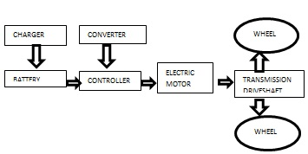
Figure 1. Working principle of electric car
The Electric vehicles power source is the battery and power supplies to the electric motor with the energy necessary to the vehicle. This gives the car acceleration. When the vehicle is idle there is no electrical current being processed, so energy is not being used up. The controller acts as regular, and controls the amount of power received from the batteries so the motor does not burn out. The battery used in electric car is lead –acid battery. The drive controller takes powers from the batteries and delivers to motor. The drive controller consist of two variable resistors operated by accelerator pedal or brake pedal. Accelerator pedal signal send to drive controller through resister to adjust the power to be delivered to the motor. The drive controller gets signals from both the potentiometer but operates only if the two signals are equal. Dc converter is used to step down the voltage from a high voltage source to a lower voltage and the required power transmit to the motor and the motor converts electrical energy to mechanical energy.
- THE COMPONENTS USED FOR ELECTRIC CAR
SR.NO. | COMPONENTS | SPECIFICATION
1 | BLDC Motor | 48V , 950 watt
2 | Battery | 12V, 35 Ah
3 | Motor Controller | 48V, 900 watt
4 | Charger | Input Voltage: 140-260V  Output Voltage: 48V
5 | DC converter | Input: 42-60V  Output: 12V DC/5A

- EXPERIMENTAL SETUP
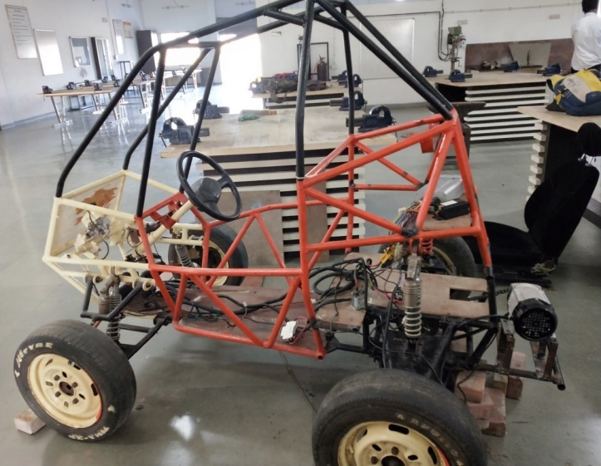
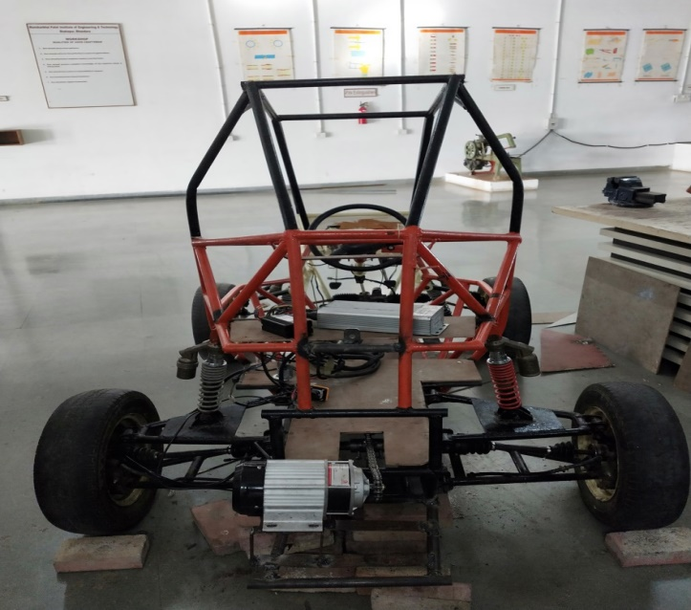
Figure 2. Set up of electric vehicle
- CONCLUSION
We have successfully design and fabricate the Electric Car and our car have successfully drive on the road. These car run upto 40 km with the battery capacity of 48 Volt and 140 Ah. These electric car is noise free as well as emission free. We have successfully fabricate these car with very cheap price. These car is more energy efficient and also having less maintenance. Hence by the use of these electric car we can reduce the emission of green house gas and also reduce the pollution.
- REFERENCES

- Brain, M. (2002). How Electric Cars Work. Retrieved January 29, 2010 from http://auto.howstuffworks.com/electric-car2.htm.
- Electric Vehicles (EVs).(2009) Retrieved January 31, 2010 from http://www.fueleconomy.gov/feg/evtech.shtml.
- Chafkin, M. (n.d.). A Broken Place: The Spectacular Failure Of The Startup That Was Going To Change The World. Retrieved July 31, 2015, from http://www.fastcompany.com/3028159/a-broken-place-better-place
- Ann Holms A Technical Research Report: The Electric Vehicle Prepared for March 11, 2010.
- X. D. Xue, K. W. E. Cheng, and N. C. Cheung. Selection of Electric Motor Drives for Electric Vehicles. 15 April 2016.

