Design, Analysis And Optimization Of Pellets Forming Hydraulic Press

Akash D. Kukade¹, Swapnil Chaudhari², Dr. Somdatta Karanjekar³, Dr. Bharat Chede⁴

¹M. Tech Student of CAD/CAM, ²Assistant Professor, ^{3,4}Professor
Wainganga College of Engineering & Management, Nagpur, India, 441110

kukadeakash@gmail.com

Received on: 18 May, 2023 Revised on: 17 June, 2023 Published on: 19 June, 2023

Abstract – This hydraulic press is a mechanical machine used for compressing various pellets and components. The exertion of force in the hydraulic press machine relies on the utilization of hydraulic fluids, which serve to amplify the pressure within the cylinder. The hydraulic press machine works on Pascal's principle. A Hydraulic press machine is used for the manufacturing of pellets. This Hydraulic press machine is designed and fabricated for a capacity of 25 Ton. The hydraulic press machine applies a maximum 25Ton force for pressing operation. The hydraulic cylinder applies pressure on the die and punches, so at applying specific load powder form material is converted to solid pellets form. In filling and pressing operation hydraulic press machine plays a very important role. The goal of structure optimization is to decrease the total mass and cost of the hydraulic press. The frame and cylinder are modeled by using Solidwork software and analyzed by using Ansys Software. The objective of this paper is to design and structural analysis, estimation of equivalent stress and deformation of existing pellets forming hydraulic press machine as well as reduce weight and cost of the hydraulic press machine. Modify the structure and reduce the material in it and the factor of safety obtained from the modified structure is within the limit of the machine.
Keywords- Hydraulic press machine; base; Finite elements analysis; Optimization.
I -INTRODUCTION
This hydraulic press is a mechanical machine used for compressing various pellets and components. The exertion of force in the hydraulic press machine relies on the utilization of hydraulic fluids, which serve to amplify the pressure within the cylinder. The hydraulic press machine works on Pascal's principle. This hydraulic press machine consists of basic components used in a hydraulic system like a hydraulic cylinder, piston, ram, 4 pillars, pipelines for fluid flow, a power pack, and a controller. The piston inside the cylinder is pushed by hydraulic fluid, which causes the movement of the piston. A ram connected with a piston then compresses the material. Incompressible fluid such as oil with proper density and viscosity is used as a link for transmitting hydraulic pressure.
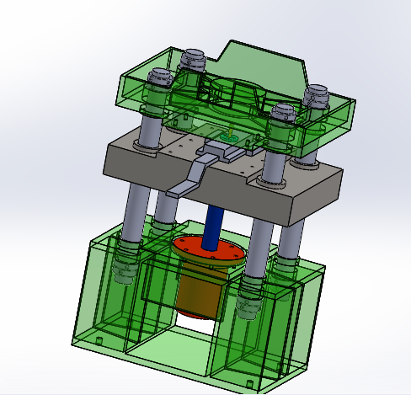
Fig 1. 3D model of existing hydraulic press machine
Given the existing circumstances in the hydraulic press machine industry, where new products are often designed solely based on experience without incorporating any enhancements, this paper aims to address this issue by focusing on optimization and parametric design using finite element analysis. Furthermore, taking into account the growing demand for lightweight designs, the study explores alternative approaches to improve the product's efficiency and performance. Modeling of hydraulic press is done by using Solidwork software and analysis of existing hydraulic press and optimization design of hydraulic press is done by using Ansys software. This Hydraulic press machine is used for the manufacturing of various types of pellets. The hydraulic cylinder applies the pressure on Die and punches, so applying a specific load of powder form material converted to solid pellets form. In filling and pressing operation hydraulic press machine plays a very important role. To analyze the existing design for checking design conditions and optimize the design for better results and requirement fulfillment. The main objective of Design analysis and optimization of the Hydraulic press is to study design and optimize the design to reduce the weight of the hydraulic press machine.
II -PROBLEM STATEMENT
At present, some new products are always designed with experience, without any improvement. Consider the current situation in the hydraulic press machine industry. At present our company needs to change hydraulic presses according to production planning and tonnage requirements. This hydraulic press is heavy and risky for movement and installation. Maintenance and changing of a hydraulic cylinder of a hydraulic press is a time taken and risky operation.
III- OBJECTIVE
- The objective of this project is to design and structural analysis of existing pellets forming a hydraulic press machine.
- Estimation of Equivalent stress and deformation of existing pellets forming hydraulic press machine.
- Optimized the design of the hydraulic press to reduce the weight of the hydraulic press machine which is helpful for easy movement and installation.
- Estimation of Equivalent stress and deformation of optimized pellets forming hydraulic press machine.
- Compare the Equivalent stress and deformation result of existing and optimized pellets forming a hydraulic press machine.
IV- METHODOLOGY
- The study has been carried out of an existing 25-ton hydraulic press.
- Modeling of hydraulic press machine by using SolidWorks software.
- To carry out the analysis of existing hydraulic press machines in Ansys software.
- Optimize the design of the existing hydraulic press machine by using SolidWorks software.
- To carry out the analysis of the optimized hydraulic press machine in Ansys software.
- Compare the result of equivalent stress and deformation of existing and optimize the design of the hydraulic press machine.
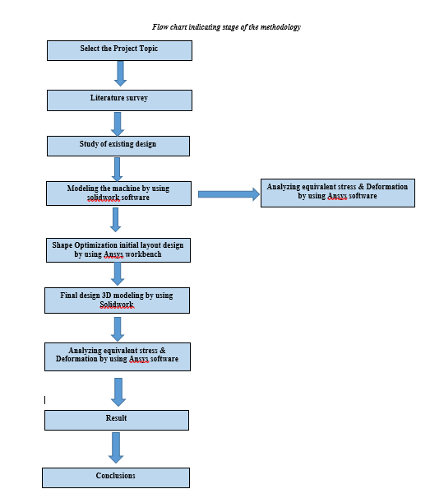
Fig 2. Flow Chart Indicating Stage of the Methodology
V-DESIGN & ANALYSIS PROCEDURE
The first step is to study the design of the existing press. After studying of existing press take some details as requirements.
The capacity of the Hydraulic press – 25 Tons
Type of Hydraulic press – Up – Stroking
Construction of material – Mild Steel (IS 2062)
The density of mild steel - 7750 Kg/M³
Compressive yield strength – 207 MPA
Tensile yield strength – 207 MPA
Guide Pillars – Dia 95 MM (EN-8)
Slide Drive – with hydraulic cylinder
Slide Guide – Dia 95 MM of 4 pillars
Day Length – 500 MM
Work table size – 600X900 MM
Total weight of press – 1395.7 Kg
Stroke length – 150 MM
Cylinder ID Diameter – 190MM
So required pressure for pressing 25 tons is –
P = $\frac{F}{A}$
A = $\frac{π}{4}xD^{2}$
= $\frac{3.142}{4}x{19}^{2}$
A = 283.56 CM²
So required pressure is
P = $\frac{250000}{283.56}$
= 88.167 Kg/ CM²
Punch and Die Materials – Structural steel
The density of structural steel – 7850 Kg/M³
Compressive yield strength – 250 MPA
Tensile yield strength – 250 MPA
Power pack Details –
Reservoir capacity – 200 Ltr
Motor capacity – 7.5 HP (1440 RPM)
Low-pressure pump – 65 LPM (Vane pump)
High-Pressure pump – 6.2 LPM (Piston pump)
Solenoid Coil
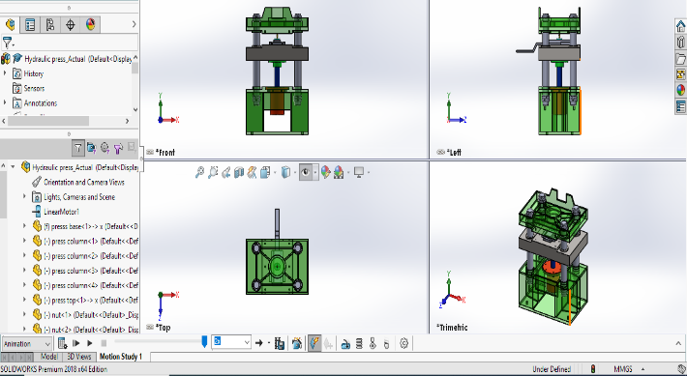
Fig 3. 3D diagram of existing hydraulic press machine
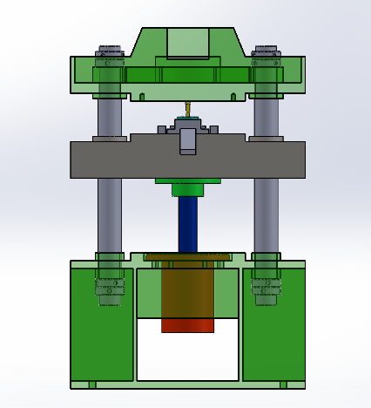
Fig 4. Working conditions Hydraulic press machine
After designing the 25 Ton Hydraulic press machine in Solidwork, analyze this hydraulic press in Ansys Software by using static structural analysis. First, create a 3D model in the modeling software SolidWorks which is used here. Then import the CAD model in Ansys Software for static structural analysis. The third step is Appling material i.e. mild steel IS 2062. Select MS material because MS is ductile material and it is good machinability and weldability property.
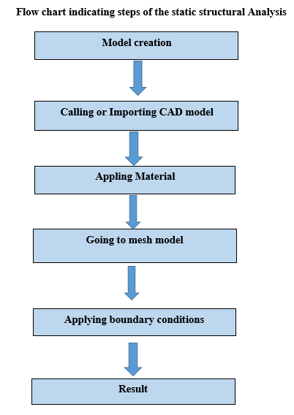
Fig 5. Flow Chart of Steps for static structural analysis
The Hydraulic press machine structure is relatively complex and it is difficult to solve the analysis. It takes a lot of time in giving results so create a mesh model for easy computational analysis.
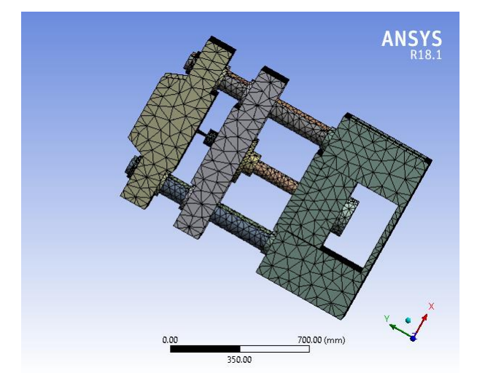
Fig 6. The meshing of existing press
Applies boundary conditions which is one is fixed support at the bottom side of the hydraulic press and top plate. Apply second boundary conditions i.e. applies 245.25 KN force upward direction of the ram and 245.25 KN force downward direction at the hydraulic cylinder.
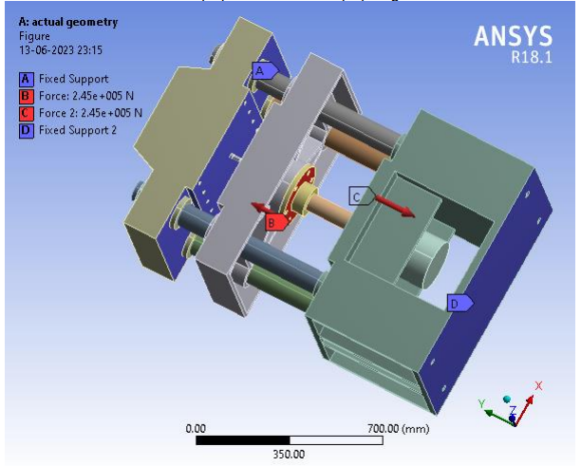
Fig 7. Appling boundary conditions
The equivalent stress and deformation result can be obtained after the finite element calculation, which can establish the condition of the hydraulic press machine, and then verify whether the design model is reasonable. It can be seen from the equivalent stress results (fig 8) that the maximum equivalent stress of the Hydraulic press machine is 197.99MPa, which mainly occurs in the die and punch contact with the ram of the hydraulic cylinder. Under the maximum stress, the maximum equivalent force of the die and punches of the hydraulic press is less than the allowable stress of structural steel, which means that the tools and die structure is safe. At the same time, it can be seen from the figure that the maximum displacement of the hydraulic press is 0.0459mm, which occurs on the contact surface between the lower side of the ram and the nut of the piston rod of a hydraulic cylinder. By observing the stress result, we can also find that the structural layout of the hydraulic press machine is not the most reasonable. The Hydraulic press machine can be regarded as composed of many ribs. Some ribs have small stress and a large safety margin, that is, the ribs do not give full play to the supporting role, which means that the whole hydraulic press has a very large space for optimization, so we can try to optimize the structure of some parts.
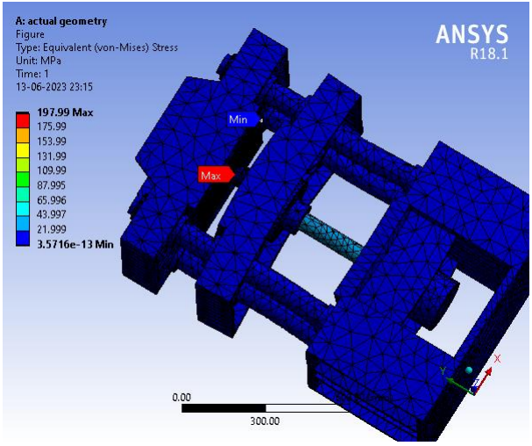
Fig 8. Equivalent stress of existing press
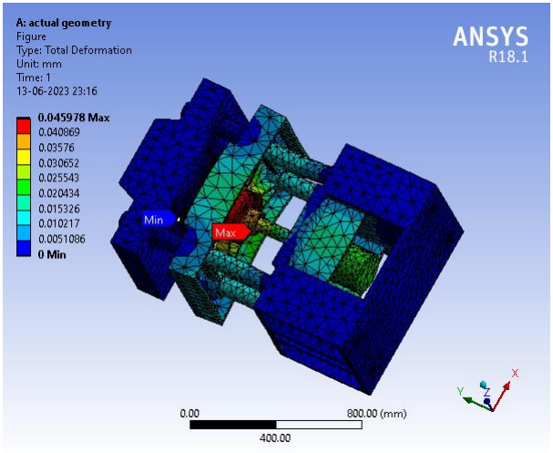
Fig 9. Total deformation of existing press
VI -OPTIMIZATION AND ANALYSIS
According to the result of static structural analysis, it is found that the structure of the hydraulic press machine has the potential chance to optimize. Some ribs and support are given only for support and it doesn't work a crucial role in the strength of the hydraulic press machine. So based on that reduce the weight of unwanted ribs and supports. Optimized the design of hydraulic press machines without compromising their strength and working capacity. Create optimize design by using SolidWorks software by removing some materials. According to the results of finite element analysis, it can be found that the maximum stress is on the die and punches and on the ram which holds the die and punches, the ram is in contact with the hydraulic cylinder and the four pillars which give support to the hydraulic press machine. The base and upper plate of the hydraulic press and other parts have less stress. Optimize the size and shape of the base, upper plate, and ram of the hydraulic press machine as shown in Fig 10.
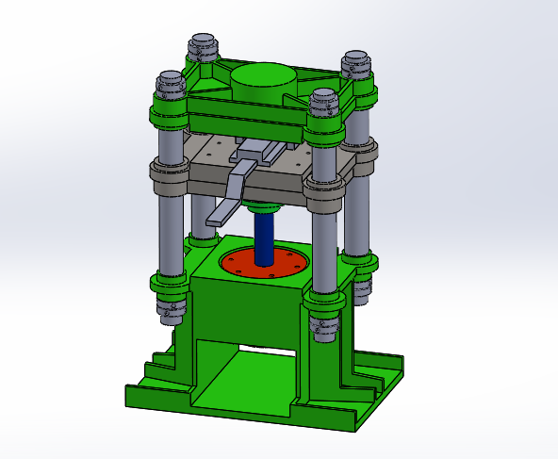
Fig 10. 3D model of optimized hydraulic press machine
The prototype results are established and meshed to obtain the static structural model (as shown in Fig 12). Meshing the prototype to easily solve the problem and get better results in less computational time.
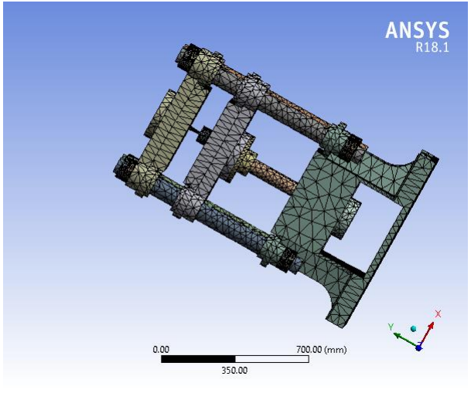
Fig 11. Optimize design Meshing
Applies the same boundary conditions which are applied to the existing design of the hydraulic press machine. Find out the equivalent stress and deformation result can be obtained after the finite element calculation, which can establish the condition of the hydraulic press machine. It can be seen from the equivalent stress results (fig 12) that the maximum equivalent stress of the Hydraulic press machine is 220.5MPa and the maximum displacement result (fig 13) of the hydraulic press is 0.0521MM.
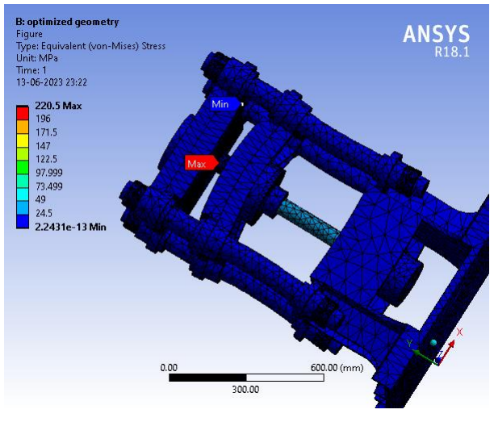
Fig 12. Equivalent stress of optimized press
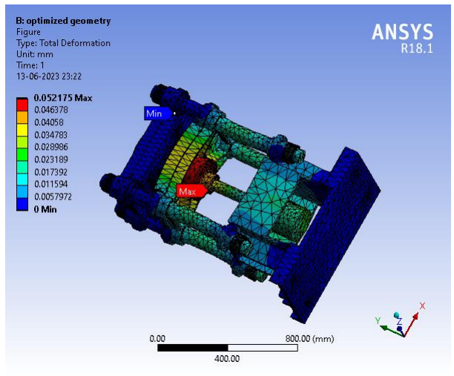
Fig 13. Total deformation of existing press
VII -RESULT
Comparison of existing pellets forming hydraulic press machine and optimized pellets forming hydraulic press machine. Optimizing the design reduced the total weight of pellets forming the hydraulic press machine by 28 %.
Table 1- Comparison between existing & optimized design
Sr.No | Parameter | Existing | Optimized
1 | Von Misses Stresses | 197.99MPa | 220.5 MPa
2 | Total Deformation | 0.0459 MM | 0.0521 MM
3 | Weight | 1395.7 Kg | 995.61 Kg

VIII- CONCLUSION
By comparing the result of existing pellets forming hydraulic press machine and optimized pellets forming hydraulic press machine, we get weight reduction. existing pellets forming hydraulic press machine that 1395.7 Kg to 995.61 Kg. i.e. 28% weight reduction. Deflection increases from 0.0459 mm to 0.0521 mm but it is in the permissible limit. Von-misses stresses increase 197.99 MPa to 220.5 MPa and it also doesn't cross the permissible limit our design is safe under working condition
REFERENCES
- Yurong Zhu et al 2021 Structure Analysis and Optimization Design of the Base of Four-pillar Hydraulic Testing Machine
- Wu Sh, Yuan X and Han M 2021 Three-dimensional parametric modeling and finite element analysis of special coil steel platform container Packaging Engineering 42(1): 129-135.
- Asim M.Kamate and Prof. Dr. J.S. Bagi, A Review on Design Analysis and Optimization of a 20 Ton Hydraulic Press, International Journal of Engineering Technology, Management, and Applied Sciences, Volume 3, Special Issue, ISSN 2349-4476, September 2015
- Zhou H Q 2017 Design and Performance Analysis of 120T Hydraulic Unit Hebei: Yanshan University.
- Mao Sh Y and Chen L 2017 Optimization design of CNC bending machine based on ANSYS workbench Modular Machine Tool & Automatic Manufacturing Technique (9): 132-135.
- Abhijeet S Khandekar, Conventional Design Calculation &3D Modeling of Metal Forming Heavy duty Hydraulic Press, International Journal of Engineering Research and Applications, Vol. 5, Issue 6, Part – 5, pp.100-103, June 2015
- Swapnil Choudharya, Chaitanya V. Kakdeb, Dr .Bharat Chede, Nitin Sawarkar, "Design & Analysis of Stress on Drill Bit." Turkish Journal of Computer and Mathematics Education (TURCOMAT) 12.13 (2021): 2243-2248.
- Mr. Umesh C. Rajmane, Mr. Sourabh S. Kulkarni, and Prof. Dr. A.M.Nagaraj, Design, Development, and Stress Analysis for Twin Punching 100 ton Forging press, International Journal of Advanced Research in Science, Engineering, and Technology, Vol. 3, Issue 1, January 2016.
- Ankit H Parmar, Kinnarraj P Zala, Ankit R Patel, "Design and Modification of Foremost Element of Hydraulic Press Machine", International Journal of Advanced Scientific and Technical Research, 2014.
- Wasekar, S., Choudhary, S., Sawarkar, N., & Chede, B. (2023, April). Design & optimization of life of hot forging die. In AIP Conference Proceedings (Vol. 2753, No. 1). AIP Publishing.
- B. Parthiban et al, "Design and Analysis of C type hydraulic press structure and cylinder", International Journal of Research in Aeronautical and Mechanical Engineering, Vol.2 Issue.3, March 2014.Pgs: 47-56
- Karkhane Himanshu Namdev1 S.M.Jadhav2, Design, Development, And Manufacture of 14 Tonnes Hydraulic Press- 30-11-2020

