REVIEW PAPER ON HEAT TRANSFER ANALYSIS OF HELICAL FIN WITH PARABOLIC CROSS SECTION
M.A. Salve¹, T.A.Koli², Dr.V.H.Patil³
1Student, Mechanical department, Godavari College of engineering, jalgaon
2Professor, Mechanical department, Godavari College of engineering, jalgaon
3Head of department, Mechanical department, Godavari college of engineering, jalgaon
Email:1)mohanrajsalve19@gmail.com 2)kolitushar09@gmail.com 3) vhpatil76@yahoo.co.in

Abstract –The Engine cylinder is one of the major automobile components, which is subjected to high temperature variations and thermal stresses. In order to cool the cylinder, fins are provided on the surface of the cylinder to increase the rate of heat transfer. By doing thermal analysis and modification on the engine cylinder fins, it is helpful to know the heat dissipation inside the cylinder. Air-cooling is used due to reduced weight and simple in construction of engine cylinder block. As the air-cooled engine builds heat, the cooling fins allow the wind and air to move the heat away from the engine. Low rate of heat transfer through cooling fins is the main problem in this type of cooling. An attempt will be made to simulate the heat transfer using CFD for helical fin with parabolic cross section and analyze effects on rate of heat dissipation from fins surfaces. The heat transfer surfaces of Engine will be modelled in CATIA and simulated in ANSYS software. The main of aim of this work is to study different shapes and geometry of fins to improve heat transfer rate

Keywords-helical fin, square fin ,heat transfer analysis
- INTRODUCTION
We know that just in case of internal combustion engines, combustion of air and fuel takes place inside the engine cylinder and hot gases are generated. The temperature of gases will be around 2300-2500°C. This is a awfully warmth and will result into burning of oil film between the moving parts and will result it seizing or welding of same.
So, this temperature should be reduced to concerning 150-200°C at that the engine can work most with efficiency. Too much cooling is additionally not fascinating since it reduces the thermal potency. So, the item of cooling system is to stay the engine running at its most effective operative temperature. It is to be noted that the engine is sort of inefficient once it's cold and therefore the cooling system is meant in such the simplest way that it prevents cooling once the engine is warming up and until it attains to most economical operative temperature, then it starts cooling. To avoid warming, and therefore the resultant sick effects, the heat transferred to an engine component (after a certain level) must be removed as quickly as possible and be conveyed to the atmosphere.
It will be correct to mention the cooling system as a temperature regulation system. It should be remembered that abstraction of heat from the operating medium by manner of cooling the engine elements may be a direct thermodynamically loss
1.1 Natural Air Cooling
In traditional cause, larger parts of an engine remain exposed to the atmospheric air. When the vehicles run, the air at certain relative velocity impinges upon the engine, and sweeps away its heat. The heat carried-away by the air is because of natural convection, therefore this method is known as natural air-cooling. Engines mounted on 2-wheelers are mostly cooled by natural air. As the cooling may be a operate of frontal cross sectional space of the engine, therefore there exists a need to enlarge this area. An engine with enlarge space can becomes large and successively also will scale back the ability by weight magnitude relation. Hence, as another arrangement, fins are constructed to enhance the frontal cross-sectional area of the engine. Fins (or ribs) are sharp projections provided on the surfaces of engine block and plate. They increase the outer contact space between a cylinder and therefore the air. Fins are, generally, casted integrally with the cylinder. They may also be mounted on the cylinder.
1.2Fins
A fin is a surface that extends from an object to increase the rate of heat transfer to or from the environment by increasing convection. The amount of conduction, convection, radiation of an object determines the amount of heat it transfers. Increasing the temperature difference between the object and the environment, increasing the convection heat transfer coefficient, or increasing the surface area of the object increases the heat transfer. Sometimes it is not economical or it is not feasible to change the first two options. Adding a fin to the object, however, increases the surface area and can sometimes be economical solution to heat transfer problem
- LITERATURE SURVEY
2.1:“Review Paper on Effect of Cylinder Block Fin Geometry on Heat Transfer Rate of Air-Cooled 4S SI Engine” (2014) Arvind S.Sorathiya, et.al. says that, the design of fin plays an important role in heat transfer. There is a scope of improvement in heat transfer of air cooled engine cylinder fin if mounted fin’s shape varied from conventional one. Contact time between air flow and fin (time between air inlet and outlet flow through fin) is also important factor in such heat transfer. Wavy fin formed casting are often used for increasing the warmth transfer from the fins by making turbulence for forthcoming air. Improvements in heat transfer can be comparing with conventional one by CFD Analysis and Wind Tunnel experiment. [1]
2.2:“Design Modification and Analysis of Two Wheeler Engine Cooling Fins by CFD” (2015) Prof. S.M.Kherde, et.al. says that, models for three different shapes of fin and effects of wind velocity and heat transfer coefficient values. A analysis is applied in associates Fluent to seek out the result of modification in pure mathematics of Fins in terms of HTC and air turbulence. Heat transfer rate will increase once ever-changing fin pure mathematics and it's discovered that HTC and turbulence square measure additional just in case of step form fin model as compare to “S” shape Fin model. Due to non-uniformness in the geometry of Fins turbulence of flowing air increases which results in more heat transfer rate. [2]
2.3:“Thermal Analysis of Engine Cylinder Fin by Varying Its Geometry and Material’’ (2014) P. Sai Chaitanya, et.al. Says that, in a present work, a cylinder fin body is modelled and transient thermal analysis is done by using Pro/Engineer and ANSYS. These fins square measure used for air cooling systems for 2 wheelers. The various parameters (i.e., geometry and thickness of the fin) are considered in the study, by reducing the thickness and also by changing the shape of the fin to circular shape from the conventional geometry i.e. rectangular, the weight of the fin body reduces thereby increasing the heat transfer rate and efficiency of the fin. By using circular fins the weight of the fin body reduces compared to existing rectangular engine cylinder fin.[3]
2.4:“Heat Transfer Simulation by CFD from Fins of an Air Cooled Motorcycle Engine under Varying Climatic Conditions’’ (2011) Pulkit Agarwal, et.al.
says that,a model for an air cooled motorcycle engine was developed and effects of wind velocity and air temperature were investigated. The paper confirms the results of the experimental study of warmth transfer dependence on completely different stream velocities. An analysis of heat transfer under completely different surrounding temperatures has additionally been applied to reduce the overcooling of engines. The temperature and heat transfer constant values from fin base to tip aren't uniform that shows the foremost advantage of CFD for analysis of warmth transfer. The extra heat loss which takes place in the regions of subzero temperature has been found out. Using this data, the amount of fuel conserved can be easily calculated. A method of preventing this excessive heat loss is to use a diffuser within the path of air before it strikes the engine surface. This will help in reducing the air velocity and help in improving the efficiency of the engine.[4]
22.5: “Optimization of Design Parameters of Various Geometries” (2000) Rong Hua Yeh says that, In his paper he find out the forgiven cylinder convex parabolic, conical, and concave parabolic fin profiles, the optimum dimensions and heat transfer characteristics of spines for various heat transfer modes and obtained with the aid of fin parameter and fin efficiency. It turns out the optimum base diameter, length, and heat duty is mainly a function of fin volume and base heat transfer coefficient. He illustrated different profiles and their relations.[5]
2.1 Problem Statement
Today, in IC Engine quantity of heat given to the cylinder walls is considerable and if this heat is not removed from the cylinders it would result in the pre-ignition of the charge. Thereby causing the seizing of the piston. Excess heating will also damage the cylinder material and also following losses uncounted in engine.
1.Thermal efficiency is reduced because of additional loss of heat to the cylinder walls..
2. The vaporization of fuel is less; this leads to fall of combustion efficiency
3. More piston friction is encountered, thus decreasing the mechanical efficiency.
2.2 Proposed Method/System
Thus, in the present day investigation on thermal issues on automobile fins are carried out. The main of aim of this work is to improve heat transfer rate of cooling fins by changing cylinder block fin geometry.
We will change the cross-section of the fin to a parabolic one in an attempt to increase the flow velocity over the fin surface and hence facilitating more heat dissipation due to a proportional increase in heat transfer coefficient. Fins will modeled over the cylinder in a helical orientation so as to accommodate more fin area than the conventional circular finned model over the cylinder with same dimensions.
3. METHODOLOGY
Fin Cross-Sections
Rate of heat transfer is proportional to the surface area. So as the surface area increases, the heat transfer and hence the fin performance increases. The cross-section must be chosen in such a way that the surface area is more in order to improve the area of contact with the fluid. Our work is an attempt to improve the performance by changing the geometry of the fin while keeping other parameters constant. We will change the cross-section of the fin to a parabolic one in an attempt to increase the flow velocity over the fin surface and hence facilitating more heat dissipation due to a proportional increase in heat transfer coefficient. Fins will modeled over the cylinder in a helical orientation so as to accommodate more fin area than the conventional circular finned model over the cylinder with same dimensions

Table 1- Design parameters
Cylinder Diameter[mm] | 60
Fin Pitch [mm] | 8-14
Fin Length [mm] | 10-50
Material | Aluminium alloy
Wind Velocity [km/hr] | 7.2-72

Material Selection
Aluminium alloy (6061)
Thermal Properties
- Co-Efficient of Thermal Expansion (20-100°C): 23.5x10⁻⁶ m/m.°C
- Thermal Conductivity: 200 W/m.K
- Typical composition of aluminium alloy 6061
Table 2 - Steady State Thermal Analysis
Analysis type | Steady state thermal
Nodes | 71308
Elements | 39121
Assignment | Aluminium
Element mesh | Smooth
Temperature | 300◦c (ramped)
Film coefficient | 4.5e-005 w/mm²
Ambient Temperature | 22◦c
A] Temperature Distribution:
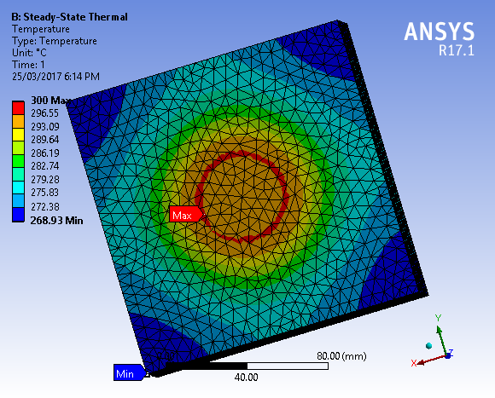
Fig. 1-Temperature Distribution of Rectangular Fin

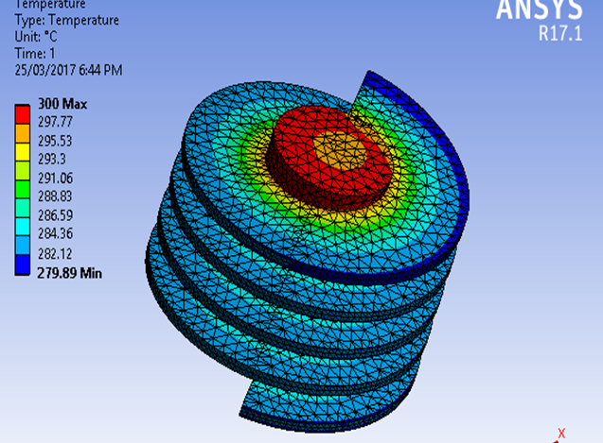
Fig. 2-Temperature Distribution of Parabolic Fin
Total Heat flux
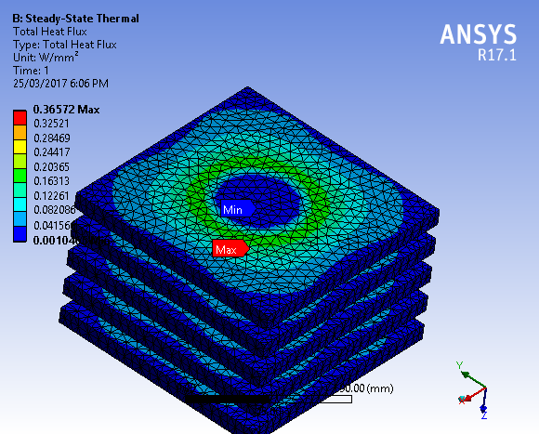

Fig. 3-Total heat flux of Rectangular Fin
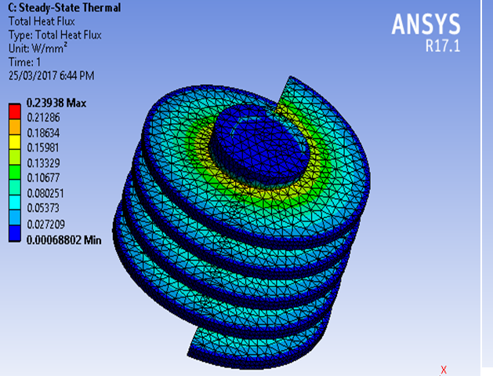
Fig. 4-Total heat flux of Parabolic Fin

- CONCLUSIONS

1. Steady state thermal analysis with average temperature about 3000⁰C and uniform heat transfer coefficient 45w/mm 20⁰C from analysis, we understood that temperature distribution is more in helical fin than rectangular fin .It conducts more heat as more uniform profile, Tip temperature is around 2760⁰c in parabolic fin.
2. Heat flux rate is also more and uniform in helical fin with parabolic cross section
REFERENCES
- .Prof.Arvind S.Sorathiya et.al “Review Paper on Effect of Cylinder Block Fin Geometry on Heat Transfer Rate of Air-Cooled 4S SI Engine” ISSN 2347 - 6435 Volume 2, Issue 1, January 20141
- Prof. S.M.Kherde et.al. “Design Modification and Analysis of Two Wheeler Engine Cooling Fins by CFD” Volume 4, Issue 2, February 2015
- P. Sai Chaitanya, et.al. “Thermal Analysis of Engine Cylinder Fin by Varying Its Geometry and Material’’ Volume 11, Issue 6 Ver. I (Nov- Dec. 2014), PP 37-44
- Pulkit Agarwal, et.al. “Heat Transfer Simulation by CFD from Fins of an Air Cooled Motorcycle Engine under Varying Climatic Conditions’’ Proceedings of the World Congress on Engineering 2011 Vol III WCE 2011, July 6 - 8, 2011
- Rong Hua Yeh “Optimization of Design Parameters of Various Geometries” Journal of marine science technology vol.3 No.1 pp 11-17 (2000)

